HOS06A Inference Pipeline in SageMaker

AI620 Fall 2024 by Verónica Elze

# Prepare input data on Amazon S3

* 1. Create a bucket

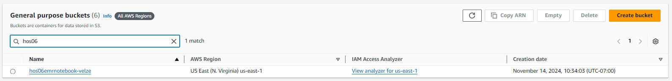

* 1. Upload data

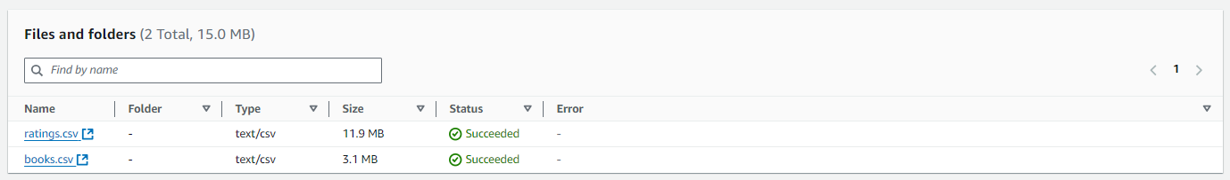

# Launch an Amazon EMR Cluster

1. Create cluster

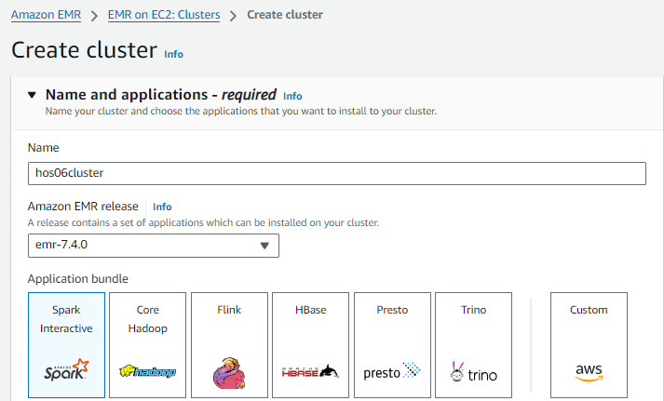

1. Set automatic termination after idle time

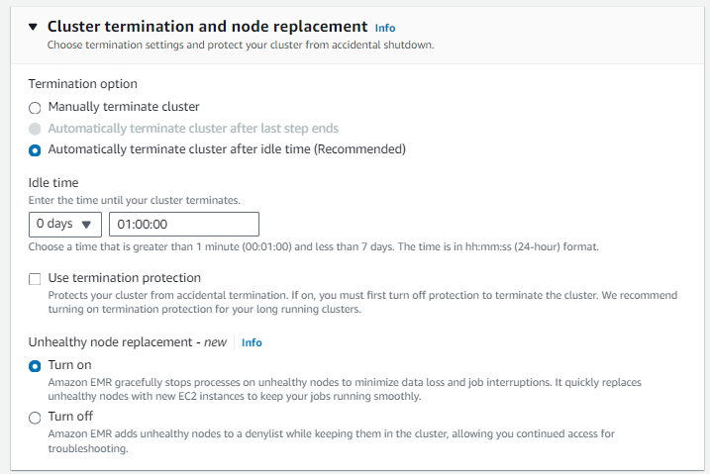

1. A screenshot of a computer

   Description automatically generated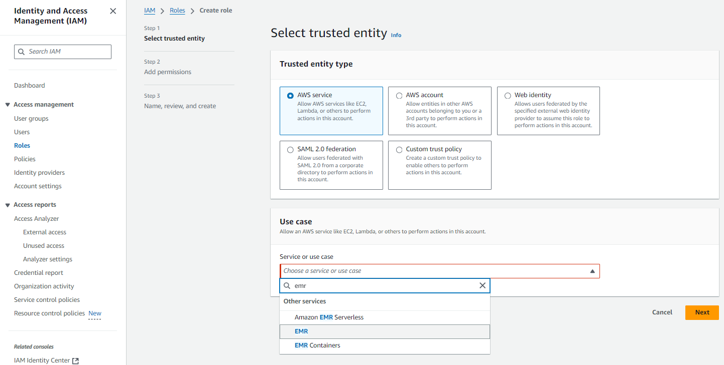Create service role

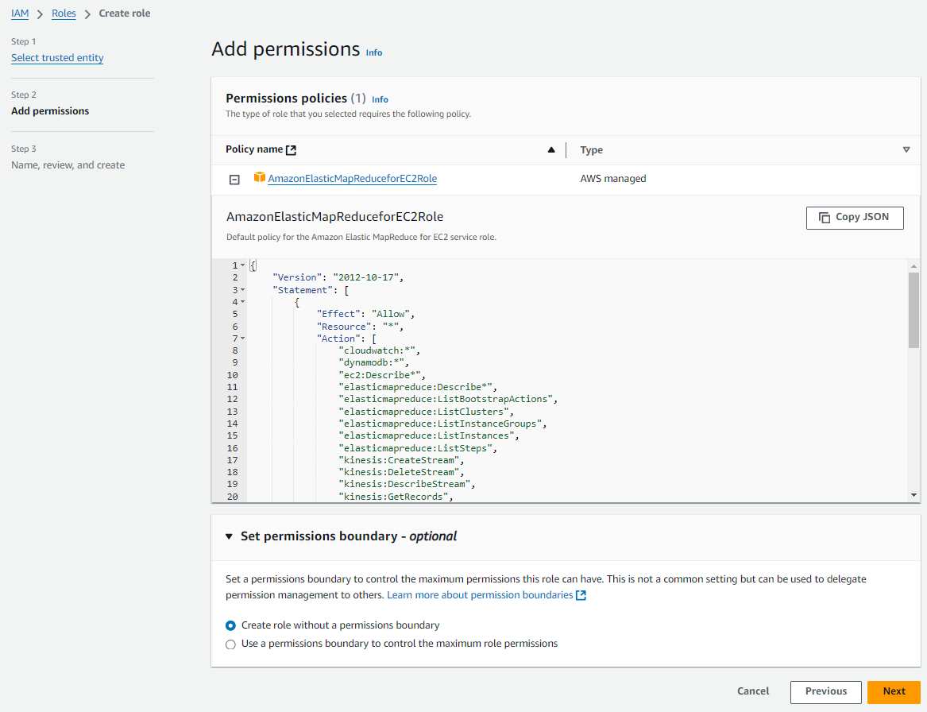

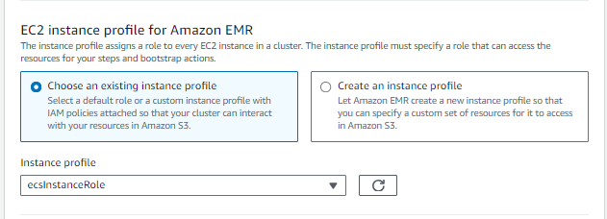

1. Create cluster

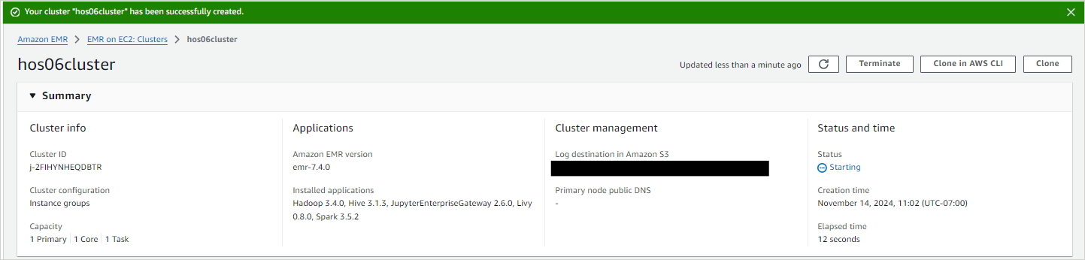

# Create Workspace

* 1. Steps 1 & 2

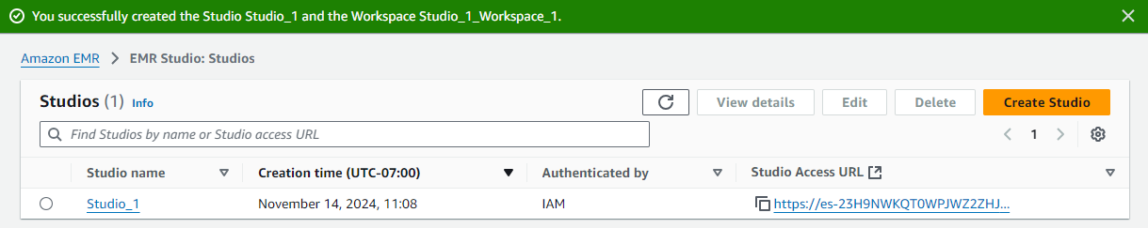

* 1. Step 3

