PE07: Programming Exercise

Fall 2024 by Verónica Elze

**NTM in SageMaker**

Closely follow the textbook chapter 9 and Lecture 07.pptx to implement NTM in SageMaker:

* PE07-1 Data
  + Follow textbook 304 to get Enron emails
    - 39.861 emails and 28101 unique words
    - We will work with a subset of these emails – 3986 emails and 17524 unique words

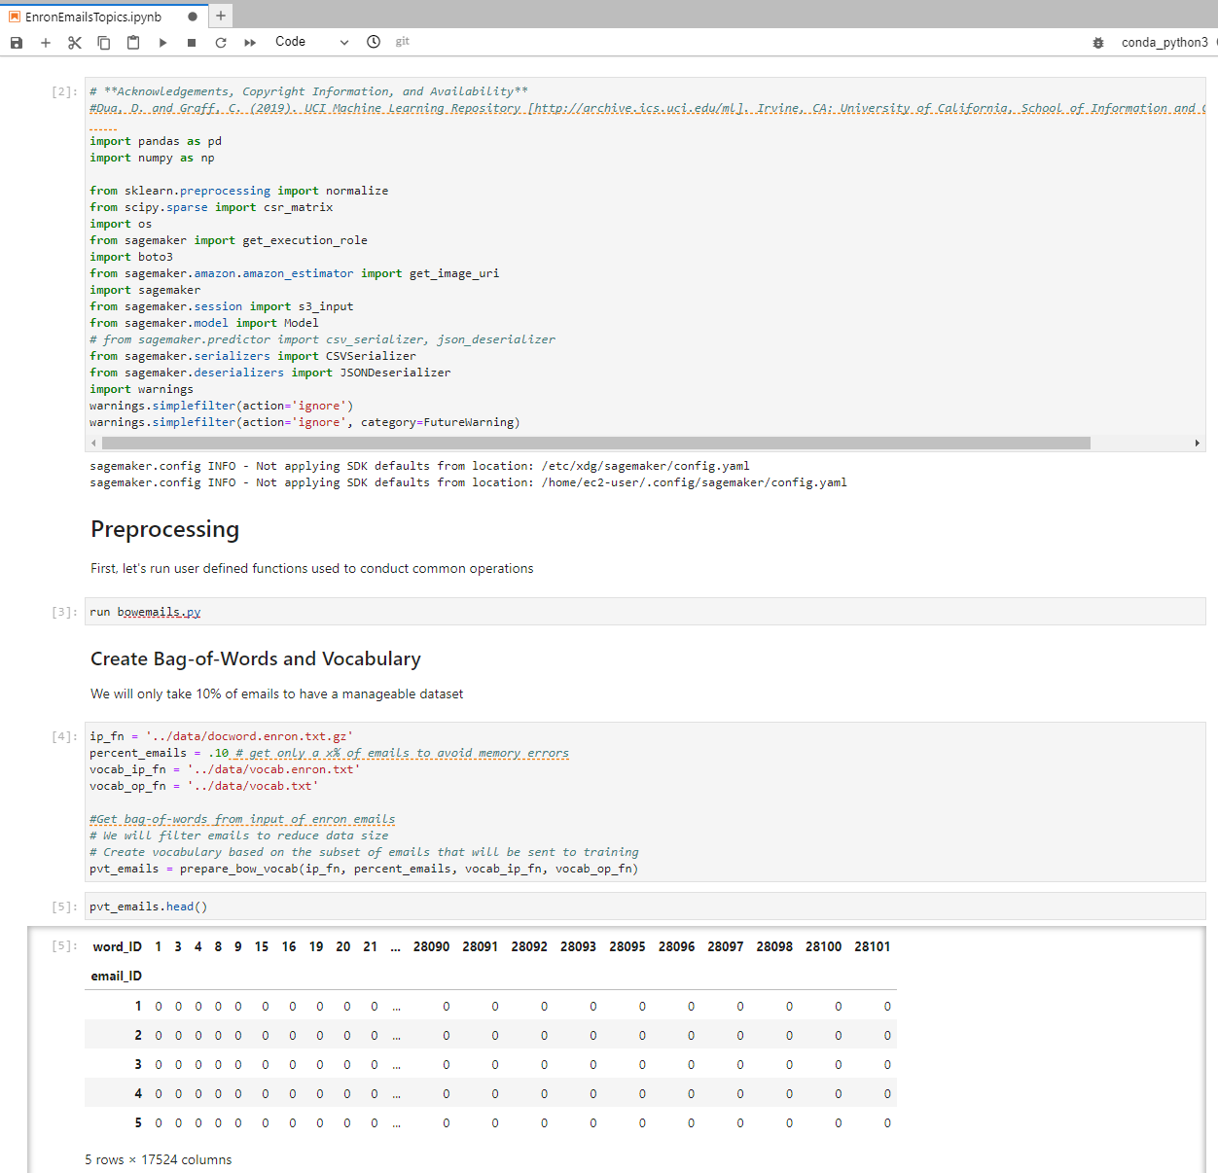

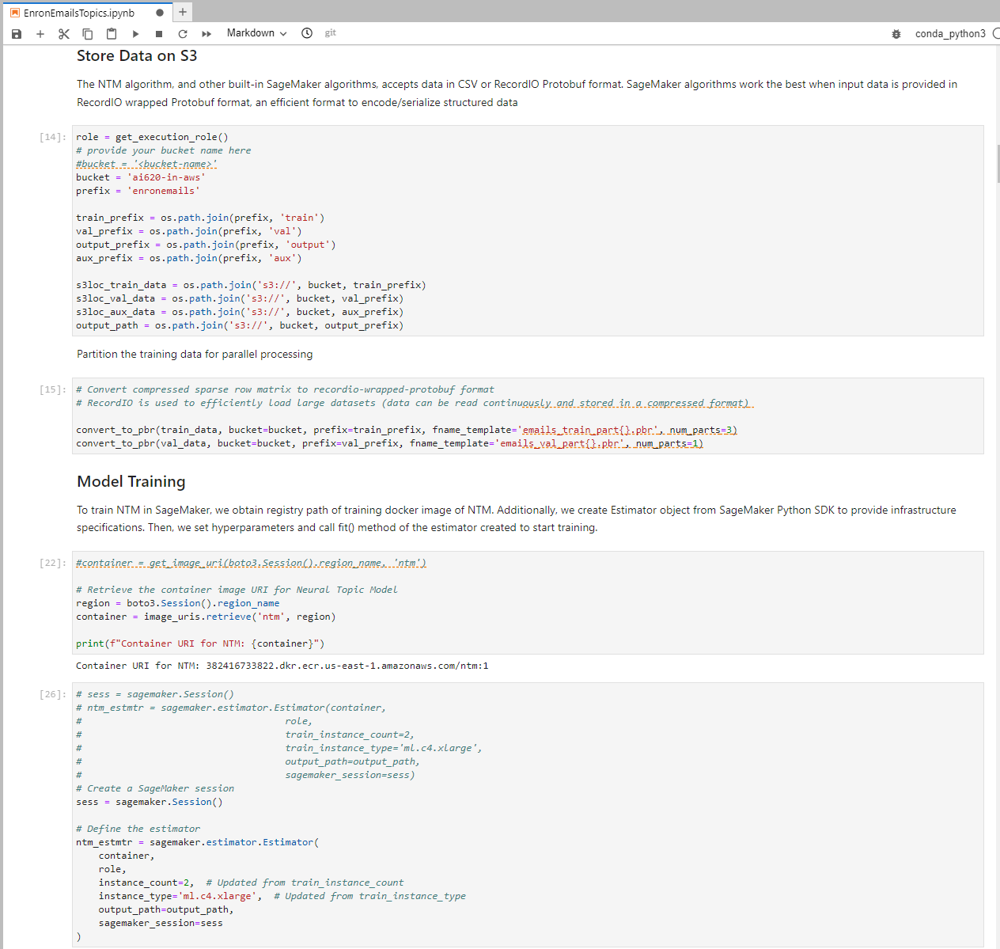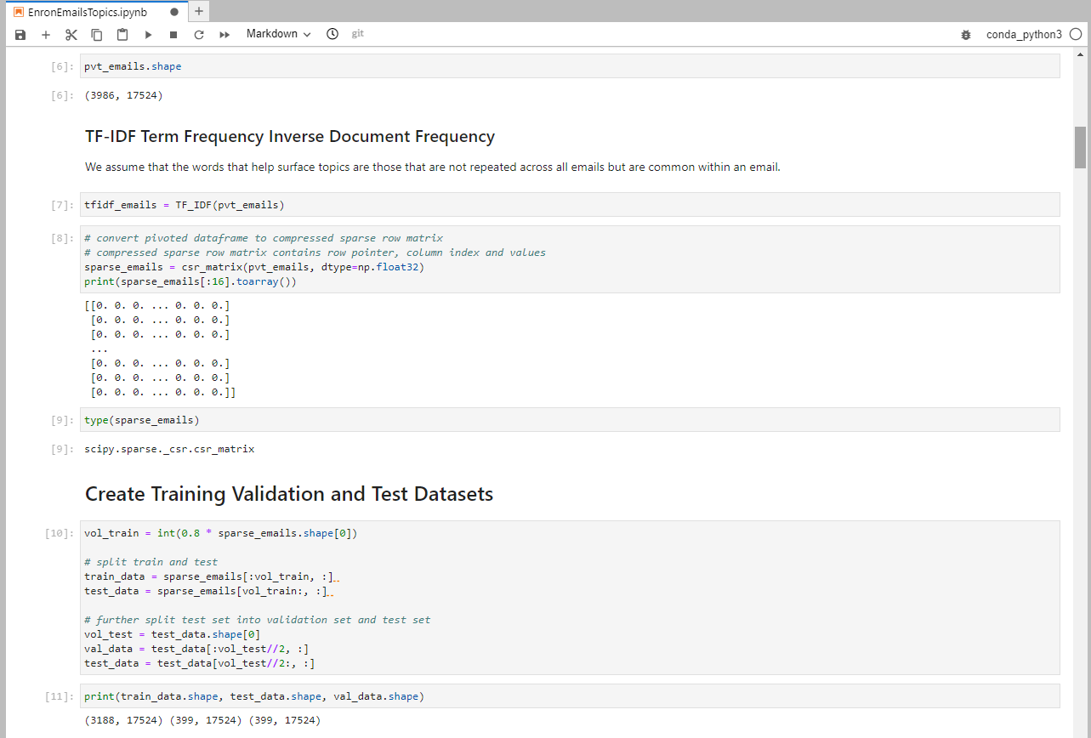

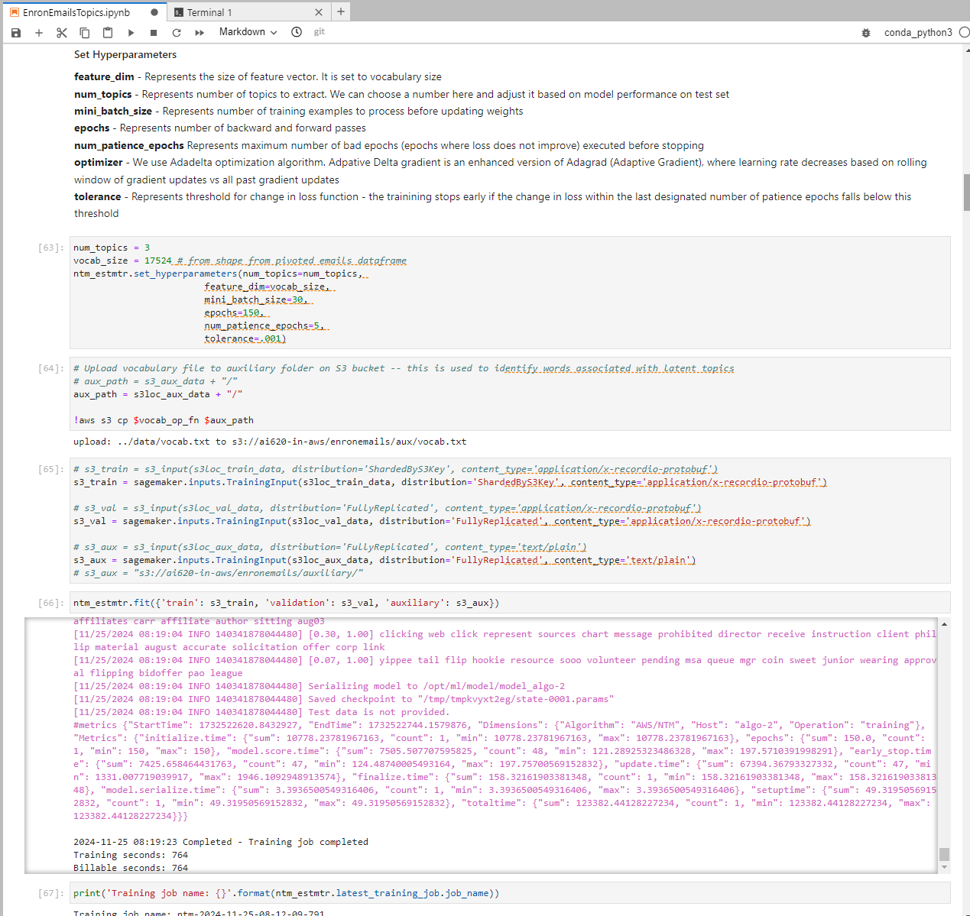

* A screenshot of a computer

  Description automatically generatedPE07-2 Implementation in SageMaker
  + Follow textbook page 311 step 1 to 13
* PE07-3 Deploy the trained NTM model and running the inference
  + Follow textbook page 317 step 1 to 5, and plot the topics

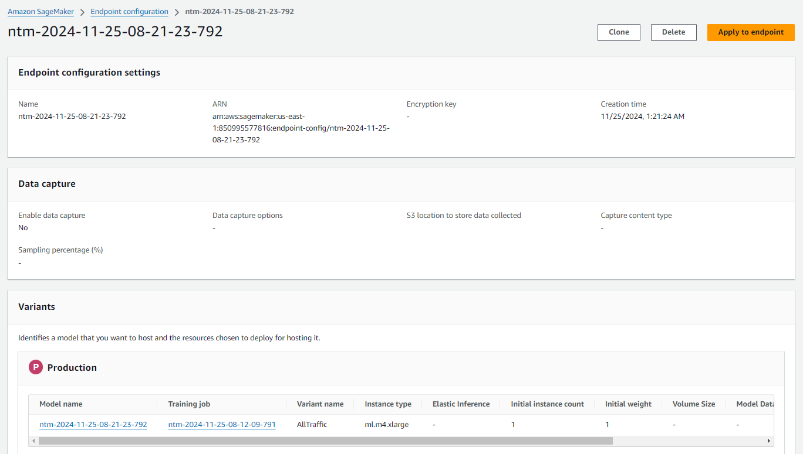

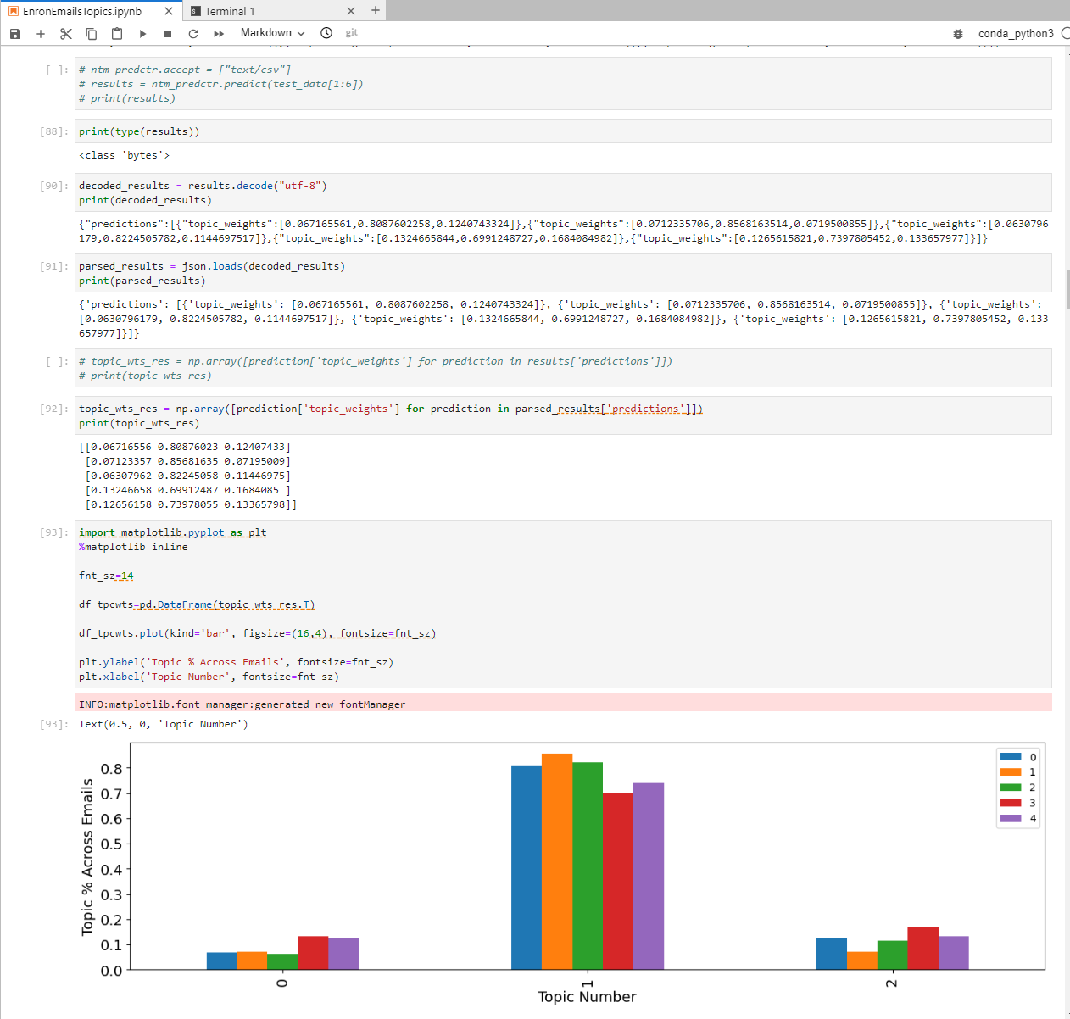

**Your task for PE07 is to:**

1. Complete above task

**Please make sure you remove all the running resources after finishing the task. Note that you will need to specifically shutdown the deployed inference.**

**HINT**:

* Should be a light PE so that you can focus on team project progress report. It took me 9 hours over 3 days to accomplish this PE with the help of the code provided by the textbook, instructor’s video, and ChatGPT. I received **more** errors than the instructor experienced in the recorded video.
* Feel free to follow the textbook’s GitHub codes if needed: <https://github.com/PacktPublishing/Hands-On-Artificial-Intelligence-on-Amazon-Web-Services/tree/master/Chapter09>
* Feel free to follow [this step-by-step video](https://cityuseattle.sharepoint.com/teams/AI620ONEmergicTopicsinArtificialIntelligence-Fall2024/_layouts/15/stream.aspx?id=%2Fteams%2FAI620ONEmergicTopicsinArtificialIntelligence%2DFall2024%2FShared%20Documents%2FModule%2007%2FRecordings%2FMeeting%20in%20%5FModule%2007%5F%2D20241110%5F213334%2DMeeting%20Recording%2Emp4&referrer=StreamWebApp%2EWeb&referrerScenario=AddressBarCopied%2Eview%2Ee9b2dbd9%2D9ba5%2D4191%2D87da%2D52c02771dce2) to complete this PE

**Submit the items below to the PE submission page:**

* Please provide screenshots after completing task1 PE07-2, PE07-3
* Please provide around 100 words of overall feelings completing this whole PE.  
  Completing this programming exercise was a rewarding yet challenging experience. It offered valuable hands-on exposure to working with AWS SageMaker, ECR, and deploying machine learning models. Troubleshooting errors, particularly around permissions and endpoint configurations, enhanced my understanding of cloud infrastructure intricacies. While the initial setup and debugging required persistence, the process deepened my appreciation for the practical applications of ML deployment. Successfully deploying the model and running predictions was a fulfilling moment that validated the effort invested. Overall, this exercise highlighted the importance of attention to detail, systematic problem-solving, and adaptability when working with cloud-based AI tools.
  + Make sure the PE module number and your name are written on the file name, e.g., "*PE07_Name.docx").*