PE08: Programming Exercise

Fall 2024 by Verónica Elze

# Predict Ad Click Conversion through XGBoost

Closely follow [ClickFraud_Tracking.ipynb](https://github.com/PacktPublishing/Hands-On-Artificial-Intelligence-on-Amazon-Web-Services/blob/master/Chapter12/Code/ClickFraud_Tracking.ipynb) up until `Training` step. You don’t need to finish `Plot Feature Importance` and `Inferences` the model parts.

**Your task for PE10 is to:**

1. Complete above task

**Please make sure you remove all the running resources after finishing the task.**

**HINT**:

* Feel free to follow [this step-by-step video](https://cityuseattle.sharepoint.com/teams/AI620ONEmergicTopicsinArtificialIntelligence-Fall2024/_layouts/15/stream.aspx?id=%2Fteams%2FAI620ONEmergicTopicsinArtificialIntelligence%2DFall2024%2FShared%20Documents%2FModule%2008%2FRecordings%2FMeeting%20in%20%5FModule%2008%5F%2D20241117%5F102033%2DMeeting%20Recording%2Emp4&referrer=StreamWebApp%2EWeb&referrerScenario=AddressBarCopied%2Eview%2Efbdf99ee%2D3ae1%2D4bf1%2Daa5d%2Daa44245f0852) to complete this PE

**Submit the items below to the PE submission page:**

1. Please provide screenshots after completing `Preprocessing`, `Explore Data`, `Create Features`, and `Training` steps.
   * Make sure the PE module number and your name are written on the file name, e.g., "*PE08_Name.docx").*

Wrapping up this programming exercise felt like running a marathon with surprise hurdles—and a few detours! SageMaker’s updates kept me on my toes, with every error message feeling like a cryptic riddle. Debugging deprecated methods was like playing detective in a tech mystery novel, but the moment everything finally worked was pure gold. It reminded me how fast tech evolves and how important it is to stay ahead of the curve (or at least not trip over it). All in all, it was a fun mix of frustration and triumph—and now I feel like I earned my coffee break! ☕🎉

# Preprocessing

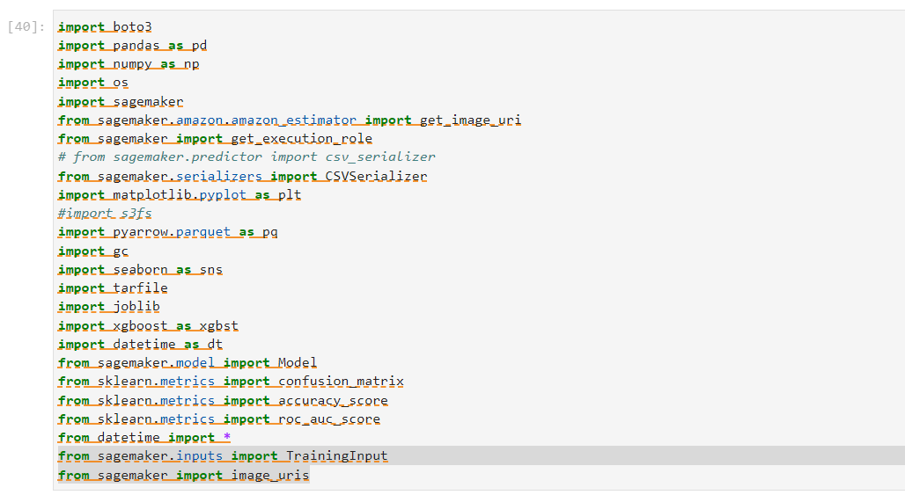

# Prepare Data

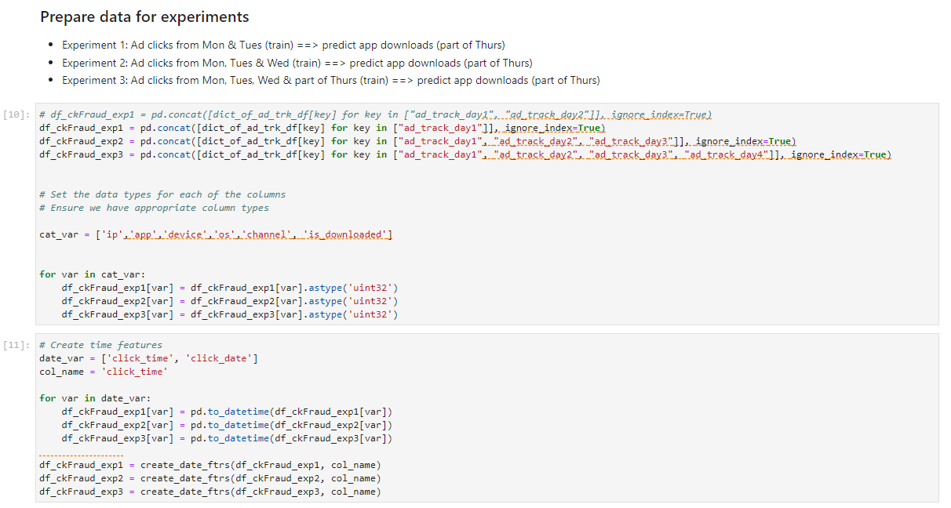

# Explore Data

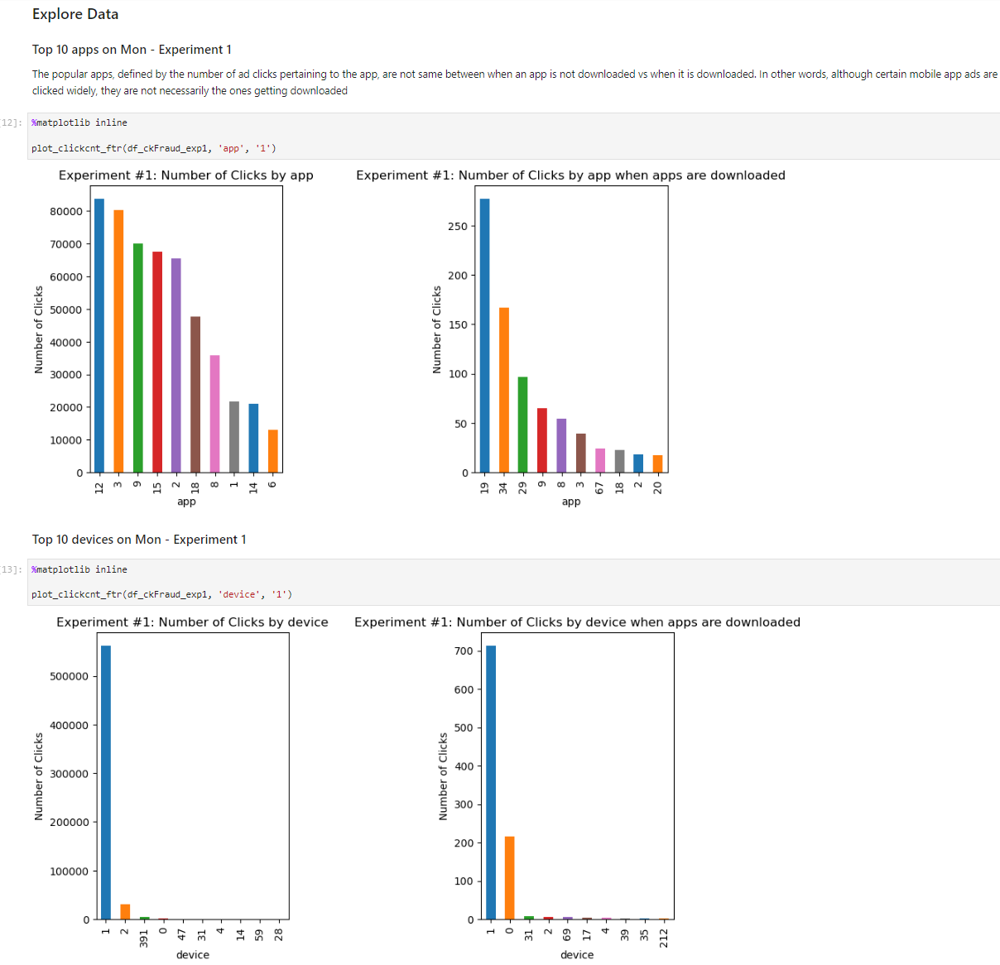

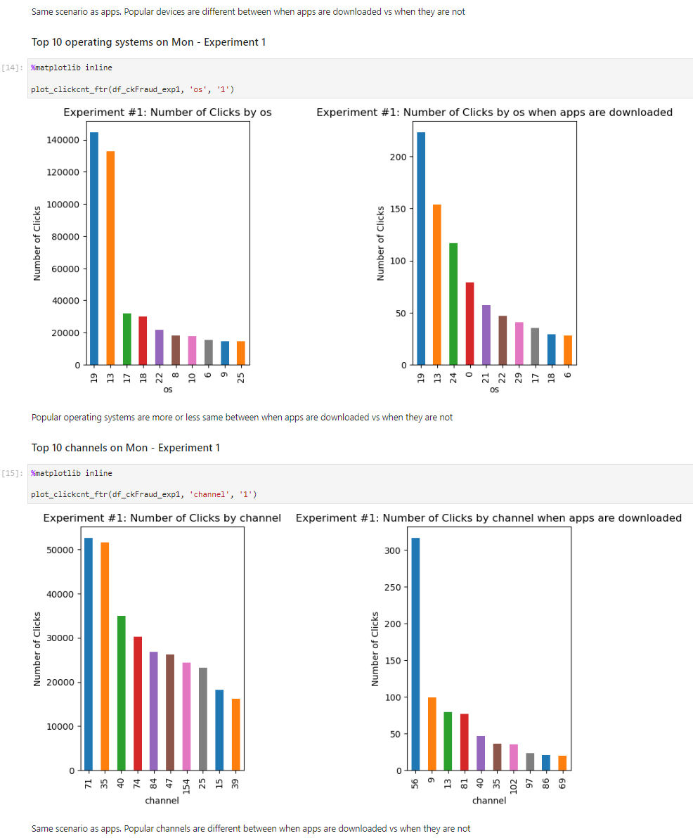

# Create Features

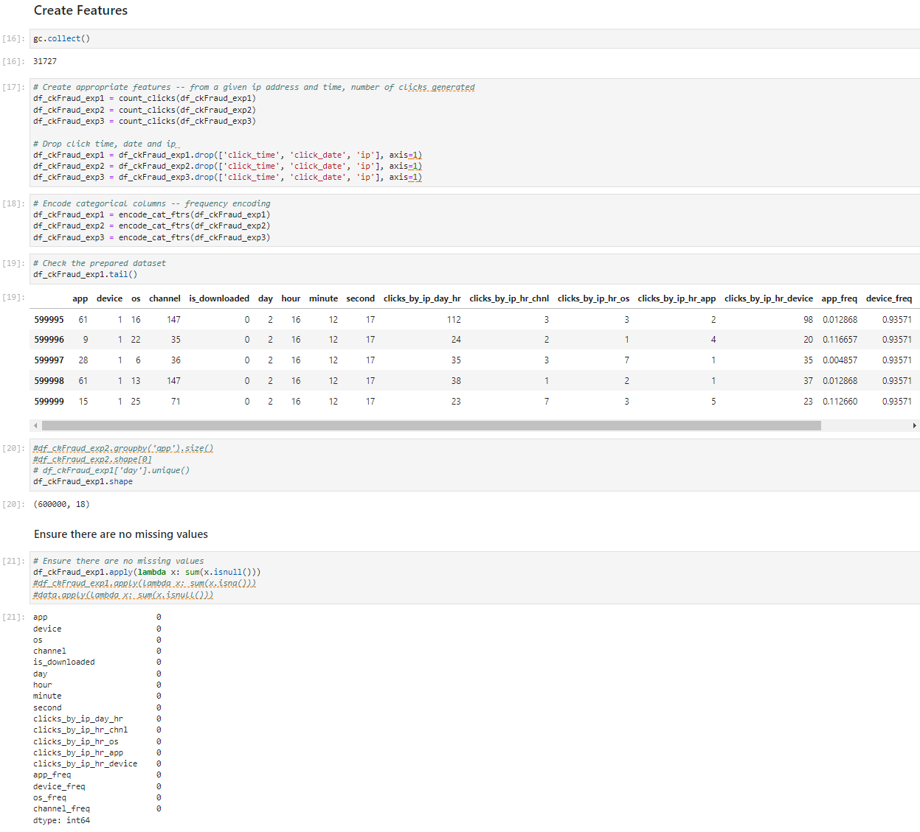

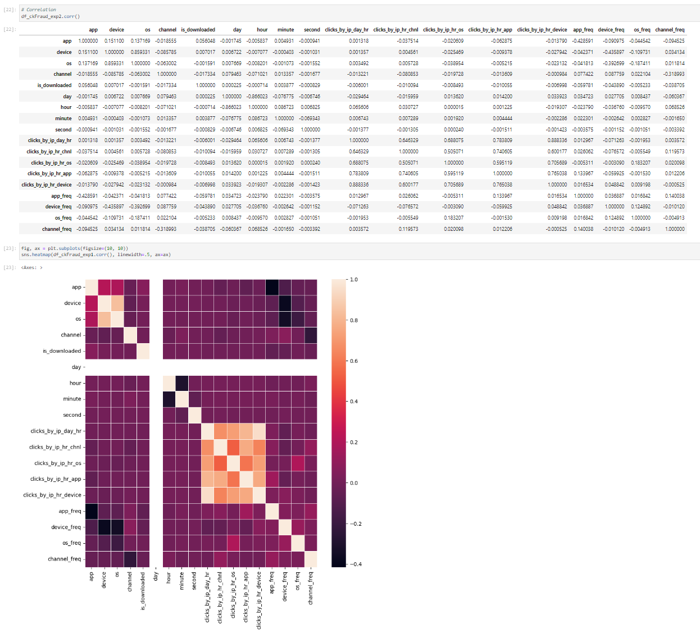

# Running Experiments

# Create Train, Validation, & Test Datasets

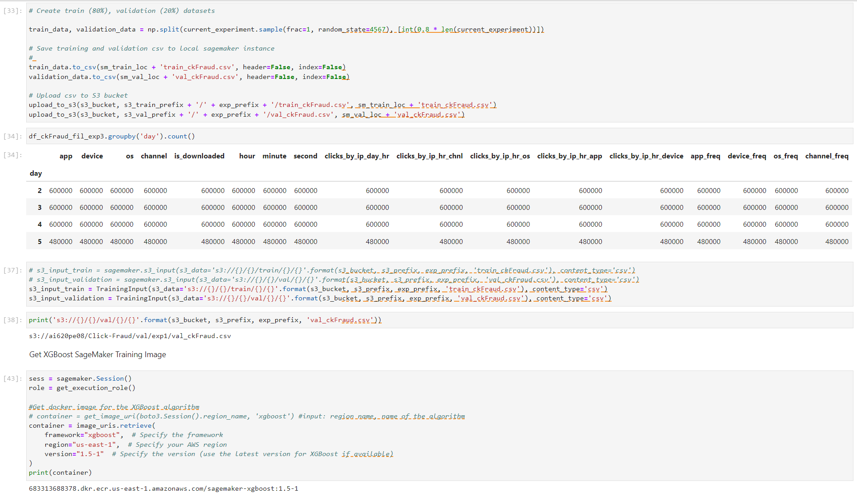

# Training



