HOS08A Predict Ad Click Conversion through XGBoost

Fall 2024 by Verónica Elze

# Practice on Mobile Ads Click-Through Rate (CTR)

1. Imports & Data

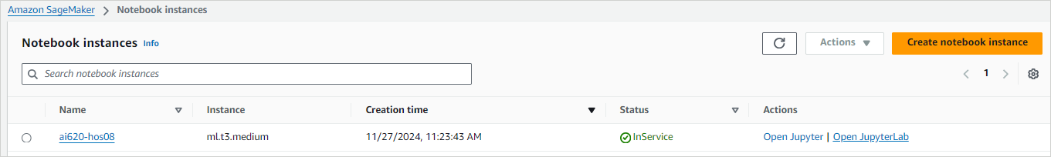

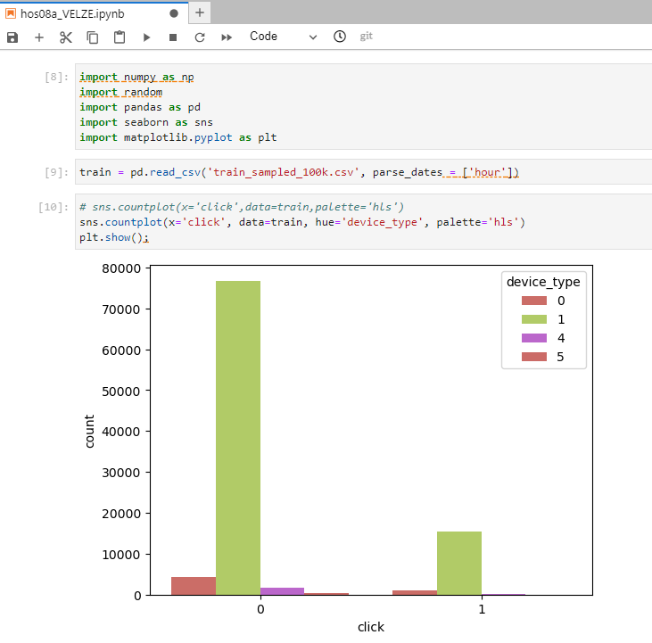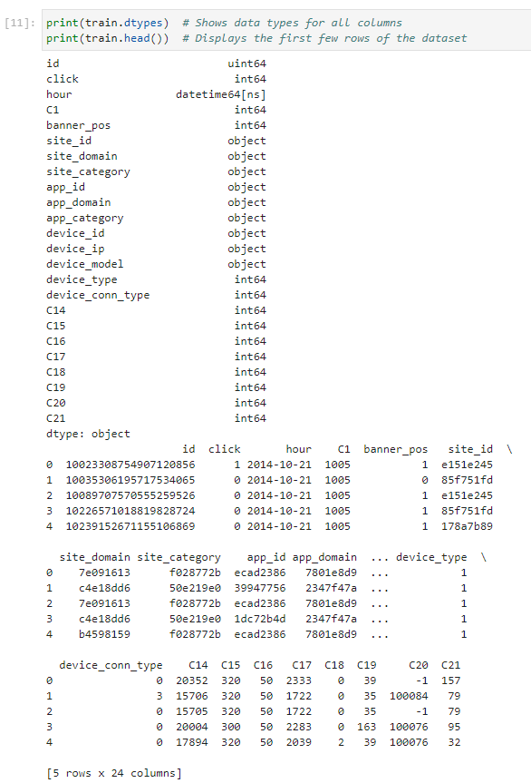

1. Apply Ads Click & Metrics

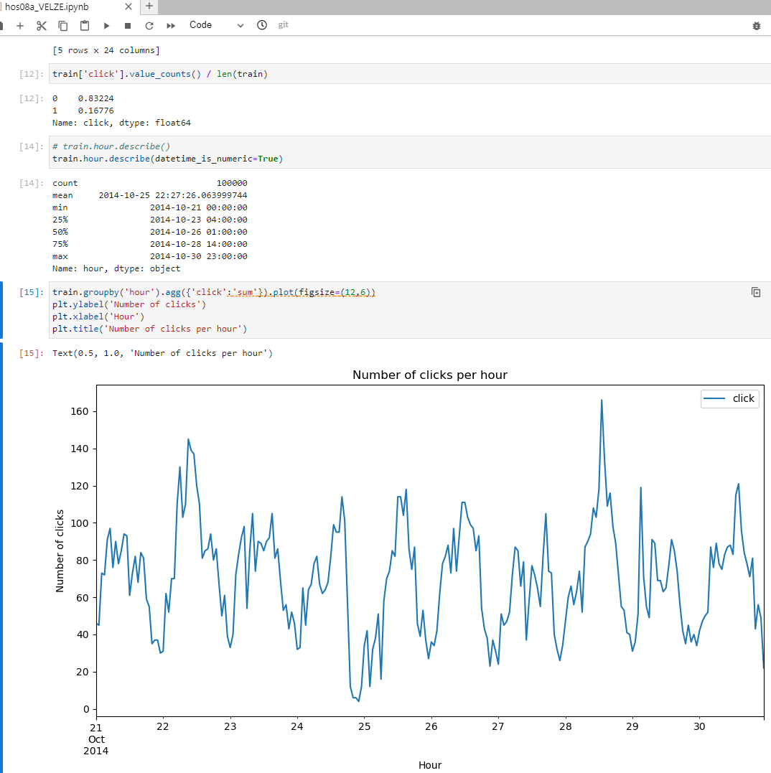

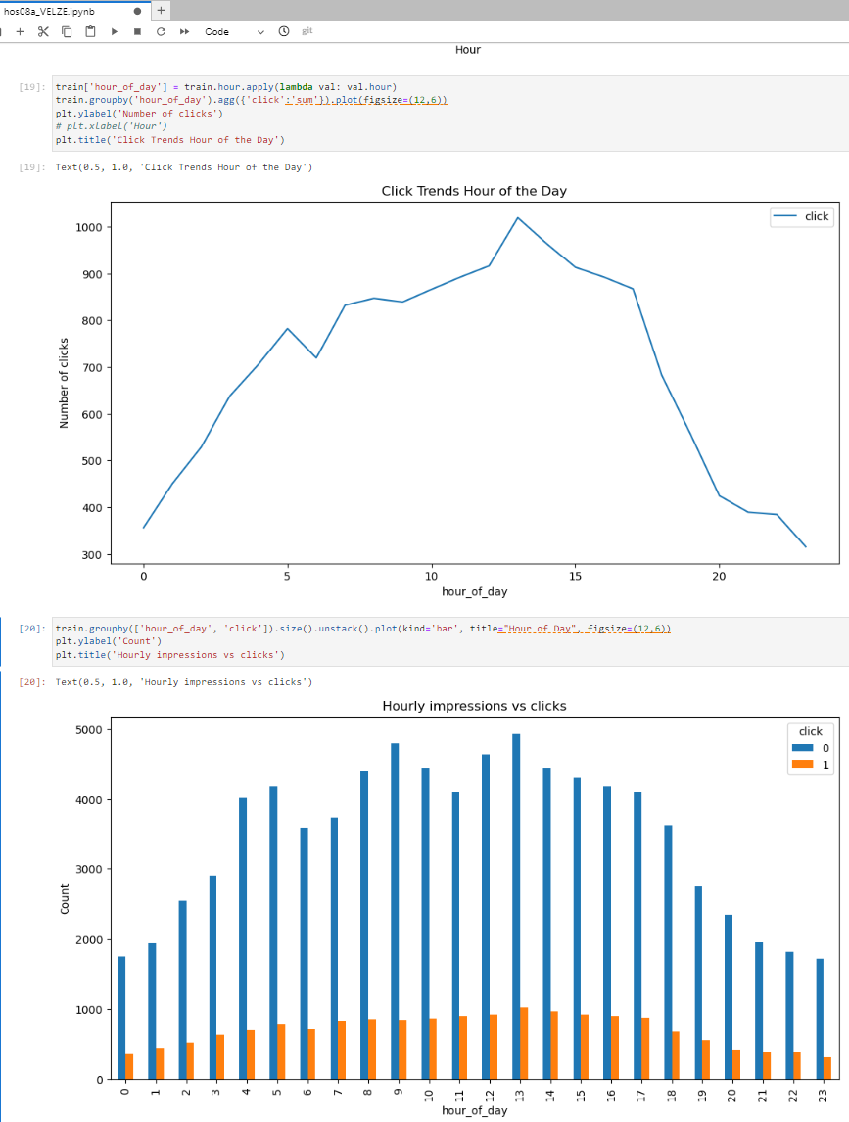

1. Hourly CTR

