PE09 Model Sales Through DeepAR

Fall 2024 by Verónica Elze

# PE09-1 Data

## Understand the Data

Go through textbook from page 354 to 360

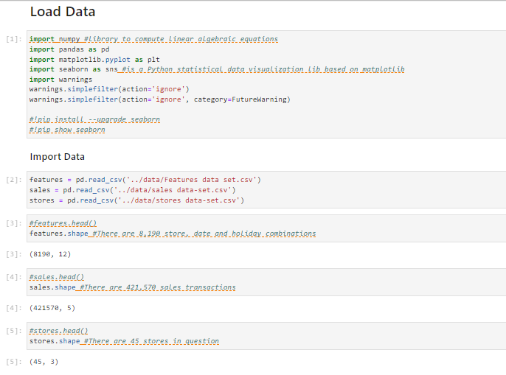

## Preprocess the data

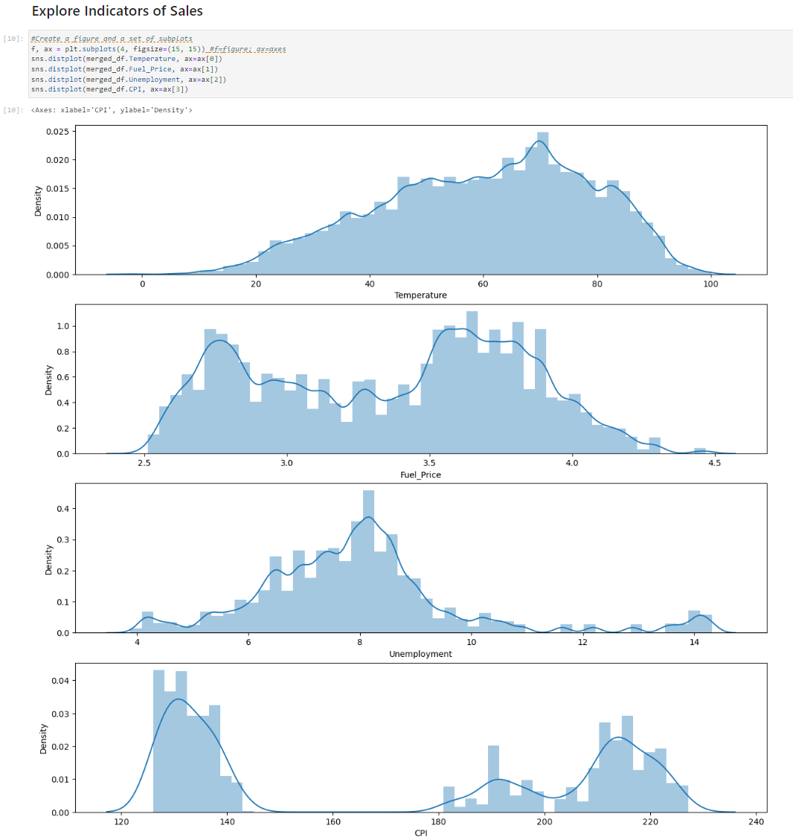

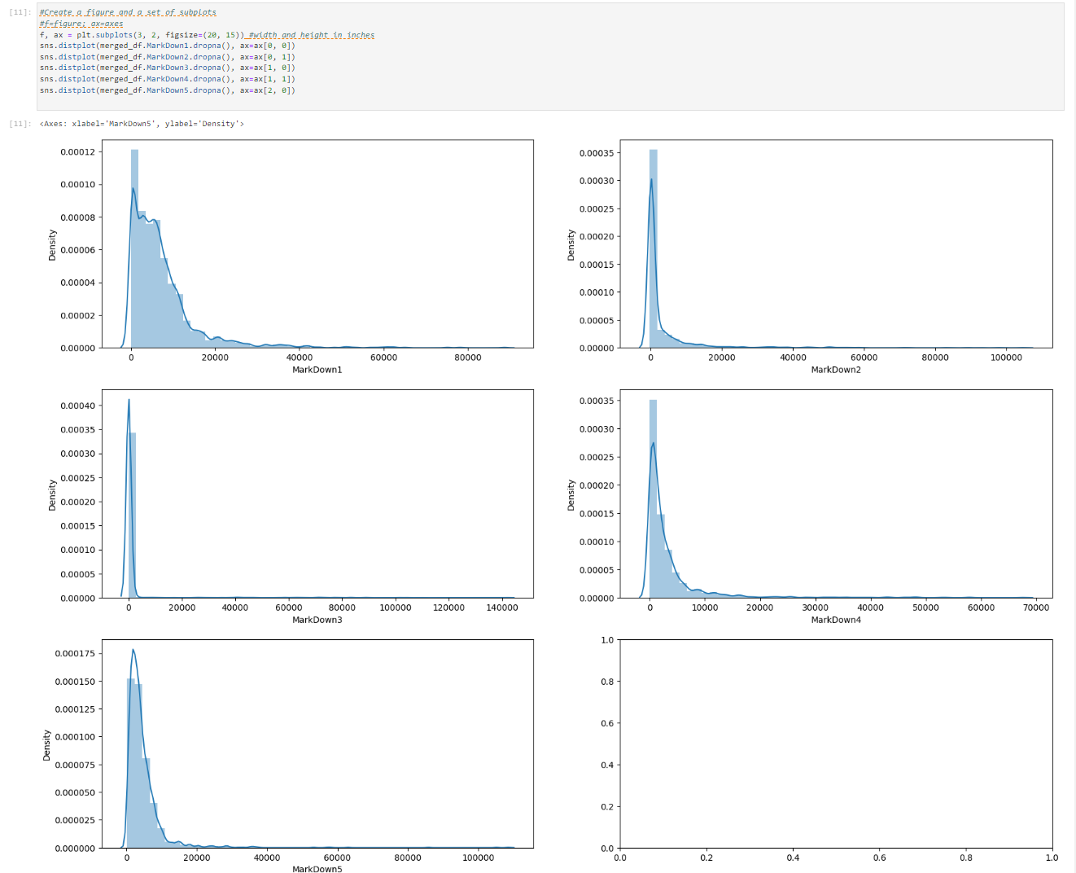

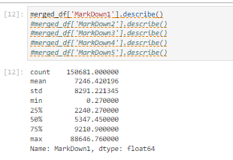

# PE09-2 Train DeepAR

Go through textbook from page 363 to 365

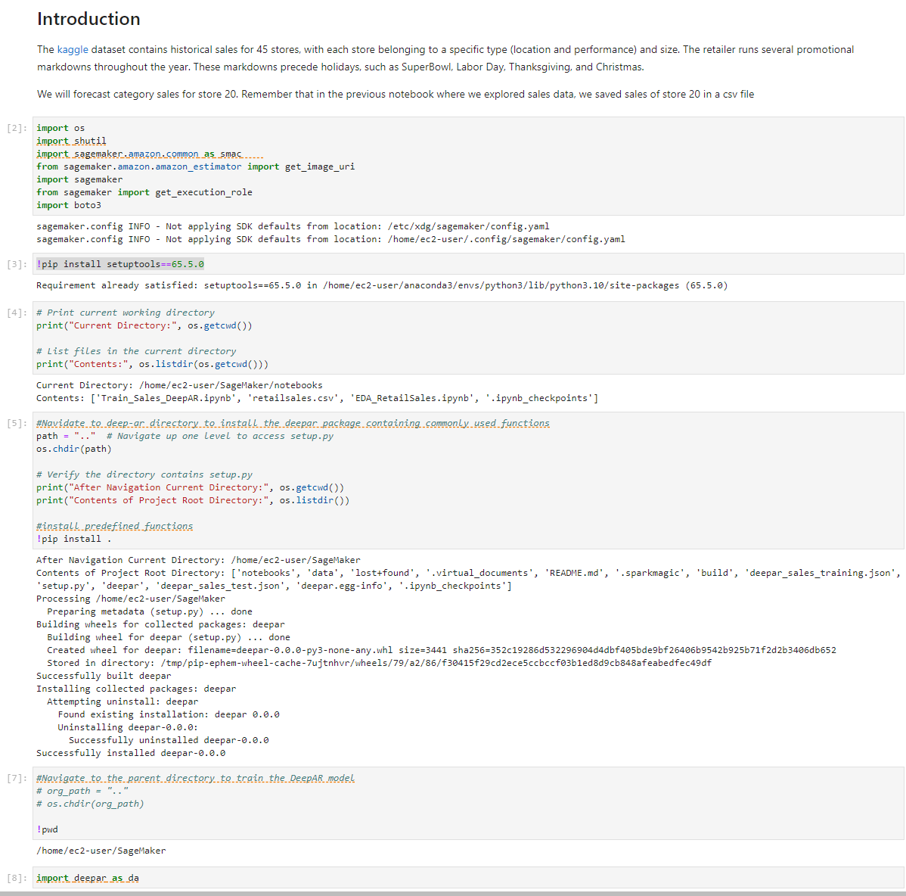

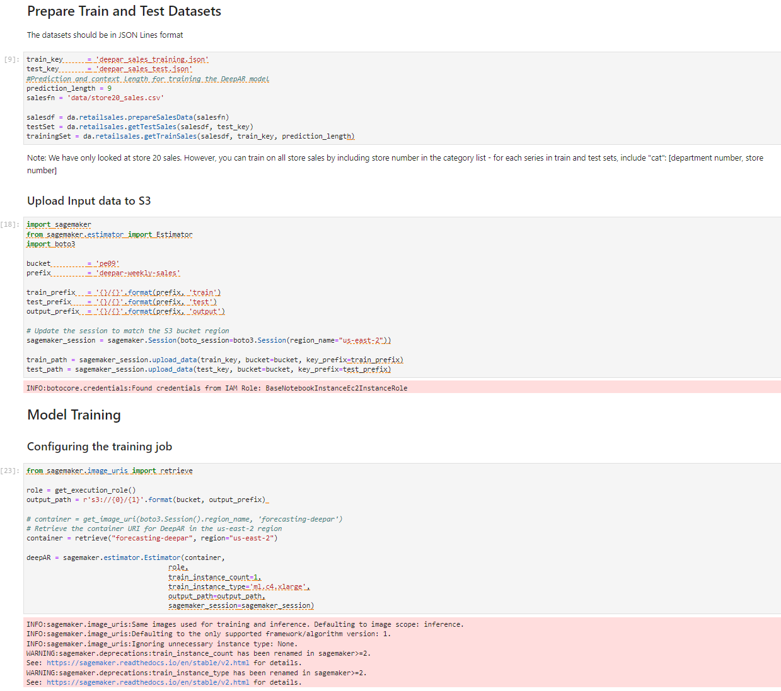

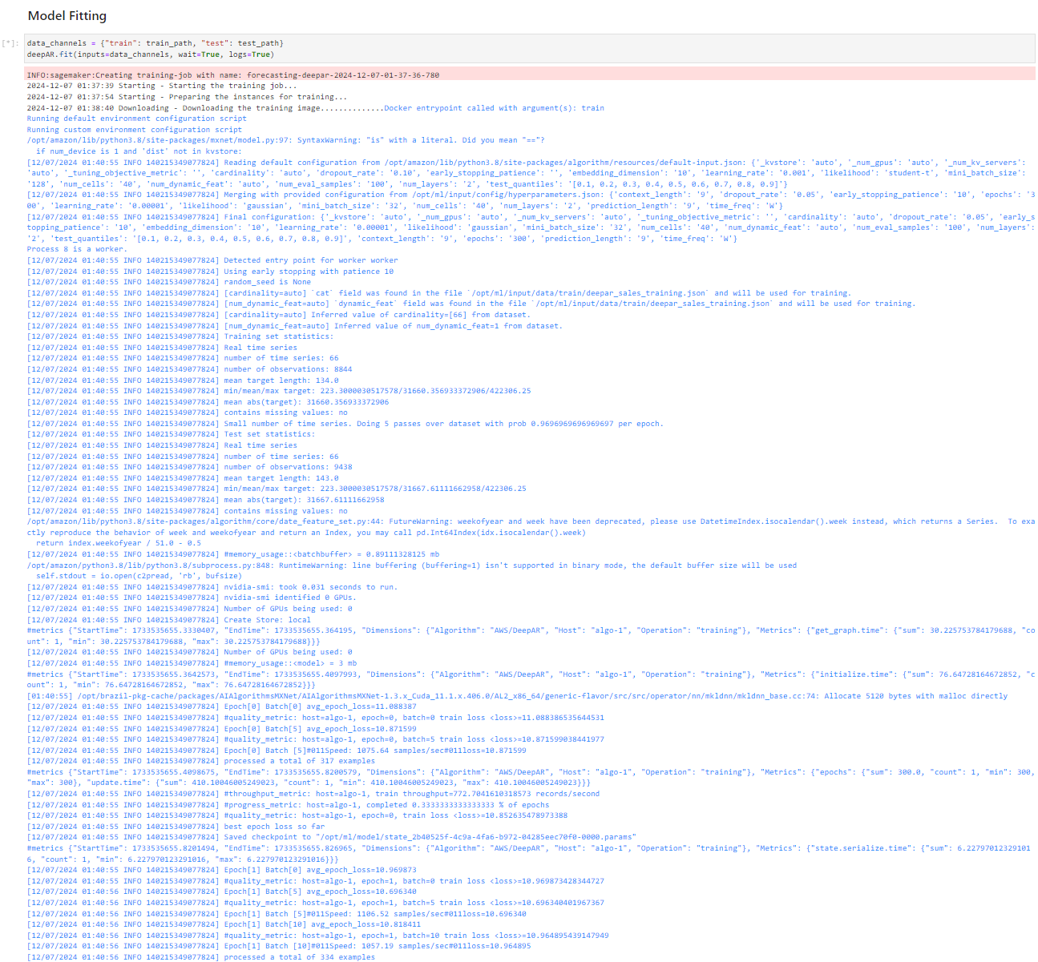

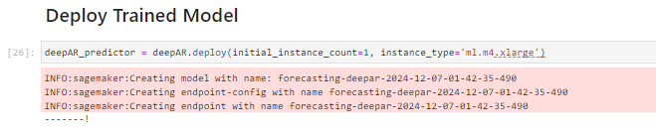

# PE09-3 Predict and evaluate sales

Include prediction and evaluation results

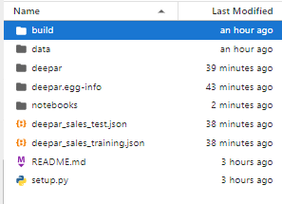

# 100 words of overall feelings completing this PE

Completing this Programming Exercise (PE) provided hands-on experience with Amazon SageMaker and the DeepAR algorithm for time-series forecasting. Debugging region mismatches, container URIs, and S3 permissions required troubleshooting, enhancing my problem-solving skills. Successfully configuring the training job and observing predictions deepened my understanding of SageMaker workflows and hyperparameter tuning. Aligning AWS resources across regions proved critical. Also, after completing HOS09A and while deploying the trained model for PE09, my SageMaker Dashboard shows no notebook instances, which is confusing since I created two: one for HOS and one for PE. This PE strengthened my technical knowledge in real-world applications.

