HOS09A DeepAR Models

Fall 2024 by Verónica Elze

1. Install the required module and prepare the data

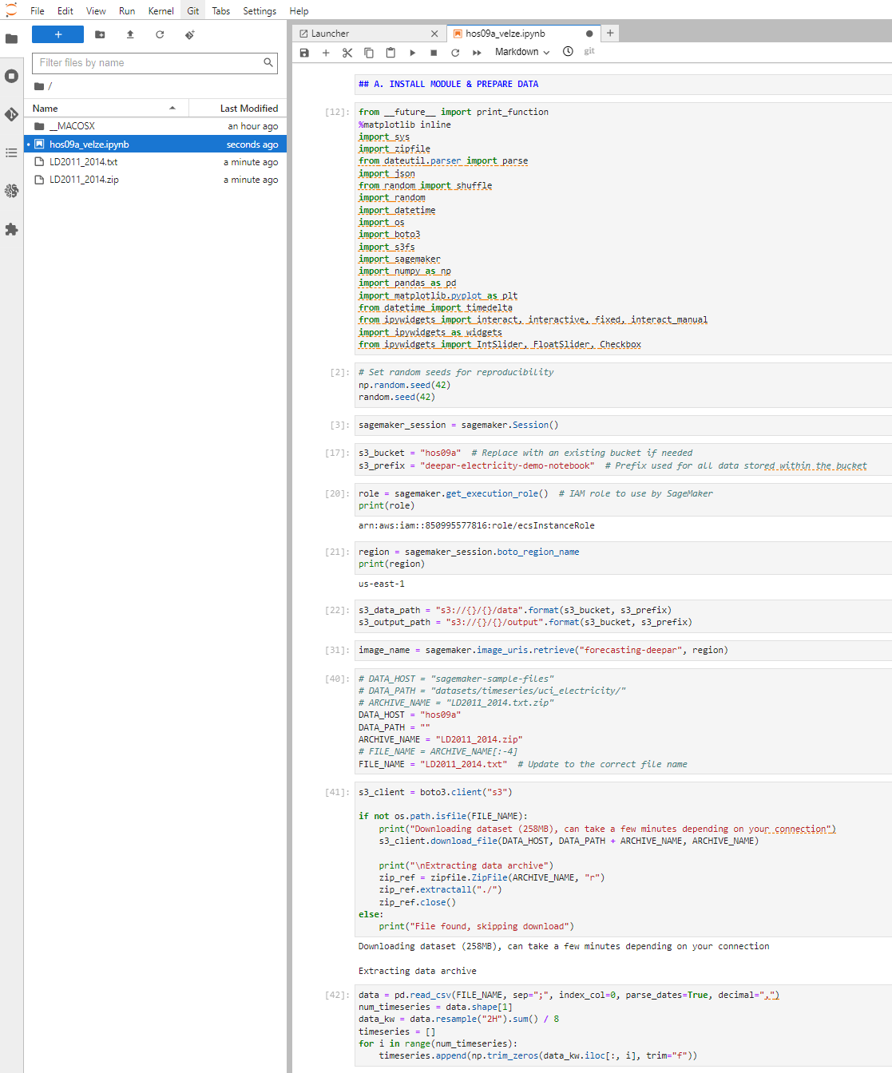

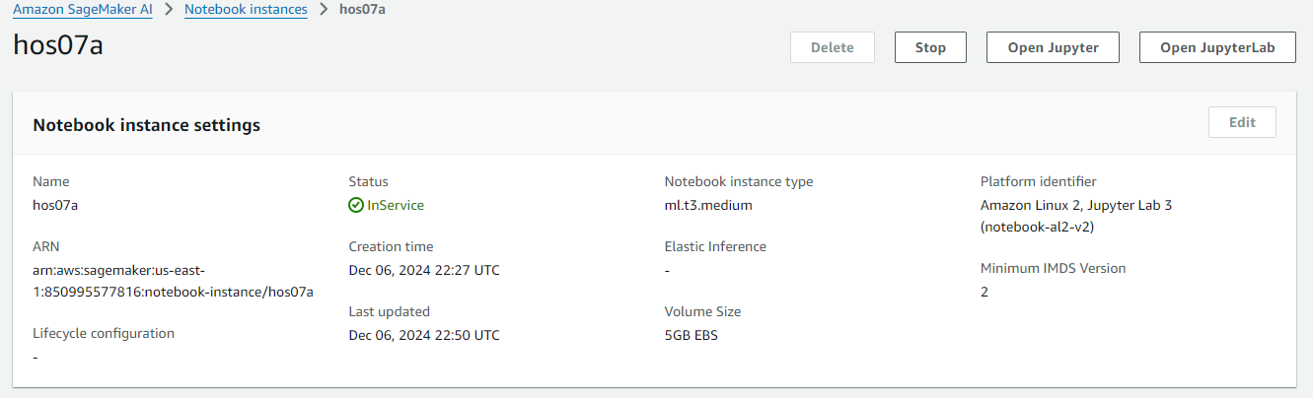

1. Type the following in your notebook to train and test splits

1. Train DeepAR model



