Programming Exercise 04 Modify HOS04A diff data

Summer 2024 by Verónica Elze

1. <https://github.com/MissVz/ai510/tree/main/Module04>
2. AutoML made it easy for me, someone with no prior experience, to apply ML to a real-world problem by modifying a model definition to read a different data file, and updating my notebook to train the model, run a prediction, and evaluate it.

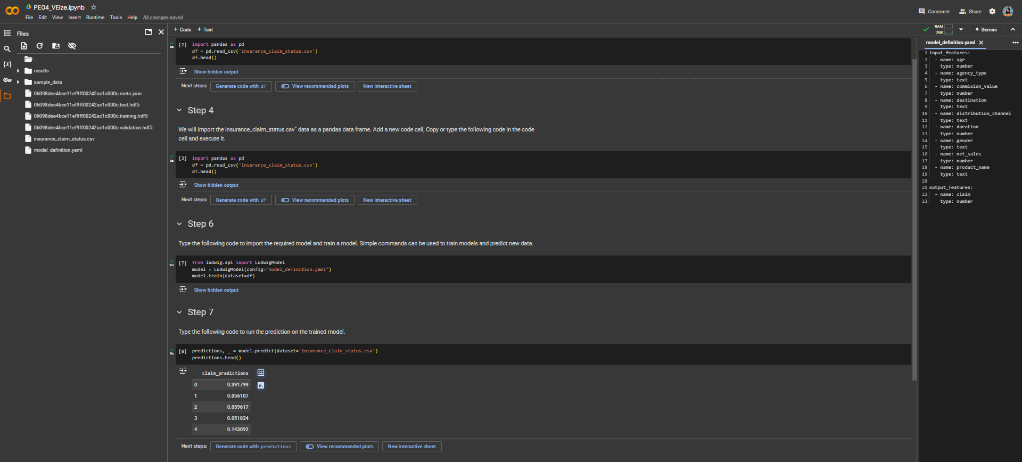

1. 