PE02: Programming Exercise on Setting up a local web application backend
  - Summer 2024 by Verónica Elze
- HOS02A complete and submitted via GitHub
- Screen captures:
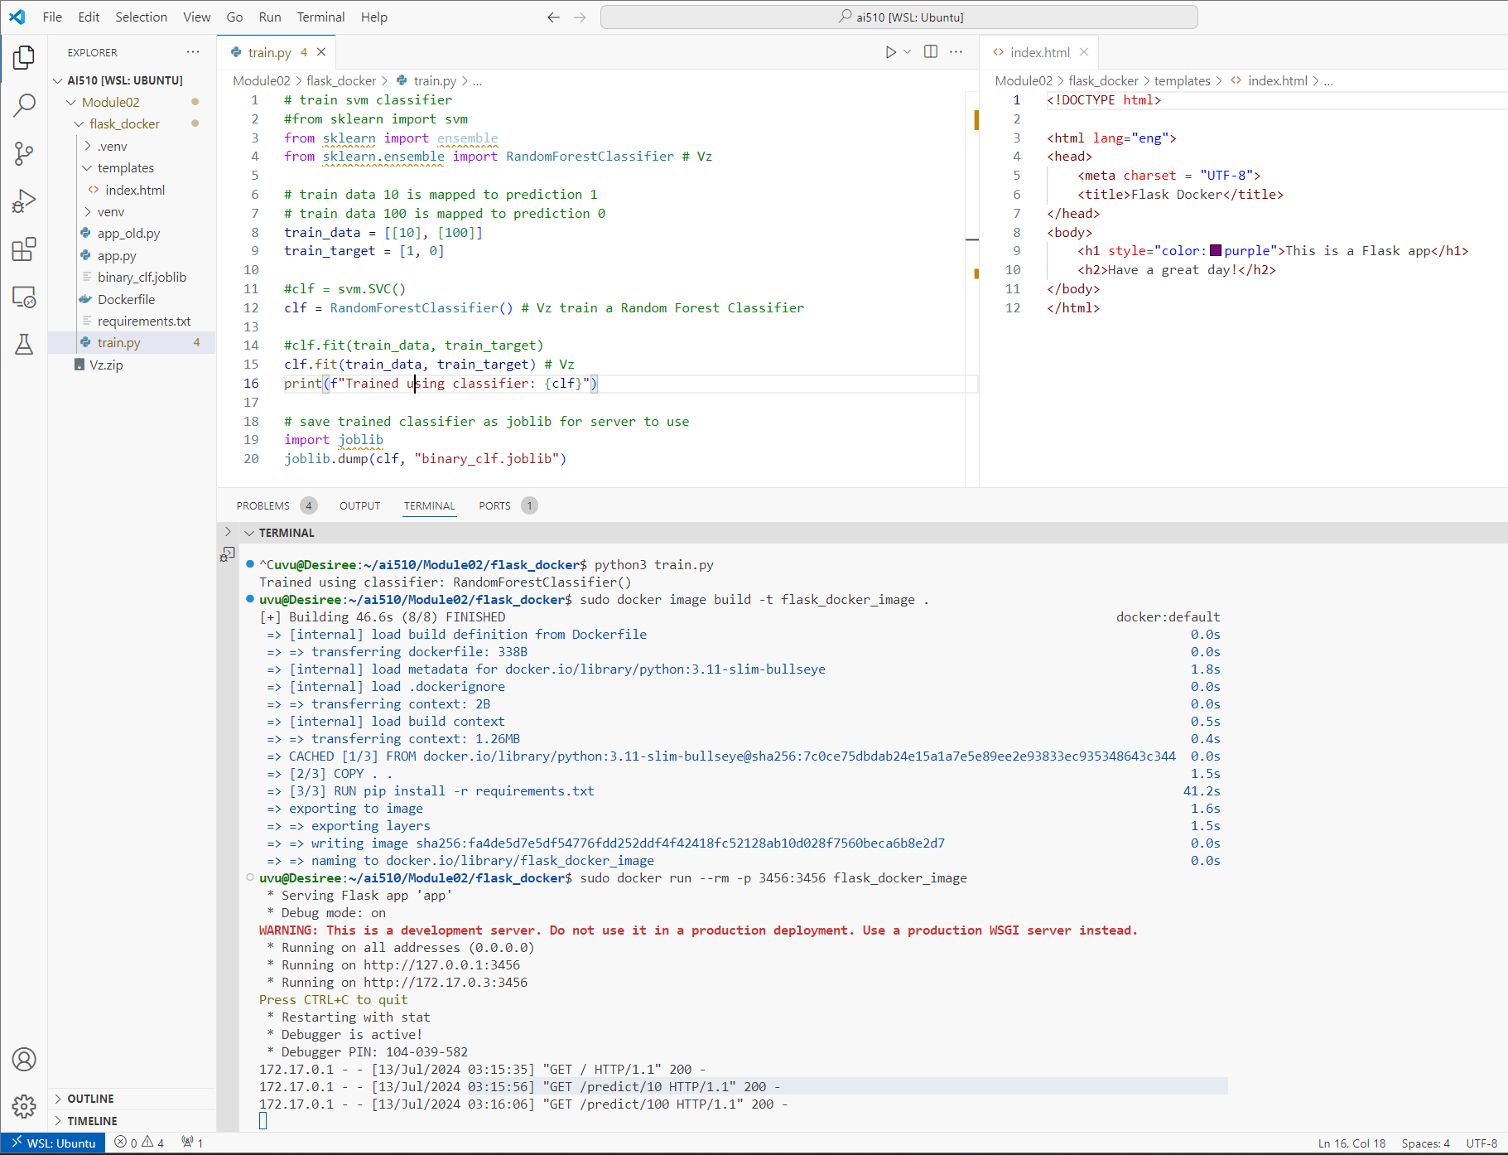
Figure 1 VS Code Python code execution connected to WSL
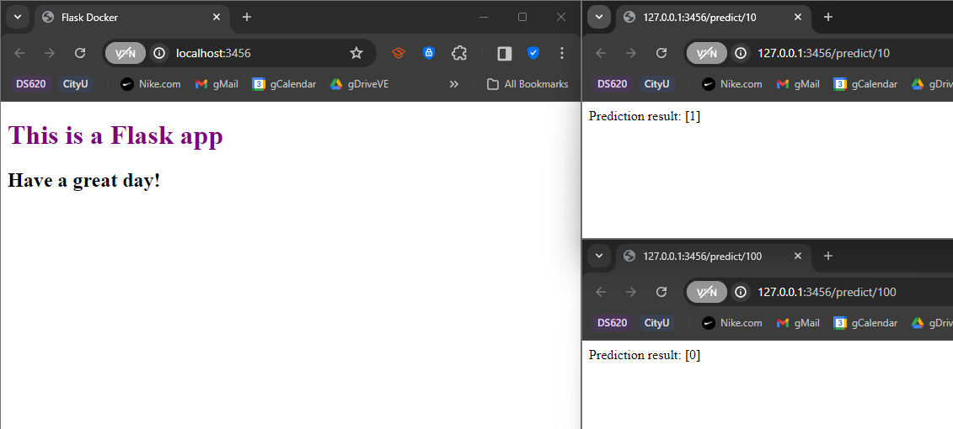
Figure 2 Browser views

SUBMISSION instructions:
- I believe this was a local web application exercise, so I am confused about which GitHub links are being requested???
- During this assignment, setting up a local web application backend offered me a portable, flexible, and isolated development and testing environment. It was quite difficult and required TA assistance given Windows 11 Home is not compatible with the Docker instructions in HOS02A.
- 

