HOS01A VS Code & Jupyter Notebooks
- 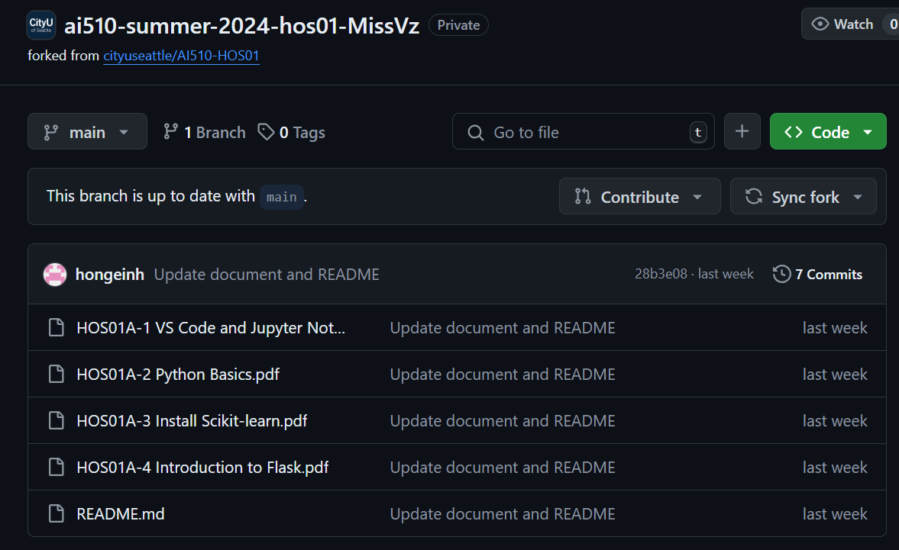
- 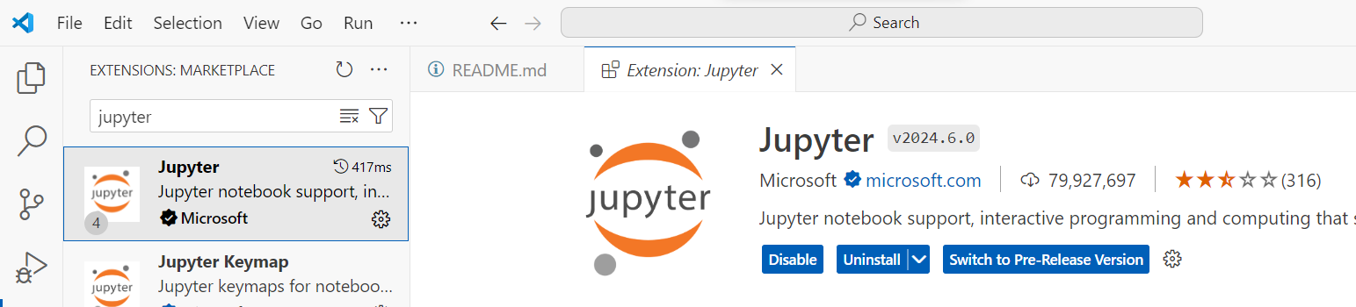
- 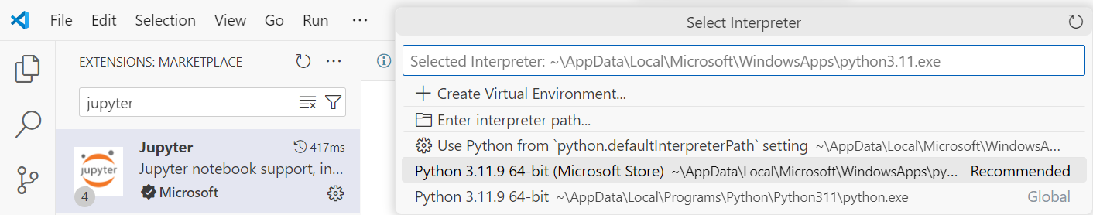

- I cannot because I get an error:

 