**#All data analysis based on Year 2021**

**Correlation analysis: Overall Performance VS. Wage**

1. Is wage a kind of motivation for overall performance in Year 2021?( wage_Overall.png)

This picture compares team players wage-motivation and their overall performance. These two variables have a positive association because as wage increases, so does motivation.

The correlation between overall performance and the wage are curve fitting and R-value=0.57.

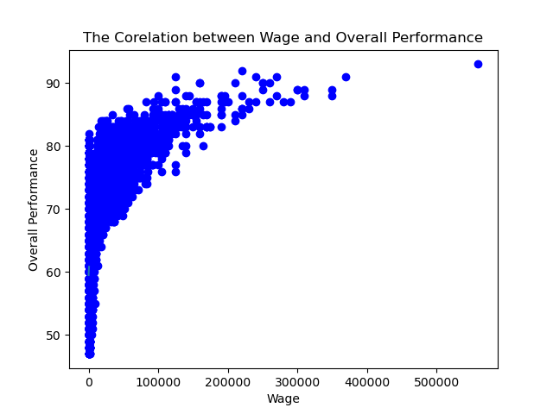

**Correlation analysis: Overall Performance VS. BMI**

1. Is BMI a key factor which will affect the overall performance? (BMI_Performace.png )

The correlation between overall performance and BMI are weak and R-value=0.19.

This picture compares team players BMI and their overall performance. These two variables have a weekly association.

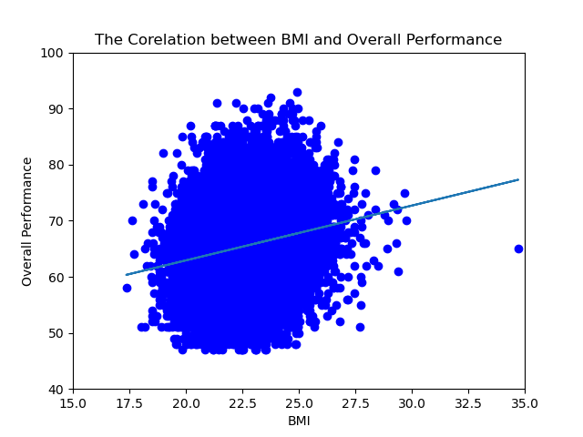

1. Average wage for overall performance (Avgwage_in Range.png)

Overall performance above 85, their wage increased dramatically.

1. **Average wage players received in different ages** (Age_AveWage.png)

Average wage of all players in Year 2021 is: €8675.67.

**Golden age: 21-28 years old.** (pic: Age_Wage 1-1 & Age_Wage 1-2)



