**\*This is a suggestion for how your invitation/event description might look like*  
  
Welcome to the Missing Maps Mapathon!**The Mapathon will take place at *insert address* from *insert time* *insert day and date*

**Schedule:**

We'll be mapping throughout the evening, in addition to:

17:45: Registration & set-up

18:00: Introduction to Missing Maps and practical information

18:10: iD Training / JOSM Training / Validator Training

19:00: Lightning talks & pizza

20:45: End of day presentation and mapping progress talk

21:00: Mapathon ends (go to the pub?)

**What is it?**

The aim of the Missing Maps Project is to map the most crisis-prone parts of the developing world. With your help we can directly improve the lives of some of the planet’s most vulnerable people. Both beginners and experienced mappers are welcome to join this mapathon, please choose your ticket according to your level of mapping skills.

**Where will we be mapping? (example location - please find your Missing Maps task description in the tasking manager and copy/paste)**

This month the focus will be on mapping the **Hadjer Lamis area of Chad**. This area is very poor, and there is an unusual burden of disease and malnutrition amongst the people who live there, which contributes to high mortality in children under five years old. In order to better understand, assess, and respond to this, we need to know more about the population.

MSF teams are mapping villages and taking their names on the ground, but identifying all of the inhabited areas and counting the structures is much more efficient from aerial photos. Knowing where all of the villages are scattered through the savanna helps us to map them, and counting the buildings within each village gives us a quick and fairly accurate method to estimate population. This is important to help MSF understand the spread of disease and identify areas of highest need.

**What do I need?**

Just a laptop (you must bring your own with you), a mouse and enthusiasm (mouse isn't absolutely necessary but makes the mapping A LOT faster).

**Where is it?**

This months mapathon is hosted by *insert name of venue and address*, see below to see the venue on OpenStreetMap.

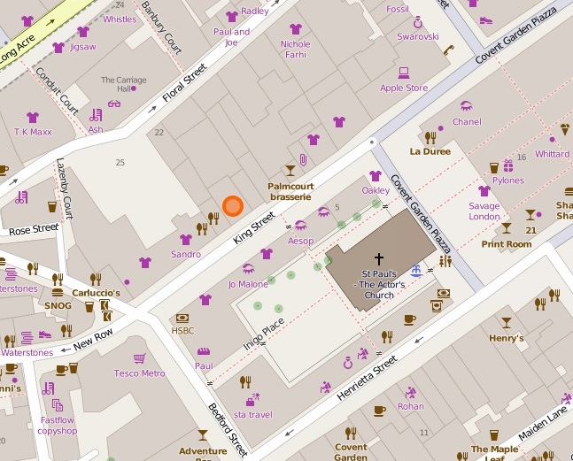

**What do I do now?**

Register for the event!

If you you want to help the organisers setting up the event please get in touch on *insert email here*

See you there!

