Event Demo

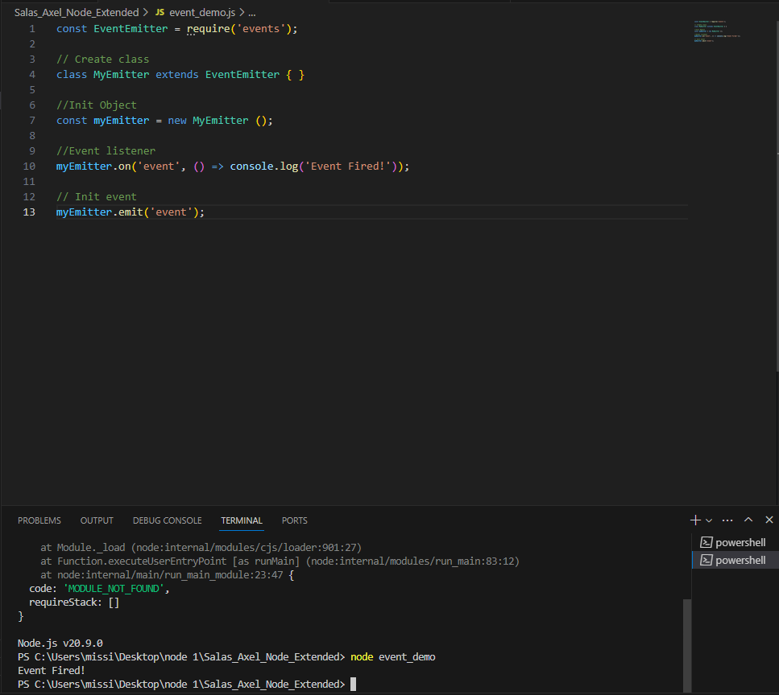

Logger Demo

Index

Http Demo

Web Server Demo Index

APIDemo

Load Pages

