# **3. Detailed Design**

## **3.1 User Interface Design**

### 3.1.1 Home Page

SRS Requirements: 3.1.1.1, 3.1.1.4, 3.1.10.3, 3.2.1.2, 3.2.2.1

Components: Login form, Guest access button, and links to educational resources.

Design Guidelines: Adhere to WCAG standards for accessibility.

Viewpoint:



Figure 1

### 3.1.2 Main Menu

SRS Requirements: 3.1.4.3, 3.1.7.1, 3.1.7.3, 3.2.2.1

**Description**: The Main Menu will be the first menu option the user sees upon login/access.

**Elements**: The Main Menu will have a dropdown menu for difficulty options and five button controls as listed:

* Difficulty dropdown menu
  + Expert
  + Intermediate
  + Novice
* Buttons for five options:
  + Load Mission
  + Write Mission
  + Configuration
  + Start Simulation
  + Exit

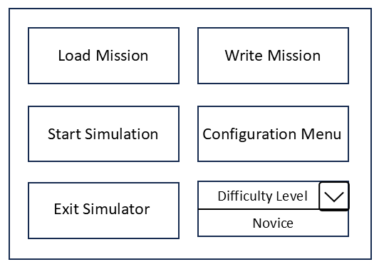 Viewpoint:

Figure 2

### 3.1.3 Configuration Menu

SRS Requirement: 3.1.7.2, 3.2.2.1

Description: After the Configuration Menu button is pressed on the Main Menu, the Configuration Menu is shown, allowing users to set their parameters themselves.

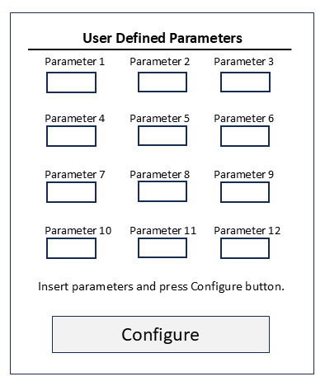 Viewpoint:

Figure 3

### **3.2 Functionality Design**

### 3.2.1 User Authentication

SRS Requirements: 3.1.1.2, 3.1.1.6, 3.2.2.1

Login Mechanism: Use JWT (JSON Web Tokens) for secure authentication.

Guest Access: Limited feature set when logged in as a guest.

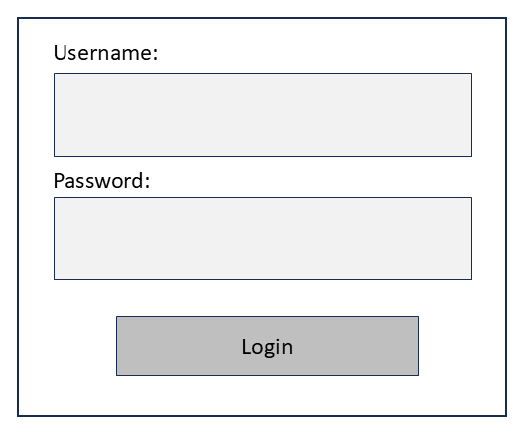 Viewpoint:

Figure 4

### 3.2.2 Cookie Management

SRS Requirements: 3.1.2.1, 3.1.2.2, 3.1.2.3

Settings Management: Interface for users to opt in/out of tracking.

### 3.2.3 Error Handling

SRS Requirements: 3.1.1.3, 3.1.3.1, 3.1.3.2, 3.1.3.3, 3.1.8.1, 3.1.9.1

Purpose: Implement a centralized error handling mechanism for user information and feedback.

Description: Handle all errors through the following:

* Display failed authentication attempts with a popup window requiring user acknowledgement.
* Any failed authentication attempt will retry authentication.
* Display server outage with a popup window requiring user acknowledgement.
* In case of guest sign on, auto-set limited features to novice default settings.
* When input configuration data is invalid, warn user with popup and reset to default value.
* Should the lander go too far off course or sustain damage, the user is prompted by popup window that the mission has failed. The application is set to default parameters.

## **3.3 Simulation Controls**

### 3.3.1 Simulation Parameters

**SRS Requirements:** 3.1.5.2, 3.1.5.4, 3.2.2.1

**Input and Display Handling**

Create a form to input and display the below parameters validated in real-time.

**Developer Defined (Constant) Parameters**

These parameters are to be defined by the developer and unable to be tweaked by the standard user.

* Acceleration due to gravity of Psyche (float)
* Average diameter of Psyche (float)
* Rotation speed of Psyche (float)
* Mass of the spacecraft lander (float)
* Amount of fuel for thrusters designated for landing (int)
* Minimum force from landing impact that the lander can sustain (int)
* Diameter of landing feet (float)
* Minimum/maximum radial distances the lander can start at (float)
* Maximum level of thrust that can be exerted (int)
* Maximum distance of the lander from Psyche that's considered too far (out of bounds threshold) (float)

**User Defined (Configurable) Parameters**

These parameters are to be adjusted by the user before (and perhaps during for some) the simulation.

* Starting location of the lander: The location of the lander will be determined using the polar coordinate system. The coordinates for such are as follows.
  + Radial distance (ρ) (float)
  + polar angle (θ) (float)
* Facing angle of the lander (same conditions from lander location apply here)
* Distance of the lander from Psyche in which to turn on thrusters (float)
* Level of thrust to decrease gravitational acceleration (float)
* Angle of thrusters relative to the lander (float)

**Real-Time (Variable) Parameters**

These parameters are those that update in real time during the simulation, not defined or adjusted by a developer or user, and displayed to the user as information during runtime.

* Current acceleration of the lander (float)
* Current velocity of the lander (float)
* Current level of thrust (float)
* Amount of fuel remaining (int)
* Amount of damage the lander has sustained (int)
* Distance between the lander and Psyche (float)
* Time elapsed (float)

**Conclusion**

With these parameters considered, implications can be made regarding the overall design.

* The simulation will run in two dimensions.
* Psyche's surface won't be perfectly symmetrical, making the facing angle of the lander and its rate of descent conditional by its starting location.
* The lander will start at a fixed position without any additional velocities due to orbit or otherwise.
* The lander must make a soft landing below the force of impact sustain threshold.
* The lander must make a secure landing without losing balance and toppling over.

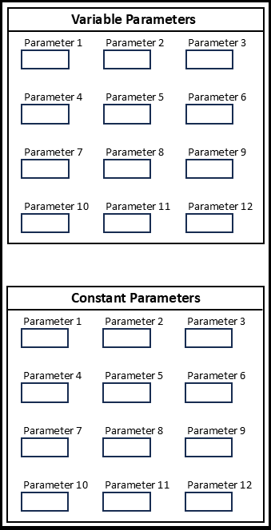Viewpoint:

Figure 5

### 3.3.2 Keyboard Controls

SRS Requirement: 3.1.7.4, 3.1.7.6

Description: User will have access to keyboard controls for real-time adjustment of thrusters. Specific keys will be identified as individual thrusters, and the cursor left and right keys will act to increase and decrease thruster angles, with the cursor down arrow acting to turn the thruster on and the cursor up key to turn the thruster off.

### 3.3.3 Simulation Management

SRS Requirement: 3.1.7.5, 3.2.2.1

**Control Functions:** Implement start, pause, exit, and resume features in the application using state management.

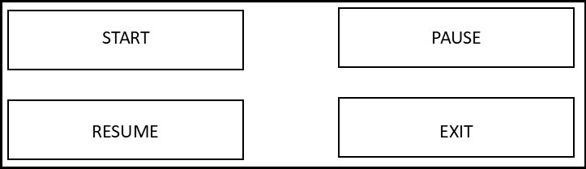 **Viewpoint:**

Figure 6

## **3.4 Data and Simulation Visuals**

3.4.1 Visualization Windows

SRS Requirement: 3.1.5.1, 3.1.5.2, 3.1.5.3, 3.1.5.4, 3.1.5.5, 3.1.7.3, 3.2.1.3, 3.2.2.1

Window Components: Two main windows for data readout, one for simulation visuals, and controls for simulation.

Data Parameters: Display constant metrics like spacecraft weight, Psyche gravity, Psyche rotation, and maximum landing speed. Show real-time data such as distance from Psyche, descent speed, fuel remaining, rotation direction, rotation speed, and all thruster actions.

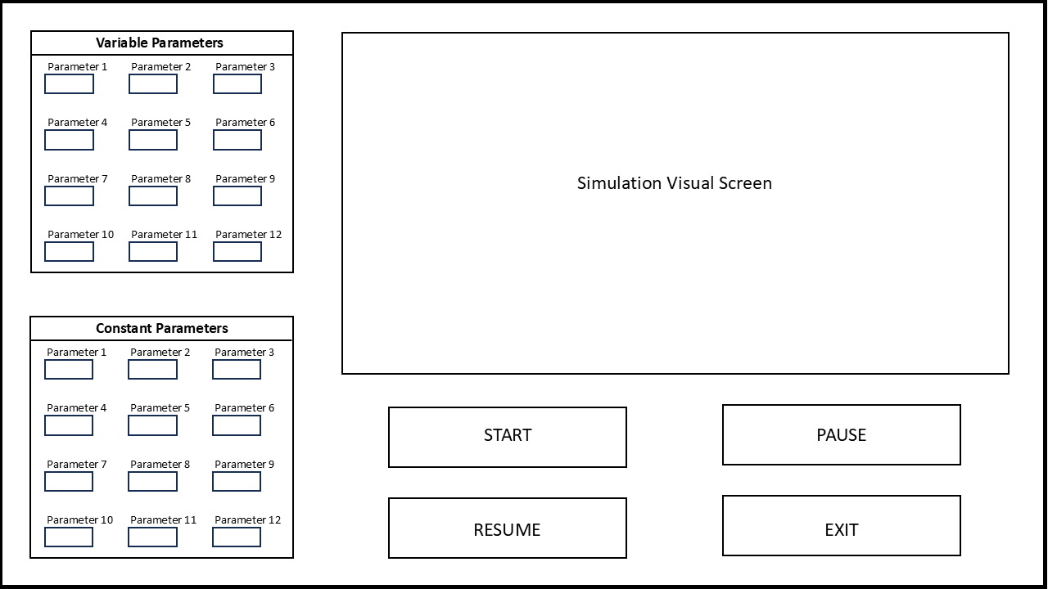 Viewpoint:

Figure 7

## **3.5 File Access**

### 3.5.1 Parameter Load and Save Functions

SRS Requirement: 3.1.4.4

Description: Allow storage of and access to parameter data on local machine and external storage medium.

Viewpoint: (See Figure 2)