# **3. Detailed Design**

## **3.1 User Interface Design**

### 3.1.1 Home Page

Components: Login form, Guest access button, and links to educational resources.

Design Guidelines: Adhere to WCAG standards for accessibility.

### 3.1.2 Main Menu

SRS Requirement 3.1.7.1:

Purpose: Describe the appearance and structure of the Main Menu Class.

Description: The Main Menu Class will contain data and modules which are called when the user selects one of five displayed options: Load Mission, Write Mission, Exit, Configuration options, Start Simulation button.

Elements: The Main Menu Class has two elements:

* Data
* Modules

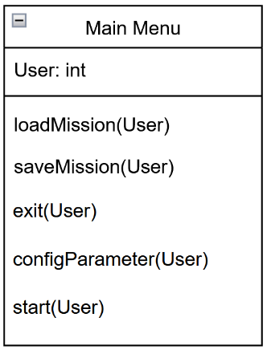 Viewpoint: Class Diagram

### **3.2 Functionality Design**

### 3.2.1 User Authentication

Login Mechanism: Use JWT (JSON Web Tokens) for secure authentication.

Guest Access: Limited feature set when logged in as a guest.

### 3.2.2 Cookie Management

Settings Management: Interface for users to opt in/out of tracking.

### 3.2.3 Error Handling

Error Notifications: Implement a centralized error handling mechanism for user feedback.

## **3.3 Simulation Controls**

### 3.3.1 Simulation Parameters

Input Handling: Create forms to input thrust, angle, speed, etc., validated in real-time.

### 3.3.2 Simulation Management

Control Functions: Implement start, pause, stop, and resume features using state management.

## **3.4 Data Visualization**

3.4.1 Visualization Windows

Window Components: Two main windows for data readout and simulation visuals.

Data Parameters: Display real-time metrics like gravity, distance, speed, etc.