Game Outline:
- Part One: Planets in our solar system
  - Introduction (Earth’s Moon)
    - Tutorial
      - Dialogue from Guide
        - Hi! Welcome to Telescope Explorer. I see you just received your first hobby telescope! Congratulations!
        - There’s lots to explore in space. Let's put that telescope to good use and take a good look at the moon! Can you see that distant twinkle? Use your arrow keys to focus your telescope on that distant object to fill up the progress bar.
          - (Scene transitions to minigame)
        - Great job! From here, complete the minigame to unlock the object you were just focusing on.
          - (Instructions for each mini game should be written and appear each time the game commences.)
          - (Transition to Journal)
    - Space Object to be discovered: Earth’s Moon
    - Mini games introduction (May need to add instructions on each mini game)
    - Play minigame
    - Reveal of Journal; guide explains how the journal works and its function.
      - DIalogue from Guide
        - Way to go! Once you successfully complete a minigame, you will be brought here to the journal where you get to enjoy the fruits of your labor! It looks like you discovered the Earth’s moon! Take a minute to read all about the moon.
  - Mars
    - Quick and brief intro to mars before letting the user find it.
      - Dialogue
        - Now that you’ve learned how to use your telescope, the world, or… the universe is your oyster! See what else you can find. Remember, find and focus on the distant twinkle to fill the progress bar.
    - Minigame
    - Journal Reveal (I’m thinking in each journal entry could be the planet's specification, first discovery date, who discovered it, where it was discovered, etc.)f
      - Dialogue
        - Wow! You’ve discovered Mars, also known as the Red Planet. Take a second to learn about this fascinating planet.
  - Saturn
    - Quick and brief intro to mars before letting the user find it.
      - Dialogue
        - I don’t think any dialogue from our guide is necessary here.
    - Minigame
    - Journal Reveal
- Galaxy
  - The Sombrero Galaxy
    - Dialogue
      - Now that you’ve learned about a few planets in our solar system, let’s focus on finding some new galaxies. Galaxies are huge clusters of solar systems, stars, and gasses. The galaxy that we are in is called the Milky Way galaxy.
      - See if you can find another galaxy out there!
    - Minigame
    - Journal Reveal
      - Dialogue
        - Wow, the Sombrero galaxy is so neat! Studying other galaxies helps scientists better understand our own galaxy and offer insights into not only the past, but also the future as scientists can formulate hypotheses and predictions based on their observations.
- Nebula
  - Crab Nebula
    - Dialogue
      - There are many different things to view in space! Lets try to find a nebula. Nebulas are large interstellar clouds made of hydrogen, helium, and dust. They’re very colorful and mesmerizing.
    - Minigame
    - Journal Reveal
    - Dialogue
      - Wow! The Crab Nebula looks so cool! Our time together is coming to a close, but before you go and continue exploring space on your own, I want to show you one last thing!

- Asteroid
  - Psyche
    - Dialogue
      - The last thing I want to show you before you go is an asteroid named after the Greek goddess, Psyche.
      - Why is this asteroid important? Well, it’s one of a kind and we stand to learn a lot about it by studying it. In fact, NASA has taken a special interest in Psyche and they are planning an expedition to study it in space! There’s a lot more about it, but you’ll have to complete the minigame to learn more.
      - By the way, because Psyche is so far away, you won’t be able to see it through that Hobby Telescope of yours. Instead, we’ll use the Very Large Telescope located in Chile. Give it a go!
    - Minigame
    - Journal Reveal
      - Because the user is using the VLT, I think the image should be this one, even though it’s not good because that’s what it actually looks like from the VLT
      - 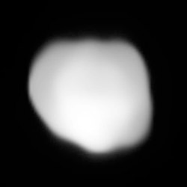
    - Dialogue
      - Wow, that’s pretty blurry. It’s amazing that Annibale de Gasparis was able to discover this asteroid with this telescope. Let’s go ahead and clean up that image.
      - 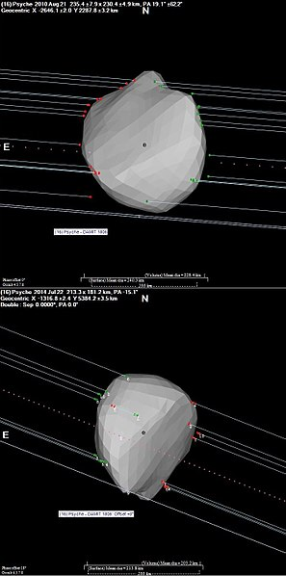(Lightcurve inversion model DAMIT 1806 and occultation chords from two observations of 2010 and 2014.)
      - That’s better. So why is Psyche important? Well, it’s believed that it’s the exposed core of a protoplanet! Psyche is made up of metal, just like the core of the Earth. Scientists can learn a lot from this asteroid. Learn more about the asteroid and the Psyche Mission in the journal.
      - Thanks for exploring space with me!

Other Discoverable objects (in case we decide we need more)

General Websites Referenced (in case they’re needed later)
- https://stargazersclubwa.com.au/what-can-you-see-with-a-telescope/

Object Specific Resources
Mars
- https://mars.nasa.gov/#red_planet/0
Saturn:
- https://solarsystem.nasa.gov/planets/saturn/overview/
Sombrero Galaxy
- https://hubblesite.org/contents/media/images/2003/28/1415-Image.html
Crab Nebula
- https://www.nasa.gov/feature/goddard/2017/messier-1-the-crab-nebula
Psyche
- Hopefully we know where to go for this ;)

