T-Minus Psyche
A virtual reality tour of NASA's Psyche mission
How to play
1. Put on the headset and tighten the strap until the picture is sharp.
2. Slip your hands through the controller wrist straps.
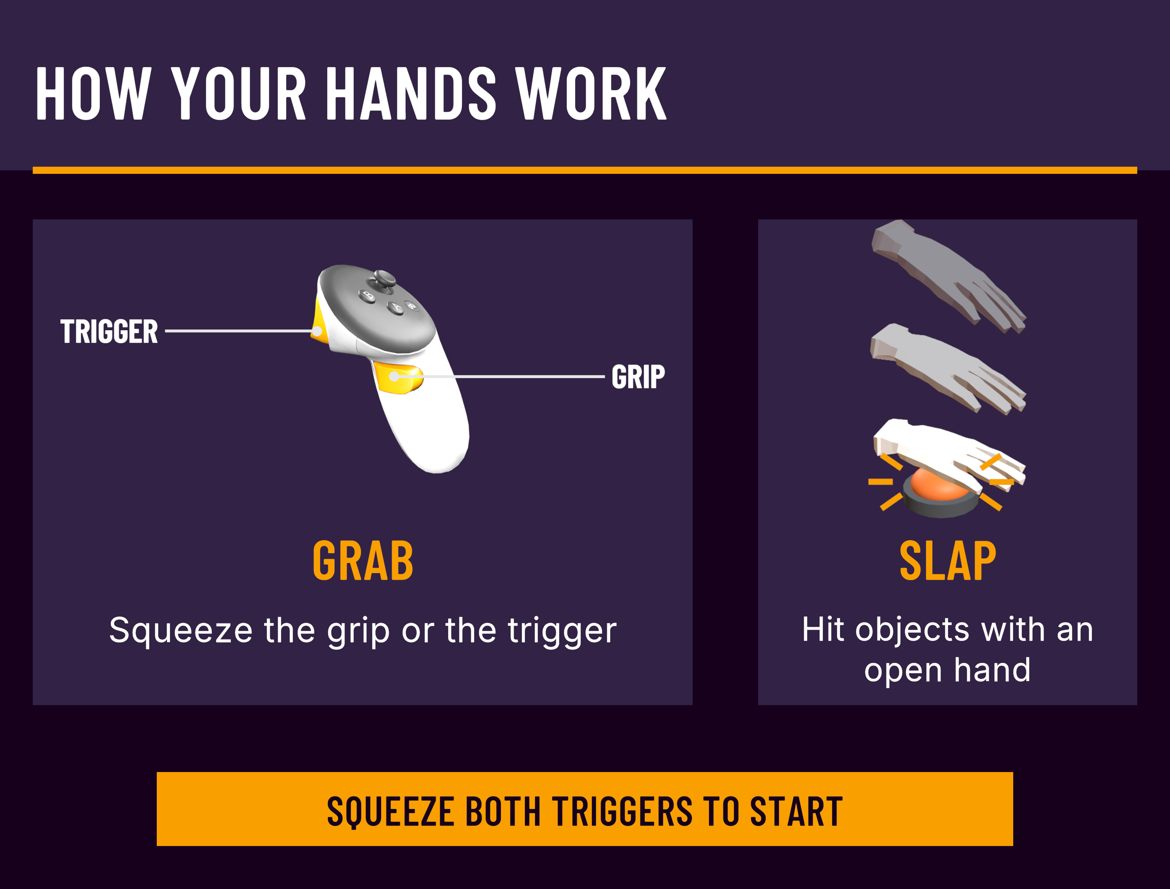
Step into a small mission control room. Using only your hands, build a model of the spacecraft, explore the mission control computer, and flip through picture books about the mission.
Who made it
A small team of software engineering undergraduates at Arizona State University built it as their senior capstone project, through the Psyche Student Collaborations program. Our goal is to give students and families a hands-on way to learn what the mission is doing and why it matters, in a few minutes and without any prior experience in virtual reality.

