T-Minus Psyche
Event team sheet · one visitor at a time, 2.5 minutes each
Each visitor  1. Check the room is fresh. The screen should show the start card. If not, reset.  2. Help with the headset. Offer to help the visitor tighten the strap until the picture is sharp, then hand them a controller for each hand with the wrist straps on.  3. Say one line. “Read the card, then squeeze both triggers to start.”  4. Follow along on the screen. The session lasts 2.5 minutes. The launch video plays at the end.  5. Take the headset back when the thank-you card shows on the screen, then reset for the next visitor. | Reset for the next visitor  Hold all six together for 4 seconds: left grip, trigger and Y; right grip, trigger and thumbstick pressed down until it clicks. You do not need to wear the headset: a ring fills on the screen, then the start card comes back.  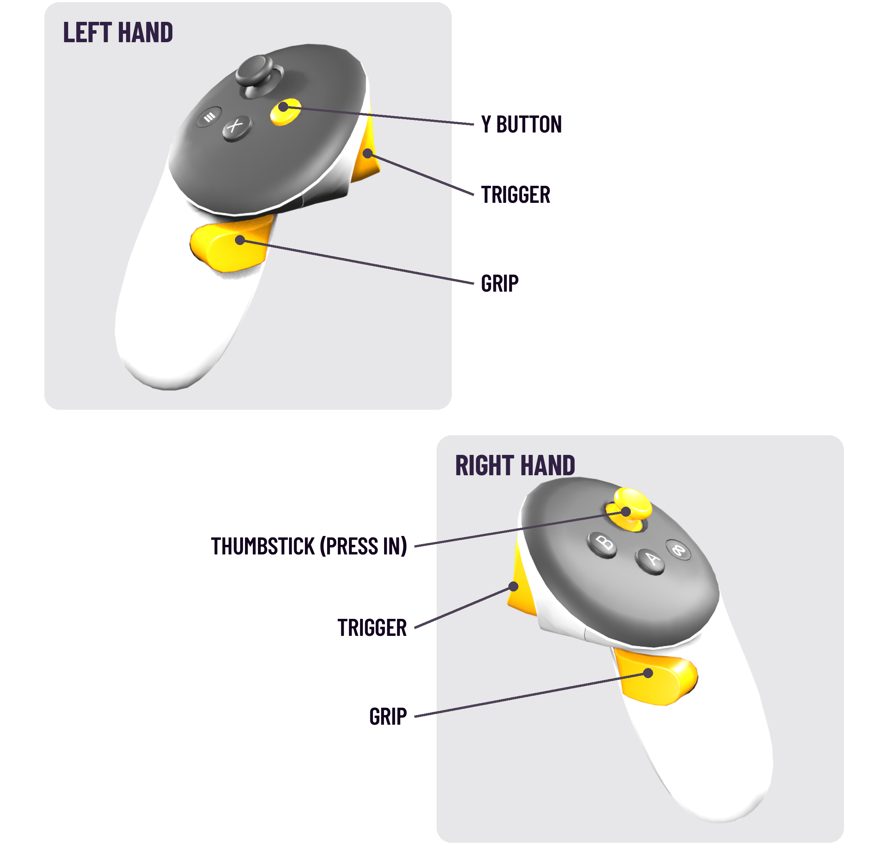
If something goes wrong
• Screen shows the room tilted or facing the wrong way: hold the Meta button (∞) on the right controller to recentre.
• Screen shows the Quest home instead of the room: open Menu, Unknown Sources, T-Minus Psyche.
• Headset taken off mid-session: the game pauses until it is back on. Reset if a new visitor takes over.
• Battery: charge the headset during breaks or keep plugged in, Quest headsets are notorious for short battery life.

