T-Minus Psyche: content review
Prepared 2026-10-28 for Dr. Bowman
Part 1 lists what the Psyche team asked us to change, with the words before and after and where each fact comes from. Part 2 shows the three new picture books in the game's bookcase, and the pages of Journey to a Metal World that changed since you reviewed it. Please mark anything to change with Word comments or Track Changes, right in the tables.
Each change and each page ends with "Where we found it": every source, with its own words in quotes. Web pages are linked and open at the quoted sentence in most browsers. Page numbers are the PDF's. The "team research folder" is the Psyche team's Psyche Research Papers - Gold Class folder (press kit and mission papers); the "team publishing folder" is its Publishing Guidelines folder.

Part 1: What the Psyche team asked us to change
Where | Before | Now
Communication time: Deep Space Network screen on the mission control monitor | A radio signal to Psyche and back takes 31 minutes. (We worked out the minutes from Psyche's distance on the data date.) | A radio signal to Psyche and back can take over an hour, depending on where Earth and Psyche are.  Where we found it:  Oh et al. 2025 spacecraft design paper, p. 22 (team research folder): “at distances over 30 light-minutes from Earth”
Communication time: the PING button's result on the monitor | A "REAL SIGNAL TIME" clock counted the round trip, then: Round trip: 31 min. You waited 12 seconds. NASA waits the full 31. Signal arrives at Psyche at 3:42 PM. | Psyche answered. You waited 12 seconds. / The real reply can take over an hour. (No clock, no arrival time.)
Communication time: Calling Psyche, page 6 | A hello to Psyche and its reply take about 17 minutes for every one of those distances. Near the asteroid, that can take about an hour. | Psyche can be more than 4 times farther from us than that, so a hello and its reply take much longer. Near the asteroid, it can take over an hour, depending on where Earth and Psyche are.  Where we found it:  Psyche press kit, p. 29 (team research folder): “Earth orbits at 1 AU” … “from less than 2 AU to greater than 4 AU”
Communication time: Calling Psyche, page 7 | A bar chart of round-trip minutes (17, 33, 50, 66) at one to four times the Earth-Sun distance, worked out by us. | A NASA photo of a 34-meter Goldstone dish. Caption: A hello to Psyche and its reply can take over an hour, depending on where Earth and Psyche are.  Where we found it:  NASA image PIA17791: “Goldstone's 111.5-foot (34-meter) Beam Waveguide tracks a spacecraft as it comes into view.”  Oh et al. 2025 spacecraft design paper, p. 22 (team research folder): “at distances over 30 light-minutes from Earth”
Thruster power at Psyche's distance: Solar Power screen on the monitor | Less sunlight, gentler push. A power number counted down between 21 kW and 2.3 kW (our own curve between NASA's two figures). | Wording kept: NASA confirms the thruster throttles down as the arrays get less sunlight. The number now shows only NASA's figures: 21 kW near Earth, about 2.3 kW at the asteroid.  Where we found it:  NASA's Psyche blog, Oct 22, 2026: “we'll be thrusting at full power before we begin slowly throttling down to approximately half power as the spacecraft moves farther away and its solar arrays receive less sunlight and generate less power”  Oh et al. 2025 launch paper, p. 5 (team research folder): “The arrays provide ~21 kW of power at Earth” … “the thruster is throttled down until the net power load matches the power generated by the array”  Psyche press kit, p. 16 (team research folder): “The solar arrays will produce 21 kilowatts when leaving the Earth and between 2.3 and 3.4 kilowatts during orbit around the asteroid.”  Psyche press kit, p. 35 (team research folder): “they'll produce about 2.3 kilowatts”
Spacecraft position and dates: Mars Flyby screen on the monitor | Location as of Oct 2, 2026, with the route after the last JPL data point filled in by us along the asteroid's orbit. | Last tracked Aug 11, 2026 (JPL navigation data). The route after it is dashed as JPL's planned route and ends at JPL's last data point. Data refreshed Oct 24, 2026.  Where we found it:  JPL Horizons tracking data: “Data through August 11, prediction thereafter.”
Name of the experience: app name and the end-of-visit message | Thanks for playing Psyche VR Experience | T-Minus Psyche / Thanks for playing “T-Minus Psyche”

Part 2: The picture books

Journey to a Metal World
You have already reviewed this book. Only the three pages we have changed since then are shown here.
Page | As seen in the game | Words on the page | Picture credit
2 | 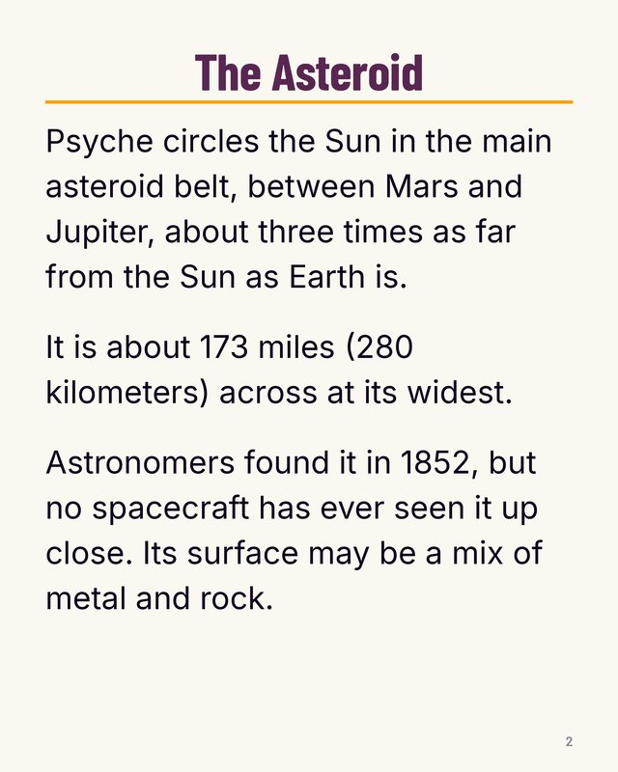 | The Asteroid  Psyche circles the Sun in the main asteroid belt, between Mars and Jupiter, about three times as far from the Sun as Earth is.  It is about 173 miles (280 kilometers) across at its widest.  Astronomers found it in 1852, but no spacecraft has ever seen it up close. Its surface may be a mix of metal and rock.  Where we found it:  NASA's asteroid Psyche page: “Psyche orbits the Sun between Mars and Jupiter” … “it would measure 173 miles (280 kilometers) across at its widest point” … “Psyche was discovered by Italian astronomer Annibale de Gasparis on March 17, 1852.” … “until NASA's Psyche mission sees the asteroid Psyche up close for the first time” … “Psyche is likely made of a mixture of rock and metal”  Psyche press kit, p. 17 (team research folder): “The asteroid Psyche orbits the Sun in the outer part of the main asteroid belt between Mars and Jupiter, and it is approximately three times farther from the Sun than Earth is.” … “The asteroid was discovered in 1852 by Italian astronomer Annibale de Gasparis.”  Psyche press kit, p. 27 (team research folder): “about 173 miles (280 kilometers) at its widest point” | Text only, no picture
7 | 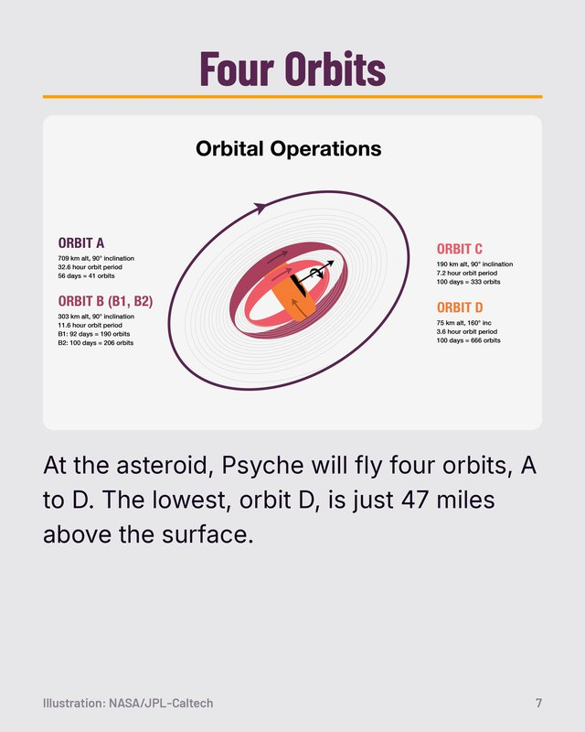 | Four Orbits  Caption: At the asteroid, Psyche will fly four orbits, A to D. The lowest, orbit D, is just 47 miles above the surface.  Where we found it:  Psyche press kit, p. 25 (team research folder): “The mission will take up to 98 days to transfer to Orbit D, the lowest in altitude, which brings the spacecraft within 47 miles (75 kilometers) of the asteroid's surface.”  Psyche press kit, p. 26 (team research folder): “The spacecraft's science-gathering operations take place at four orbit altitudes above the asteroid”  NASA image PIA26102. | Illustration: NASA/JPL-Caltech
8 | 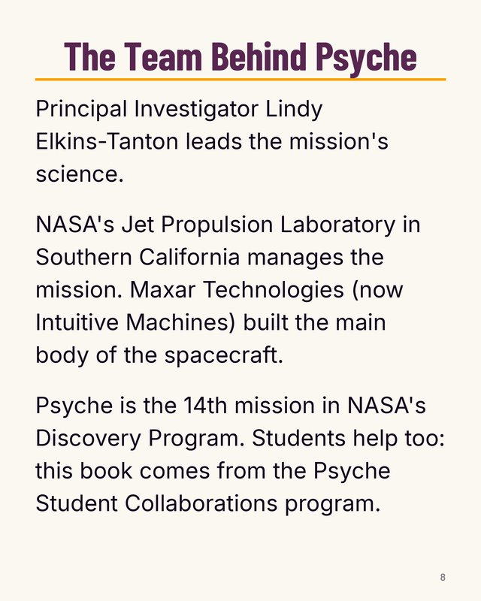 | The Team Behind Psyche  Principal Investigator Lindy Elkins-Tanton leads the mission's science.  NASA's Jet Propulsion Laboratory in Southern California manages the mission. Maxar Technologies (now Intuitive Machines) built the main body of the spacecraft.  Psyche is the 14th mission in NASA's Discovery Program. Students help too: this book comes from the Psyche Student Collaborations program.  Where we found it:  JPL news, Oct 13, 2023: “Lindy Elkins-Tanton, Psyche principal investigator” … “JPL is responsible for the mission's overall management” … “Maxar Space in Palo Alto, California, provided the high-power solar electric propulsion spacecraft chassis.” … “Psyche is the 14th mission selected as part of NASA's Discovery Program”  Psyche press kit, p. 39 (team research folder): “the home to the mission's principal investigator, Lindy Elkins-Tanton”  Psyche press kit, p. 7 (team research folder): “NASA's Jet Propulsion Laboratory in Southern California, a leader in robotic exploration of the solar system, manages the mission” … “delivered the solar electric propulsion chassis – the main body of the spacecraft”  Mission Facts to Remember slides, slide 8 (team publishing folder): “Intuitive Machines - West (formerly Maxar Technologies)”  Bowman et al. 2023 paper, p. 5 (team research folder): “Psyche Student Collaborations consists of four main programs” | Text only, no picture

The Cat Who Crossed the Solar System
Cover colour: Orange. Spine reads: The Cat Who Crossed the Solar System
Page | As seen in the game | Words on the page | Picture credit
Cover | 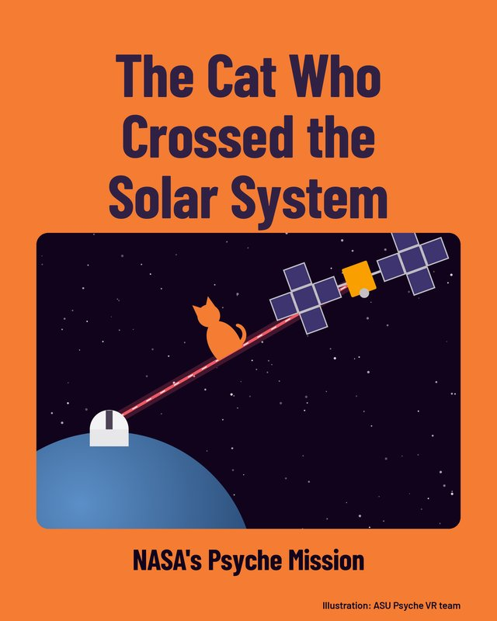 | The Cat Who Crossed the Solar System  NASA's Psyche Mission  Where we found it:  drawn by our team. | Illustration: ASU Psyche VR team
1 | 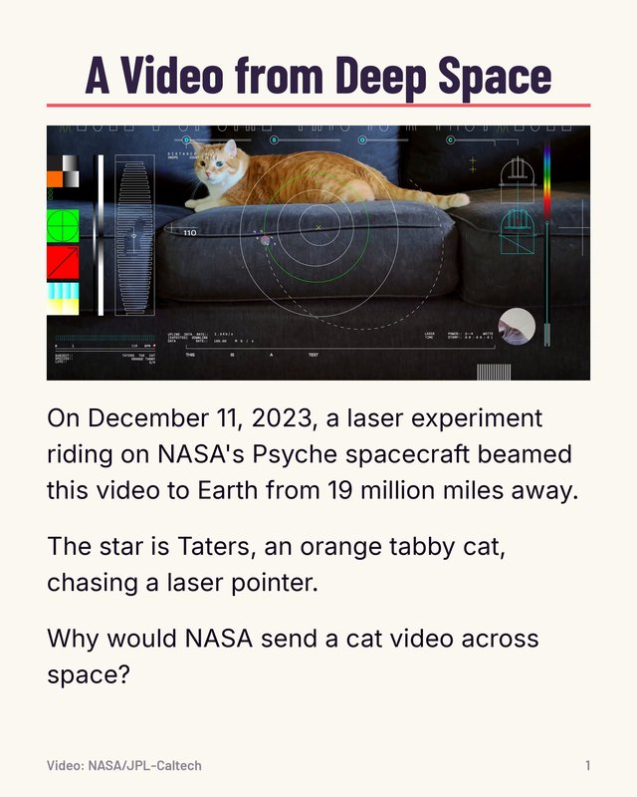 | A Video from Deep Space  On December 11, 2023, a laser experiment riding on NASA's Psyche spacecraft beamed this video to Earth from 19 million miles away.  The star is Taters, an orange tabby cat, chasing a laser pointer.  Why would NASA send a cat video across space?  Where we found it:  JPL news, Dec 18, 2023: “beamed an ultra-high definition streaming video on Dec. 11 from a record-setting 19 million miles away” … “features an orange tabby cat named Taters, the pet of a JPL employee, chasing a laser pointer”  NASA's video page for the cat video: “streamed via laser from deep space by NASA on Dec. 11, 2023”  Psyche press kit, p. 20 (team research folder): “the Deep Space Optical Communications (DSOC) technology demonstration, which is attached to the Psyche spacecraft but is an experiment separate from the Psyche mission”  Note for reviewer: In the game the picture on this page is a video: the first 13 seconds of NASA's Taters laser video (NASA Scientific Visualization Studio item 31275), looped, with no sound, while the book is held. The thumbnail shows its first frame. | Video: NASA/JPL-Caltech
2 |  | Felix, 1928  To get the joke, go back to 1928.  In 1928, engineers in New York were testing a brand-new invention: television. They needed something to film for hours.  They picked a small statue of Felix the Cat, a cartoon star of the day, spinning on a record turntable.  The picture was made of just 60 lines and was about 2 inches tall.  Where we found it:  JPL news, Dec 18, 2023: “Beginning in 1928, a small statue of the popular cartoon character Felix the Cat was featured in television test broadcast transmissions.”  Poynter article on Felix the Cat (not NASA): “In 1928 RCA/NBC began testing their early television equipment with a Felix the Cat statue.” … “station W2XBS (New York-Channel #1)” … “placed on a record player turntable” … “The image was broadcast for two hours a day, simply rotating on a turntable.” … “transmitting 60 line pictures” … “appeared as only 2 inches tall” | Text only, no picture
3 | 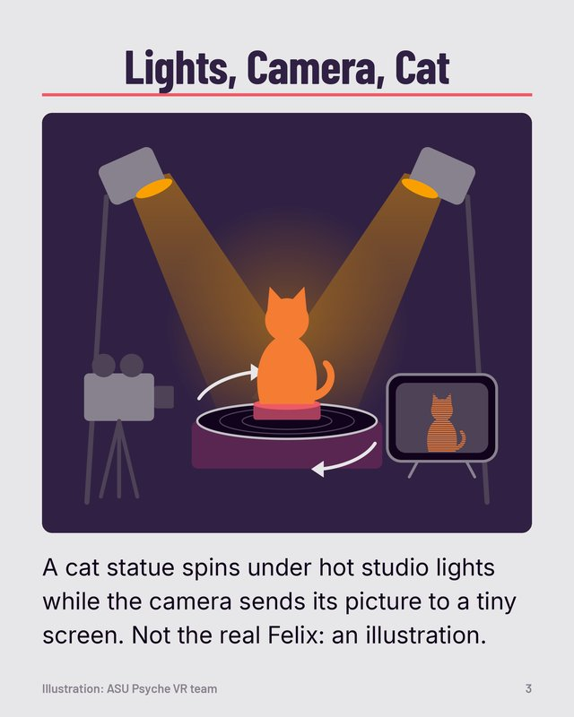 | Lights, Camera, Cat  Caption: A cat statue spins under hot studio lights while the camera sends its picture to a tiny screen. Not the real Felix: an illustration.  Where we found it:  Poynter article on Felix the Cat (not NASA): “would be unaffected by the intense heat from studio lights”  drawn by our team. | Illustration: ASU Psyche VR team
4 | 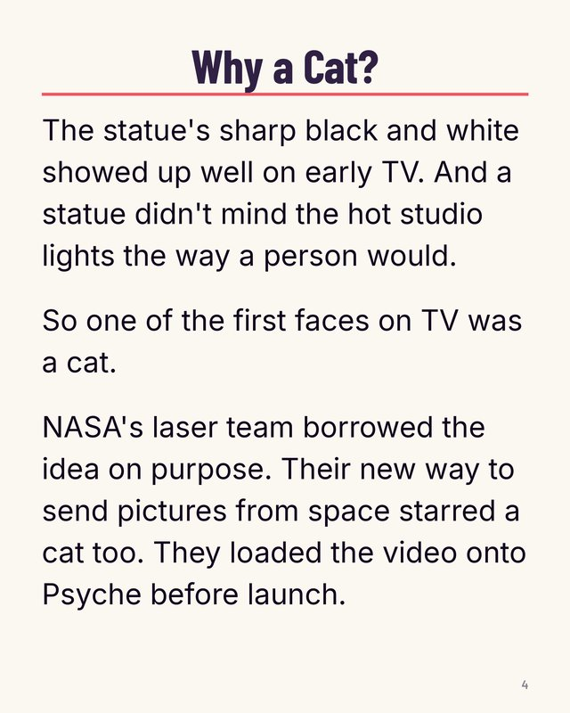 | Why a Cat?  The statue's sharp black and white showed up well on early TV. And a statue didn't mind the hot studio lights the way a person would.  So one of the first faces on TV was a cat.  NASA's laser team borrowed the idea on purpose. Their new way to send pictures from space starred a cat too. They loaded the video onto Psyche before launch.  Where we found it:  Poynter article on Felix the Cat (not NASA): “the right color (black and white) and, as a statue, would be unaffected by the intense heat from studio lights” … “Felix the Cat was a television and technology pioneer.”  NASA's video page for the cat video: “The video was inspired by the first television test broadcast of Felix the Cat in 1928” … “Uploaded before launch”  JPL news, Dec 18, 2023: “There's also a historical link” | Text only, no picture
5 | 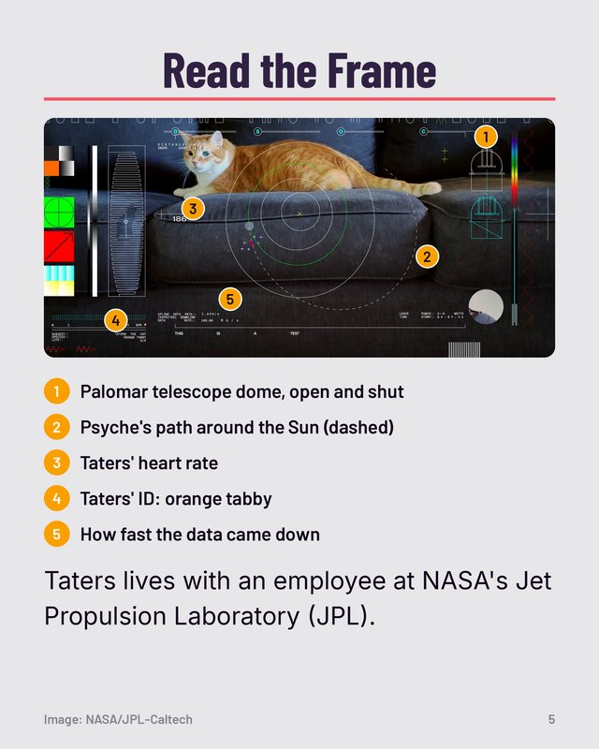 | Read the Frame  1 Palomar telescope dome, open and shut  2 Psyche's path around the Sun (dashed)  3 Taters' heart rate  4 Taters' ID: orange tabby  5 How fast the data came down  Caption: Taters lives with an employee at NASA's Jet Propulsion Laboratory (JPL).  Where we found it:  NASA image PIA26146: “the telescope dome at Caltech's Palomar Observatory” … “Psyche's orbital path” … “who lives with an employee of NASA's Jet Propulsion Laboratory”  JPL news, Dec 18, 2023: “the pet of a JPL employee”  Note for reviewer: The numbered dots are added by us on a frame of the NASA video; the legend explains them. | Image: NASA/JPL-Caltech
6 | 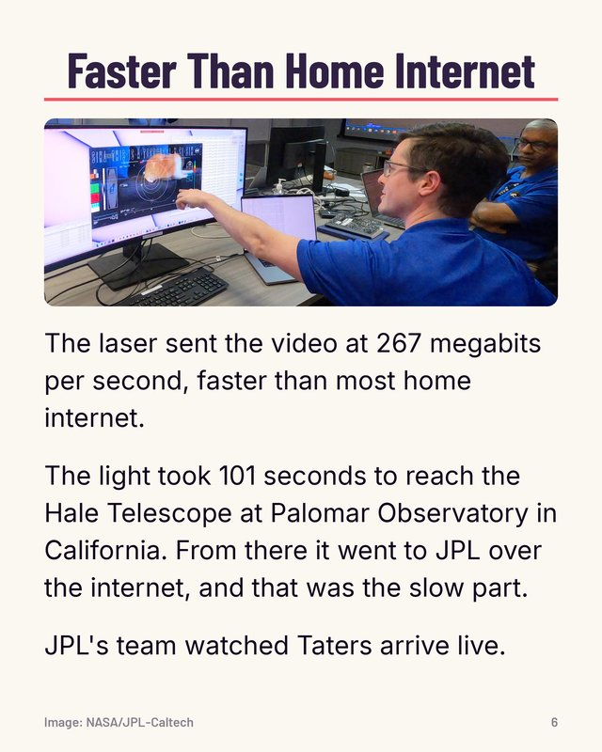 | Faster Than Home Internet  The laser sent the video at 267 megabits per second, faster than most home internet.  The light took 101 seconds to reach the Hale Telescope at Palomar Observatory in California. From there it went to JPL over the internet, and that was the slow part.  JPL's team watched Taters arrive live.  Where we found it:  JPL news, Dec 18, 2023: “sent at the system's maximum bit rate of 267 megabits per second (Mbps)” … “it was able to send the video faster than most broadband internet connections” … “The video signal took 101 seconds to reach Earth” … “beamed an encoded near-infrared laser to the Hale Telescope at Caltech's Palomar Observatory” … “it was sent to JPL over the internet, and that connection was slower than the signal coming from deep space” … “Each frame from the looping video was then sent "live" to NASA's Jet Propulsion Laboratory in Southern California, where the video was played in real time.”  NASA image PIA26145. | Image: NASA/JPL-Caltech
7 | 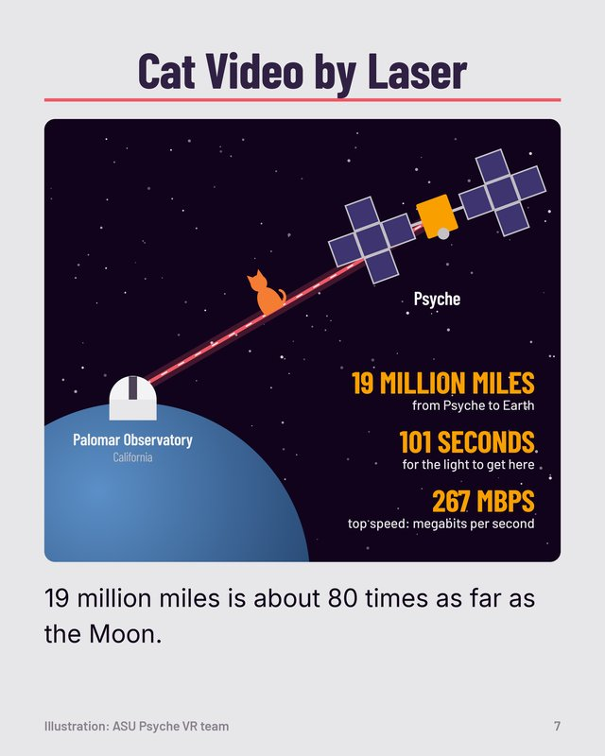 | Cat Video by Laser  Caption: 19 million miles is about 80 times as far as the Moon.  Words in the picture: Psyche / Palomar Observatory / California / 19 MILLION MILES / from Psyche to Earth / 101 SECONDS / for the light to get here / 267 MBPS / top speed: megabits per second  Where we found it:  JPL news, Dec 18, 2023: “31 million kilometers, or about 80 times the Earth-Moon distance” … “from a record-setting 19 million miles away” … “The video signal took 101 seconds to reach Earth” … “maximum bit rate of 267 megabits per second”  drawn by our team. | Illustration: ASU Psyche VR team
8 | 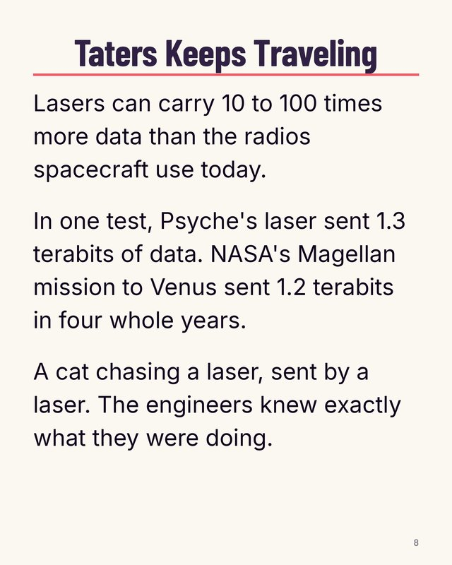 | Taters Keeps Traveling  Lasers can carry 10 to 100 times more data than the radios spacecraft use today.  In one test, Psyche's laser sent 1.3 terabits of data. NASA's Magellan mission to Venus sent 1.2 terabits in four whole years.  A cat chasing a laser, sent by a laser. The engineers knew exactly what they were doing.  Where we found it:  JPL news, Dec 18, 2023: “transmit data from deep space at rates 10 to 100 times greater than the state-of-the-art radio frequency systems used by deep space missions today” … “The team was able to download a total of 1.3 terabits of data during that time. As a comparison, NASA's Magellan mission to Venus downlinked 1.2 terabits during its entire mission from 1990 to 1994.”  Psyche press kit, p. 8 (team research folder): “going from radio communications to laser communications would increase current data rate capacity by 10 to 100 times” | Text only, no picture

Psyche at Mars
Cover colour: Deep rose. Spine reads: Psyche at Mars
Page | As seen in the game | Words on the page | Picture credit
Cover | 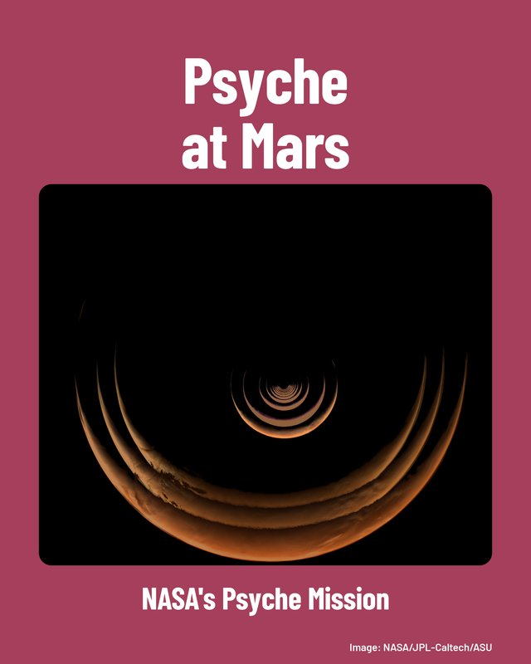 | Psyche at Mars  NASA's Psyche Mission  Where we found it:  NASA image PIA26586. | Image: NASA/JPL-Caltech/ASU
1 | 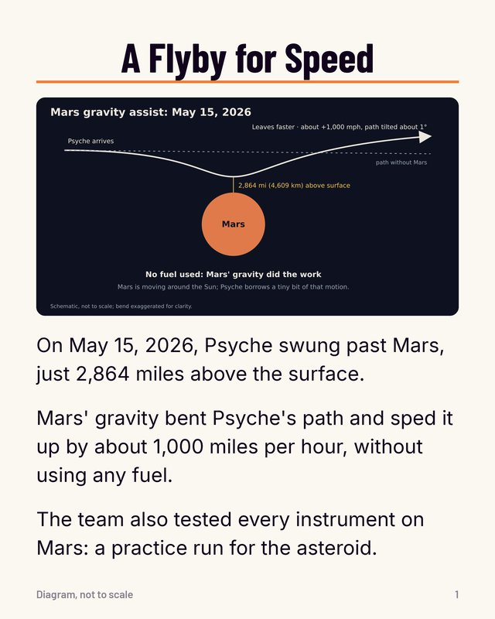 | A Flyby for Speed  On May 15, 2026, Psyche swung past Mars, just 2,864 miles above the surface.  Mars' gravity bent Psyche's path and sped it up by about 1,000 miles per hour, without using any fuel.  The team also tested every instrument on Mars: a practice run for the asteroid.  Words in the picture: Mars gravity assist: May 15, 2026 / Mars / path without Mars / Psyche arrives / Leaves faster · about +1,000 mph, path tilted about 1° / 2,864 mi (4,609 km) above surface / No fuel used: Mars' gravity did the work / Mars is moving around the Sun; Psyche borrows a tiny bit of that motion. / Schematic, not to scale; bend exaggerated for clarity.  Where we found it:  JPL news, May 19, 2026: “coming within 2,864 miles (4,609 kilometers) of the planet's surface” … “Mars gave the spacecraft a 1,000 mile-per-hour boost and shifted its orbital plane by about 1 degree relative to the Sun” … “without using any onboard propellant” … “all of Psyche's instruments were powered up for calibration efforts” … “provided the mission team with a valuable practice run” … “This flyby used a gravity assist from Mars to provide a critical boost in speed”  NASA's Psyche blog, Jul 17, 2026: “the flyby altitude of 2,864 miles (4,609 kilometers)” … “Using Mars as a stand-in for the asteroid during the flyby” | Diagram, not to scale
2 | 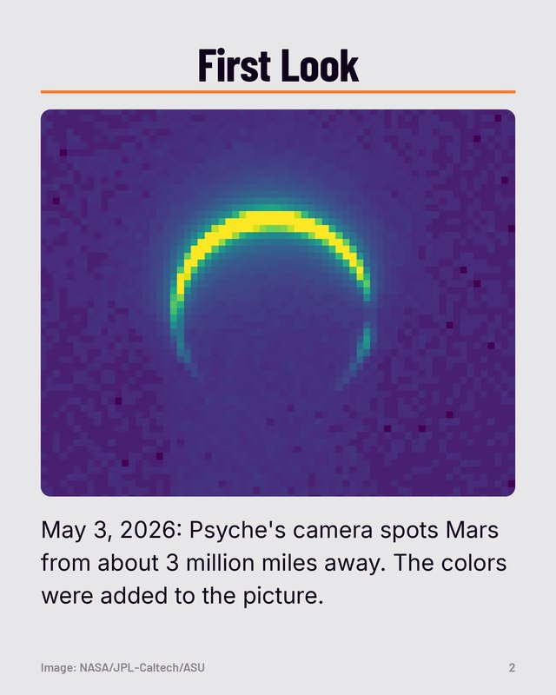 | First Look  Caption: May 3, 2026: Psyche's camera spots Mars from about 3 million miles away. The colors were added to the picture.  Where we found it:  NASA image PIA26750: “This colorized image of Mars was captured by NASA's Psyche mission on May 3, 2026, about 3 million miles (4.8 million kilometers) from the planet.” | Image: NASA/JPL-Caltech/ASU
3 | 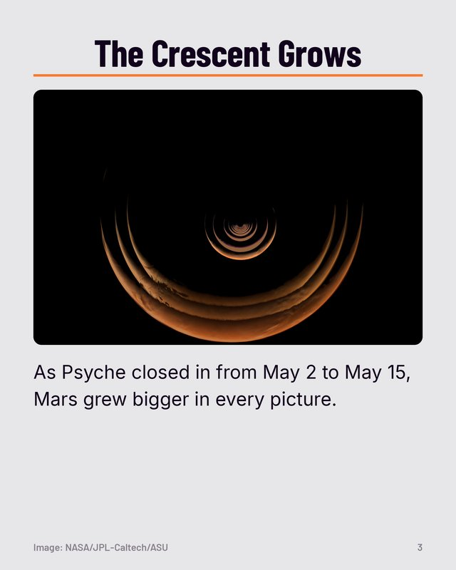 | The Crescent Grows  Caption: As Psyche closed in from May 2 to May 15, Mars grew bigger in every picture.  Where we found it:  NASA image PIA26586: “grow as the spacecraft approached the planet for a gravity assist from May 2 to May 15, 2026” | Image: NASA/JPL-Caltech/ASU
4 | 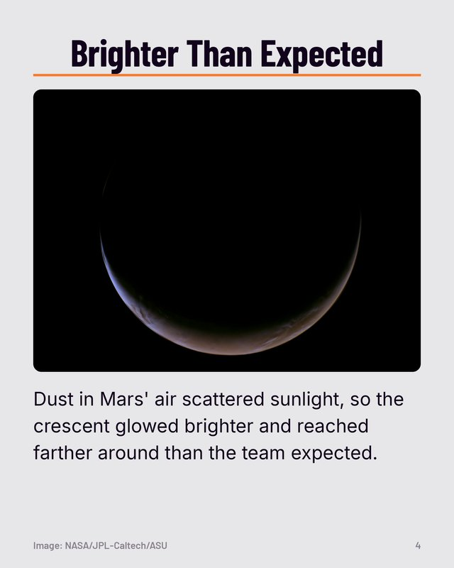 | Brighter Than Expected  Caption: Dust in Mars' air scattered sunlight, so the crescent glowed brighter and reached farther around than the team expected.  Where we found it:  NASA image PIA26771: “the crescent appeared brighter and extended farther around the planet's disk than anticipated because of the strong scattering of sunlight through the planet's dusty atmosphere” | Image: NASA/JPL-Caltech/ASU
5 | 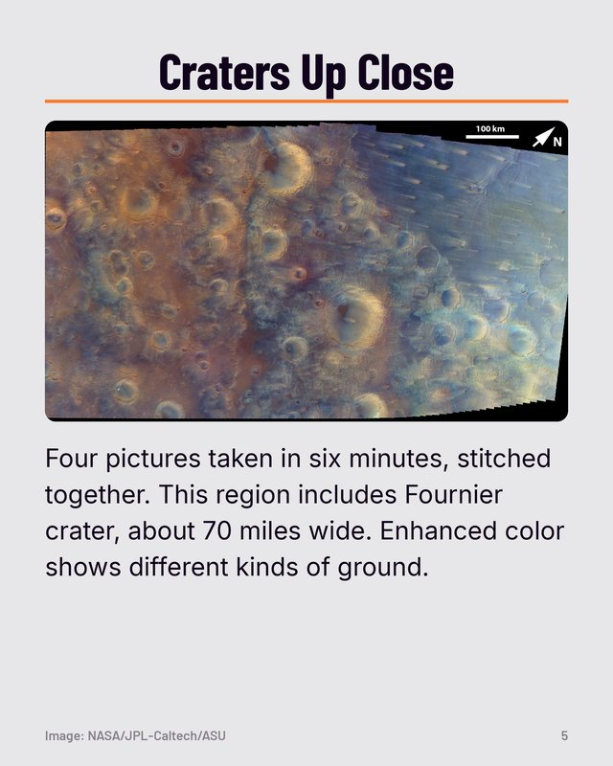 | Craters Up Close  Caption: Four pictures taken in six minutes, stitched together. This region includes Fournier crater, about 70 miles wide. Enhanced color shows different kinds of ground.  Where we found it:  NASA image PIA26749: “an enhanced-color mosaic created from four individual images” … “during the six minutes that it took to acquire the images for this mosaic” … “The largest crater, just below center, is called Fournier and is about 71 miles (114 kilometers) in diameter.” … “helped to reveal highly contrasting craters, ridges, wind streaks, and volcanic plains materials on the surface” | Image: NASA/JPL-Caltech/ASU
6 | 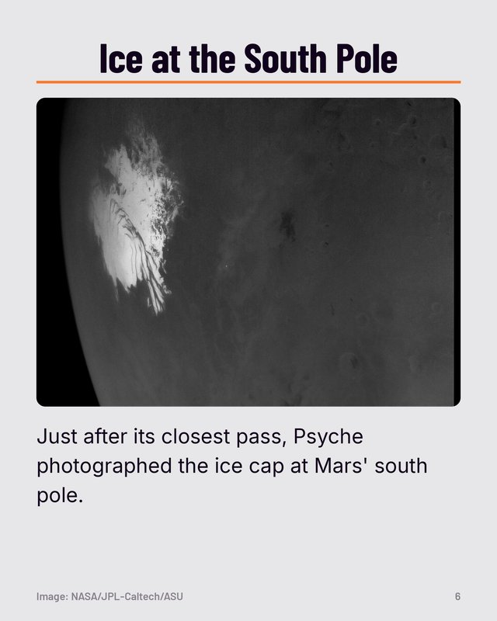 | Ice at the South Pole  Caption: Just after its closest pass, Psyche photographed the ice cap at Mars' south pole.  Where we found it:  JPL news, May 19, 2026: “the water ice-rich south polar cap of Mars captured by NASA's Psyche mission after it made its close approach” | Image: NASA/JPL-Caltech/ASU
7 | 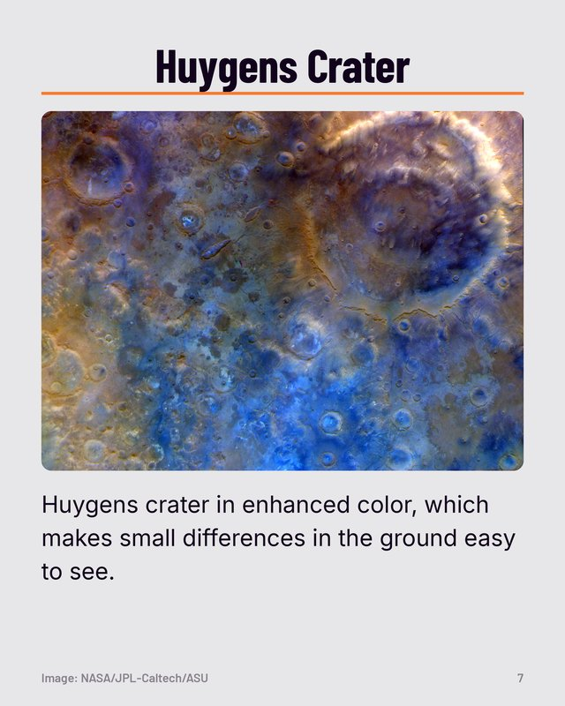 | Huygens Crater  Caption: Huygens crater in enhanced color, which makes small differences in the ground easy to see.  Where we found it:  JPL news, May 19, 2026: “an enhanced-color view of the large double-ring crater Huygens” | Image: NASA/JPL-Caltech/ASU
8 | 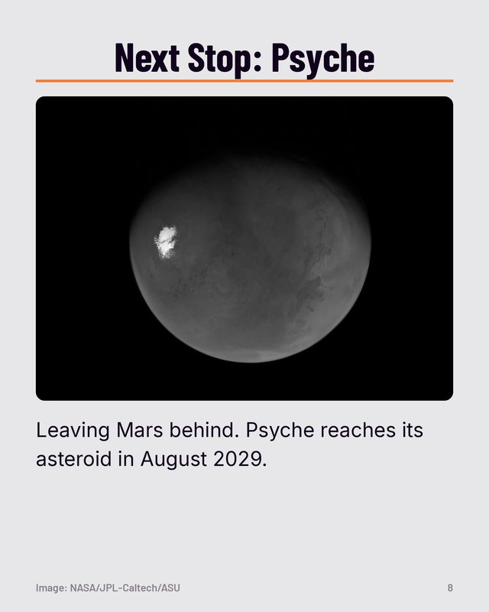 | Next Stop: Psyche  Caption: Leaving Mars behind. Psyche reaches its asteroid in August 2029.  Where we found it:  JPL news, May 19, 2026: “When it arrives in August 2029, it will insert itself into orbit around the asteroid Psyche” | Image: NASA/JPL-Caltech/ASU

Calling Psyche
Cover colour: Near-black. Spine reads: Calling Psyche
Page | As seen in the game | Words on the page | Picture credit
Cover | 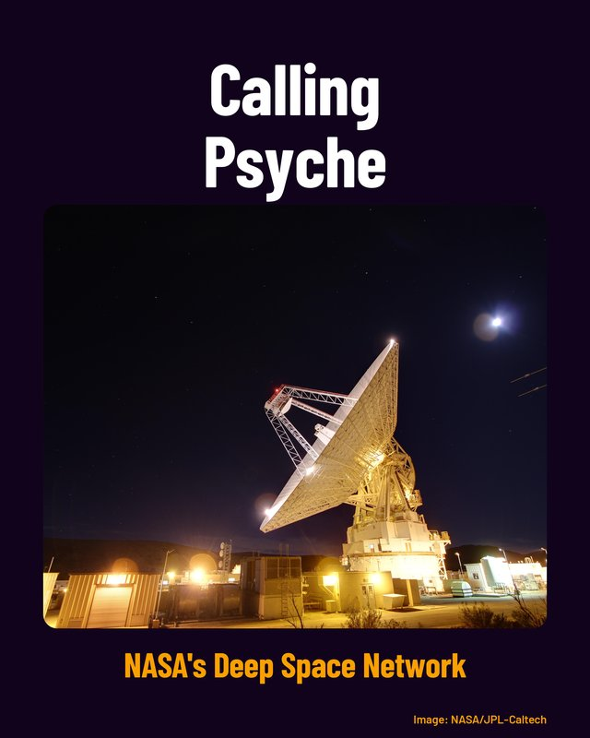 | Calling Psyche  NASA's Deep Space Network  Where we found it:  NASA image PIA17790. | Image: NASA/JPL-Caltech
1 | 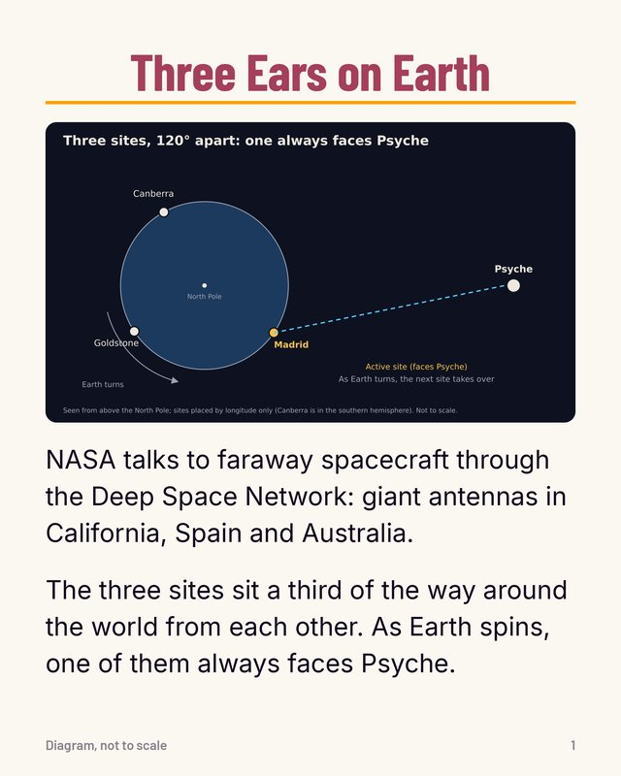 | Three Ears on Earth  NASA talks to faraway spacecraft through the Deep Space Network: giant antennas in California, Spain and Australia.  The three sites sit a third of the way around the world from each other. As Earth spins, one of them always faces Psyche.  Words in the picture: Three sites, 120° apart: one always faces Psyche / North Pole / Goldstone / Madrid / Canberra / Earth turns / Psyche / Active site (faces Psyche) / As Earth turns, the next site takes over / Seen from above the North Pole; sites placed by longitude only (Canberra is in the southern hemisphere). Not to scale.  Where we found it:  NASA's Deep Space Network page: “The three Deep Space Network complexes are located at Goldstone, near Barstow, California; near Madrid, Spain; and near Canberra, Australia.” … “The strategic placement of these sites permits constant communication with spacecraft as our planet rotates”  JPL Deep Space Network handbook, chapter 2, p. 2: “placed approximately 120 degrees (deg) apart around the world” | Diagram, not to scale
2 | 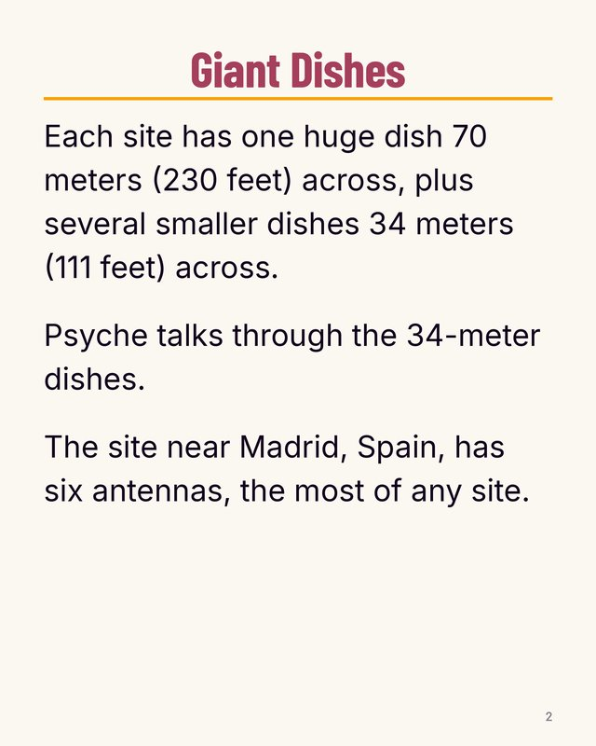 | Giant Dishes  Each site has one huge dish 70 meters (230 feet) across, plus several smaller dishes 34 meters (111 feet) across.  Psyche talks through the 34-meter dishes.  The site near Madrid, Spain, has six antennas, the most of any site.  Where we found it:  NASA image PIA26147: “Each complex consists of one 70-meter (230-foot) antenna and several 34-meter (112-foot) antennas.” … “Madrid is the only deep space communication complex currently with six operational antennas (the other two complexes have four apiece).”  NASA's Deep Space Network page: “Each Deep Space Network site has one huge, 230-foot (70-meter) diameter antenna”  Psyche press kit, p. 36 (team research folder): “Psyche will rely on the DSN's 111-foot-wide (34-meter-wide) antennas” | Text only, no picture
3 |  | Inside a Big Dish  Caption: Workers upgrade the 70-meter dish near Canberra, Australia, in 2020. The white bowl is the dish itself.  Where we found it:  NASA image PIA23795: “Workers perform upgrades on the central cone of the Deep Space Network's Deep Space Station 43's antenna in Canberra, Australia.” … “Since early March 2020, DSS-43 has been offline for the upgrades”  our description of the photo. | Image: NASA/JPL-Caltech
4 | 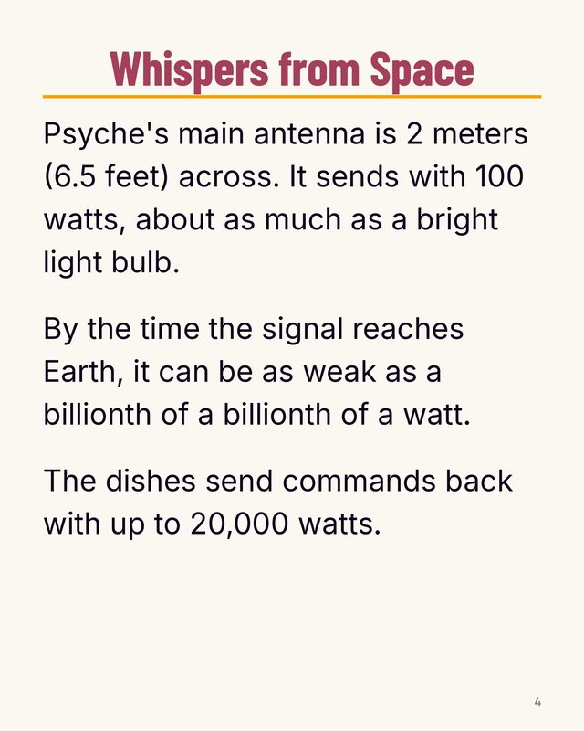 | Whispers from Space  Psyche's main antenna is 2 meters (6.5 feet) across. It sends with 100 watts, about as much as a bright light bulb.  By the time the signal reaches Earth, it can be as weak as a billionth of a billionth of a watt.  The dishes send commands back with up to 20,000 watts.  Where we found it:  Psyche press kit, p. 36 (team research folder): “one 6.5-foot (2-meter) fixed high-gain”  Oh et al. 2025 spacecraft design paper, p. 20 (team research folder): “The spacecraft's 100 W Traveling Wave Tube Amplifier (TWTA)”  JPL lesson "Catching a Whisper from Space": “Signals arriving at DSN antennas on Earth can be as weak as a billionth of a billionth of a watt”  JPL Deep Space Network handbook, chapter 2, p. 18: “The 20-kW S-band and X-band transmitters (Table 2-2) can be operated at levels between 200 W and the full rated 20 kW.” | Text only, no picture
5 | 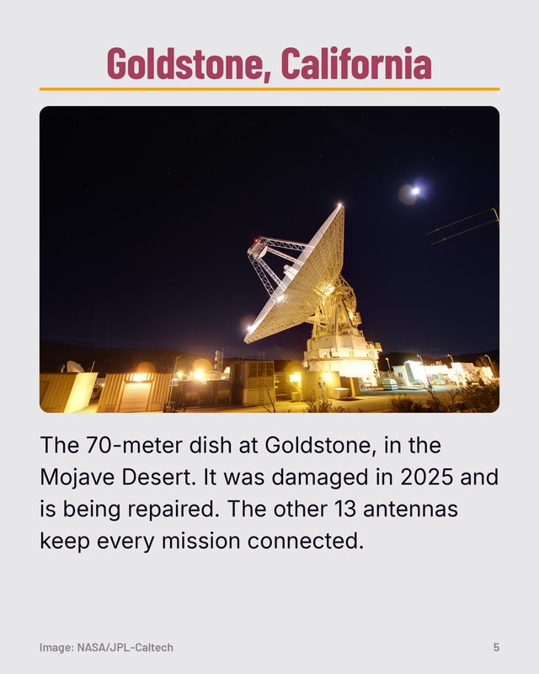 | Goldstone, California  Caption: The 70-meter dish at Goldstone, in the Mojave Desert. It was damaged in 2025 and is being repaired. The other 13 antennas keep every mission connected.  Where we found it:  NASA image PIA17790: “The Goldstone Deep Space Communications Complex is located in the Mojave Desert in California, USA.”  JPL Deep Space Network handbook, chapter 2, p. 2: “at Goldstone, in California's Mojave Desert”  NASA news, Jun 5, 2026: “On Sept. 16, 2025, the DSS-14 antenna over-rotated” … “The antenna will remain offline to complete repairs” … “The network's 13 other antennas, located at complexes in California, Australia, and Spain, are supporting all tracking needs without interruption.” | Image: NASA/JPL-Caltech
6 | 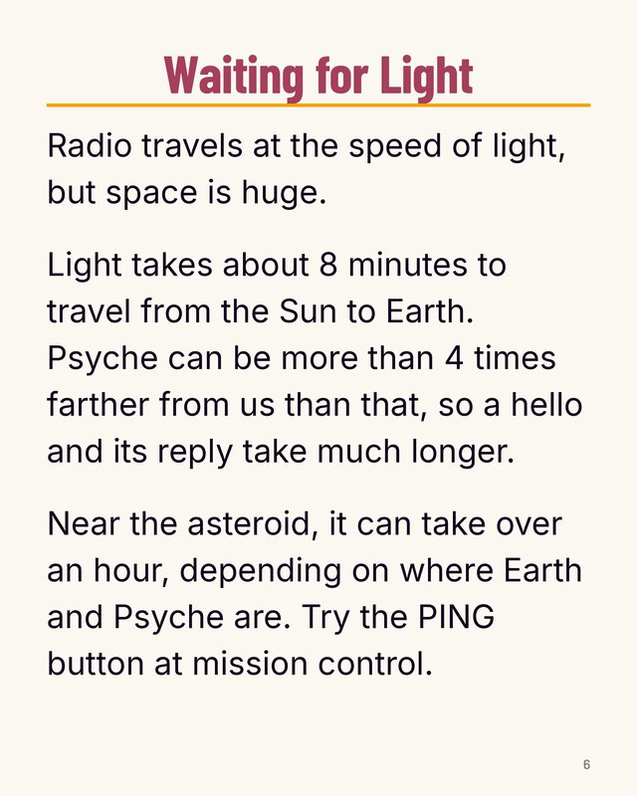 | Waiting for Light  Radio travels at the speed of light, but space is huge.  Light takes about 8 minutes to travel from the Sun to Earth. Psyche can be more than 4 times farther from us than that, so a hello and its reply take much longer.  Near the asteroid, it can take over an hour, depending on where Earth and Psyche are. Try the PING button at mission control.  Where we found it:  JPL Deep Space Network handbook, chapter 2, p. 8: “the round-trip light time (RTLT) between the DSS and spacecraft”  NASA's solar flare FAQ: “Light only takes about 8 minutes to travel from the Sun to Earth”  Psyche press kit, p. 29 (team research folder): “Earth orbits at 1 AU” … “from less than 2 AU to greater than 4 AU”  Oh et al. 2025 spacecraft design paper, p. 22 (team research folder): “at distances over 30 light-minutes from Earth” | Text only, no picture
7 | 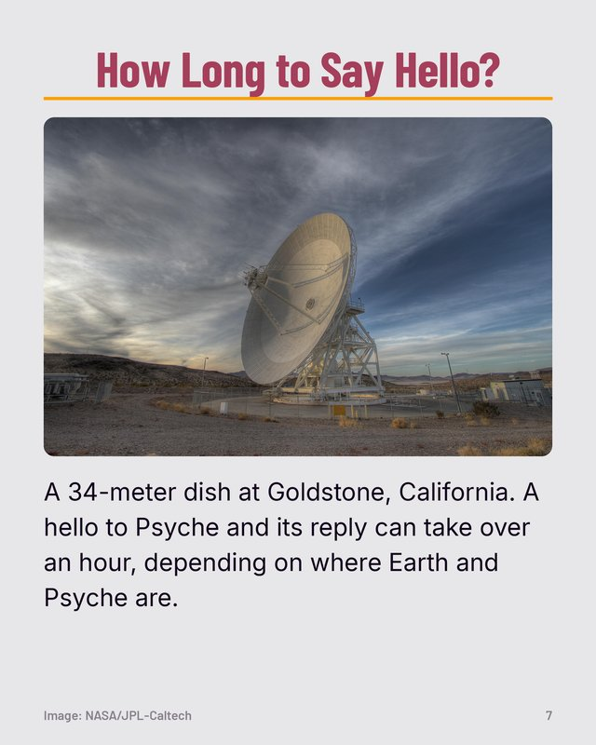 | How Long to Say Hello?  Caption: A 34-meter dish at Goldstone, California. A hello to Psyche and its reply can take over an hour, depending on where Earth and Psyche are.  Where we found it:  NASA image PIA17791: “Goldstone's 111.5-foot (34-meter) Beam Waveguide tracks a spacecraft as it comes into view.”  Oh et al. 2025 spacecraft design paper, p. 22 (team research folder): “at distances over 30 light-minutes from Earth” | Image: NASA/JPL-Caltech
8 | 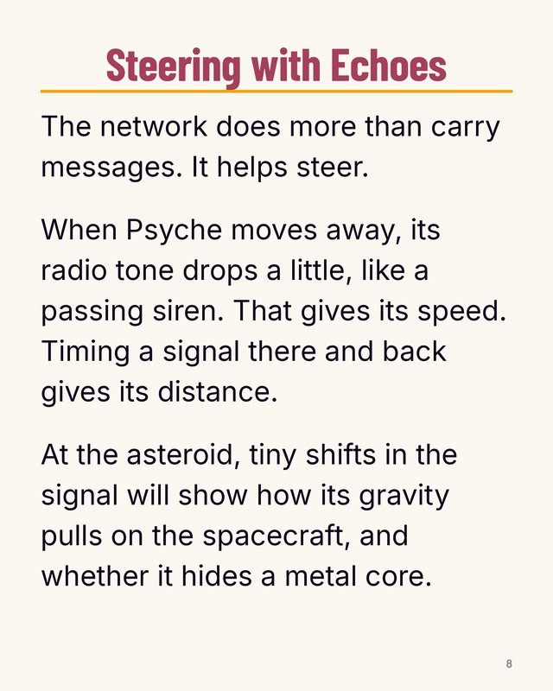 | Steering with Echoes  The network does more than carry messages. It helps steer.  When Psyche moves away, its radio tone drops a little, like a passing siren. That gives its speed. Timing a signal there and back gives its distance.  At the asteroid, tiny shifts in the signal will show how its gravity pulls on the spacecraft, and whether it hides a metal core.  Where we found it:  NASA's Deep Space Network page: “Scientists and engineers can infer a spacecraft's location and how fast it's going by measuring changes in the spacecraft's radio signal frequency.” … “the same phenomenon that causes a siren to sound different as it travels towards and away from you”  JPL Deep Space Network handbook, chapter 2, p. 8: “The Doppler measurements establish the spacecraft-station velocity” … “the measured two-way phase delay permits the determination of the round-trip light time”  Psyche press kit, p. 32 (team research folder): “By analyzing the X-band radio waves the spacecraft communicates with, scientists can measure how Psyche affects the spacecraft's orbit.”  Zuber et al. 2022 gravity paper, p. 2 (team research folder): “The Doppler shift of the radio signal detected on Earth is sensitive to the changes in the motion of a spacecraft due to gravitational variations” … “as to whether the asteroid represents an iron core” | Text only, no picture

