**Blog 10**

Self-organizing map is a divisive clustering (grouping a set of objects according to their similarity) approach based on Artificial Neural Networks, trained with the use of unsupervised learning to create mappings, that transform the high-dimensional data space into low-dimensional, maintaining the topological relations of the input patterns. SOM assigns the genes to a partition, which expression vectors are the most similar to the reference vectors (distinguishing SOMs from k-means clustering).

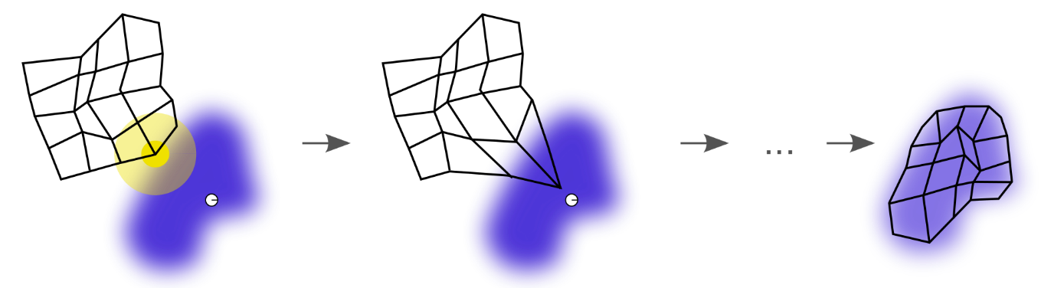

The process begins with defining the geometric arrangement for the partitions (e.g. hexagonal grid) and “training” the vectors using an iterative process until the data is most effectively separated. Once the data convergence is minimalized, the system creates and assigns random vectors to each partition. Then, the reference vector closest to the chosen at random gene is identified with the use of selected distance metric. The reference vector is then adjusted to given gene and the process iterates to increase the stringency (used to define closeness). Finally, the vectors converge to fixed values and the genes are assigned to the relevant partitions based on the reference vector with highest rate of similarity.

Due to its characteristics, SOMs are extremely useful for *multidimensional scaling –* means of visualization of certain similarity between individual cases in a dataset*.* Their advantage is the ability to construct clusters conforming to a meta-structure (e.g. two-dimensional grid) and representing it visually.However, one of the main drawbacks of utilizing Self-organizing maps for clustering is that they require the user to detailed specification of the meta-structure (i.e. number of clusters), what is rarely known prior to cluster analysis.