Source Data Mapping Approach to CDMV5.4

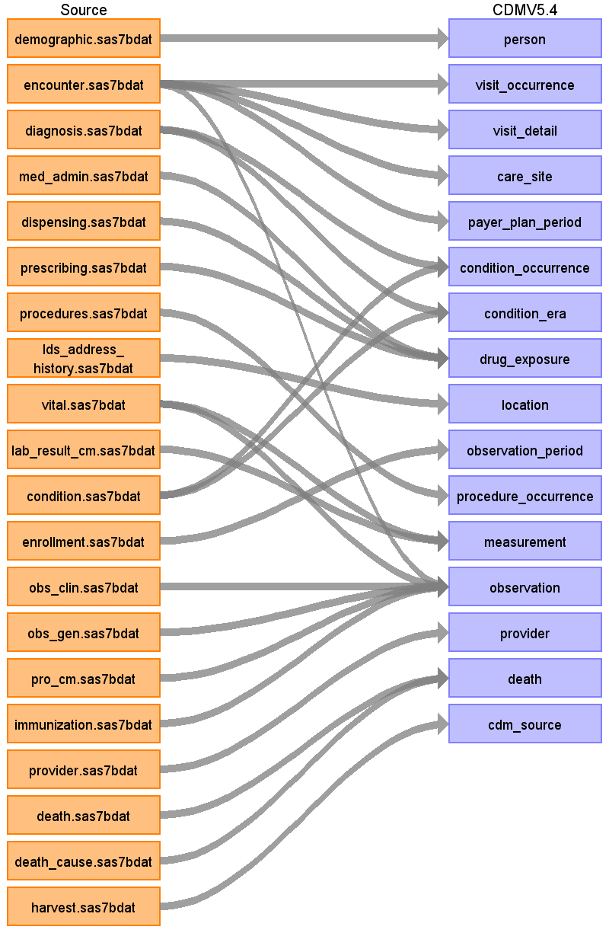

Table name: person

Reading from demographic.sas7bdat

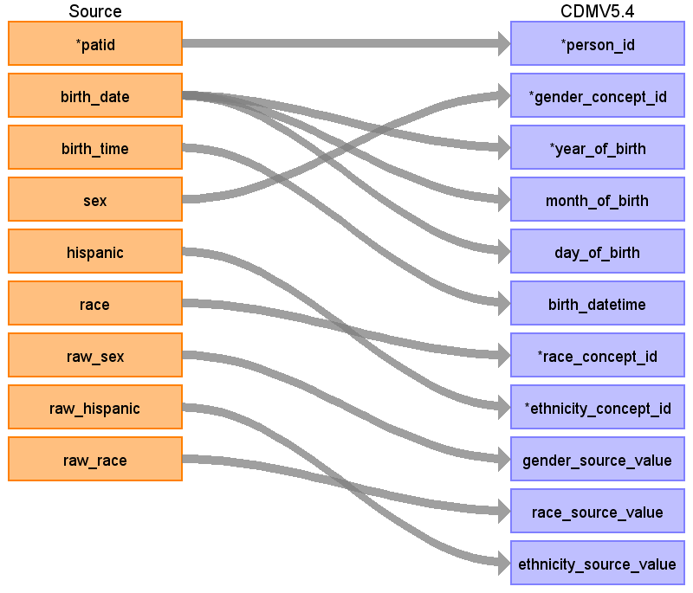

|  |  |  |  |
| --- | --- | --- | --- |
| Destination Field | Source Field | Logic | Comment |
| person_id | patid |  |  |
| gender_concept_id | sex |  |  |
| year_of_birth | birth_date |  |  |
| month_of_birth | birth_date |  |  |
| day_of_birth | birth_date |  |  |
| birth_datetime | birth_time |  |  |
| race_concept_id | race |  |  |
| ethnicity_concept_id | hispanic |  |  |
| location_id |  |  |  |
| provider_id |  |  |  |
| care_site_id |  |  |  |
| person_source_value |  |  |  |
| gender_source_value | raw_sex |  |  |
| gender_source_concept_id |  |  |  |
| race_source_value | raw_race |  |  |
| race_source_concept_id |  |  |  |
| ethnicity_source_value | raw_hispanic |  |  |
| ethnicity_source_concept_id |  |  |  |

Table name: visit_occurrence

Reading from encounter.sas7bdat

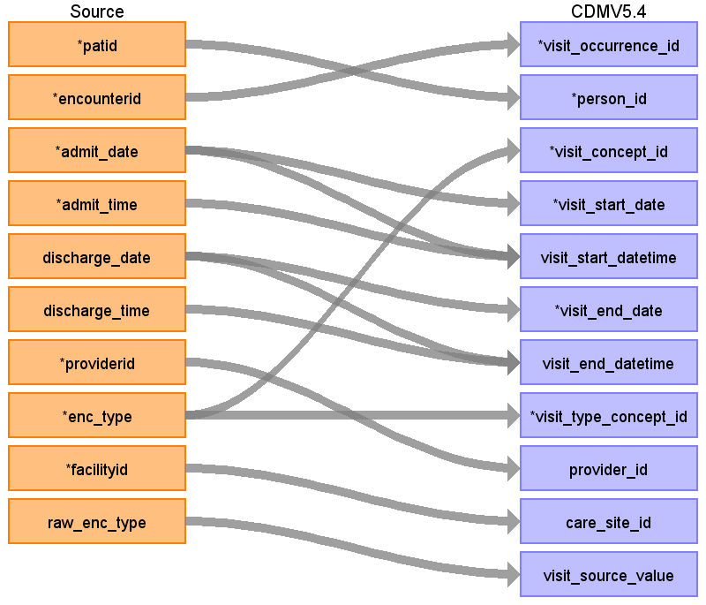

|  |  |  |  |
| --- | --- | --- | --- |
| Destination Field | Source Field | Logic | Comment |
| visit_occurrence_id | encounterid |  |  |
| person_id | patid |  |  |
| visit_concept_id | enc_type |  |  |
| visit_start_date | admit_date |  |  |
| visit_start_datetime | admit_time  admit_date |  |  |
| visit_end_date | discharge_date |  |  |
| visit_end_datetime | discharge_date  discharge_time |  |  |
| visit_type_concept_id | enc_type |  |  |
| provider_id | providerid |  |  |
| care_site_id | facilityid |  |  |
| visit_source_value | raw_enc_type |  |  |
| visit_source_concept_id |  |  |  |
| admitted_from_concept_id |  |  |  |
| admitted_from_source_value |  |  |  |
| discharged_to_concept_id |  |  |  |
| discharged_to_source_value |  |  |  |
| preceding_visit_occurrence_id |  |  |  |

Table name: visit_detail

Reading from encounter.sas7bdat

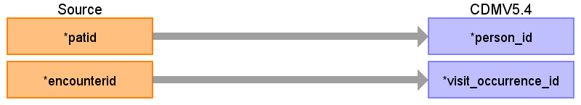

|  |  |  |  |
| --- | --- | --- | --- |
| Destination Field | Source Field | Logic | Comment |
| visit_detail_id |  |  |  |
| person_id | patid |  |  |
| visit_detail_concept_id |  |  |  |
| visit_detail_start_date |  |  |  |
| visit_detail_start_datetime |  |  |  |
| visit_detail_end_date |  |  |  |
| visit_detail_end_datetime |  |  |  |
| visit_detail_type_concept_id |  |  |  |
| provider_id |  |  |  |
| care_site_id |  |  |  |
| visit_detail_source_value |  |  |  |
| visit_detail_source_concept_id |  |  |  |
| admitted_from_concept_id |  |  |  |
| admitted_from_source_value |  |  |  |
| discharged_to_source_value |  |  |  |
| discharged_to_concept_id |  |  |  |
| preceding_visit_detail_id |  |  |  |
| parent_visit_detail_id |  |  |  |
| visit_occurrence_id | encounterid |  |  |

Table name: care_site

Reading from encounter.sas7bdat

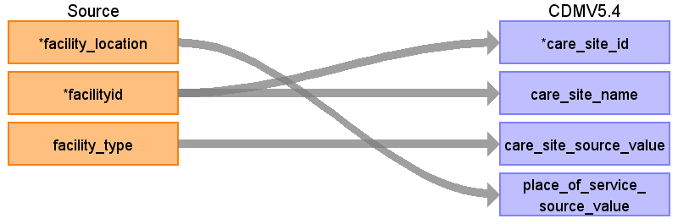

|  |  |  |  |
| --- | --- | --- | --- |
| Destination Field | Source Field | Logic | Comment |
| care_site_id | facilityid |  |  |
| care_site_name | facilityid |  |  |
| place_of_service_concept_id |  |  |  |
| location_id |  |  |  |
| care_site_source_value | facility_type |  |  |
| place_of_service_source_value | facility_location |  |  |

Table name: payer_plan_period

Reading from encounter.sas7bdat

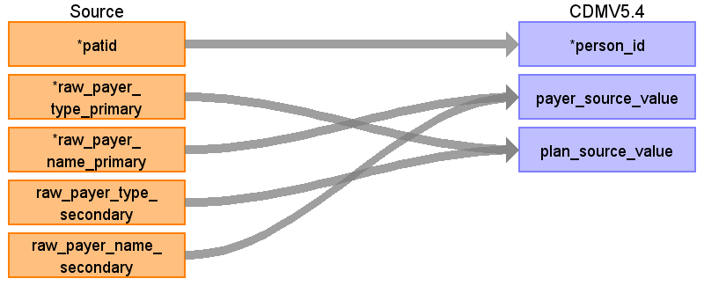

|  |  |  |  |
| --- | --- | --- | --- |
| Destination Field | Source Field | Logic | Comment |
| payer_plan_period_id |  |  |  |
| person_id | patid |  |  |
| payer_plan_period_start_date |  |  |  |
| payer_plan_period_end_date |  |  |  |
| payer_concept_id |  |  |  |
| payer_source_value | raw_payer_name_primary  raw_payer_name_secondary |  |  |
| payer_source_concept_id |  |  |  |
| plan_concept_id |  |  |  |
| plan_source_value | raw_payer_type_primary  raw_payer_type_secondary |  |  |
| plan_source_concept_id |  |  |  |
| sponsor_concept_id |  |  |  |
| sponsor_source_value |  |  |  |
| sponsor_source_concept_id |  |  |  |
| family_source_value |  |  |  |
| stop_reason_concept_id |  |  |  |
| stop_reason_source_value |  |  |  |
| stop_reason_source_concept_id |  |  |  |

Table name: condition_occurrence

Reading from diagnosis.sas7bdat

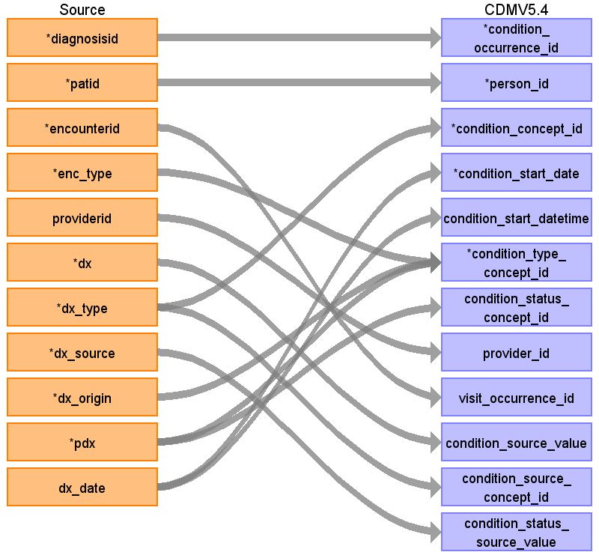

|  |  |  |  |
| --- | --- | --- | --- |
| Destination Field | Source Field | Logic | Comment |
| condition_occurrence_id | diagnosisid |  |  |
| person_id | patid |  |  |
| condition_concept_id | dx_type |  |  |
| condition_start_date | dx_date |  |  |
| condition_start_datetime | dx_date |  |  |
| condition_end_date |  |  |  |
| condition_end_datetime |  |  |  |
| condition_type_concept_id | enc_type  dx_origin  pdx |  | case  when enc_type='ED' and dx_origin='BI' and pdx='P'then 2000001282  when enc_type='ED' and dx_origin='OD' and pdx='P'then 2000001280  when enc_type='ED' and dx_origin='CL' and pdx='P'then 2000001281  when enc_type='ED' and dx_origin='BI' and pdx='S'then 2000001284  when enc_type='ED' and dx_origin='OD' and pdx='S'then 2000001283  when enc_type='ED' and dx_origin='CL' and pdx='S'then 2000001285  when enc_type in ('AV','OA','TH') and dx_origin='BI' and pdx='P'then 2000000096  when enc_type in ('AV','OA','TH') and dx_origin='OD' and pdx='P'then 2000000095  when enc_type in ('AV','OA','TH') and dx_origin='CL' and pdx='P'then 2000000097  when enc_type in ('AV','OA','TH') and dx_origin='BI' and pdx='S'then 2000000102  when enc_type in ('AV','OA','TH') and dx_origin='OD' and pdx='S'then 2000000101  when enc_type in ('AV','OA','TH') and dx_origin='CL' and pdx='S'then 2000000103  when enc_type in ('IP','OS','IS','EI') and dx_origin='BI' and pdx='P'then 2000000093  when enc_type in ('IP','OS','IS','EI') and dx_origin='OD' and pdx='P'then 2000000092  when enc_type in ('IP','OS','IS','EI') and dx_origin='CL' and pdx='P'then 2000000094  when enc_type in ('IP','OS','IS','EI') and dx_origin='BI' and pdx='S'then 2000000099  when enc_type in ('IP','OS','IS','EI') and dx_origin='OD' and pdx='S'then 2000000098  when enc_type in ('IP','OS','IS','EI') and dx_origin='CL' and pdx='S'then 2000000100  else  44814650  end as condition_type_concept_id |
| condition_status_concept_id | pdx |  |  |
| stop_reason |  |  |  |
| provider_id | providerid |  |  |
| visit_occurrence_id | encounterid |  |  |
| visit_detail_id |  |  |  |
| condition_source_value | dx |  |  |
| condition_source_concept_id | dx_type |  |  |
| condition_status_source_value | dx_source |  |  |

Reading from condition.sas7bdat

Generated

|  |  |  |  |
| --- | --- | --- | --- |
| Destination Field | Source Field | Logic | Comment |
| condition_occurrence_id |  |  |  |
| person_id |  |  |  |
| condition_concept_id |  |  |  |
| condition_start_date |  |  |  |
| condition_start_datetime |  |  |  |
| condition_end_date |  |  |  |
| condition_end_datetime |  |  |  |
| condition_type_concept_id |  |  | case  when enc_type='ED' and dx_origin='BI' and pdx='P'then 2000001282  when enc_type='ED' and dx_origin='OD' and pdx='P'then 2000001280  when enc_type='ED' and dx_origin='CL' and pdx='P'then 2000001281  when enc_type='ED' and dx_origin='BI' and pdx='S'then 2000001284  when enc_type='ED' and dx_origin='OD' and pdx='S'then 2000001283  when enc_type='ED' and dx_origin='CL' and pdx='S'then 2000001285  when enc_type in ('AV','OA','TH') and dx_origin='BI' and pdx='P'then 2000000096  when enc_type in ('AV','OA','TH') and dx_origin='OD' and pdx='P'then 2000000095  when enc_type in ('AV','OA','TH') and dx_origin='CL' and pdx='P'then 2000000097  when enc_type in ('AV','OA','TH') and dx_origin='BI' and pdx='S'then 2000000102  when enc_type in ('AV','OA','TH') and dx_origin='OD' and pdx='S'then 2000000101  when enc_type in ('AV','OA','TH') and dx_origin='CL' and pdx='S'then 2000000103  when enc_type in ('IP','OS','IS','EI') and dx_origin='BI' and pdx='P'then 2000000093  when enc_type in ('IP','OS','IS','EI') and dx_origin='OD' and pdx='P'then 2000000092  when enc_type in ('IP','OS','IS','EI') and dx_origin='CL' and pdx='P'then 2000000094  when enc_type in ('IP','OS','IS','EI') and dx_origin='BI' and pdx='S'then 2000000099  when enc_type in ('IP','OS','IS','EI') and dx_origin='OD' and pdx='S'then 2000000098  when enc_type in ('IP','OS','IS','EI') and dx_origin='CL' and pdx='S'then 2000000100  else  44814650  end as condition_type_concept_id |
| condition_status_concept_id |  |  |  |
| stop_reason |  |  |  |
| provider_id |  |  |  |
| visit_occurrence_id |  |  |  |
| visit_detail_id |  |  |  |
| condition_source_value |  |  |  |
| condition_source_concept_id |  |  |  |
| condition_status_source_value |  |  |  |

Table name: condition_era

Reading from diagnosis.sas7bdat

Generated

|  |  |  |  |
| --- | --- | --- | --- |
| Destination Field | Source Field | Logic | Comment |
| condition_era_id |  |  |  |
| person_id |  |  |  |
| condition_concept_id |  |  |  |
| condition_era_start_date |  |  |  |
| condition_era_end_date |  |  |  |
| condition_occurrence_count |  |  |  |

Reading from condition.sas7bdat

Generated

|  |  |  |  |
| --- | --- | --- | --- |
| Destination Field | Source Field | Logic | Comment |
| condition_era_id |  |  |  |
| person_id |  |  |  |
| condition_concept_id |  |  |  |
| condition_era_start_date |  |  |  |
| condition_era_end_date |  |  |  |
| condition_occurrence_count |  |  |  |

Table name: drug_exposure

Reading from med_admin.sas7bdat

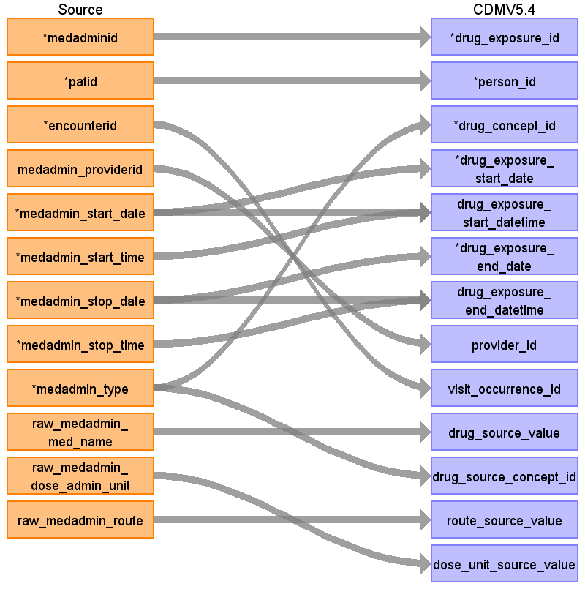

|  |  |  |  |
| --- | --- | --- | --- |
| Destination Field | Source Field | Logic | Comment |
| drug_exposure_id | medadminid |  |  |
| person_id | patid |  |  |
| drug_concept_id | medadmin_type |  | coalesce(  case  when medadmin_type='ND' then ndc_map.concept_id_2  when medadmin_type='RX' then rxnorm.concept_id  else 0  end, 0) as drug_concept_id  coalesce(ndc_map.concept_id_2,0) drug_concept_id |
| drug_exposure_start_date | medadmin_start_date |  |  |
| drug_exposure_start_datetime | medadmin_start_time  medadmin_start_date |  |  |
| drug_exposure_end_date | medadmin_stop_date |  |  |
| drug_exposure_end_datetime | medadmin_stop_date  medadmin_stop_time |  |  |
| verbatim_end_date |  |  |  |
| drug_type_concept_id |  |  | 38000180 as drug_type_concept_id --medadmin  38000175 as drug_type_concept_id --dispensing |
| stop_reason |  |  |  |
| refills |  |  |  |
| quantity |  |  |  |
| days_supply |  |  |  |
| sig |  |  |  |
| route_concept_id |  |  | case  when medadmin.medadmin_route = 'OT' then 44814649  else route.concept_id::int  end,0) as route_concept_id |
| lot_number |  |  |  |
| provider_id | medadmin_providerid |  |  |
| visit_occurrence_id | encounterid |  |  |
| visit_detail_id |  |  |  |
| drug_source_value | raw_medadmin_med_name |  | NDC/RXCUI |
| drug_source_concept_id | medadmin_type |  | case  when medadmin_type='ND' then ndc.concept_id  when medadmin_type='RX' then rxnorm.concept_id  else 0 end as drug_source_concept_id  case  when dispense_source = 'OD' then 38000275  when dispense_source = 'BI' then 44786630  else 44814653  end as drug_source_concept_id |
| route_source_value | raw_medadmin_route |  |  |
| dose_unit_source_value | raw_medadmin_dose_admin_unit |  |  |

Reading from dispensing.sas7bdat

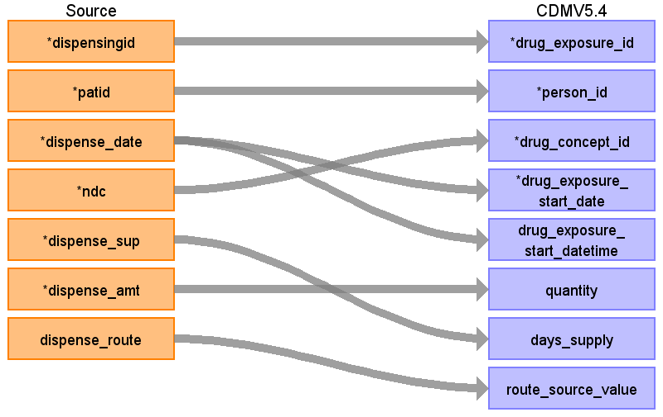

|  |  |  |  |
| --- | --- | --- | --- |
| Destination Field | Source Field | Logic | Comment |
| drug_exposure_id | dispensingid |  |  |
| person_id | patid |  |  |
| drug_concept_id | ndc |  | coalesce(  case  when medadmin_type='ND' then ndc_map.concept_id_2  when medadmin_type='RX' then rxnorm.concept_id  else 0  end, 0) as drug_concept_id  coalesce(ndc_map.concept_id_2,0) drug_concept_id |
| drug_exposure_start_date | dispense_date |  |  |
| drug_exposure_start_datetime | dispense_date |  |  |
| drug_exposure_end_date |  |  |  |
| drug_exposure_end_datetime |  |  |  |
| verbatim_end_date |  |  |  |
| drug_type_concept_id |  |  | 38000180 as drug_type_concept_id --medadmin  38000175 as drug_type_concept_id --dispensing |
| stop_reason |  |  |  |
| refills |  |  |  |
| quantity | dispense_amt |  |  |
| days_supply | dispense_sup |  |  |
| sig |  |  |  |
| route_concept_id |  |  | case  when medadmin.medadmin_route = 'OT' then 44814649  else route.concept_id::int  end,0) as route_concept_id |
| lot_number |  |  |  |
| provider_id |  |  |  |
| visit_occurrence_id |  |  |  |
| visit_detail_id |  |  |  |
| drug_source_value |  |  | NDC/RXCUI |
| drug_source_concept_id |  |  | case  when medadmin_type='ND' then ndc.concept_id  when medadmin_type='RX' then rxnorm.concept_id  else 0 end as drug_source_concept_id  case  when dispense_source = 'OD' then 38000275  when dispense_source = 'BI' then 44786630  else 44814653  end as drug_source_concept_id |
| route_source_value | dispense_route |  |  |
| dose_unit_source_value |  |  |  |

Reading from prescribing.sas7bdat

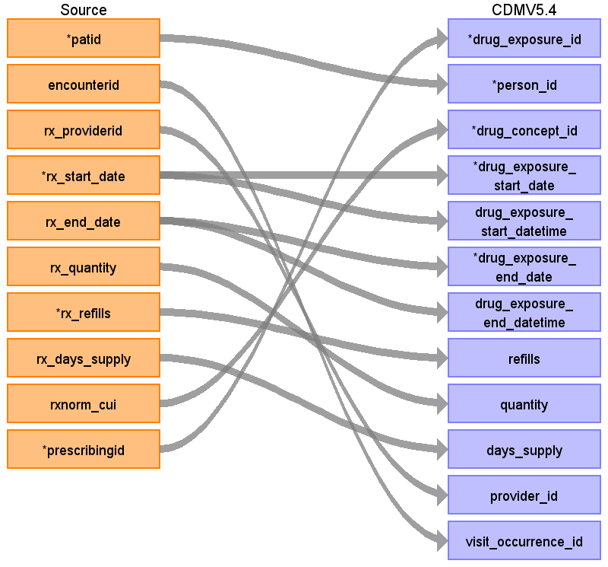

|  |  |  |  |
| --- | --- | --- | --- |
| Destination Field | Source Field | Logic | Comment |
| drug_exposure_id | prescribingid |  |  |
| person_id | patid |  |  |
| drug_concept_id | rxnorm_cui |  | coalesce(  case  when medadmin_type='ND' then ndc_map.concept_id_2  when medadmin_type='RX' then rxnorm.concept_id  else 0  end, 0) as drug_concept_id  coalesce(ndc_map.concept_id_2,0) drug_concept_id |
| drug_exposure_start_date | rx_start_date |  |  |
| drug_exposure_start_datetime | rx_start_date |  |  |
| drug_exposure_end_date | rx_end_date |  |  |
| drug_exposure_end_datetime | rx_end_date |  |  |
| verbatim_end_date |  |  |  |
| drug_type_concept_id |  |  | 38000180 as drug_type_concept_id --medadmin  38000175 as drug_type_concept_id --dispensing |
| stop_reason |  |  |  |
| refills | rx_refills |  |  |
| quantity | rx_quantity |  |  |
| days_supply | rx_days_supply |  |  |
| sig |  |  |  |
| route_concept_id |  |  | case  when medadmin.medadmin_route = 'OT' then 44814649  else route.concept_id::int  end,0) as route_concept_id |
| lot_number |  |  |  |
| provider_id | rx_providerid |  |  |
| visit_occurrence_id | encounterid |  |  |
| visit_detail_id |  |  |  |
| drug_source_value |  |  | NDC/RXCUI |
| drug_source_concept_id |  |  | case  when medadmin_type='ND' then ndc.concept_id  when medadmin_type='RX' then rxnorm.concept_id  else 0 end as drug_source_concept_id  case  when dispense_source = 'OD' then 38000275  when dispense_source = 'BI' then 44786630  else 44814653  end as drug_source_concept_id |
| route_source_value |  |  |  |
| dose_unit_source_value |  |  |  |

Table name: location

Reading from lds_address_history.sas7bdat

Generated

|  |  |  |  |
| --- | --- | --- | --- |
| Destination Field | Source Field | Logic | Comment |
| location_id |  |  |  |
| address_1 |  |  |  |
| address_2 |  |  |  |
| city |  |  |  |
| state |  |  |  |
| zip |  |  |  |
| county |  |  |  |
| location_source_value |  |  |  |
| country_concept_id |  |  |  |
| country_source_value |  |  |  |
| latitude |  |  |  |
| longitude |  |  |  |

Table name: observation_period

Reading from enrollment.sas7bdat

Generated

|  |  |  |  |
| --- | --- | --- | --- |
| Destination Field | Source Field | Logic | Comment |
| observation_period_id |  |  |  |
| person_id |  |  |  |
| observation_period_start_date |  |  |  |
| observation_period_end_date |  |  |  |
| period_type_concept_id |  |  |  |

Table name: procedure_occurrence

Reading from procedures.sas7bdat

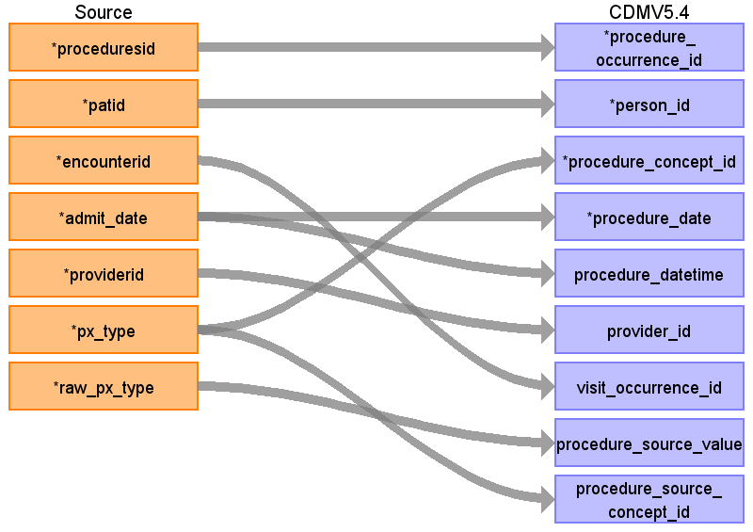

|  |  |  |  |
| --- | --- | --- | --- |
| Destination Field | Source Field | Logic | Comment |
| procedure_occurrence_id | proceduresid |  |  |
| person_id | patid |  |  |
| procedure_concept_id | px_type |  | coalesce(case  when c_hcpcs.concept_id is not null then c_hcpcs.concept_id  when proc.px_type='CH' then c_cpt.concept_id  when proc.px_type='10' then c_icd9.concept_id  when proc.px_type='09' then c_icd10.concept_id  else 0  end, 0) as procedure_concept_id |
| procedure_date | admit_date |  |  |
| procedure_datetime | admit_date |  |  |
| procedure_end_date |  |  |  |
| procedure_end_datetime |  |  |  |
| procedure_type_concept_id |  |  | case  when proc.px_source = 'OD' then 38000275  when proc.px_source ='BI' then 44786631  else 44814650  end AS procedure_type_concept_id |
| modifier_concept_id |  |  | 0 |
| quantity |  |  |  |
| provider_id | providerid |  |  |
| visit_occurrence_id | encounterid |  |  |
| visit_detail_id |  |  |  |
| procedure_source_value | raw_px_type |  |  |
| procedure_source_concept_id | px_type |  | case  when c_hcpcs.concept_id is not null then c_hcpcs.concept_id  when proc.px_type='CH' then c_cpt.concept_id  when proc.px_type='10' then c_icd9.concept_id  when proc.px_type='09' then c_icd10.concept_id  else 0  end as procedure_source_concept_id |
| modifier_source_value |  |  |  |

Table name: measurement

Reading from vital.sas7bdat

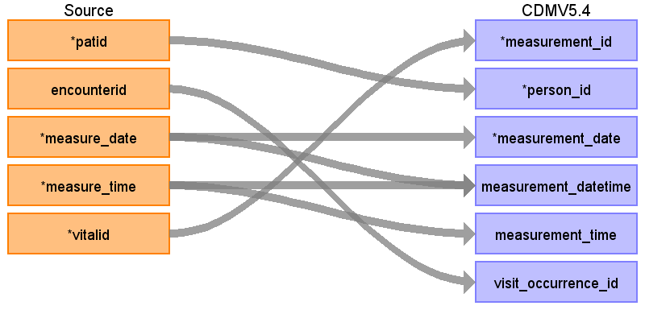

|  |  |  |  |
| --- | --- | --- | --- |
| Destination Field | Source Field | Logic | Comment |
| measurement_id | vitalid |  |  |
| person_id | patid |  |  |
| measurement_concept_id |  |  |  |
| measurement_date | measure_date |  |  |
| measurement_datetime | measure_time  measure_date |  |  |
| measurement_time | measure_time |  |  |
| measurement_type_concept_id |  |  |  |
| operator_concept_id |  |  |  |
| value_as_number |  |  |  |
| value_as_concept_id |  |  |  |
| unit_concept_id |  |  |  |
| range_low |  |  |  |
| range_high |  |  |  |
| provider_id |  |  |  |
| visit_occurrence_id | encounterid |  |  |
| visit_detail_id |  |  |  |
| measurement_source_value |  |  |  |
| measurement_source_concept_id |  |  |  |
| unit_source_value |  |  |  |
| unit_source_concept_id |  |  |  |
| value_source_value |  |  |  |
| measurement_event_id |  |  |  |
| meas_event_field_concept_id |  |  |  |

Reading from lab_result_cm.sas7bdat

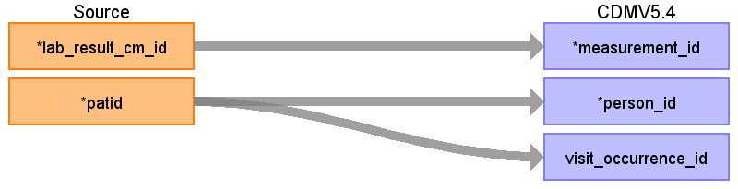

|  |  |  |  |
| --- | --- | --- | --- |
| Destination Field | Source Field | Logic | Comment |
| measurement_id | lab_result_cm_id |  |  |
| person_id | patid |  |  |
| measurement_concept_id |  |  |  |
| measurement_date |  |  |  |
| measurement_datetime |  |  |  |
| measurement_time |  |  |  |
| measurement_type_concept_id |  |  |  |
| operator_concept_id |  |  |  |
| value_as_number |  |  |  |
| value_as_concept_id |  |  |  |
| unit_concept_id |  |  |  |
| range_low |  |  |  |
| range_high |  |  |  |
| provider_id |  |  |  |
| visit_occurrence_id | patid |  |  |
| visit_detail_id |  |  |  |
| measurement_source_value |  |  |  |
| measurement_source_concept_id |  |  |  |
| unit_source_value |  |  |  |
| unit_source_concept_id |  |  |  |
| value_source_value |  |  |  |
| measurement_event_id |  |  |  |
| meas_event_field_concept_id |  |  |  |

Table name: observation

Reading from obs_clin.sas7bdat

Generated

|  |  |  |  |
| --- | --- | --- | --- |
| Destination Field | Source Field | Logic | Comment |
| observation_id |  |  |  |
| person_id |  |  |  |
| observation_concept_id |  |  |  |
| observation_date |  |  |  |
| observation_datetime |  |  |  |
| observation_type_concept_id |  |  |  |
| value_as_number |  |  |  |
| value_as_string |  |  |  |
| value_as_concept_id |  |  |  |
| qualifier_concept_id |  |  |  |
| unit_concept_id |  |  |  |
| provider_id |  |  |  |
| visit_occurrence_id |  |  |  |
| visit_detail_id |  |  |  |
| observation_source_value |  |  |  |
| observation_source_concept_id |  |  |  |
| unit_source_value |  |  |  |
| qualifier_source_value |  |  |  |
| value_source_value |  |  |  |
| observation_event_id |  |  |  |
| obs_event_field_concept_id |  |  |  |

Reading from obs_gen.sas7bdat

Generated

|  |  |  |  |
| --- | --- | --- | --- |
| Destination Field | Source Field | Logic | Comment |
| observation_id |  |  |  |
| person_id |  |  |  |
| observation_concept_id |  |  |  |
| observation_date |  |  |  |
| observation_datetime |  |  |  |
| observation_type_concept_id |  |  |  |
| value_as_number |  |  |  |
| value_as_string |  |  |  |
| value_as_concept_id |  |  |  |
| qualifier_concept_id |  |  |  |
| unit_concept_id |  |  |  |
| provider_id |  |  |  |
| visit_occurrence_id |  |  |  |
| visit_detail_id |  |  |  |
| observation_source_value |  |  |  |
| observation_source_concept_id |  |  |  |
| unit_source_value |  |  |  |
| qualifier_source_value |  |  |  |
| value_source_value |  |  |  |
| observation_event_id |  |  |  |
| obs_event_field_concept_id |  |  |  |

Reading from immunization.sas7bdat

Generated

|  |  |  |  |
| --- | --- | --- | --- |
| Destination Field | Source Field | Logic | Comment |
| observation_id |  |  |  |
| person_id |  |  |  |
| observation_concept_id |  |  |  |
| observation_date |  |  |  |
| observation_datetime |  |  |  |
| observation_type_concept_id |  |  |  |
| value_as_number |  |  |  |
| value_as_string |  |  |  |
| value_as_concept_id |  |  |  |
| qualifier_concept_id |  |  |  |
| unit_concept_id |  |  |  |
| provider_id |  |  |  |
| visit_occurrence_id |  |  |  |
| visit_detail_id |  |  |  |
| observation_source_value |  |  |  |
| observation_source_concept_id |  |  |  |
| unit_source_value |  |  |  |
| qualifier_source_value |  |  |  |
| value_source_value |  |  |  |
| observation_event_id |  |  |  |
| obs_event_field_concept_id |  |  |  |

Reading from pro_cm.sas7bdat

Generated

|  |  |  |  |
| --- | --- | --- | --- |
| Destination Field | Source Field | Logic | Comment |
| observation_id |  |  |  |
| person_id |  |  |  |
| observation_concept_id |  |  |  |
| observation_date |  |  |  |
| observation_datetime |  |  |  |
| observation_type_concept_id |  |  |  |
| value_as_number |  |  |  |
| value_as_string |  |  |  |
| value_as_concept_id |  |  |  |
| qualifier_concept_id |  |  |  |
| unit_concept_id |  |  |  |
| provider_id |  |  |  |
| visit_occurrence_id |  |  |  |
| visit_detail_id |  |  |  |
| observation_source_value |  |  |  |
| observation_source_concept_id |  |  |  |
| unit_source_value |  |  |  |
| qualifier_source_value |  |  |  |
| value_source_value |  |  |  |
| observation_event_id |  |  |  |
| obs_event_field_concept_id |  |  |  |

Reading from encounter.sas7bdat

Generated

|  |  |  |  |
| --- | --- | --- | --- |
| Destination Field | Source Field | Logic | Comment |
| observation_id |  |  |  |
| person_id |  |  |  |
| observation_concept_id |  |  |  |
| observation_date |  |  |  |
| observation_datetime |  |  |  |
| observation_type_concept_id |  |  |  |
| value_as_number |  |  |  |
| value_as_string |  |  |  |
| value_as_concept_id |  |  |  |
| qualifier_concept_id |  |  |  |
| unit_concept_id |  |  |  |
| provider_id |  |  |  |
| visit_occurrence_id |  |  |  |
| visit_detail_id |  |  |  |
| observation_source_value |  |  |  |
| observation_source_concept_id |  |  |  |
| unit_source_value |  |  |  |
| qualifier_source_value |  |  |  |
| value_source_value |  |  |  |
| observation_event_id |  |  |  |
| obs_event_field_concept_id |  |  |  |

Reading from vital.sas7bdat

Generated

|  |  |  |  |
| --- | --- | --- | --- |
| Destination Field | Source Field | Logic | Comment |
| observation_id |  |  |  |
| person_id |  |  |  |
| observation_concept_id |  |  |  |
| observation_date |  |  |  |
| observation_datetime |  |  |  |
| observation_type_concept_id |  |  |  |
| value_as_number |  |  |  |
| value_as_string |  |  |  |
| value_as_concept_id |  |  |  |
| qualifier_concept_id |  |  |  |
| unit_concept_id |  |  |  |
| provider_id |  |  |  |
| visit_occurrence_id |  |  |  |
| visit_detail_id |  |  |  |
| observation_source_value |  |  |  |
| observation_source_concept_id |  |  |  |
| unit_source_value |  |  |  |
| qualifier_source_value |  |  |  |
| value_source_value |  |  |  |
| observation_event_id |  |  |  |
| obs_event_field_concept_id |  |  |  |

Table name: provider

Reading from provider.sas7bdat

Generated

|  |  |  |  |
| --- | --- | --- | --- |
| Destination Field | Source Field | Logic | Comment |
| provider_id |  |  |  |
| provider_name |  |  |  |
| npi |  |  |  |
| dea |  |  |  |
| specialty_concept_id |  |  |  |
| care_site_id |  |  |  |
| year_of_birth |  |  |  |
| gender_concept_id |  |  |  |
| provider_source_value |  |  |  |
| specialty_source_value |  |  |  |
| specialty_source_concept_id |  |  |  |
| gender_source_value |  |  |  |
| gender_source_concept_id |  |  |  |

Table name: dose_era

Table name: drug_era

Table name: death

Reading from death.sas7bdat

Generated

|  |  |  |  |
| --- | --- | --- | --- |
| Destination Field | Source Field | Logic | Comment |
| person_id |  |  |  |
| death_date |  |  |  |
| death_datetime |  |  |  |
| death_type_concept_id |  |  |  |
| cause_concept_id |  |  |  |
| cause_source_value |  |  |  |
| cause_source_concept_id |  |  |  |

Reading from death_cause.sas7bdat

Generated

|  |  |  |  |
| --- | --- | --- | --- |
| Destination Field | Source Field | Logic | Comment |
| person_id |  |  |  |
| death_date |  |  |  |
| death_datetime |  |  |  |
| death_type_concept_id |  |  |  |
| cause_concept_id |  |  |  |
| cause_source_value |  |  |  |
| cause_source_concept_id |  |  |  |

Table name: note

Table name: note_nlp

Table name: episode

Table name: episode_event

Table name: specimen

Table name: fact_relationship

Table name: device_exposure

Table name: cost

Table name: metadata

Table name: cdm_source

Reading from harvest.sas7bdat

Generated

|  |  |  |  |
| --- | --- | --- | --- |
| Destination Field | Source Field | Logic | Comment |
| cdm_source_name |  |  |  |
| cdm_source_abbreviation |  |  |  |
| cdm_holder |  |  |  |
| source_description |  |  |  |
| source_documentation_reference |  |  |  |
| cdm_etl_reference |  |  |  |
| source_release_date |  |  |  |
| cdm_release_date |  |  |  |
| cdm_version |  |  |  |
| cdm_version_concept_id |  |  |  |
| vocabulary_version |  |  |  |

Table name: cohort

Table name: cohort_definition

Appendix: source tables

Table: demographic.sas7bdat

|  |  |  |  |
| --- | --- | --- | --- |
| Field | Type | Most freq. value | Comment |
| patid | INT |  |  |
| birth_date | VARCHAR |  |  |
| birth_time | INT | 18000 |  |
| sex | VARCHAR | F |  |
| sexual_orientation | EMPTY |  |  |
| gender_identity | EMPTY |  |  |
| hispanic | VARCHAR |  |  |
| race | VARCHAR | 05 |  |
| biobank_flag | EMPTY |  |  |
| pat_pref_language_spoken | VARCHAR |  |  |
| raw_sex | VARCHAR | Female |  |
| raw_sexual_orientation | EMPTY |  |  |
| raw_gender_identity | EMPTY |  |  |
| raw_hispanic | VARCHAR |  |  |
| raw_race | VARCHAR | WHITE |  |
| raw_pat_pref_language_spoken | VARCHAR |  |  |

Table: encounter.sas7bdat

|  |  |  |  |
| --- | --- | --- | --- |
| Field | Type | Most freq. value | Comment |
| patid | INT | 257875 |  |
| encounterid | INT |  |  |
| admit_date | VARCHAR | Tue Dec 20 18:00:00 CST 2022 |  |
| admit_time | INT | 120 |  |
| discharge_date | VARCHAR |  |  |
| discharge_time | INT | 86399 |  |
| providerid | INT | 20247 |  |
| facility_location | INT | 65201 |  |
| enc_type | VARCHAR | AV |  |
| facilityid | VARCHAR | STUDENT HL CL |  |
| discharge_disposition | VARCHAR | A |  |
| discharge_status | VARCHAR | HO |  |
| drg | INT |  |  |
| drg_type | VARCHAR | NI |  |
| admitting_source | VARCHAR | RS |  |
| payer_type_primary | VARCHAR | 5 |  |
| payer_type_secondary | VARCHAR | 8 |  |
| facility_type | VARCHAR | HOSPITAL_OUTPATIENT_FAMILY_MEDICINE_CLINIC |  |
| raw_siteid | EMPTY |  |  |
| raw_enc_type | VARCHAR | OUTPATIENT |  |
| raw_discharge_disposition | VARCHAR | HOME/SELF CARE |  |
| raw_discharge_status | VARCHAR | HOME/SELF CARE |  |
| raw_drg_type | EMPTY |  |  |
| raw_admitting_source | VARCHAR | NON-HEALTH CARE FACILITY |  |
| raw_facility_type | EMPTY |  |  |
| raw_payer_type_primary | VARCHAR | MEDICARE |  |
| raw_payer_name_primary | VARCHAR | MEDICARE ASSIGNED |  |
| raw_payer_id_primary | INT | 81 |  |
| raw_payer_type_secondary | VARCHAR | SELF PAY |  |
| raw_payer_name_secondary | VARCHAR | SELF PAY - AFTER INS |  |
| raw_payer_id_secondary | INT | 1 |  |

Table: diagnosis.sas7bdat

|  |  |  |  |
| --- | --- | --- | --- |
| Field | Type | Most freq. value | Comment |
| diagnosisid | INT |  |  |
| patid | INT | 461986 |  |
| encounterid | INT | 80290294 |  |
| enc_type | VARCHAR | AV |  |
| admit_date | VARCHAR | Mon Oct 31 19:00:00 CDT 2022 |  |
| providerid | INT |  |  |
| dx | VARCHAR | I10 |  |
| dx_type | VARCHAR | 10 |  |
| dx_source | VARCHAR | DI |  |
| dx_origin | VARCHAR | BI |  |
| pdx | VARCHAR | S |  |
| dx_poa | VARCHAR | N |  |
| raw_dx | VARCHAR | I10 |  |
| raw_dx_type | INT | 10 |  |
| raw_dx_source | VARCHAR | DI |  |
| raw_pdx | INT | 1 |  |
| raw_dx_poa | INT |  |  |
| dx_date | VARCHAR |  |  |

Table: med_admin.sas7bdat

|  |  |  |  |
| --- | --- | --- | --- |
| Field | Type | Most freq. value | Comment |
| medadminid | INT |  |  |
| patid | INT | 438923 |  |
| encounterid | INT | 3402880 |  |
| prescribingid | INT | 61730224 |  |
| medadmin_providerid | INT |  |  |
| medadmin_start_date | VARCHAR | Mon Aug 27 19:00:00 CDT 2012 |  |
| medadmin_start_time | INT | 43207 |  |
| medadmin_stop_date | VARCHAR | Mon Aug 27 19:00:00 CDT 2012 |  |
| medadmin_stop_time | INT | 63235 |  |
| medadmin_type | VARCHAR | ND |  |
| medadmin_code | INT |  |  |
| medadmin_dose_admin | REAL |  |  |
| medadmin_dose_admin_unit | VARCHAR | mg |  |
| medadmin_route | VARCHAR | ORAL |  |
| medadmin_source | VARCHAR | OD |  |
| raw_medadmin_med_name | VARCHAR | acetaminophen |  |
| raw_medadmin_code | INT |  |  |
| raw_medadmin_dose_admin | VARCHAR |  |  |
| raw_medadmin_dose_admin_unit | VARCHAR | mg |  |
| raw_medadmin_route | VARCHAR | Oral |  |

Table: dispensing.sas7bdat

|  |  |  |  |
| --- | --- | --- | --- |
| Field | Type | Most freq. value | Comment |
| dispensingid | INT |  |  |
| patid | INT | 241262 |  |
| prescribingid | EMPTY |  |  |
| dispense_date | VARCHAR | Sun Nov 27 18:00:00 CST 2016 |  |
| ndc | INT | 00406012301 |  |
| dispense_source | VARCHAR | OD |  |
| dispense_sup | INT | 30 |  |
| dispense_amt | REAL | 30 |  |
| dispense_dose_disp | INT |  |  |
| dispense_dose_disp_unit | VARCHAR | mg |  |
| dispense_route | VARCHAR | ORAL |  |
| raw_ndc | INT | 00406012301 |  |
| raw_dispense_dose_disp | VARCHAR | 100 |  |
| raw_dispense_dose_disp_unit | VARCHAR | MG |  |
| raw_dispense_route | VARCHAR | PO |  |

Table: prescribing.sas7bdat

|  |  |  |  |
| --- | --- | --- | --- |
| Field | Type | Most freq. value | Comment |
| patid | INT | 1782258 |  |
| encounterid | INT |  |  |
| rx_providerid | INT |  |  |
| rx_order_date | VARCHAR | Mon Jun 12 19:00:00 CDT 2017 |  |
| rx_order_time | INT | 52741 |  |
| rx_start_date | VARCHAR | Mon Dec 06 18:00:00 CST 2021 |  |
| rx_end_date | VARCHAR |  |  |
| rx_dose_ordered | REAL |  |  |
| rx_dose_ordered_unit | VARCHAR | NI |  |
| rx_quantity | REAL |  |  |
| rx_dose_form | VARCHAR | NI |  |
| rx_refills | INT | 0 |  |
| rx_days_supply | INT |  |  |
| rx_frequency | VARCHAR | NI |  |
| rx_prn_flag | VARCHAR | N |  |
| rx_route | VARCHAR | ORAL |  |
| rx_basis | VARCHAR | 02 |  |
| rxnorm_cui | VARCHAR |  |  |
| rx_source | VARCHAR | OD |  |
| rx_dispense_as_written | VARCHAR | NI |  |
| raw_rx_med_name | VARCHAR | Sodium Chloride 0.9% |  |
| raw_rx_frequency | VARCHAR |  |  |
| raw_rxnorm_cui | INT |  |  |
| raw_rx_quantity | VARCHAR |  |  |
| raw_rx_ndc | EMPTY |  |  |
| raw_rx_dose_ordered | VARCHAR |  |  |
| raw_rx_dose_ordered_unit | VARCHAR |  |  |
| raw_rx_route | VARCHAR | Oral |  |
| raw_rx_refills | INT |  |  |
| prescribingid | INT |  |  |

Table: procedures.sas7bdat

|  |  |  |  |
| --- | --- | --- | --- |
| Field | Type | Most freq. value | Comment |
| proceduresid | INT |  |  |
| patid | INT | 2629943 |  |
| encounterid | INT | 14855900 |  |
| enc_type | VARCHAR | AV |  |
| admit_date | VARCHAR | Sun Sep 07 19:00:00 CDT 2014 |  |
| providerid | INT | 16334 |  |
| px_date | VARCHAR | Sun Aug 05 19:00:00 CDT 2012 |  |
| px | VARCHAR | 99213 |  |
| px_type | VARCHAR | CH |  |
| px_source | VARCHAR | BI |  |
| ppx | VARCHAR | P |  |
| raw_px | VARCHAR | 0199213 |  |
| raw_px_type | VARCHAR | CPT4 |  |
| raw_ppx | INT | 1 |  |

Table: lds_address_history.sas7bdat

|  |  |  |  |
| --- | --- | --- | --- |
| Field | Type | Most freq. value | Comment |
| addressid | INT |  |  |
| patid | INT |  |  |
| address_use | VARCHAR | HO |  |
| address_type | VARCHAR | BO |  |
| address_preferred | VARCHAR | Y |  |
| address_city | VARCHAR | COLUMBIA |  |
| address_state | VARCHAR | MO |  |
| address_zip5 | INT | 65201 |  |
| address_zip9 | INT |  |  |
| address_period_start | VARCHAR | Thu Dec 31 18:00:00 CST 1959 |  |
| address_period_end | VARCHAR |  |  |

Table: vital.sas7bdat

|  |  |  |  |
| --- | --- | --- | --- |
| Field | Type | Most freq. value | Comment |
| patid | INT | 2008258 |  |
| encounterid | INT |  |  |
| measure_date | VARCHAR | Tue Aug 23 19:00:00 CDT 2022 |  |
| measure_time | INT | 18000 |  |
| vital_source | VARCHAR | HC |  |
| ht | REAL |  |  |
| wt | REAL |  |  |
| diastolic | INT |  |  |
| systolic | INT | 120 |  |
| original_bmi | INT |  |  |
| bp_position | VARCHAR | NI |  |
| smoking | VARCHAR | NI |  |
| tobacco | VARCHAR | NI |  |
| tobacco_type | VARCHAR | NI |  |
| raw_vital_source | EMPTY |  |  |
| raw_ht | EMPTY |  |  |
| raw_wt | EMPTY |  |  |
| raw_diastolic | INT |  |  |
| raw_systolic | INT | 120 |  |
| raw_bp_position | EMPTY |  |  |
| raw_smoking | EMPTY |  |  |
| raw_tobacco | EMPTY |  |  |
| raw_tobacco_type | EMPTY |  |  |
| vitalid | INT |  |  |

Table: lab_result_cm.sas7bdat

|  |  |  |  |
| --- | --- | --- | --- |
| Field | Type | Most freq. value | Comment |
| lab_result_cm_id | INT |  |  |
| patid | INT | 2461895 |  |
| encounterid | INT | 82266698 |  |
| specimen_source | VARCHAR | BLD |  |
| lab_loinc | VARCHAR |  |  |
| lab_result_source | VARCHAR | OD |  |
| lab_loinc_source | VARCHAR | LM |  |
| priority | VARCHAR | R |  |
| result_loc | VARCHAR | L |  |
| lab_px | VARCHAR |  |  |
| lab_px_type | VARCHAR | LC |  |
| lab_order_date | VARCHAR | Mon Feb 21 18:00:00 CST 2022 |  |
| specimen_date | VARCHAR |  |  |
| specimen_time | INT | 32400 |  |
| result_date | VARCHAR | Sun Mar 13 19:00:00 CDT 2022 |  |
| result_time | INT | 32400 |  |
| result_qual | VARCHAR | NI |  |
| result_snomed | EMPTY |  |  |
| result_num | REAL |  |  |
| result_modifier | VARCHAR | EQ |  |
| result_unit | VARCHAR |  |  |
| norm_range_low | VARCHAR |  |  |
| norm_modifier_low | VARCHAR | EQ |  |
| norm_range_high | VARCHAR |  |  |
| norm_modifier_high | VARCHAR | EQ |  |
| abn_ind | VARCHAR | NL |  |
| raw_lab_name | VARCHAR | POC, Glucose |  |
| raw_lab_code | INT | 36002000 |  |
| raw_panel | EMPTY |  |  |
| raw_result | VARCHAR | Negative |  |
| raw_unit | VARCHAR |  |  |
| raw_order_dept | EMPTY |  |  |
| raw_facility_code | VARCHAR | UNIVERSITY HOSP |  |

Table: condition.sas7bdat

|  |  |  |  |
| --- | --- | --- | --- |
| Field | Type | Most freq. value | Comment |
| conditionid | INT |  |  |
| patid | INT | 1402664 |  |
| encounterid | EMPTY |  |  |
| report_date | VARCHAR | Mon Jan 27 18:00:00 CST 2014 |  |
| resolve_date | VARCHAR |  |  |
| onset_date | VARCHAR |  |  |
| condition_status | VARCHAR | AC |  |
| condition | VARCHAR | 191073013 |  |
| condition_type | VARCHAR | SM |  |
| condition_source | VARCHAR | HC |  |
| raw_condition_status | INT | 1753 |  |
| raw_condition | VARCHAR | 191073013 |  |
| raw_condition_type | INT | 11576719 |  |
| raw_condition_source | EMPTY |  |  |

Table: enrollment.sas7bdat

|  |  |  |  |
| --- | --- | --- | --- |
| Field | Type | Most freq. value | Comment |
| patid | INT |  |  |
| enr_start_date | VARCHAR | Sun Jun 13 19:00:00 CDT 1999 |  |
| enr_end_date | VARCHAR | Sat Dec 31 18:00:00 CST 2022 |  |
| chart | VARCHAR | Y |  |
| enr_basis | VARCHAR | A |  |
| raw_chart | VARCHAR | Y |  |
| raw_basis | VARCHAR | A |  |

Table: obs_clin.sas7bdat

|  |  |  |  |
| --- | --- | --- | --- |
| Field | Type | Most freq. value | Comment |
| obsclinid | INT |  |  |
| patid | INT | 2646467 |  |
| encounterid | INT |  |  |
| obsclin_providerid | INT |  |  |
| obsclin_date | VARCHAR |  |  |
| obsclin_time | INT |  |  |
| obsclin_type | VARCHAR | LC |  |
| obsclin_code | VARCHAR | 59408-5 |  |
| obsclin_result_text | VARCHAR | < 3 Seconds |  |
| obsclin_result_snomed | EMPTY |  |  |
| obsclin_result_modifier | VARCHAR | EQ |  |
| obsclin_result_unit | VARCHAR |  |  |
| raw_obsclin_name | VARCHAR | Heart Rate |  |
| raw_obsclin_code | VARCHAR | 59408-5 |  |
| raw_obsclin_type | VARCHAR | LC |  |
| raw_obsclin_result | VARCHAR | < 3 Seconds |  |
| obsclin_result_qual | VARCHAR | NI |  |
| raw_obsclin_unit | INT | 0 |  |
| obsclin_result_num | REAL |  |  |
| raw_obsclin_modifier | EMPTY |  |  |
| obsclin_source | VARCHAR | HC |  |
| obsclin_start_date | VARCHAR | Sun Dec 04 18:00:00 CST 2022 |  |
| obsclin_start_time | INT |  |  |
| obsclin_stop_date | VARCHAR | Sun Dec 04 18:00:00 CST 2022 |  |
| obsclin_stop_time | INT | 61200 |  |
| obsclin_abn_ind | VARCHAR |  |  |

Table: obs_gen.sas7bdat

|  |  |  |  |
| --- | --- | --- | --- |
| Field | Type | Most freq. value | Comment |
| obsgenid | INT |  |  |
| patid | INT | 2687434 |  |
| encounterid | INT |  |  |
| obsgen_providerid | INT |  |  |
| obsgen_date | VARCHAR | Tue Jun 18 19:00:00 CDT 2019 |  |
| obsgen_time | INT | 18000 |  |
| obsgen_type | VARCHAR | PC_COVID |  |
| obsgen_code | VARCHAR | 3000 |  |
| obsgen_result_qual | VARCHAR | NI |  |
| obsgen_result_text | VARCHAR | Y |  |
| obsgen_result_num | EMPTY |  |  |
| obsgen_result_modifier | VARCHAR | TX |  |
| obsgen_result_unit | VARCHAR | NI |  |
| obsgen_id_modified | EMPTY |  |  |
| raw_obsgen_name | VARCHAR | ALLERGY |  |
| raw_obsgen_code | VARCHAR | 96.71 |  |
| raw_obsgen_type | VARCHAR | ICD-9-CM |  |
| raw_obsgen_result | VARCHAR | NULL |  |
| raw_obsgen_unit | VARCHAR | NI |  |
| obsgen_table_modified | VARCHAR | OB |  |
| obsgen_source | VARCHAR | DR |  |
| obsgen_abn_ind | VARCHAR | NI |  |
| obsgen_start_date | VARCHAR | Tue Jun 18 19:00:00 CDT 2019 |  |
| obsgen_start_time | INT | 18000 |  |
| obsgen_stop_date | VARCHAR | Tue Jun 18 19:00:00 CDT 2019 |  |
| obsgen_stop_time | INT | 18000 |  |

Table: pro_cm.sas7bdat

|  |  |  |  |
| --- | --- | --- | --- |
| Field | Type | Most freq. value | Comment |
| patid | INT | 3023680 |  |
| encounterid | INT | 215479 |  |
| pro_cm_id | INT |  |  |
| pro_loinc | EMPTY |  |  |
| pro_date | VARCHAR | Mon Oct 24 19:00:00 CDT 2022 |  |
| pro_time | INT | 3600 |  |
| pro_type | VARCHAR | OT |  |
| pro_item_name | EMPTY |  |  |
| pro_item_loinc | EMPTY |  |  |
| pro_response_text | EMPTY |  |  |
| pro_response_num | INT | 0 |  |
| pro_method | VARCHAR | OT |  |
| pro_mode | VARCHAR | OT |  |
| pro_cat | VARCHAR | UN |  |
| pro_item_version | EMPTY |  |  |
| pro_measure_name | EMPTY |  |  |
| pro_measure_seq | EMPTY |  |  |
| pro_measure_score | EMPTY |  |  |
| pro_measure_theta | EMPTY |  |  |
| pro_measure_scaled_tscore | EMPTY |  |  |
| pro_measure_standard_error | EMPTY |  |  |
| pro_measure_count_scored | EMPTY |  |  |
| pro_measure_loinc | EMPTY |  |  |
| pro_measure_version | EMPTY |  |  |
| pro_item_fullname | VARCHAR | Pain Score |  |
| pro_item_text | EMPTY |  |  |
| pro_measure_fullname | EMPTY |  |  |
| pro_source | VARCHAR | UN |  |

Table: immunization.sas7bdat

|  |  |  |  |
| --- | --- | --- | --- |
| Field | Type | Most freq. value | Comment |
| immunizationid | INT |  |  |
| patid | INT | 520127 |  |
| encounterid | INT |  |  |
| proceduresid | INT |  |  |
| vx_providerid | INT |  |  |
| vx_record_date | VARCHAR | Wed Mar 03 18:00:00 CST 2021 |  |
| vx_admin_date | VARCHAR | Wed Mar 03 18:00:00 CST 2021 |  |
| vx_code_type | VARCHAR | CX |  |
| vx_code | INT | 88 |  |
| vx_status | VARCHAR | CP |  |
| vx_status_reason | VARCHAR | IM |  |
| vx_source | VARCHAR | OD |  |
| vx_dose | REAL | 0 |  |
| vx_dose_unit | VARCHAR | UN |  |
| vx_route | VARCHAR |  |  |
| vx_body_site | VARCHAR | UN |  |
| vx_manufacturer | VARCHAR | UN |  |
| vx_lot_num | VARCHAR |  |  |
| vx_exp_date | VARCHAR |  |  |
| raw_vx_name | VARCHAR | influenza virus vaccine inactivated |  |
| raw_vx_code | INT | 0 |  |
| raw_vx_code_type | VARCHAR | OT |  |
| raw_vx_dose | REAL | 0 |  |
| raw_vx_dose_unit | INT | 129643243 |  |
| raw_vx_route | INT | 0 |  |
| raw_vx_body_site | INT | 0 |  |
| raw_vx_status | INT | 9 |  |
| raw_vx_status_reason | INT | 154 |  |
| raw_vx_manufacturer | INT | 0 |  |

Table: provider.sas7bdat

|  |  |  |  |
| --- | --- | --- | --- |
| Field | Type | Most freq. value | Comment |
| providerid | INT |  |  |
| provider_sex | VARCHAR |  |  |
| provider_specialty_primary | VARCHAR | NI |  |
| provider_npi | INT |  |  |
| provider_npi_flag | VARCHAR | Y |  |
| raw_provider_specialty_primary | VARCHAR |  |  |

Table: death.sas7bdat

|  |  |  |  |
| --- | --- | --- | --- |
| Field | Type | Most freq. value | Comment |
| patid | INT |  |  |
| death_date | VARCHAR | Tue Sep 30 19:00:00 CDT 1986 |  |
| death_date_impute | VARCHAR | N |  |
| death_source | VARCHAR | L |  |
| death_match_confidence | VARCHAR | E |  |

Table: death_cause.sas7bdat

|  |  |  |  |
| --- | --- | --- | --- |
| Field | Type | Most freq. value | Comment |
| patid | INT |  |  |
| death_cause | VARCHAR | A41.9 |  |
| death_cause_code | INT | 09 |  |
| death_cause_type | VARCHAR | I |  |
| death_cause_source | VARCHAR | DR |  |
| death_cause_confidence | VARCHAR | F |  |

Table: harvest.sas7bdat

|  |  |  |  |
| --- | --- | --- | --- |
| Field | Type | Most freq. value | Comment |
| networkid | VARCHAR |  |  |
| network_name | VARCHAR |  |  |
| datamartid | VARCHAR |  |  |
| datamart_name | VARCHAR |  |  |
| datamart_platform | INT |  |  |
| cdm_version | INT |  |  |
| datamart_claims | INT |  |  |
| datamart_ehr | INT |  |  |
| token_encryption_key | EMPTY |  |  |
| birth_date_mgmt | INT |  |  |
| enr_start_date_mgmt | INT |  |  |
| enr_end_date_mgmt | INT |  |  |
| admit_date_mgmt | INT |  |  |
| discharge_date_mgmt | INT |  |  |
| dx_date_mgmt | INT |  |  |
| px_date_mgmt | INT |  |  |
| rx_order_date_mgmt | INT |  |  |
| rx_start_date_mgmt | INT |  |  |
| rx_end_date_mgmt | INT |  |  |
| dispense_date_mgmt | INT |  |  |
| lab_order_date_mgmt | INT |  |  |
| specimen_date_mgmt | INT |  |  |
| result_date_mgmt | INT |  |  |
| measure_date_mgmt | INT |  |  |
| onset_date_mgmt | INT |  |  |
| report_date_mgmt | INT |  |  |
| resolve_date_mgmt | INT |  |  |
| pro_date_mgmt | INT |  |  |
| death_date_mgmt | INT |  |  |
| medadmin_start_date_mgmt | INT |  |  |
| medadmin_stop_date_mgmt | INT |  |  |
| obsclin_start_date_mgmt | INT |  |  |
| obsclin_stop_date_mgmt | INT |  |  |
| obsgen_start_date_mgmt | INT |  |  |
| obsgen_stop_date_mgmt | INT |  |  |
| address_period_start_mgmt | INT |  |  |
| address_period_end_mgmt | INT |  |  |
| vx_record_date_mgmt | INT |  |  |
| vx_admin_date_mgmt | INT |  |  |
| vx_exp_date_mgmt | INT |  |  |
| refresh_demographic_date | VARCHAR |  |  |
| refresh_enrollment_date | VARCHAR |  |  |
| refresh_encounter_date | VARCHAR |  |  |
| refresh_diagnosis_date | VARCHAR |  |  |
| refresh_procedures_date | VARCHAR |  |  |
| refresh_vital_date | VARCHAR |  |  |
| refresh_dispensing_date | VARCHAR |  |  |
| refresh_lab_result_cm_date | VARCHAR |  |  |
| refresh_condition_date | VARCHAR |  |  |
| refresh_pro_cm_date | VARCHAR |  |  |
| refresh_prescribing_date | VARCHAR |  |  |
| refresh_pcornet_trial_date | VARCHAR |  |  |
| refresh_death_date | VARCHAR |  |  |
| refresh_death_cause_date | VARCHAR |  |  |
| refresh_med_admin_date | VARCHAR |  |  |
| refresh_obs_clin_date | VARCHAR |  |  |
| refresh_provider_date | VARCHAR |  |  |
| refresh_obs_gen_date | VARCHAR |  |  |
| refresh_hash_token_date | VARCHAR |  |  |
| refresh_lds_address_hx_date | VARCHAR |  |  |
| refresh_immunization_date | VARCHAR |  |  |

Table: lab_history.sas7bdat

|  |  |  |  |
| --- | --- | --- | --- |
| Field | Type | Most freq. value | Comment |
| labhistoryid | INT |  |  |
| lab_loinc | VARCHAR | 33898-8 |  |
| lab_facilityid | EMPTY |  |  |
| sex | VARCHAR |  |  |
| race | EMPTY |  |  |
| age_min_wks | REAL | 0 |  |
| age_max_wks | REAL | 7800 |  |
| result_unit | VARCHAR | mg/dL |  |
| norm_range_low | INT | 0 |  |
| norm_modifier_low | EMPTY |  |  |
| norm_range_high | INT | 0 |  |
| norm_modifier_high | EMPTY |  |  |
| period_start | VARCHAR | Wed Jun 19 19:00:00 CDT 2019 |  |
| period_end | VARCHAR | Thu Dec 30 18:00:00 CST 2100 |  |
| raw_lab_name | VARCHAR | LOINC!33898-8 |  |
| raw_unit | INT | 134474 |  |
| raw_range | VARCHAR | 0, 0 |  |

Table: pcornet_trial.sas7bdat

|  |  |  |  |
| --- | --- | --- | --- |
| Field | Type | Most freq. value | Comment |
| patid | INT |  |  |
| trialid | VARCHAR | ADPT |  |
| participantid | VARCHAR |  |  |
| trial_siteid | VARCHAR | D3 |  |
| trial_enroll_date | VARCHAR |  |  |
| trial_end_date | VARCHAR | Mon Jun 29 19:00:00 CDT 2020 |  |
| trial_withdraw_date | VARCHAR |  |  |
| trial_invite_code | VARCHAR |  |  |

Table: hash_token.sas7bdat

|  |  |  |  |
| --- | --- | --- | --- |
| Field | Type | Most freq. value | Comment |
| patid | INT |  |  |
| token_01 | VARCHAR | XXX - G00000 |  |
| token_02 | VARCHAR | XXX - G00000 |  |
| token_03 | VARCHAR | XXX - Z00000 |  |
| token_04 | VARCHAR | XXX - G00000 |  |
| token_05 | VARCHAR | XXX - S00000 |  |
| token_16 | VARCHAR | XXX - S00000 |  |