2.0 Requirement Specification

2.1 Functional Requirement

- The application must visualize the building in 3D model.

- It should display in Augmented Reality mode.

- It should display in Virtual Reality mode.

2.2 Non Functional Requirement

- The system should be able to display or visualize the building in Virtual Reality and Augmented Reality mode.

- The 3D model that display must be particular 3D model defined by the developer.

2.3 Hardware and Software Requirement

|  |  |
| --- | --- |
| Hardware | Software |
| Laptop | SketchUp |
| Smartphone (Android 4.4 and higher) | Unity |
| VR Cardbox | Adobe Illustrator |

2.4 System Configuration

Install Unity

Make sure that the Android Build Support component is selected during installation.

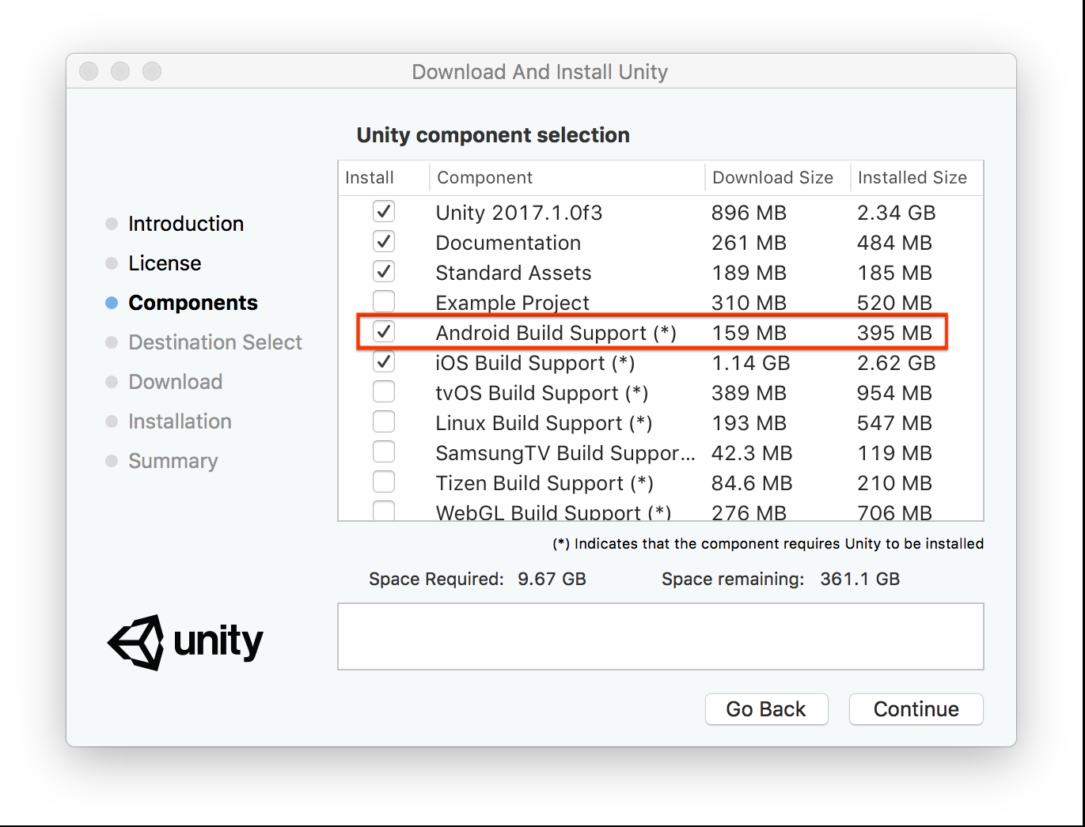

Import Vuforia SDK Package and Google Cardboard VR SDK Package for Unity

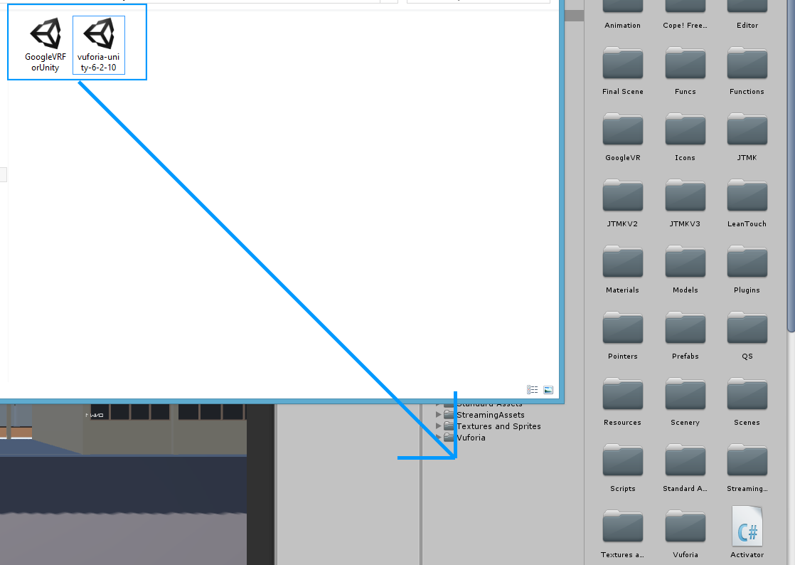

7.0 References

Aukstakalnis, S. (2017). Practical augmented reality : a guide to the technologies, applications, and human factors for AR and VR. Boston: Addison-Wesley.

Bailenson, J. (2018). Experience on demand : what virtual reality is, how it works, and what it can do. New York: W.W. Norton & Company.

Challoner., Kidd, B. & Barton, E. (2017). Virtual reality. New York, New York: DK Publishing.

Hackl, C. & Wolfe, S. (2017). Marketing new realities : an introduction to virtual reality & augmented reality marketing, branding, & communications. Lexington, KY: manufacturer not identified.

Kipper, G. & Rampolla, J. (2012). Augmented reality : an emerging technologies guide to AR. Waltham, MA: Syngress.

Lanham, M. (2017). Augmented reality game development : create your own augmented reality games from scratch with Unity 5. Birmingham, UK: Packt Publishing.

Linowes, J. & Babilinski, K. (2017). Augmented reality for developers : build practical augmented reality applications with Unity, ARCore, ARKit, and Vuforia. Birmingham, UK: Packt Publishing.

Linowes, J. (2015). Unity virtual reality projects : explore the world of virtual reality by building immersive and fun VR projects using Unity 3D. Birmingham, UK: Packt Publishing.

Sood, R. (2012). Pro Android augmented reality. Berkeley, CA: Apress.