2.0 Requirement Specification

2.1 Functional Requirement

2.1.1 Download mobile apps

- User should be able to download PintARVR apps from PintARVR website.

2.1.2 Choose Mode

- There are three mode available that can be choose by user

2.1.3 Virtual Reality mode

- User can use virtual reality mode with virtual reality device such as Google VR Cardboard

2.1.4 Augmented Reality mode

- User can use augmented reality mode and scan image target that can be obtain from PintARVR website.

2.1.5 3D Tour mode

- User can control view and movement by using control button on the screen interface

2.2 Non-Functional Requirement

2.2.1 Performance

- Mode can be access instantly after selected

- Scanning image target for augmented reality fast and accurate.

2.2.2 Environmental

- Augmented reality can be used without even use of paper for image target.

2.2.3 Availability

- PintARVR available 24/7 even when it is not connected to the internet.

- PintARVR website can be access with 99% uptime.

2.3 Hardware and Software Requirement

|  |  |
| --- | --- |
| Hardware | Minimum Requirement |
| Laptop | Intel i5 Processor, 4 GB RAM |
| Smartphone | Android (4.4 or higher) |
| VR Cardbox | Two lenses |

|  |  |
| --- | --- |
| Software | Minimum Requirement |
| SketchUp | Intel i5 Processor, 4GB RAM |
| Unity |
| Java SDK | JDK 1.8.0 |
| Vuforia SDK | Latest version |
| Google VR SDK |

2.4 System Configuration

2.4.1 Install Unity

Make sure that the Android Build Support component is selected during installation.

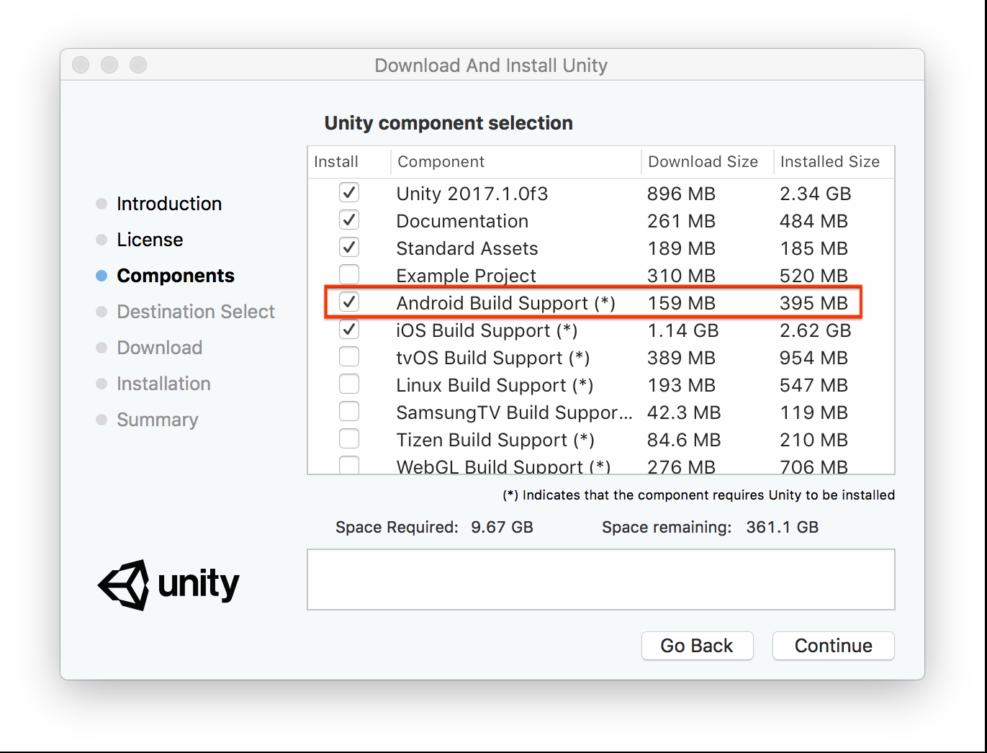

2.4.2 Install Java JDK

The installation process starts. Click the Install button to accept the license terms and to continue with the installation

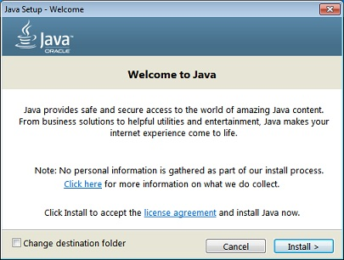

A few brief dialogs confirm the last steps of the installation process; click Close on the last dialog. This will complete Java installation process.

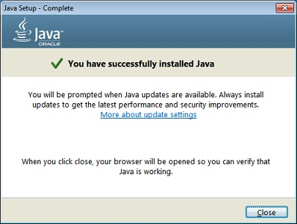

2.4.3 Import Vuforia SDK Package and Google Cardboard VR SDK Package for Unity

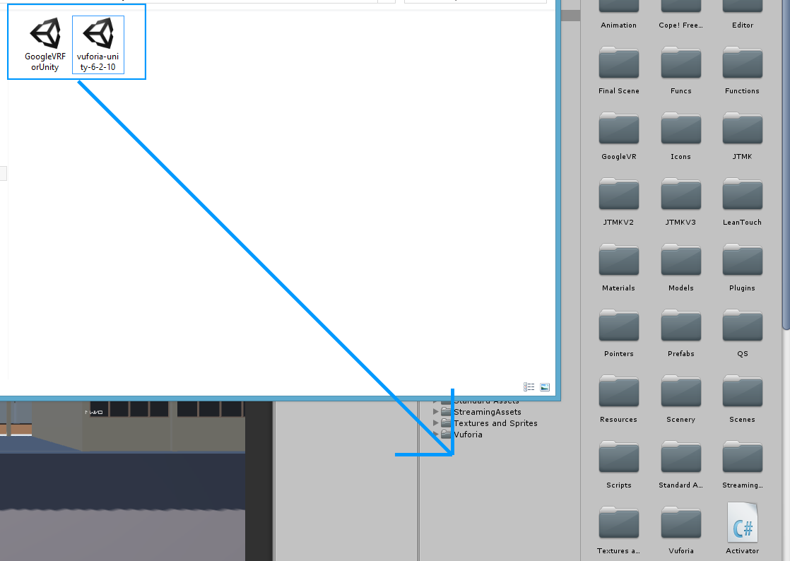

3.0 Final Design

3.1 Logical Design

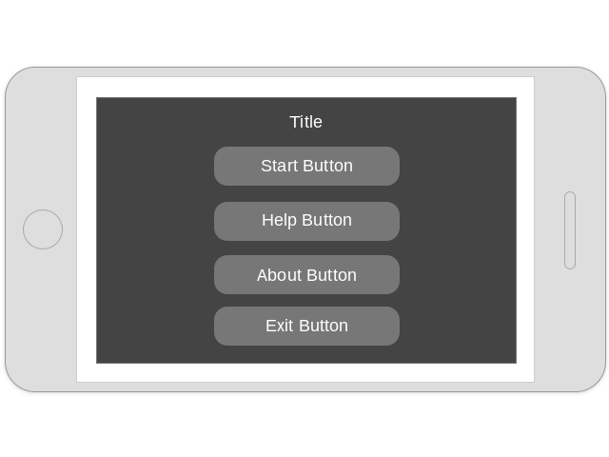 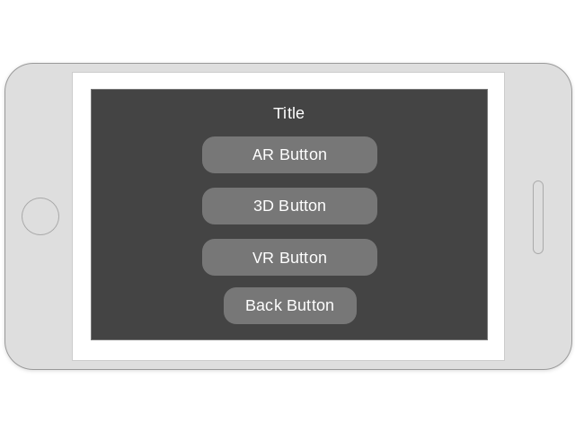

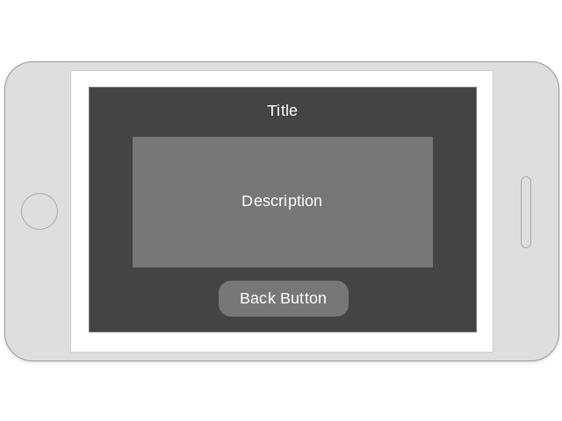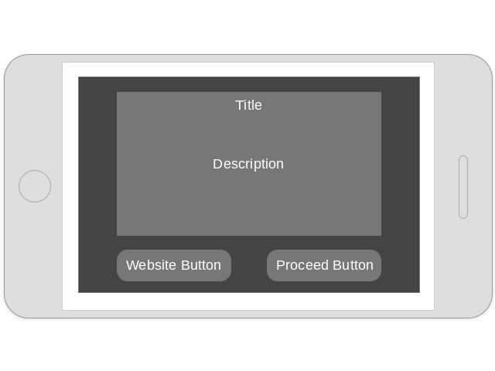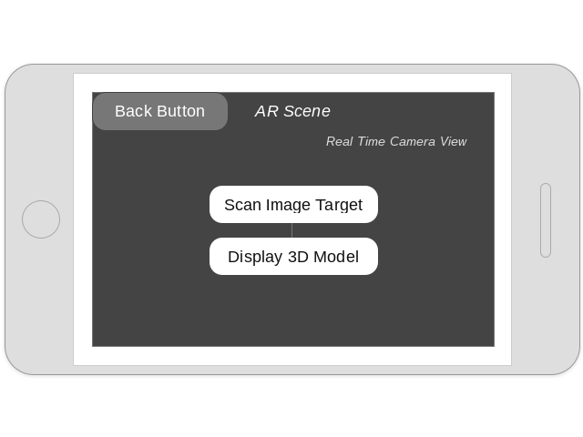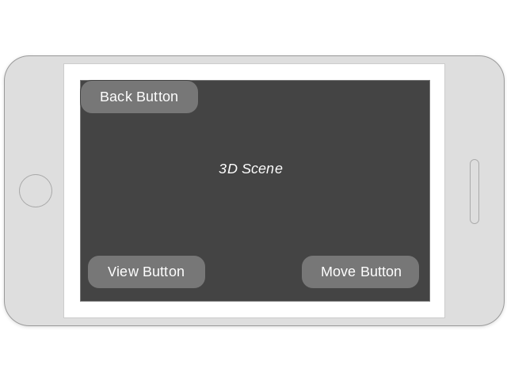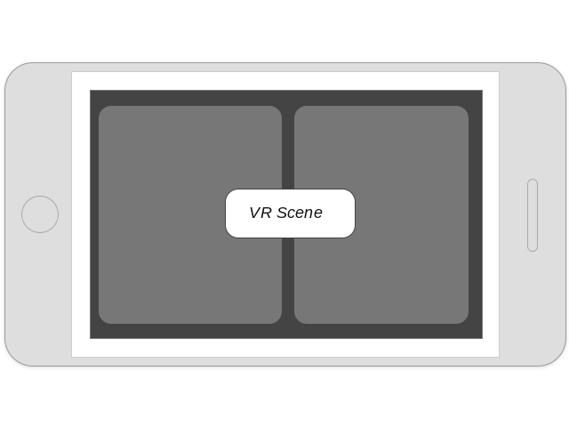

3.2 Physical Design

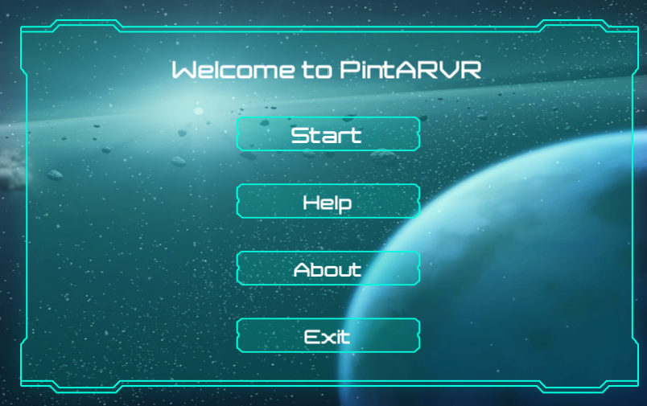

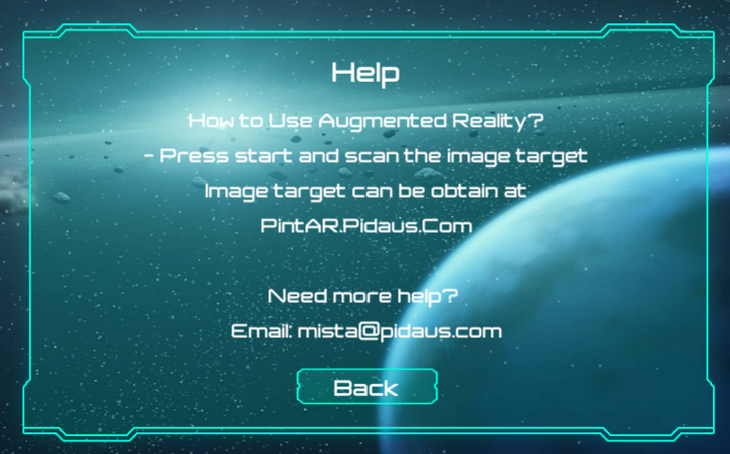

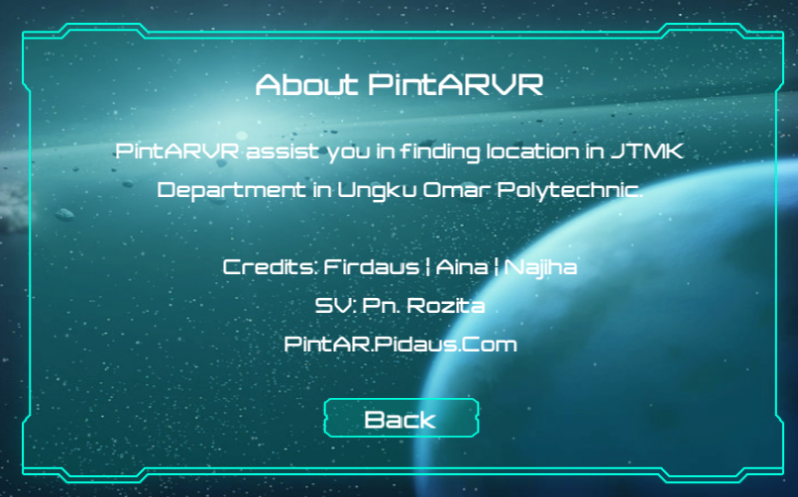

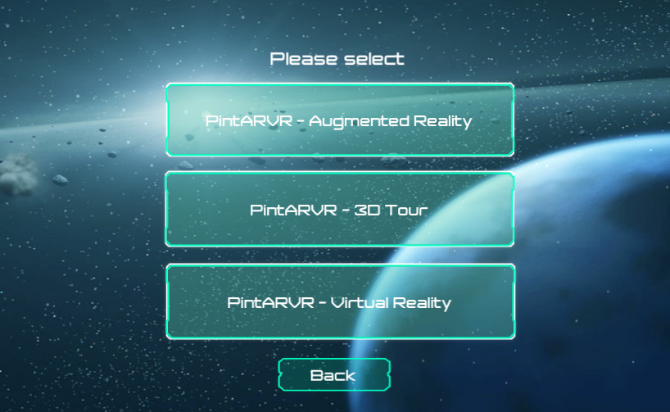

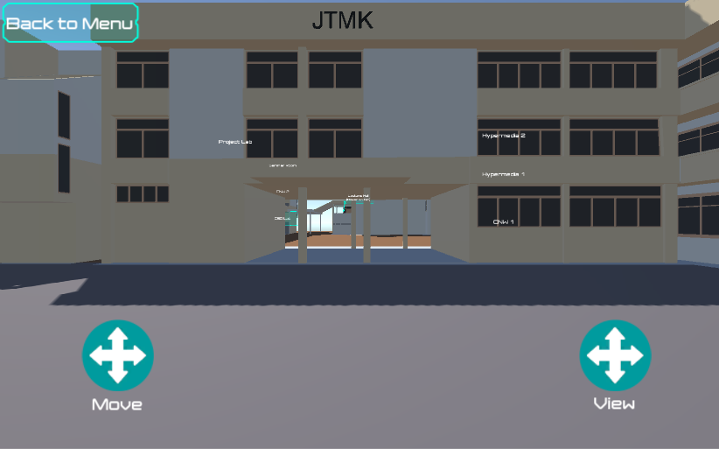

7.0 References

Aukstakalnis, S. (2017). Practical augmented reality : a guide to the technologies, applications, and human factors for AR and VR. Boston: Addison-Wesley.

Bailenson, J. (2018). Experience on demand : what virtual reality is, how it works, and what it can do. New York: W.W. Norton & Company.

Challoner., Kidd, B. & Barton, E. (2017). Virtual reality. New York, New York: DK Publishing.

Hackl, C. & Wolfe, S. (2017). Marketing new realities : an introduction to virtual reality & augmented reality marketing, branding, & communications. Lexington, KY: manufacturer not identified.

Kipper, G. & Rampolla, J. (2012). Augmented reality : an emerging technologies guide to AR. Waltham, MA: Syngress.

Lanham, M. (2017). Augmented reality game development : create your own augmented reality games from scratch with Unity 5. Birmingham, UK: Packt Publishing.

Linowes, J. & Babilinski, K. (2017). Augmented reality for developers : build practical augmented reality applications with Unity, ARCore, ARKit, and Vuforia. Birmingham, UK: Packt Publishing.

Linowes, J. (2015). Unity virtual reality projects : explore the world of virtual reality by building immersive and fun VR projects using Unity 3D. Birmingham, UK: Packt Publishing.

Sood, R. (2012). Pro Android augmented reality. Berkeley, CA: Apress.