Prison treatment and community screening to reduce hepatitis C infections and deaths among people who inject drugs in Singapore: A modelling study
Short title: Hepatitis C treatment after prison release in Singapore
Yichen He¹*
¹ [Affiliation to be added]
* Corresponding author: [email to be added]

Abstract

Background
Hepatitis C virus (HCV) infection in Singapore is concentrated among people who inject drugs (PWID), who often cycle between the community and prison. Singapore expanded treatment in prison from 2019. We asked whether prison treatment alone could meet the World Health Organization (WHO) 2030 targets, and how community screening should be split after release.

Methods and findings
We built an age structured HCV model with four groups: active PWID never imprisoned (D), people in prison (J), and released people who still inject (F) or have stopped (X). We calibrated it to 2015 prison data with Bayesian methods. We assumed treatment in prison from 2019. From 2026 we compared 15 community screening scenarios of 600 to 8,000 tests a year, with 25%, 50% or 75% for F and the rest for X. Results are medians with 95% uncertainty intervals (UI) across 2,000 posterior draws. Without treatment, new infections in 2030 were 101.9% (95% UI: 98.8%–105.5%) of the 2015 level. With prison treatment alone, new infections fell by 47.6% (95% UI: 36.5%–57.5%) by 2030 and HCV deaths by 47.4% (95% UI: 44.7%–48.8%). In 2026, 86% of chronic infections among released people were in X. No scenario met the incidence target: even screening everyone eligible after release cut new infections by only 57%, because 59% of new infections in 2030 occurred among people who had never been imprisoned. The mortality target was met at the median only at 8,000 tests a year with 25% or 50% to F. At 8,000 tests a year, the incidence reduction was 57.1% to 57.3% for every split, while the mortality reduction fell from 67.2% to 60.3% as the F share rose from 25% to 75%. The model covers only PWID and assumes ideal linkage to treatment.

Conclusions
In this model, prison treatment alone roughly halves new HCV infections and HCV deaths by 2030, short of both targets. Most remaining deaths occur among released people who no longer inject, so large scale community screening is needed to reach the mortality target. The F group is small, so screening beyond its size adds no benefit, and most community capacity should go to X. The incidence target cannot be met through prison and post release services, because most new infections occur in people who have never been imprisoned.

Author summary

Why was this study done?
- Singapore aims to eliminate hepatitis C as a public health threat. Most infections are among people who inject drugs, and many of them pass through prison.
- Treatment in prison expanded in 2019. It is not known whether this alone can meet the WHO 2030 targets for new infections and deaths.
- Community services have limited screening capacity. It is not clear how this capacity should be shared between people who still inject after release and people who have stopped.

What did the researchers do and find?
- We built a model of hepatitis C transmission and liver disease among people with a history of injecting drugs in Singapore. We calibrated it to prison data and carried uncertainty in all model parameters through to the results.
- Prison treatment alone reduced new infections by 48% and hepatitis C deaths by 47% by 2030, short of the WHO targets of 80% and 65%.
- By 2026, nearly all chronic infections and deaths among released people were in those who had stopped injecting. Shifting screening towards people who still inject did not improve infections once that small group was covered. It did reduce the fall in deaths.
- No strategy met the target for new infections. Most new infections occurred among people who inject but have never been imprisoned, whom prison and post release services do not reach.

What do these findings mean?
- Prison treatment reaches only people who are imprisoned. Cutting new infections further needs testing and prevention for people who inject before they are ever imprisoned.
- Reaching the mortality target needs large scale community screening, mainly among people who have stopped injecting.
- These results come from a model with ideal links from testing to treatment. Real programmes will need data on uptake, referral and cost before they set targets.

Introduction
Hepatitis C virus (HCV) infection causes cirrhosis, liver cancer and death. Direct acting antivirals (DAAs) cure more than 95% of people treated [1]. The World Health Organization (WHO) has set targets for 2030. These are an 80% reduction in new HCV infections and a 65% reduction in HCV deaths compared with 2015 [2,3]. Many countries are not on track [4].
In Singapore, HCV is concentrated among people who inject drugs (PWID) [5,6]. An earlier study estimated that about 11,000 people in Singapore have ever injected drugs [7]. Many of them move between the community, halfway houses and prison [5]. Prison is a key point of contact with health services. Singapore expanded DAA treatment in prison in 2019. In that year 681 people were treated in one prison cohort, with a cure rate above 99% [8]. Sofosbuvir and velpatasvir were later subsidised for wider use [9,10]. Community programmes have also started. One programme plans to screen 600 high risk people a year [11,12]. A national HCV programme now coordinates this work [13].
Treating people who inject drugs can prevent onward transmission [14,15]. Deaths are a different matter. They come from cirrhosis and liver cancer, which develop over decades [16]. Cure lowers but does not remove the risk of liver cancer in people with cirrhosis [17,18]. A programme can therefore cut infections quickly and still miss the mortality target. A previous Singapore model estimated the treatment needed for elimination [5]. It did not separate released people who still inject from those who have stopped. These two groups play different roles. The first drives transmission. The second may hold most of the burden of advanced liver disease.
We used a calibrated model to answer three questions. First, how much does prison treatment from 2019 reduce new infections and deaths by 2030? Second, how much community screening is needed to meet the WHO targets? Third, how should a fixed screening capacity be shared between released people who still inject and those who have stopped?

Methods

Study design and reporting
This is a modelling study. It used published and aggregate data only, so ethics approval was not required. The analysis was not prospectively registered. We report it following the CHEERS 2022 checklist where it applies [19] (S1 Text, Section 7).

Model structure
We built a deterministic compartmental model of HCV transmission and liver disease (Fig 1). The population includes everyone with a history of injecting drugs in Singapore. It is split into four groups. Active PWID who have never been imprisoned form group D. People in prison form group J. Released people who still inject form group F. Released people who have stopped injecting form group X. People enter D through new drug use. They move to J on first arrest. On release they move to F or X. People in F can be arrested again. The model has six age groups and four liver stages. The stages are no cirrhosis, compensated cirrhosis, decompensated cirrhosis and hepatocellular carcinoma. Each person is susceptible, acutely infected, chronically infected, on treatment, or recovered.
Transmission occurs only among active injectors in D and F. People in J and X are not exposed. Recovery does not give immunity, so recovered people in D and F can be reinfected. Liver disease progresses at rates taken from the literature [15,16,20]. Cure stops progression before cirrhosis and reduces it after cirrhosis [17,18]. Treatment is 12 weeks of sofosbuvir and velpatasvir. Cure rates depend on genotype and liver stage [1,21]. People with HCV have higher death rates from decompensated cirrhosis and liver cancer [15,22]. People with chronic infection also die 1.47 times as fast from other causes [23]. Release and re-arrest rates and the yearly number of first arrests came from Singapore Prison Service records, and the first arrest rate was set so that the model reproduces that number. S1 Text gives all equations, parameter values and sources.

Data and calibration
We fitted the model to 2015 data from the Singapore Prison Service. These were seroprevalence and prison population counts in six age groups. We estimated 12 parameters. Six scaled the contact rates by age. Six set the rate of entry into injecting by age, as an excess above the minimum entry that supplies the observed first arrests. Each model run started in model year 0 and ran for 150 years to reach equilibrium. The end of that period represents 2015. From 2016, entry into injecting followed the official annual number of new drug users by age [24]. The 2025 value was held constant to 2030.
A multi start Nelder Mead fit gave the best fitting parameter values. We used them as the centre of a normal prior with standard deviation 0.20 on the log scale. Any best fit value closer than five prior standard deviations to a parameter bound was moved inward to that distance, so that the prior lies within the bounds. The likelihood was binomial for the prevalence counts and log normal for the population counts and for the 2015 entry into injecting, compared with the official count of new drug users. Parameter sets that did not reach equilibrium were excluded. We sampled the posterior with an adaptive random walk Metropolis algorithm [25]. We ran four chains from independent prior draws, with 50,000 model runs each. All parameters reached rank normalised R-hat below 1.01 [26]. We also trained single round neural posterior estimation [27,28] on 50,000 prior simulations drawn by Latin hypercube sampling and compared it with MCMC. Simulation based calibration on 973 simulated datasets showed well calibrated neural posteriors (95% coverage 0.94 to 0.96). Policy results agreed within 1.2%. The neural posterior’s 95% intervals were on average 1% narrower than those from MCMC. We used MCMC, which samples the exact posterior and whose error falls with longer runs. S1 Text, Section 2 gives details.

Treatment and screening scenarios
All scenarios share the same history up to 2025. There was no treatment from 2016 to 2018. From 2019, people with chronic infection in prison started treatment at a high rate. This rate corresponds to an annual probability of 0.99995 when there are no competing events. We call this the prison only scenario (J only). It is a model assumption, not an observed treatment volume. We also ran a counterfactual with no treatment at any time.
From 2026, we added community screening for F and X. Each year a fixed number of screening tests was available. We tested 600, 1,000, 2,000, 5,000 and 8,000 tests a year. The 600 level matches the target of the existing community programme [11]. Each total was split between F and X in three ways. F received 25%, 50% or 75% and X received the rest. Unused tests in one group were not passed to the other. This gave 15 scenarios. We also ran an ideal reference in which everyone eligible in F and X was screened every year.
Screening worked as follows. At the start of each year, we counted the people in F and X who were not already on treatment. The number screened was the smaller of the quota and this eligible count. The share of those screened who had chronic infection set the maximum number of treatment starts that year. Identified people then started treatment at a rate equal to an annual probability of 0.99. The model ensured that starts never exceeded the maximum. No one in D was treated in any scenario.

Outcomes
The two main outcomes were the reductions in 2030 compared with 2015 in annual new infections and annual HCV deaths. New infections include reinfections. HCV deaths are excess deaths from decompensated cirrhosis and liver cancer. These are event counts per year in the modelled population. They are not rates per person. A scenario met a target if its median reduction was at least 80% for infections or 65% for deaths. We also report the share of posterior draws in which each target, and both together, were met. Secondary outcomes were screening tests, treatment starts and costs from 2026 to 2030.
Costs covered antibody tests, RNA tests, one consultation per treatment start and a full course of sofosbuvir and velpatasvir. The drug cost was S$40,405 per course [29,30]. Test and consultation prices came from public price lists [31,32]. These are model prices. They are not Singapore payer costs. Costs were discounted at 3% a year to 2026. Treatment starts were not discounted. S1 Text, Section 3 lists all cost inputs.

Uncertainty analysis
We drew 2,000 parameter sets at random from the MCMC posterior. For each draw we ran the full analysis. This covered the 2015 equilibrium, the shared history to 2025 and all scenarios to 2030. All draws passed the equilibrium check. We report the median and the 2.5th and 97.5th percentiles across draws as the 95% uncertainty interval (UI). The UI therefore reflects uncertainty in the calibrated parameters. It does not reflect uncertainty in uptake, linkage to care or prices. We used R with C++ code through Rcpp [33].

Results

Calibration
The model reproduced the age specific seroprevalence and population targets. All 95% predictive intervals overlapped the target intervals (S1 Text, Section 2). In 2015, the model estimated 18,453 (95% interval: 17,799–19,380) people with a history of injecting drugs. Of these, 2,157 (2,148–2,165) were in F and 9,608 (9,545–9,664) were in X.

Prison treatment alone met neither target
Without any treatment, new infections rose after 2015 as entry into injecting increased. They remained high to 2030 (Fig 2). In 2030 annual new infections were 101.9% (95% UI: 98.8%–105.5%) of the 2015 level. HCV deaths were 100.1% (95% UI: 99.8%–100.4%) of the 2015 level.
Prison treatment from 2019 changed the course of new infections. By 2025 they were 64.0% (95% UI: 56.5%–72.2%) of the 2015 level. By 2030 they had fallen by 47.6% (95% UI: 36.5%–57.5%). This was well short of the 80% target. Deaths fell at a similar pace. By 2025 they were 66.8% (95% UI: 65.8%–68.5%) of the 2015 level. By 2030 the reduction was 47.4% (95% UI: 44.7%–48.8%), well short of the 65% target.
The reason lies in where infection and disease sit after release. In 2026, F held 149 (95% UI: 138–160) people with chronic infection. X held 909 (95% UI: 846–969). X thus held 86% of chronic infections among released people. In the J only scenario, 81% of HCV deaths in 2026 occurred in F and X. By 2030 this share was 80%. People in X do not inject and do not transmit. Prison treatment does not reach them after release.

Community screening can meet the mortality target but not the incidence target
Adding community screening increased both reductions (Table 1). No scenario met the incidence target. The largest reduction in a finite scenario was 57.3%, and screening everyone eligible in F and X every year gave 57.3% (95% UI: 44.4%–68.4%). In that ideal reference, 59% of new infections in 2030 occurred in D, among people who inject but have never been imprisoned. Neither prison treatment nor screening after release reaches them, and no draw met the incidence target in any scenario.
The mortality target was met at the median in 2 of 15 scenarios: 8,000 tests a year with 25% or 50% to F. At 8,000 tests a year with 25% to F, the mortality target was met in 87% of draws. With 50% to F, the share was 60%. At 5,000 tests a year with 25% to F, the median mortality reduction was 64.9% (95% UI: 60.9%–67.0%), just below the target. The mortality target was met in 47% of draws, so this scenario sits on the threshold. The ideal reference reduced mortality by 67.4% (95% UI: 63.3%–69.7%).
At 600 tests a year, the planned size of the current community programme, the mortality reduction was at most 51.1%. This was a gain of under 5 percentage points over prison treatment alone.

How screening is split between F and X matters
The split between F and X changed the results in a consistent way (Fig 3). More screening for F gave a larger fall in new infections, up to a ceiling. More screening for X gave a larger fall in deaths.
The F group is small. In 2026 about 2,110 people in F were eligible for screening each year. Once the F quota exceeded this number, extra tests could not be used (S1 Text, Fig S5). At 8,000 tests a year with 25% to F, 100% of the F quota was used. With 75% to F, only 35% was used. In all three splits at this capacity, the incidence reduction was 57.1% to 57.3%. The extra F tests were idle, while the X tests they replaced were lost. The mortality reduction fell from 67.2% (95% UI: 63.1%–69.4%) with 25% to F to 60.3% (95% UI: 56.7%–62.2%) with 75% to F.
At lower capacities there was a real trade off. At 2,000 tests a year, moving from 25% to 75% for F raised the incidence reduction from 51.9% to 56.1%. It lowered the mortality reduction from 57.6% to 52.1%. A simple rule follows. F should receive enough tests to cover its eligible group each year, about 1,550. All remaining capacity should go to X.

Treatment volume and cost
Treatment starts in F and X over 2026 to 2030 ranged from 171 (95% UI: 157–184) at 600 tests a year with 75% to F, to 1,194 (95% UI: 1,116–1,269) at 8,000 tests a year with 25% to F (Table 1). Starts were highest in 2026 and fell each year as the stock of chronic infection was treated. The discounted cost of the 2 finite scenarios that met the mortality target ranged from S$63.8 million to S$68.8 million over five years. Drugs made up 94% to 95% of this cost. Compared with prison treatment alone, each extra percentage point of mortality reduction cost about S$2.1 million in the two scenarios with 25% to F at 5,000 and 8,000 tests a year. Single round neural posterior estimation gave policy results within 1.2% of these values (S1 Text, Table S4).
Table 1. HCV outcomes in 2030 and services from 2026 to 2030 in selected scenarios.
Scenario | Incidence reduction | Mortality reduction | Draws meeting the mortality target | F and X treatment starts | Discounted cost, 2026 to 2030 (S$ million)
Prison treatment only (J only) | 47.6% (95% UI: 36.5%–57.5%) | 47.4% (95% UI: 44.7%–48.8%) | 0% | 0 | 26.2 (95% UI: 22.9–29.5)
J + 600/year, F 50% | 50.4% (95% UI: 38.8%–60.7%) | 50.1% (95% UI: 47.2%–51.6%) | 0% | 196 (95% UI: 182–209) | 31.8 (95% UI: 28.3–35.3)
J + 2,000/year, F 25% | 51.9% (95% UI: 40.0%–62.4%) | 57.6% (95% UI: 54.2%–59.5%) | 0% | 591 (95% UI: 551–631) | 46.5 (95% UI: 42.6–50.4)
J + 2,000/year, F 75% | 56.1% (95% UI: 43.4%–67.0%) | 52.1% (95% UI: 49.1%–53.7%) | 0% | 431 (95% UI: 399–463) | 36.6 (95% UI: 32.7–40.7)
J + 5,000/year, F 25% | 55.4% (95% UI: 42.8%–66.3%) | 64.9% (95% UI: 60.9%–67.0%) | 47% | 1,025 (95% UI: 957–1,091) | 62.0 (95% UI: 57.3–66.7)
J + 5,000/year, F 50% | 57.3% (95% UI: 44.4%–68.4%) | 62.0% (95% UI: 58.3%–64.1%) | 0% | 936 (95% UI: 875–998) | 56.4 (95% UI: 51.9–60.9)
J + 5,000/year, F 75% | 57.3% (95% UI: 44.4%–68.4%) | 56.8% (95% UI: 53.5%–58.6%) | 0% | 688 (95% UI: 640–734) | 46.1 (95% UI: 41.9–50.3)
J + 8,000/year, F 25% | 57.1% (95% UI: 44.3%–68.2%) | 67.2% (95% UI: 63.1%–69.4%) | 87% | 1,194 (95% UI: 1,116–1,269) | 68.8 (95% UI: 63.7–73.8)
J + 8,000/year, F 50% | 57.3% (95% UI: 44.4%–68.4%) | 65.4% (95% UI: 61.4%–67.6%) | 60% | 1,101 (95% UI: 1,029–1,170) | 63.8 (95% UI: 58.9–68.6)
J + 8,000/year, F 75% | 57.3% (95% UI: 44.4%–68.4%) | 60.3% (95% UI: 56.7%–62.2%) | 0% | 852 (95% UI: 795–909) | 52.9 (95% UI: 48.4–57.3)
J + no screening cap | 57.3% (95% UI: 44.4%–68.4%) | 67.4% (95% UI: 63.3%–69.7%) | 89% | 1,255 (95% UI: 1,174–1,332) | 73.3 (95% UI: 68.1–78.4)
Reductions compare 2030 with 2015. Values are medians (95% UI) across 2,000 posterior draws. Targets are at least 80% for incidence and at least 65% for mortality. No draw met the incidence target in any scenario. Costs are in 2026 Singapore dollars, discounted at 3% a year, and include prison treatment costs from 2026. Treatment starts count courses, not people. S1 Text, Table S9 gives all 17 scenarios.

Discussion
In this model, prison treatment from 2019 cut new HCV infections among people who inject drugs in Singapore by 48% and HCV deaths by 47% by 2030. By 2026, nearly all chronic infections and HCV deaths among released people were in those who had stopped injecting. Community screening was needed to meet the mortality target. The split of screening between released people who still inject and those who have stopped mattered as much as the total amount. No strategy we modelled met the incidence target, because most new infections occurred in people who had not yet been imprisoned.
Prison treatment works on transmission among people who pass through prison. Curing them before release removes infection from that part of the injecting network, which matches earlier work on treatment as prevention [14,15]. But people inject for years before their first arrest, and in this model they acquired 59% of new infections in 2030 even when everyone eligible after release was screened. Reducing these infections needs testing and prevention in the community before imprisonment. Deaths follow a different path. They arise from cirrhosis and liver cancer that built up over many years. Most of this burden sits in people who stopped injecting long ago. They are rarely in prison and do not transmit. Cure also does not remove all risk in people who already have cirrhosis [17,18].
Our findings on the F and X split have direct use for planning. A programme that targets people who still inject may seem the best choice for elimination. Our results show this holds only up to a point. The F group is small and quickly covered. After that, extra tests for F add nothing. The same tests given to X would prevent deaths. Planners should therefore set the F quota by the size of the eligible F group. They should direct the rest to people who have stopped injecting. These people may be harder to reach. They may not use drug services and may not see themselves as at risk. Outreach through primary care, addiction services and records of past imprisonment may be needed.
The scale required is large. The scenarios that met the mortality target needed 8,000 tests a year. That is about 13 times the planned capacity of the current community programme [11]. Even 5,000 tests a year with 25% to F met the mortality target in only 47% of draws. All scenarios also assumed that every person identified starts treatment. Real linkage is weaker. In a Singapore trial among halfway house residents, only 12.6% of people with antibodies started treatment [34]. Care navigation and simpler models of care can raise uptake [35,36]. Even then, real programmes will likely need more screening than our model suggests.
Our study has several strengths. We propagated parameter uncertainty through every scenario using 2,000 draws from a well converged MCMC posterior. We checked the posterior against an independent method, neural posterior estimation. We modelled screening capacity explicitly, so treatment depends on how many people are found. We separated released people by injecting status, which earlier work did not do [5].
The study also has limitations. First, the model covers only people with a history of injecting drugs. It cannot show elimination in the whole population [3]. Second, we calibrated the model to one year of prison data. We did not fit it to observed treatment numbers after 2019. The prison treatment assumption may therefore overstate or understate what happened. Third, we assumed perfect linkage from screening to treatment and no loss to follow up. Fourth, people in X cannot be reinfected or return to injecting. Some do relapse, which would add transmission. Fifth, entry into injecting uses counts of new drug users from law enforcement as a proxy, and the same counts anchor the number of people who inject without ever being imprisoned. That number sets the incidence result that prison and post release services cannot reach. Sixth, costs use list prices and an older drug price. Actual payer costs are not public. Seventh, our uncertainty intervals cover model parameters only. The prior was centred on a fit to the same data, and for 8 parameters the data narrowed the prior little.
In conclusion, prison treatment has done much to reduce HCV among people who inject drugs in Singapore, but by itself it will not meet either WHO target by 2030. Large scale community screening after release can meet the mortality target, if most of it reaches people who have stopped injecting after enough is set aside for those who still inject. Meeting the incidence target needs testing and prevention that reach people who inject before they are ever imprisoned.

Supporting information
S1 Text. Supplementary Information. Model equations and parameters, calibration methods and diagnostics, the comparison with neural posterior estimation, scenario definitions, cost inputs, full scenario results with 95% uncertainty intervals, cost sensitivity and the CHEERS 2022 checklist.

Acknowledgments
[To be added.]

Data availability
All model code, inputs and generated results are in the project repository [repository link to be added]. The analysis uses aggregate data only.

Funding
[To be added.]

Competing interests
[To be added.]

Author contributions
[To be added.]

Figure legends
Fig 1. Model structure. People enter group D when they start injecting. They move to prison (J) on arrest. On release they move to F if they keep injecting or to X if they stop. People in F can be arrested again. Transmission occurs only in D and F. Treatment in prison starts in 2019. Community screening for F and X starts in 2026.
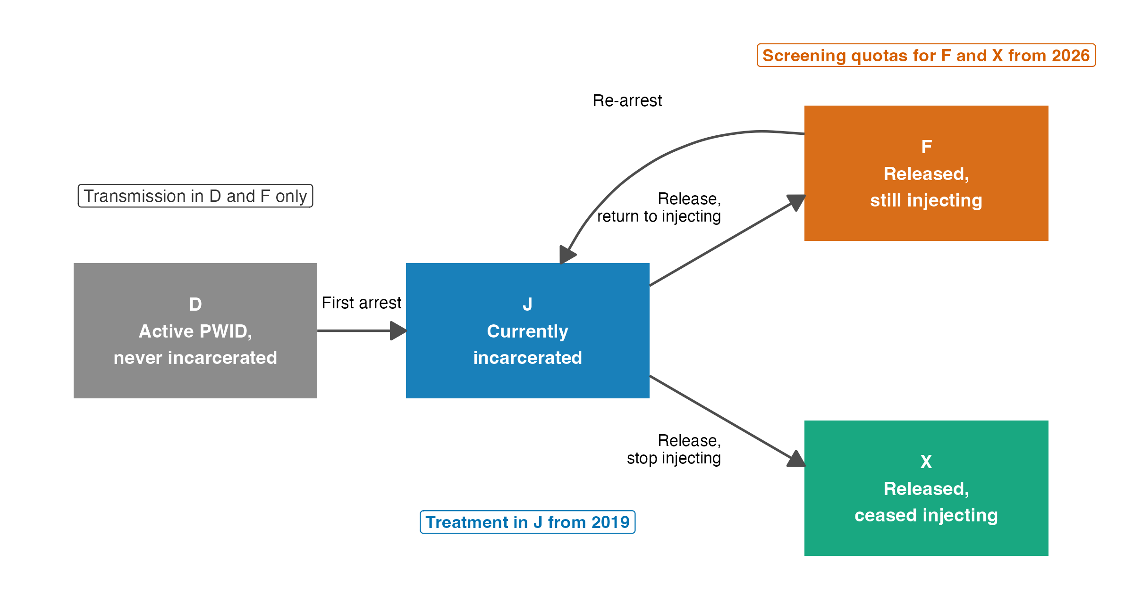
Fig 1. Model structure.
Fig 2. Annual new HCV infections and HCV deaths relative to 2015. (A) New infections, including reinfections. (B) HCV deaths from decompensated cirrhosis and liver cancer. Lines show medians and shaded bands show 95% UIs across 2,000 posterior draws. Dashed horizontal lines show the WHO targets of 20% and 35% of the 2015 level. Dotted vertical lines mark 2019 and 2026. In panel A the two lines with 8,000 tests a year overlap.
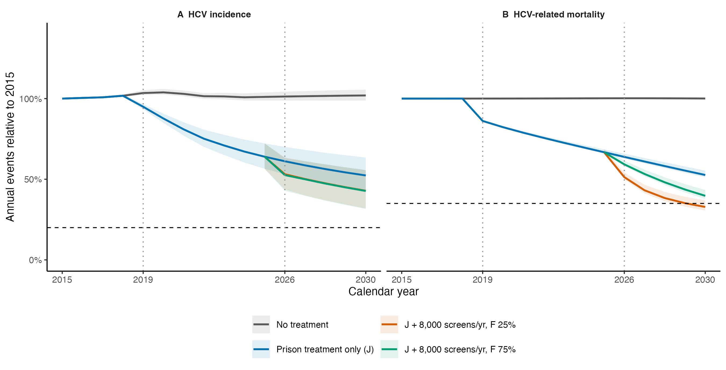
Fig 2. Annual new HCV infections and HCV deaths relative to 2015.
Fig 3. Reductions in 2030 by screening capacity and share allocated to F. (A) Incidence. (B) Mortality. Points show medians and bars show 95% UIs. Dashed lines show the 80% and 65% targets. Grey lines show the prison only scenario and the ideal reference.
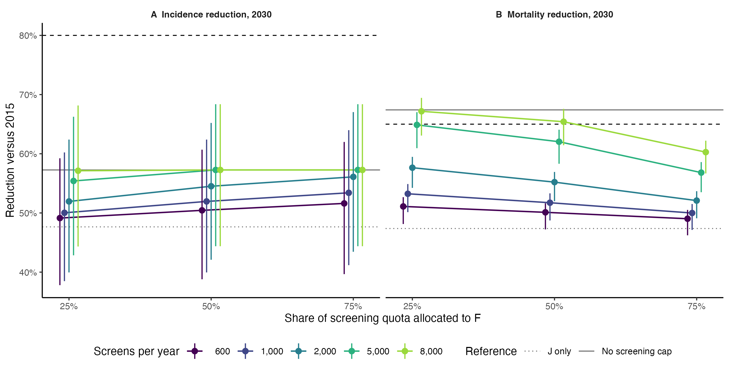
Fig 3. Reductions in 2030 by screening capacity and share allocated to F.

References
1. Pawlotsky J-M, Negro F, Aghemo A, Berenguer M, Dalgard O, Dusheiko G, et al. EASL recommendations on treatment of hepatitis C: Final update of the series. Journal of Hepatology. 2020;73: 1170–1218. doi:10.1016/j.jhep.2020.08.018
2. World Health Organization. Global health sector strategies on, respectively, HIV, viral hepatitis and sexually transmitted infections for the period 2022–2030. Geneva: World Health Organization; 2022.
3. World Health Organization. Guidance for country validation of viral hepatitis elimination and path to elimination. Geneva: World Health Organization; 2023.
4. Dore GJ, Bajis S. Hepatitis C virus elimination: laying the foundation for achieving 2030 targets. Nature Reviews Gastroenterology & Hepatology. 2021;18: 91–92. doi:10.1038/s41575-020-00392-3
5. Chaillon A, Thurairajah PH, Hsiang JC, Martin NK. What is required for achieving hepatitis C virus elimination in Singapore? A modeling study. Journal of Gastroenterology and Hepatology. 2021;36: 1110–1117. doi:10.1111/jgh.15211
6. Communicable Diseases Agency Singapore. Hepatitis C. Available: https://www.cda.gov.sg/professionals/diseases/hepatitis-c/
7. Teo AKJ, Prem K, Chen MIC, Roellin A, Wong ML, La HH, et al. Estimating the size of key populations for HIV in Singapore using the network scale-up method. Sexually Transmitted Infections. 2019;95: 602–607. doi:10.1136/sextrans-2018-053747
8. Wong YJ, Thurairajah PH, Kumar R, Fock KM, Law NM, Chong S-Y, et al. The impact of unrestricted access to direct-acting antiviral among incarcerated hepatitis C virus-infected patients. Clinical and Molecular Hepatology. 2021;27: 474–485. doi:10.3350/cmh.2021.0015
9. Tan C, Luo X, Ong BS, Lin L, Ng K. Real‐world impact of a subsidy decision of sofosbuvir–velpatasvir for treatment of chronic hepatitis C on clinical practice and patient outcomes. JGH Open. 2023;7: 48–54. doi:10.1002/jgh3.12850
10. Agency for Care Effectiveness. Direct-acting antiviral agents for treating chronic hepatitis C. Available: https://www.ace-hta.gov.sg/healthcare-professionals/ace-technology-guidance/drug-guidance/direct-acting-antiviral-agents-for-treating-chronic-hepatitis-c/
11. Ministry of Health Singapore. Speech by Mdm Rahayu Mahzam, Minister of State, MDDI and MOH, at the “Educate, Test, Treat!” MOU signing ceremony between HCSA Highpoint and TTSH. 2025. Available: https://www.moh.gov.sg/newsroom/speech-by-mdm-rahayu-mahzam--minister-of-state--mddi--and-moh--at-the--educate--test--treat-----mou-signing-ceremony-between-hcsa-highpoint-and-ttsh/
12. Ministry of Health Singapore. Opening address by Mdm Rahayu Mahzam, Minister of State, Ministry of Health, at the “Educate, Test, Treat” MOU signing ceremony between HCSA Community Services and Tzu Chi Foundation (Singapore) on Thursday, 25 July 2024. 2024. Available: https://www.moh.gov.sg/newsroom/opening-address-by-mdm-rahayu-mahzam--minister-of-state--ministry-of-health--at-the--educate--test--treat--mou-signing-ceremony-between-hcsa-community-services-and-tzu-chi-foundation-%28singapore%29-on-thursday-25-july-2024/
13. Communicable Diseases Agency Singapore. National HIV, Hepatitis C, and STI Programmes. Available: https://www.cda.gov.sg/professionals/national-hiv-hepatitis-c-and-sti-programmes/
14. Martin NK, Vickerman P, Grebely J, Hellard M, Hutchinson SJ, Lima VD, et al. Hepatitis C virus treatment for prevention among people who inject drugs: Modeling treatment scale-up in the age of direct-acting antivirals. Hepatology. 2013;58: 1598–1609. doi:10.1002/hep.26431
15. Lim AG, Qureshi H, Mahmood H, Hamid S, Davies CF, Trickey A, et al. Curbing the hepatitis C virus epidemic in Pakistan: the impact of scaling up treatment and prevention for achieving elimination. International Journal of Epidemiology. 2018;47: 550–560. doi:10.1093/ije/dyx270
16. Thein H, Yi Q, Dore GJ, Krahn MD. Estimation of stage‐specific fibrosis progression rates in chronic hepatitis C virus infection. Hepatology. 2008;48: 418–431. doi:10.1002/hep.22375
17. Morgan RL, Baack B, Smith BD, Yartel A, Pitasi M, Falck-Ytter Y. Eradication of Hepatitis C Virus Infection and the Development of Hepatocellular Carcinoma. Annals of Internal Medicine. 2013;158: 329–337. doi:10.7326/0003-4819-158-5-201303050-00005
18. Meer AJ van der, Veldt BJ, Feld JJ, Wedemeyer H, Dufour J-F, Lammert F, et al. Association Between Sustained Virological Response and All-Cause Mortality Among Patients With Chronic Hepatitis C and Advanced Hepatic Fibrosis. JAMA. 2012;308: 2584–2593. doi:10.1001/jama.2012.144878
19. Husereau D, Drummond M, Augustovski F, Bekker-Grob E de, Briggs AH, Carswell C, et al. Consolidated Health Economic Evaluation Reporting Standards 2022 (CHEERS 2022) statement: updated reporting guidance for health economic evaluations. BMJ. 2022;376: e067975. doi:10.1136/bmj-2021-067975
20. Kanwal F, Kramer JR, Ilyas J, Duan Z, El-Serag HB. HCV Genotype 3 Is Associated With an Increased Risk of Cirrhosis and Hepatocellular Cancer in a National Sample of U.S. Veterans With HCV. Hepatology. 2014;60: 98–105. doi:10.1002/hep.27095
21. Xiao J, Zhang X, Mao X, Lai S, Li S, Sheng Y. Efficacy and Safety of Velpatasvir Plus Sofosbuvir With or Without Ribavirin in Hepatitis C Patients With Decompensated Cirrhosis: A Systematic Review and Meta‐Analysis. Journal of Viral Hepatitis. 2025;32: e70078. doi:10.1111/jvh.70078
22. Mathers BM, Degenhardt L, Bucello C, Lemon J, Wiessing L, Hickman M. Mortality among people who inject drugs: a systematic review and meta-analysis. Bulletin of the World Health Organization. 2013;91: 102–123. doi:10.2471/blt.12.108282
23. Lee M-H, Yang H-I, Lu S-N, Jen C-L, You S-L, Wang L-Y, et al. Chronic hepatitis C virus infection increases mortality from hepatic and extrahepatic diseases: a community-based long-term prospective study. The Journal of Infectious Diseases. 2012;206: 469–477. doi:10.1093/infdis/jis385
24. Singapore Department of Statistics. Number of drug abusers by age group, annual. data.gov.sg; Available: https://data.gov.sg/datasets/d_f174679381e9085e32869c32bdb01b87/view
25. Haario H, Saksman E, Tamminen J. An adaptive Metropolis algorithm. Bernoulli. 2001;7: 223–242. doi:10.2307/3318737
26. Vehtari A, Gelman A, Simpson D, Carpenter B, Bürkner P-C. Rank-normalization, folding, and localization: an improved R-hat for assessing convergence of MCMC (with discussion). Bayesian Analysis. 2021;16: 667–718. doi:10.1214/20-BA1221
27. Greenberg D, Nonnenmacher M, Macke J. Automatic posterior transformation for likelihood-free inference. Proceedings of the 36th international conference on machine learning. 2019. pp. 2404–2414.
28. Tejero-Cantero A, Boelts J, Deistler M, Lueckmann J-M, Durkan C, Gonçalves P, et al. sbi: A toolkit for simulation-based inference. Journal of Open Source Software. 2020;5: 2505. doi:10.21105/joss.02505
29. Wong Y, Cheen MH, Hsiang JC, Kumar R, Tan J, Teo EK, et al. Economic evaluation of direct‐acting antivirals for the treatment of genotype 3 hepatitis C infection in Singapore. JGH Open. 2019;3: 210–216. doi:10.1002/jgh3.12139
30. Singapore Department of Statistics. Exchange rates, annual average: SGD per USD. data.gov.sg; Available: https://data.gov.sg/datasets/d_b09aeaf8eb591c4bfe347b66148c6b53/view
31. National Healthcare Group. DSC clinic charges. Available: https://www.nhghealth.com.sg/nsc/about-dsc-clinic/dsc-patient-information/dsc-services/clinic-charges/
32. Parkway Laboratories. Send-out test price list. 2025. Available: https://www.parkwaylabs.com.sg/docs/parkwaylablibraries/test-catalogues/send-out-test-price.pdf
33. Eddelbuettel D, François R. Rcpp: Seamless R and C++ Integration. Journal of Statistical Software. 2011;40: 1–18. doi:10.18637/jss.v040.i08
34. Hsiang J, Sinnaswami P, Lee M, Zhang M, Quek K, Tan K, et al. Point-of-care hepatitis C screening with direct access referral to improve linkage to care among halfway house residents: a pilot randomised study. Singapore Medical Journal. 2022;63: 86–92. doi:10.11622/smedj.2020116
35. Papaluca T, Craigie A, McDonald L, Edwards A, Winter R, Hoang A, et al. Care Navigation Increases Initiation of Hepatitis C Treatment After Release From Prison in a Prospective Randomized Controlled Trial: The C-LINK Study. Open Forum Infectious Diseases. 2022;9: ofac350. doi:10.1093/ofid/ofac350
36. Eckhardt B, Mateu-Gelabert P, Aponte-Melendez Y, Fong C, Kapadia S, Smith M, et al. Accessible Hepatitis C Care for People Who Inject Drugs. JAMA Internal Medicine. 2022;182: 494–502. doi:10.1001/jamainternmed.2022.0170

