**Wire-Frame Design**

**STORE SALES PREDICTION**

| Written By | Raghav Kachroo |
| --- | --- |
| Document Version | 1.0 |
| Last Revised Date | 04-Jan-2022 |

**Document Change Control Record**

| **Version** | **Date** | **Author** | **Comments** |
| --- | --- | --- | --- |
|  |  |  |  |
|  |  |  |  |
|  |  |  |  |
|  |  |  |  |
|  |  |  |  |
|  |  |  |  |
|  |  |  |  |
|  |  |  |  |
|  |  |  |  |
|  |  |  |  |
|  |  |  |  |
|  |  |  |  |
|  |  |  |  |
|  |  |  |  |
|  |  |  |  |
|  |  |  |  |

**HOME PAGE**

On the homepage the user will be able to see the heading of the project name and there will be inputs which the user needs to give.

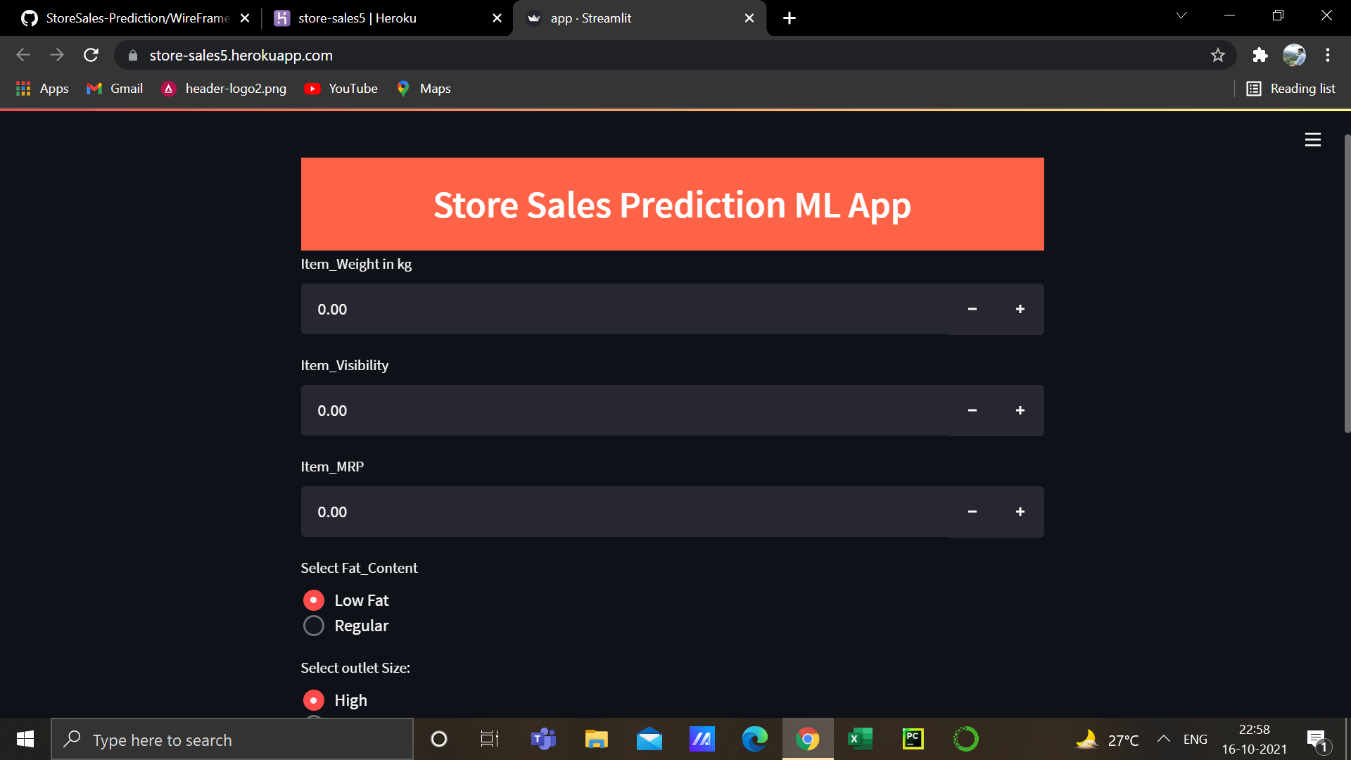

After the user will give inputs there will be a predict button, on clicking the predict button the Output will be shown in the same page. Below is the image how the result will look like:

