LOANS AT RISK: CAPTURING DEFAULT
  - 2026 | J.J.A. Knoest


TABLE OF CONTENTS
- Introduction & Project Background
- Executive Summary
- Data & Constraints
- Loan Portfolio Dynamics
- Model Performance
- Risk Structure
- Decision Analysis
- Economic Interpretation
- Conclusion
- References

INTRODUCTION & PROJECT BACKGROUND
Lending decisions require committing capital under uncertainty using information that is incomplete by construction. At the moment of application, the lender observes a limited snapshot of the borrower—income, credit history, current obligations—while the true outcome unfolds over time. The practical question is not whether risk can be predicted in theory, but whether this limited information can be structured in a way that improves how capital is allocated in practice.
This project evaluates that question using historical data from LendingClub, a U.S.-based consumer lending platform. LendingClub operated as an intermediary between borrowers and investors, assigning internal risk grades that determined both pricing and how capital was distributed across loans. The grading system therefore functioned as a decision mechanism under uncertainty, not just a descriptive label.
The analysis does not redesign the underwriting process. It uses the same information that was available at application submission and evaluates whether that information can be used more effectively. Only borrower-level information available at application submission is used. No post-origination behavior, servicing data, or pricing outcomes are allowed to enter the feature space. This restriction is structural. It defines the maximum amount of information any model can use and therefore sets the upper bound on achievable performance.
The dataset reflects realized lending decisions rather than a full applicant population. Only issued loans are observed, and rejected applications are not available. As a result, the evaluation is conducted within LendingClub’s historical acceptance boundary. The question is therefore not whether better decisions could be made across all applicants, but whether the same set of accepted loans could have been allocated more effectively.
Two systems are compared. The first is LendingClub’s internal grading framework, which represents the platform’s original risk ordering. The second is a data-driven model trained on the same submission-time information. The comparison is not framed as a competition in predictive accuracy alone. It is framed as a decision problem: whether differences in risk ordering translate into different acceptance choices and, ultimately, different portfolio outcomes.
This introduces a necessary constraint on interpretation. Because rejected loans are not observed and a full economic model is not constructed, results are evaluated using a controlled proxy framework. Predictions are linked back to individual loans and assessed in terms of loss exposure and missed opportunity. These results reflect relative differences in capital allocation, not complete measures of profitability.
The objective of the analysis is therefore narrow and explicit. Given a fixed information set and a fixed population of issued loans, can risk be organized in a way that leads to better lending decisions—and where does that improvement actually exist?

EXECUTIVE SUMMARY
Default risk can be predicted using application-time information, but separation between good and bad loans is limited. A CatBoost model improves risk ranking relative to LendingClub’s grading system (AUC ~0.72 vs ~0.69), but this improvement does not translate uniformly across the portfolio.
The model does not introduce new information. It produces a more consistent ordering of existing borrower characteristics. As a result, its impact depends on where decisions are made.
Three operating regimes emerge. At low acceptance levels (~35–40%), both strategies produce negative outcomes. The model reduces loss exposure by approximately $27 million, but does not create profitability. At high acceptance levels (>85%), most borrowers are accepted and differences between systems diminish.
The main impact appears in the mid-range (~65–85% acceptance). In this region, borrower risk is less clearly separated and decisions are sensitive to ranking. The model improves allocation outcomes by approximately $11–15 million by reducing default exposure while retaining more performing loans.
The implication is that the model improves how risk is ordered, not what is known. Its value depends on how the decision threshold is set. This makes the problem primarily one of policy rather than modeling.

DATA & CONSTRAINTS
The analysis is conducted on historical LendingClub loan data containing borrower characteristics, loan attributes, and realized repayment outcomes. The dataset reflects actual lending decisions rather than a constructed sample. This distinction matters. The data does not represent the full applicant pool. It represents the subset of borrowers that LendingClub chose to approve and fund.
This introduces the first structural constraint. Rejected applications are not observed and do not have realized outcomes. The evaluation therefore operates entirely within the platform’s historical acceptance boundary. Any improvement identified in this analysis is conditional on that boundary. The results show whether the same set of accepted loans could have been allocated more effectively, not whether the overall approval strategy was optimal.
The second constraint is the prediction boundary. All variables are restricted to information available at the moment of application submission. This includes borrower-declared attributes and credit bureau data retrieved at that point in time. Variables determined after submission—such as funding outcomes, pricing decisions, servicing behavior, or repayment dynamics—are explicitly excluded. This prevents information leakage and ensures that the model operates under the same informational conditions as the original underwriting decision.
This boundary defines the maximum amount of usable signal. The model cannot learn from information that was not observable at origination. Any remaining prediction error must therefore be interpreted as a consequence of limited information rather than insufficient modeling.
The dataset is structured using a temporal split. Loans issued between 2007 and 2014 are used for training, while loans issued in 2015 are used for testing. This preserves a forward-looking evaluation design and reflects how a model trained on historical data would perform on a new lending period. The temporal structure of the dataset is stable, with issuance volume increasing over time while default rates remain broadly consistent. This supports the use of a single out-of-sample test period without introducing structural breaks in the underlying process.
The modeling population is further restricted to loans with terminal outcomes. Loans in active or intermediate states are excluded because their final repayment behavior is not yet observed. The remaining population contains loans that are either fully repaid or defaulted, allowing the prediction target to be defined unambiguously. This removes label uncertainty but introduces a trade-off: the analysis focuses on realized outcomes rather than time-to-event dynamics.
A number of variables exhibit systematic missingness across vintages. In particular, several balance-related fields are partially missing in earlier years but fully populated in later periods. This pattern reflects changes in LendingClub’s reporting practices rather than borrower behavior. Treating these missing values as risk indicators would introduce an artificial signal driven by reporting changes rather than borrower behavior. To avoid this, missingness is explicitly modeled as a reporting indicator, separating data availability from economic meaning.
Feature governance follows directly from these constraints. Variables not available at application are removed to prevent leakage. LendingClub outputs such as grade and interest rate are retained only as benchmarks and are not used as predictors. Geographic variables are excluded to reduce the risk of proxy discrimination. Credit-event timing variables are preserved by encoding structural absence separately from observed events, ensuring that missing values are not misinterpreted as data loss.
Finally, the economic evaluation is conducted using a constrained proxy framework. Predictions are mapped back to individual loans and evaluated in terms of two outcomes: accepted defaults, which represent loss exposure, and rejected performing loans, which represent missed opportunity. Loan amounts are used to approximate the magnitude of these effects. This framework does not model interest income, recoveries, funding costs, or cash-flow timing. It is designed to compare relative allocation outcomes without introducing additional assumptions.
Taken together, these constraints define the scope of the analysis. The model operates on a fixed information set, within a fixed population, and is evaluated using a simplified but controlled economic lens. The results should therefore be interpreted as improvements in how risk is organized and acted upon within these boundaries, not as a complete representation of lending performance.

LOAN PORTFOLIO DYNAMICS
Before evaluating models or decisions, it is necessary to understand how the loan portfolio behaves over time. The dataset is not a static sample. It reflects an evolving platform where loan volume, reporting practices, and borrower composition change across vintages. If these dynamics are unstable, any comparison between model and baseline becomes unreliable.
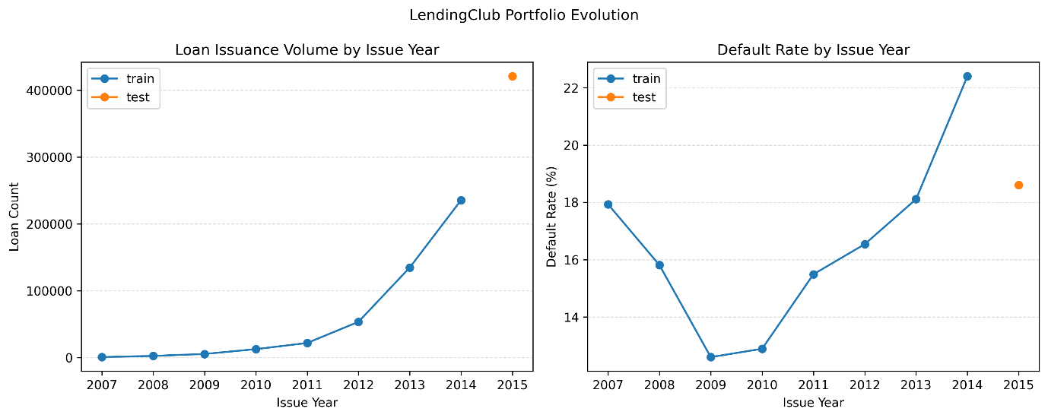
The issuance pattern shows a clear expansion of the platform. Loan volume increases substantially from the early years to the later vintages. This growth is expected for a scaling marketplace, but it introduces a potential risk: changes in volume could be accompanied by changes in borrower quality or underwriting standards. If that were the case, a model trained on earlier data would not generalize to later periods.
The default rate provides the relevant anchor. Despite the increase in issuance, default rates remain broadly stable across vintages once the modeling population is restricted to loans with realized outcomes. This indicates that the underlying risk profile of accepted borrowers does not shift materially over time. The platform scales, but it does not appear to systematically move into a higher- or lower-risk segment. This stability supports the use of a temporal split, where models are trained on earlier cohorts and evaluated on a later period without introducing a structural mismatch.
A second dynamic emerges in the data through reporting behavior. Several balance-related variables show systematic missingness in earlier vintages but become consistently populated in later years. This pattern does not align with borrower behavior. It aligns with changes in reporting coverage. Treating these variables naively would cause the model to use missing-ness as a proxy for time. Earlier vintages contain more missing values due to changes in reporting coverage, so missingness would be interpreted as risk rather than as a data artifact. This is addressed by splitting each variable into an availability indicator and a value com-ponent, with missing values replaced by a constant placeholder. This ensures that the model separates reporting availability from borrower characteristics instead of conflating the two.
The dataset also reveals that underwriting is not strictly deterministic. A small subset of loans is labeled as not meeting LendingClub’s own credit policy but is funded regardless. These observations are limited in number, but they are informative. They show that the acceptance boundary is not perfectly enforced and that decisions at the margin involve discretion. From a modeling perspective, these loans are not noise. They represent realized decisions with outcomes and therefore form part of the environment the model is expected to operate in.
Taken together, these dynamics define the structure within which the analysis operates. The portfolio expands over time, but the risk profile remains broadly stable. Reporting practices change, but these changes can be separated from borrower information. The acceptance boundary is mostly consistent, but not rigid. These conditions are sufficient to support a forward-looking evaluation while maintaining interpretability of results.
The implication is that differences observed between the model and the baseline can be attributed to differences in risk ordering rather than to shifts in the underlying data-generating process. The portfolio is not static, but it is stable enough for the comparison to be meaningful.

MODEL PERFORMANCE
Model performance is evaluated in terms of how well default risk can be ordered using application-time information. The objective is not to maximize classification accuracy at a fixed threshold, but to determine whether borrowers who eventually default are systematically ranked above those who do not. This distinction matters because lending decisions are threshold-based. A model is useful only if its ranking translates into different acceptance choices.
Three model classes are evaluated that represent established and increasingly adopted approaches in credit risk modeling. Logistic Regression serves as a baseline due to its widespread use in traditional credit scoring and its interpretability (Thomas et al., 2017). Random Forest introduces nonlinear structure and interaction effects through ensemble learning (Breiman, 2001), while CatBoost represents a more flexible gradient boosting approach designed to capture complex patterns in tabular data (Prokhorenkova et al., 2018). Together, these models provide increasing levels of flexibility within a consistent modeling framework.
Each model is trained on the same application-time feature set under a consistent preprocessing pipeline. This ensures that differences in performance reflect differences in model capacity rather than differences in input data. Variations in preprocessing, such as log transformations for skewed variables and categorical encoding strategies, are applied systematically and evaluated across models to assess whether representation limits performance.
Across all model classes, default risk is meaningfully predictable. Logistic Regression provides a stable baseline, while Random Forest and CatBoost introduce nonlinear structure and interaction effects. Moving from a linear model to more flexible tree-based models does improve ranking performance, with CatBoost achieving the strongest results.
The best-performing configuration is the CatBoost model trained on the shared preprocessing pipeline with log-transformed features and hyperparameter tuning. This model slightly outperforms the native CatBoost variant, indicating that preprocessing contributes at the margin. It also outperforms LendingClub’s subgrade-based risk ordering, demonstrating that borrower-level information can be organized more effectively than the platform’s internal segmentation. The increase in AUC from approximately 0.69 to 0.72 reflects improved separation, but not a structural change in predictability.
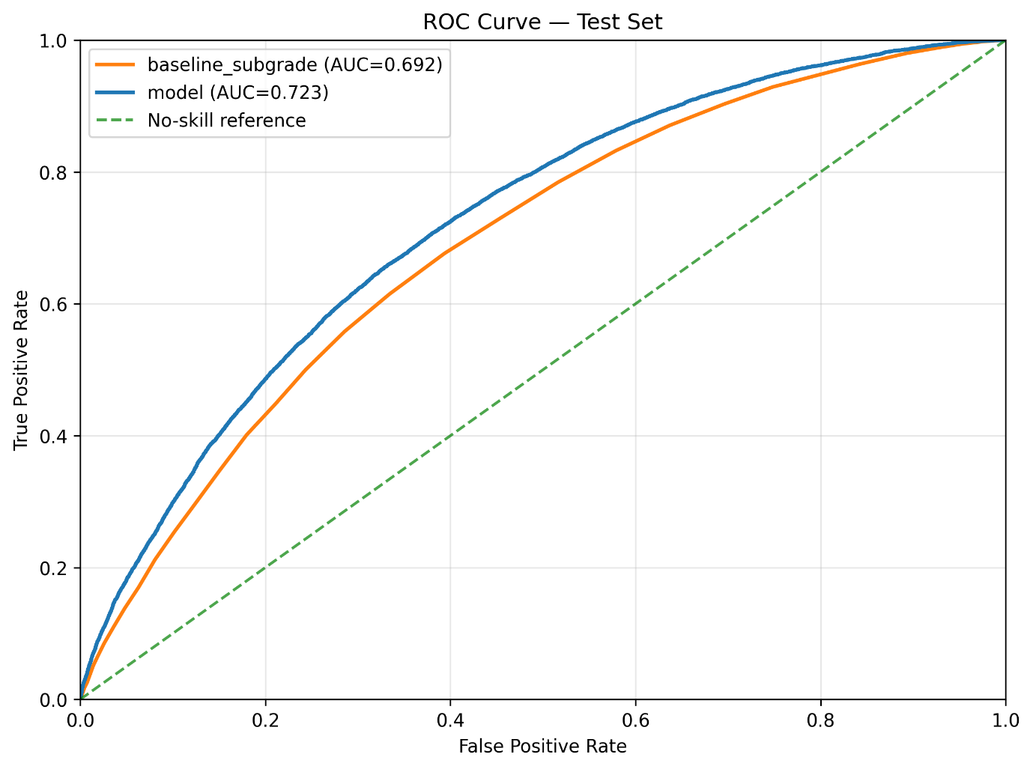

This pattern is consistent across evaluation metrics. More flexible models reduce false negatives, but this comes with corresponding changes in false positives depending on the threshold. The improvement shifts the balance between error types rather than eliminating them.
Preprocessing variations lead to the same conclusion. Transformations such as numeric log scaling or alternative categorical handling do not materially change model ranking. Performance differences across these configurations are small and do not alter the relative ordering of models. This indicates that the current feature set already captures most of the available signal. The limitation lies in the information itself rather than in how it is represented.
Prediction errors reinforce this interpretation. Missed defaults are not concentrated in a specific borrower segment that could be isolated through additional feature engineering. Instead, they remain spread across similar borrower profiles. This suggests that remaining errors reflect uncertainty that is not observable at application rather than a correctable modeling gap.
These observations are consistent with established results in statistical learning. As model flexibility increases, performance improvements tend to diminish once the available signal has been extracted. Additional complexity refines the fit but does not materially reduce error when the underlying information is limited. This behavior reflects the presence of irreducible error in the data-generating process, which cannot be eliminated through further modeling or feature engineering (Hastie et al., 2009; Ng, 2000).
From a practical perspective, model performance cannot be evaluated in isolation. Two models with similar ranking performance can produce different decision outcomes depending on how predictions are distributed around the acceptance threshold. A modest improvement in ordering can still lead to materially different decisions if it changes which loans cross that boundary.
Model selection therefore reflects decision impact rather than metric maximization. The CatBoost shared configuration is preferred because it reduces default exposure without rejecting a disproportionate share of performing loans. The native CatBoost variant achieves slightly stronger separation, but at the cost of rejecting more good loans, resulting in a less favorable trade-off.
Further optimization confirms the same boundary. Hyperparameter tuning produces incremental improvements but does not change the structure of results. Weighting the model toward larger loans shifts the objective but does not improve the overall balance of outcomes. These adjustments refine the model but do not extend its capability.
The conclusion is that model performance is bounded by the information available at application. More flexible models improve risk ordering, but the gains are gradual and do not reveal a large reserve of unused signal. The model can rank borrowers more effectively than the baseline, but it cannot achieve precise separation. Its role is therefore to provide a better ordering of risk, with the impact determined by how that ordering is used in decision-making.
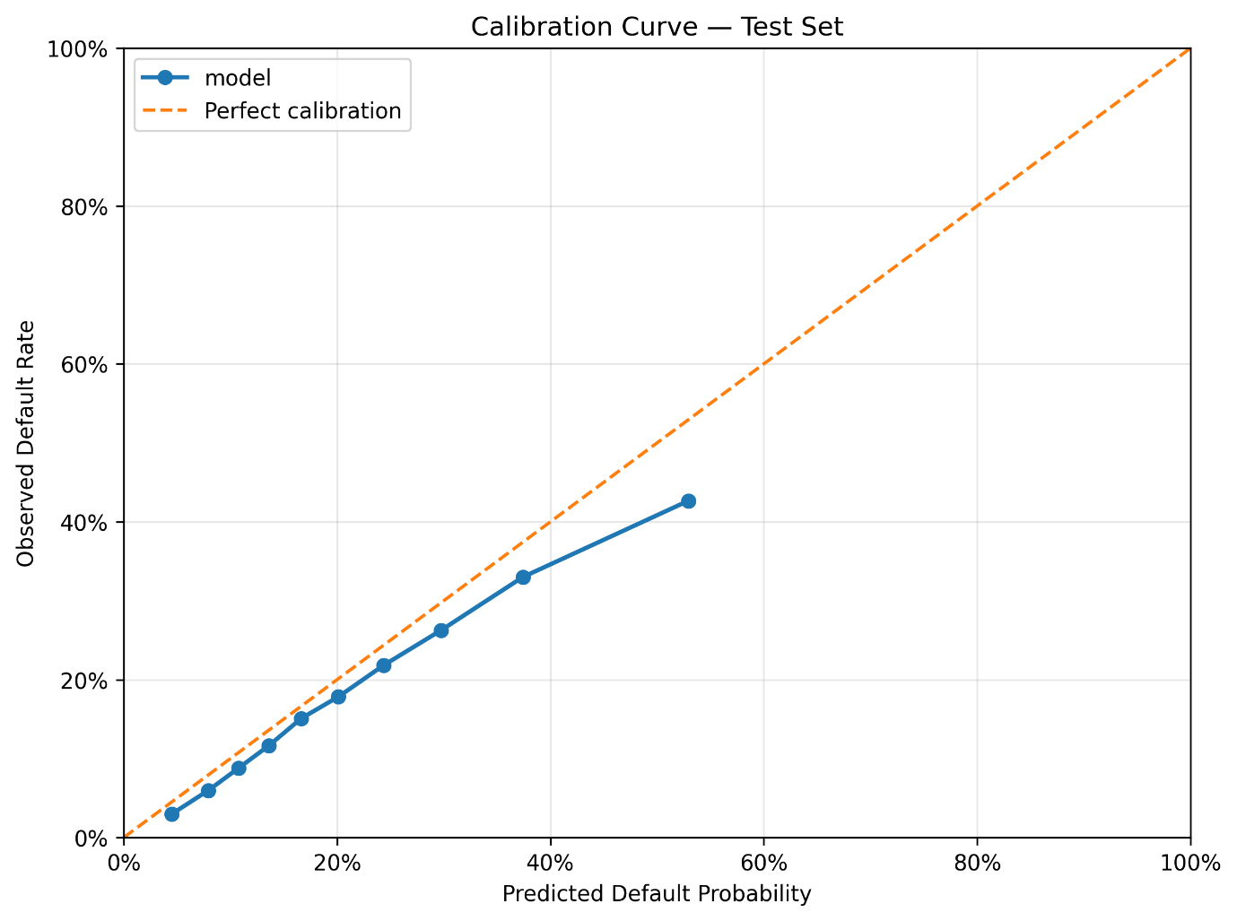

The selected model reduces default exposure without materially increasing the rejection of performing loans. Further optimization produces only incremental improvements and does not change this balance.

RISK STRUCTURE
Model performance establishes that risk can be ranked, but it does not explain how that risk is distributed across the portfolio. For decision-making, the structure of that distribution matters more than the aggregate metric. The relevant question is not whether one model has a higher AUC, but how borrowers are positioned relative to each other and where differences between systems actually occur.
At a broad level, both LendingClub’s grading system and the model capture the same underlying ordering. Higher-risk borrowers are associated with higher observed default rates, and lower-risk borrowers with lower default rates. This consistency is expected. Both systems operate on the same application-time information, and both reflect the same economic drivers of default risk.
The difference appears in how that information is organized. LendingClub’s grading system groups borrowers into discrete categories. Within these categories, particularly at the subgrade level, there is still meaningful variation in default outcomes. Borrowers with similar assigned grades do not exhibit identical risk, indicating that the grading system does not fully resolve differences within groups.
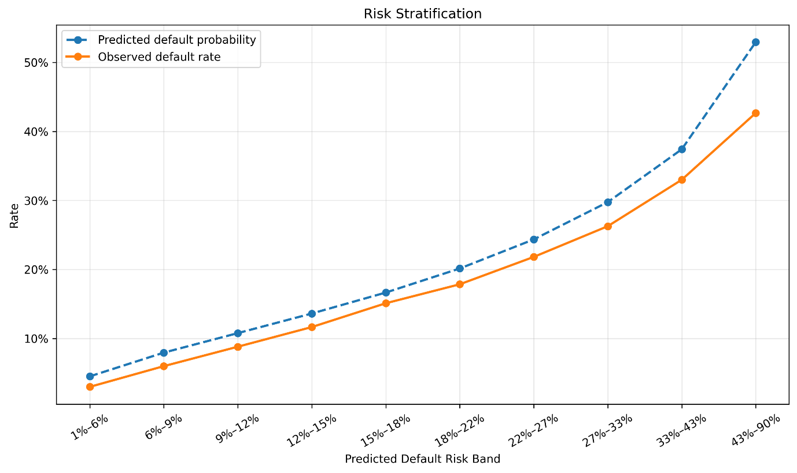
The model produces a continuous risk score. This allows it to differentiate borrowers within the same grade or subgrade, effectively redistributing them along a finer risk spectrum.
The result is not a different set of borrowers, but a different ordering of the same borrowers. Some loans that appear similar under the grading system are separated by the model, while others remain close together.
This distinction is most relevant in the mid-risk region. At the low-risk end, both systems agree on borrower quality. These loans have low default rates and are consistently identified as safe. At the high-risk end, the same pattern holds in reverse. Both systems identify these loans as risky, and the differences in ordering have limited practical impact.
In the middle of the distribution, however, the situation changes. Borrowers in this region exhibit overlapping characteristics and intermediate default rates. LendingClub’s grading system places many of these loans into the same categories, while the model spreads them across a wider range of predicted risk. This creates separation where the baseline groups remain coarse.
From a structural perspective, this is where the model adds value. It does not alter the extremes of the distribution, but it reshapes the density of borrowers in the central region. Loans that are close to the decision boundary are repositioned relative to each other, which directly affects which loans fall above or below a given acceptance threshold.
This redistribution also clarifies the limits of the model. Even with a continuous risk score, the model does not produce clear clusters of safe and unsafe loans. The distribution remains continuous, with substantial overlap between defaulting and non-defaulting borrowers. This reinforces the earlier conclusion that uncertainty is structural rather than a result of insufficient modeling.
The implication is that improvements in risk ordering translate into decision impact only where the ordering changes relative positions near the threshold. Outside that region, where borrowers are already clearly classified as low or high risk, additional precision has little effect. The model’s contribution is therefore localized. It refines the structure of risk where it is most ambiguous, but does not redefine it across the entire portfolio.
This framing shifts the interpretation of model improvement. The relevant outcome is not a global increase in predictive accuracy, but a change in how borrowers are distributed around the decision boundary. The model’s value lies in that redistribution, and its limitations follow directly from the fact that the underlying risk structure remains continuous and only partially observable.

DECISION ANALYSIS
Model performance and risk structure establish that borrowers can be ranked, but decisions are not made on rankings alone. Lending requires a binary action: accept or reject. This action is determined by a threshold applied to the predicted risk. The choice of this threshold defines the operating policy of the lender.
Each threshold produces a different combination of outcomes. Lower thresholds accept more loans, increasing lending volume but also allowing more defaults to pass through. Higher thresholds restrict lending, reducing default exposure at the cost of rejecting more performing loans. There is no threshold that eliminates both types of error. The decision is therefore not about finding an optimal prediction, but about selecting a trade-off.
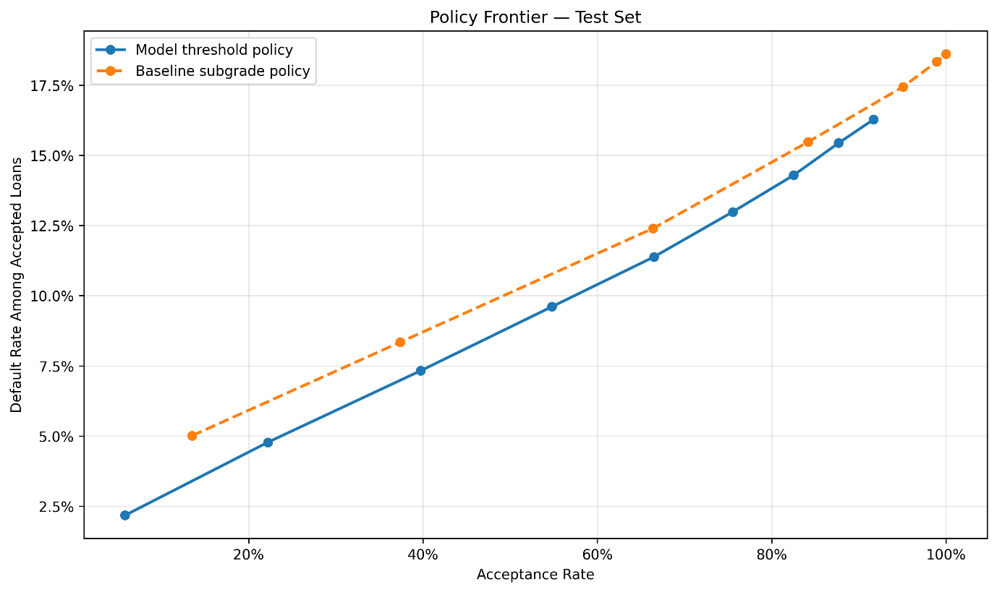
This trade-off can be expressed in terms of two error types. A false negative occurs when a defaulting loan is accepted, resulting in a realized loss. A false positive occurs when a performing loan is rejected, resulting in missed opportunity. These errors move in opposite directions as the threshold changes. Reducing one necessarily increases the other.
The model changes how this trade-off can be managed. Because it provides a more refined ordering of borrowers, it allows the threshold to be applied more selectively. The effect is not uniform across all thresholds. At very low thresholds, most borrowers are accepted regardless of ranking. Both the model and the baseline allow a large volume of defaults, and outcomes are negative. The model reduces losses by rejecting some high-risk loans, but it does not change the overall result.
At very high thresholds, most borrowers are rejected. Default exposure decreases, but so does lending volume. In this region, the difference between systems narrows because both reject a large share of borrowers. Improved ranking has limited room to influence decisions.
The impact of the model emerges in the mid-range of thresholds. This is where borrowers are densely distributed and where small changes in ranking shift loans across the acceptance boundary. In this region, the model reduces false negatives by excluding more defaulting loans while retaining a larger share of performing loans compared to the baseline. The result is a more favorable balance between loss avoidance and lending opportunity.
This behavior reflects the structure of the risk distribution. In the mid-risk region, borrowers have similar observable characteristics but different outcomes. LendingClub’s grading system groups many of these borrowers together, while the model spreads them across a continuous scale. When the threshold is applied, this difference in ordering determines which loans are accepted and which are rejected.
The decision analysis therefore shows that the value of the model is conditional. It depends on where the threshold is set. The same model can produce materially different outcomes under different policies. A model that appears stronger in aggregate metrics does not guarantee better decisions if the threshold is not aligned with the desired trade-off.
This leads to a shift in interpretation. The model should not be viewed as a tool that produces a single best decision. It is a mechanism that enables control over the decision boundary. It allows the lender to adjust risk tolerance and observe the resulting changes in outcomes.
The constraint remains that uncertainty cannot be removed. Even in the mid-risk region, the model does not perfectly separate borrowers. Some defaults will be accepted and some performing loans will be rejected under any threshold. The role of the model is to manage this uncertainty more effectively, not to eliminate it.
The conclusion is that decision quality is determined by the interaction between risk ordering and threshold selection. The model improves the ordering, but the outcome depends on how that ordering is used. Improvements in lending performance therefore require explicit policy choices about acceptable levels of loss and missed opportunity, rather than further increases in model complexity.

ECONOMIC INTERPRETATION
The decision analysis defines how errors change across thresholds, but it does not indicate how large those errors are in practical terms. In lending, the impact of a mistake depends on the size of the loan. A false negative on a large loan carries more consequence than multiple errors on smaller exposures. For this reason, model outcomes are evaluated not only in counts, but in terms of the loan amounts attached to each decision.
The analysis uses a constrained economic proxy. Each predicted outcome is mapped back to the original loan and aggregated by total principal. Accepted defaults represent loss exposure. Rejected performing loans represent missed opportunity. This framework does not attempt to estimate full profitability. Interest income, recovery rates, funding costs, and timing of cash flows are not modeled. The objective is to compare how different decision rules redistribute exposure across these two outcomes without introducing additional assumptions.
Under this framework, the same pattern observed in the decision analysis remains visible, but becomes more concrete. At low acceptance levels, both the model and the baseline produce negative outcomes. The model reduces loss exposure by rejecting more high-risk loans, but the overall result remains unfavorable because a large share of capital is not deployed.
At high acceptance levels, most loans are approved. Loss exposure increases, but the difference between systems becomes small because both accept a similar set of borrowers. Improved ranking has limited economic impact when the decision boundary is not restrictive.
The economic effect of the model is concentrated in the mid-range. In this region, the model reduces exposure to defaulting loans while preserving a larger volume of performing loans relative to the baseline. The result is a shift in the balance between loss and opportunity that is visible in aggregated loan amounts. Improvements on the order of tens of millions in exposure can be observed, depending on the chosen threshold.

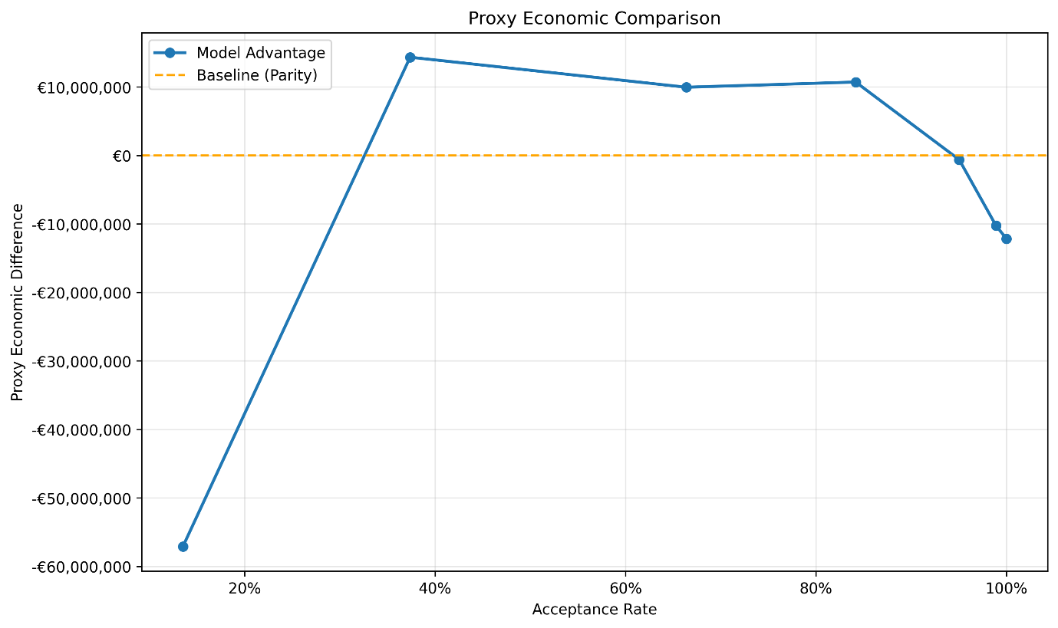
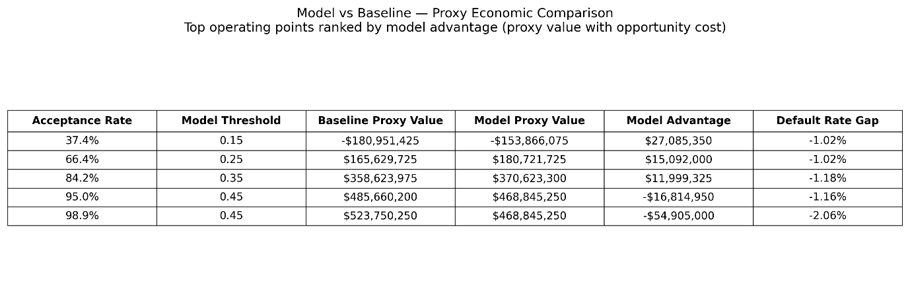
This concentration of value follows directly from the structure of the portfolio. Larger volumes of capital are allocated in the mid-risk region, where borrower density is highest and uncertainty is greatest. Small improvements in ranking in this region therefore translate into larger changes in exposure than similar improvements at the extremes.
The comparison between model variants reinforces the same conclusion. The CatBoost native configuration reduces false negative exposure slightly more than the shared configuration, but at the cost of rejecting a materially larger volume of performing loans. The net effect is not an improvement in the economic balance. The preferred model is therefore not the one that minimizes a single type of error, but the one that produces the most balanced allocation of capital across outcomes.
This result highlights a limitation of purely statistical evaluation. A model that appears stronger based on ranking metrics alone does not necessarily produce better economic outcomes. The distribution of errors across loan sizes matters, and different models can shift this distribution in ways that are not captured by aggregate metrics.
The proxy framework also imposes a boundary on interpretation. Because full cash-flow dynamics are not modeled, the analysis cannot determine absolute profitability or optimal acceptance rates. It evaluates relative differences in exposure under different decision rules. The results indicate whether one approach allocates capital more effectively than another, but not whether the resulting portfolio is profitable in an absolute sense.
The implication is that economic value in this setting is conditional. It depends on how risk is distributed, how thresholds are set, and how errors are weighted in terms of exposure. The model provides a mechanism to influence this distribution, but it does not change the underlying economics of lending. Losses remain possible, and opportunity costs remain unavoidable.
The conclusion is consistent with the earlier sections. The model improves how existing information is translated into decisions. Its economic value is real, but localized and bounded. It does not create profitability on its own. It enables more efficient allocation of capital within the limits imposed by the available information and the chosen decision policy.

CONCLUSION
This analysis evaluates whether borrower-level information available at application submission can be used to improve lending decisions. The results show that default risk is meaningfully predictable, but not to a level that supports precise separation between good and bad loans. The model improves risk ordering relative to LendingClub’s grading system, but operates within a fixed information ceiling.
The improvement is therefore structural in form, but limited in scope. The model does not introduce new information. It reorganizes existing borrower data into a more consistent ranking of risk. As a result, its impact is not uniform across the portfolio. It is concentrated in the mid-risk region, where borrower characteristics overlap and decisions are most sensitive to ordering. In this region, improved ranking leads to a more favorable balance between loss exposure and lending opportunity.
Outside this region, the effect is limited. At low acceptance levels, both the model and the baseline produce negative outcomes, and the model mainly reduces losses without changing the overall result. At high acceptance levels, most loans are approved, and differences between systems diminish. Improved ranking has little effect when decisions are not selective.
The economic interpretation reinforces the same conclusion. The model shifts how capital is allocated across loans, reducing exposure to defaulting borrowers while preserving more performing loans in the region where decisions are marginal. These improvements are meaningful, but they do not change the underlying economics of lending. The analysis is based on a constrained proxy framework and should be interpreted as a comparison of relative allocation outcomes rather than absolute profitability.
The key limitation is informational. Performance gains across model classes are not structural, and more complex models do not uncover materially more predictive signal. Remaining prediction error reflects factors that are not observable at application, rather than deficiencies in model design. This places a clear boundary on what can be achieved through modeling alone.
The central implication is that this is not primarily a modeling problem. The model provides a better ordering of risk, but its value depends on how that ordering is used. Lending outcomes are determined by the interaction between risk ranking and threshold selection. Different thresholds produce different balances between accepted defaults and rejected performing loans, and no single choice eliminates this trade-off.
Improving lending performance therefore requires changes in decision policy rather than further increases in model complexity. The model enables more precise control over the decision boundary, but it does not remove uncertainty. Its role is to support better allocation under constraint, not to replace the need for explicit choices about risk tolerance and capital deployment.

REFERENCES
Breiman, Leo. 2001. “Random Forests.” Machine Learning 45: 5–32.
Grinsztajn, Léo, Edouard Oyallon, and Gaël Varoquaux. 2022. “Why Do Tree-Based Models Still Outperform Deep Learning on Tabular Data?” In Advances in Neural Information Processing Systems (NeurIPS).
Harrell, Frank E. 2015. Regression Modeling Strategies. 2nd ed. Springer.
Hastie, Trevor, Robert Tibshirani, and Jerome Friedman. 2009. The Elements of Statistical Learning. 2nd ed. Springer.
LendingClub. n.d. LendingClub Loan Data Dictionary and Loan Statistics Dataset.
Ng, Andrew Y. 2000. “Model Complexity, Goodness of Fit and Diminishing Returns.” In Advances in Neural Information Processing Systems (NeurIPS).
Peduzzi, Peter, John Concato, Elizabeth Kemper, Theodore R. Holford, and Alvan R. Feinstein. 1996. “A Simulation Study of the Number of Events per Variable in Logistic Regression Analysis.” Journal of Clinical Epidemiology 49 (12): 1373–79.
Prokhorenkova, Liudmila, Gleb Gusev, Aleksandr Vorobev, Anna Veronika Dorogush, and Andrey Gulin. 2018. “CatBoost: Unbiased Boosting with Categorical Features.” In Advances in Neural Information Processing Systems (NeurIPS).
Seven Pillars Institute. 2019. “Peer-to-Peer Lending: Lending Club.”
Thomas, Lyn C., David B. Edelman, and Jonathan N. Crook. 2017. Credit Scoring and Its Applications. 2nd ed. SIAM.
Vittinghoff, Eric, and Charles E. McCulloch. 2007. “Relaxing the Rule of Ten Events per Variable in Logistic and Cox Regression.” American Journal of Epidemiology 165 (6): 710–18.

