# Okay so some interesting results just looking at the charts it is clear through cards like prized amalgam that the video vector on 2023/09/25 has some effect on the market. There is a few thing we will have to take into account for the cards we want to look more closely at e.g. card type lands don’t seem to have been positively affected by the vector, Volumn finding the cards with lowest volumn and the lowest trade velocity(not sure if that’s a term) will allow us to taget the cards most likely to increase in value

# Conflagrate [TSP].csv

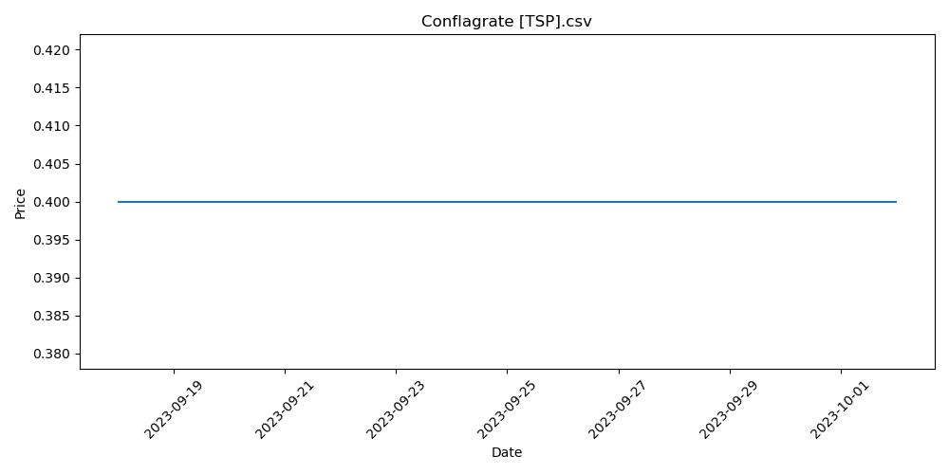

# City of Brass [MMA].csv

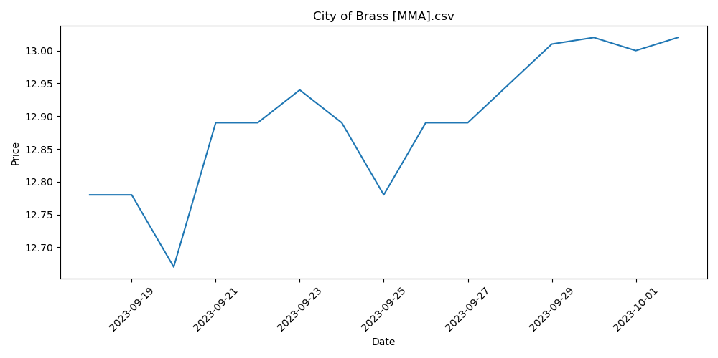

# Thrilling Discovery [STX].csv

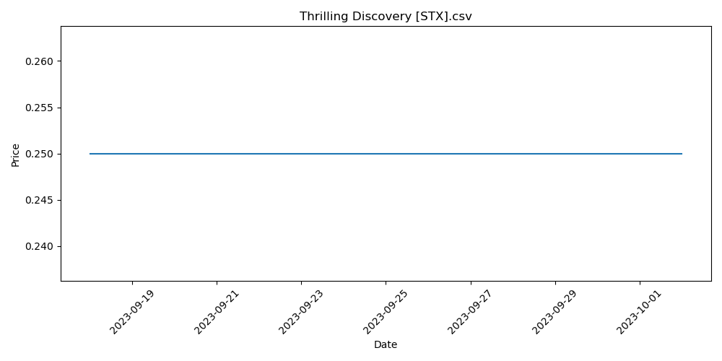

# Stinkweed Imp [MMA] (F).csv

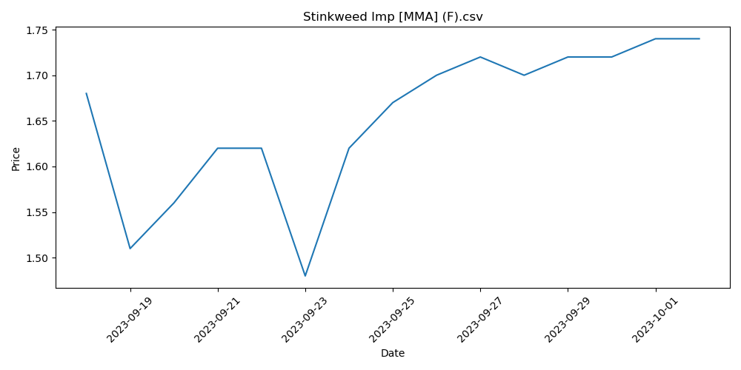

# Merchant of the Vale [ELD].csv

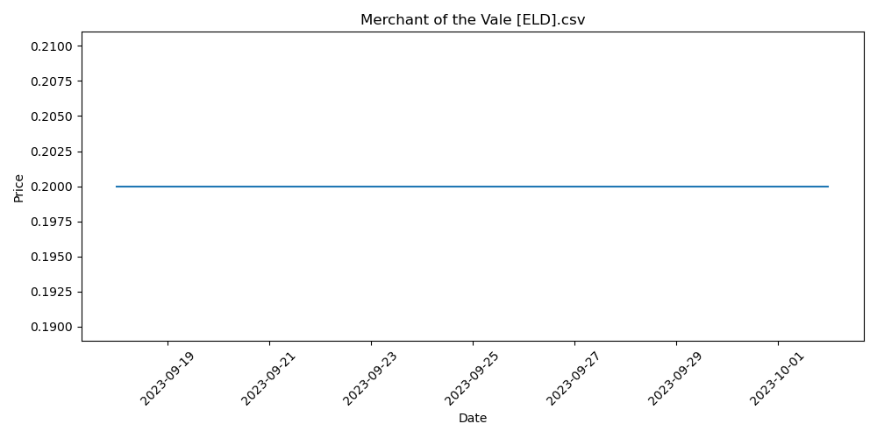

# Duress [XLN] (F).csv

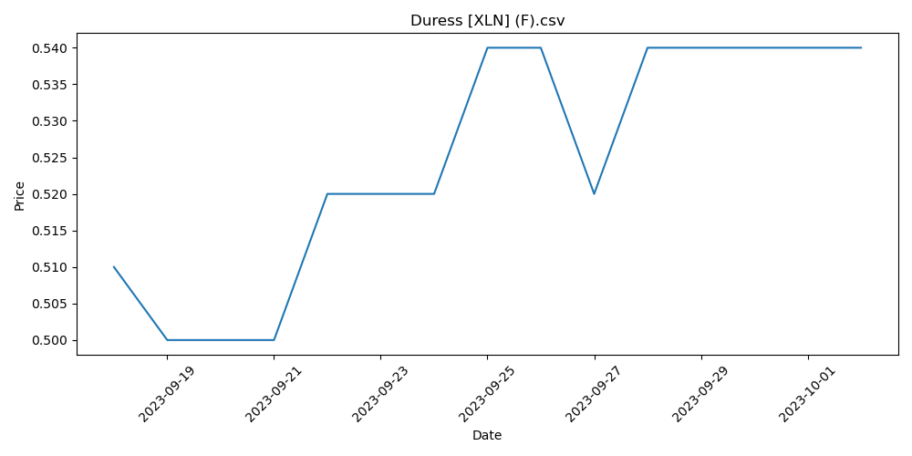

# Ancient Grudge [ISD].csv

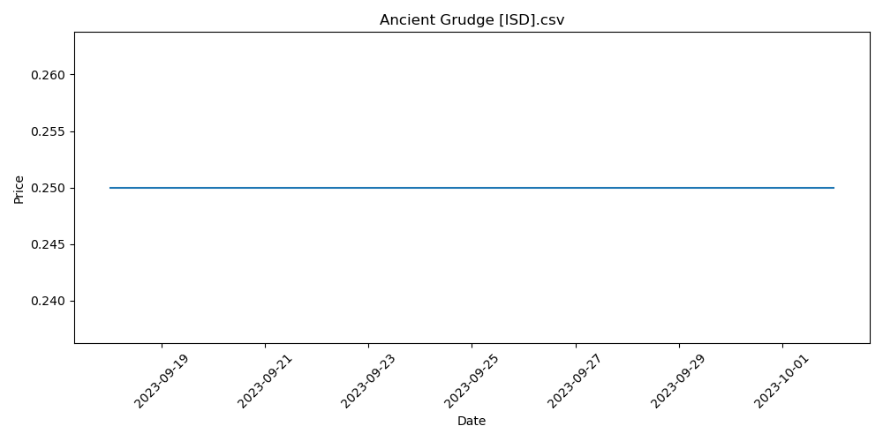

# Stern Dismissal [THB].csv

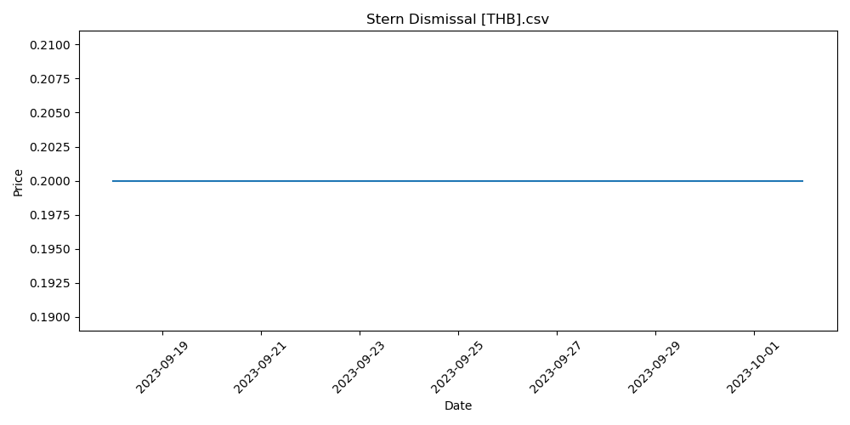

# Silversmote Ghoul [M21].csv

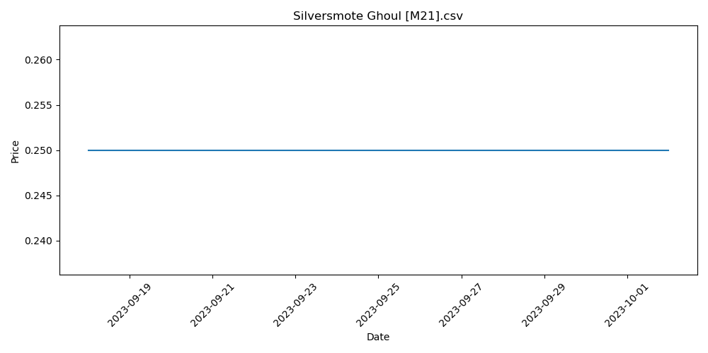

# Underground River [10E].csv

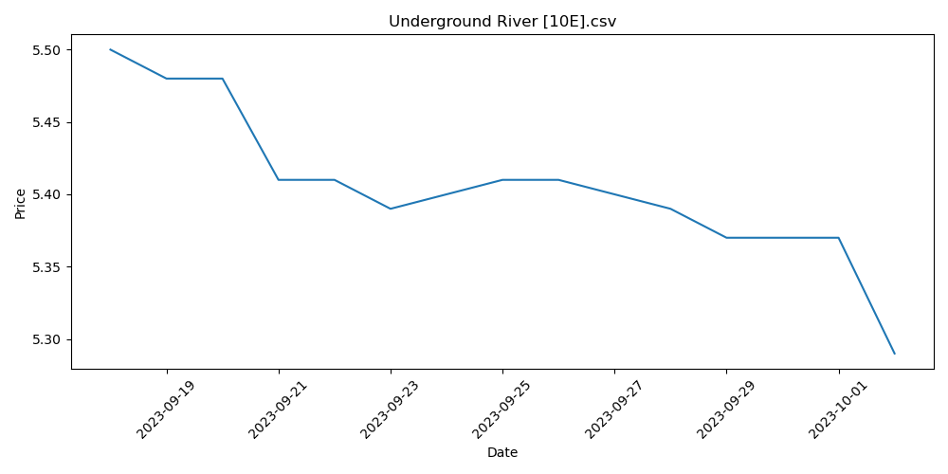

# Ox of Agonas [THB].csv

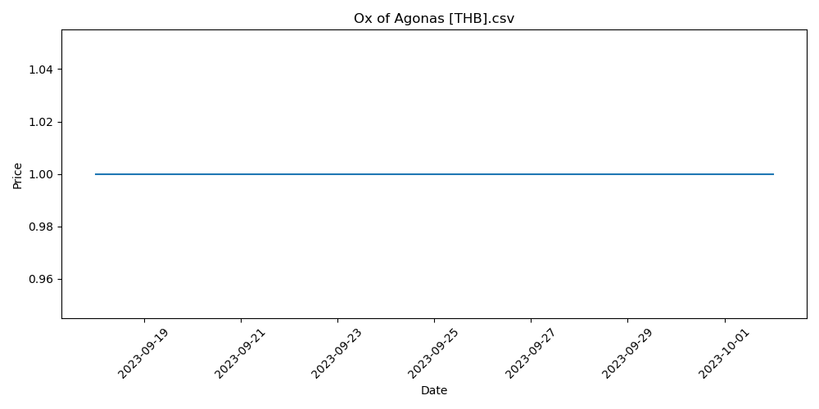

# Tormod's Crypt [M13].csv

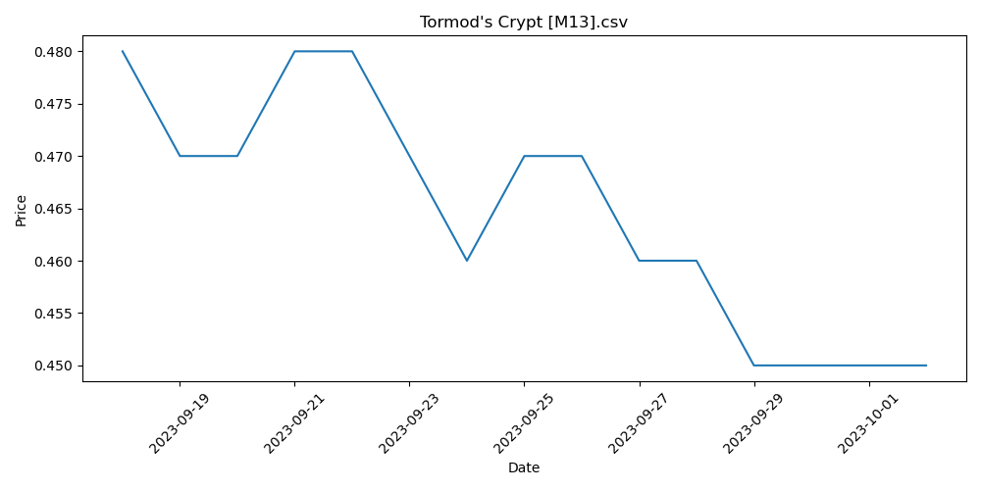

# Shivan Reef [M15].csv

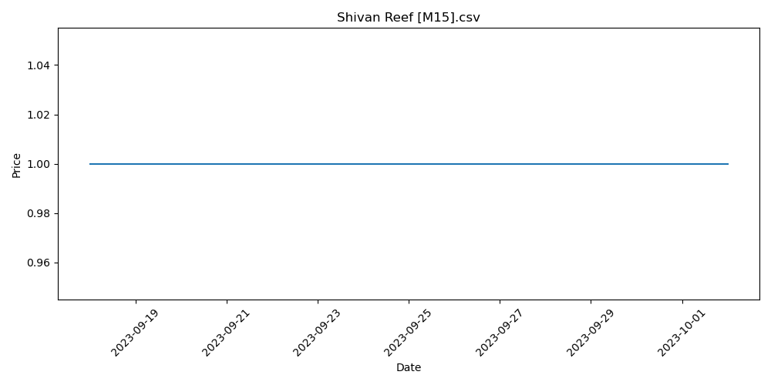

# Darkblast [RAV].csv

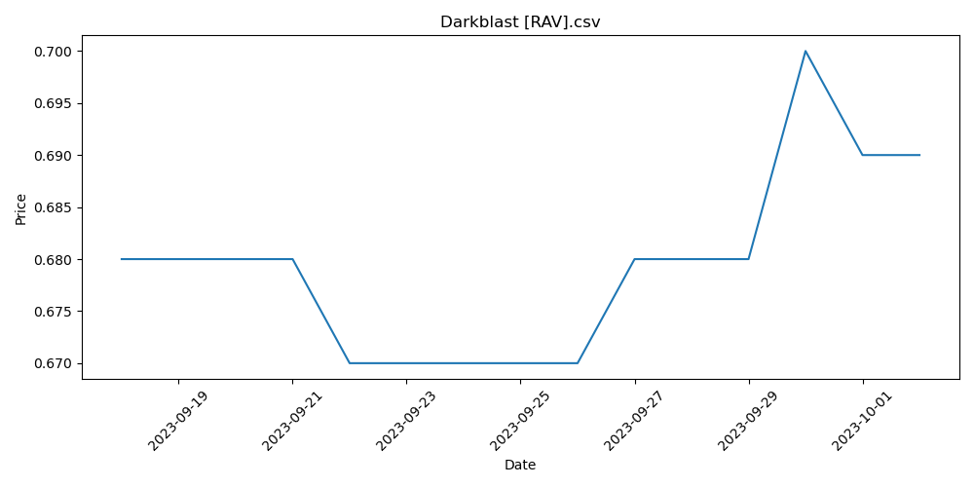

# Creeping Chill [GRN].csv

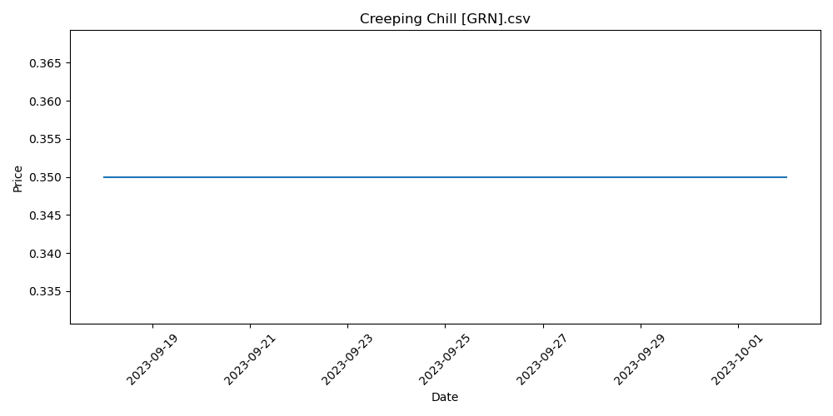

# Otherworldly Gaze [MID].csv

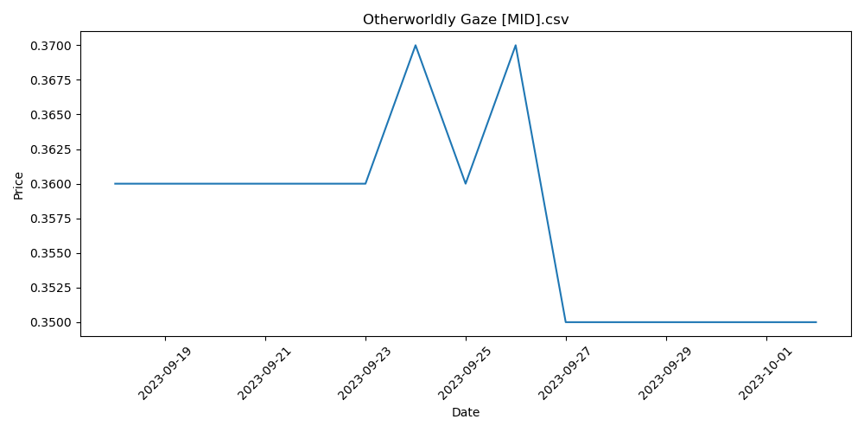

# Prized Amalgam [SOI].csv

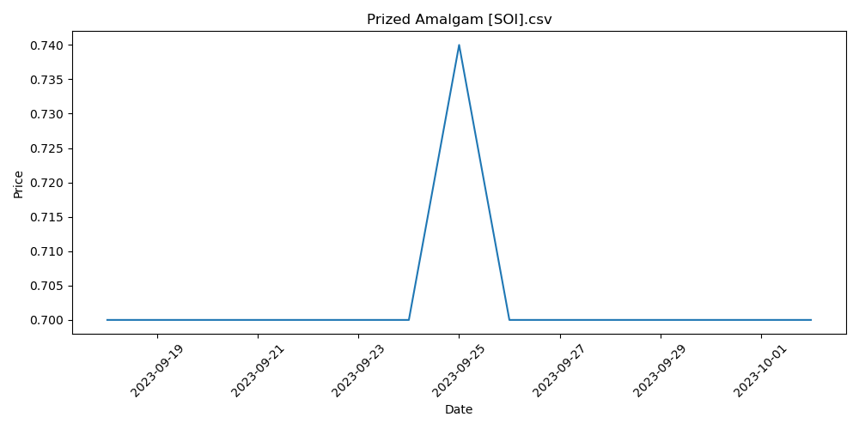

# Swamp _252_ [THB].csv

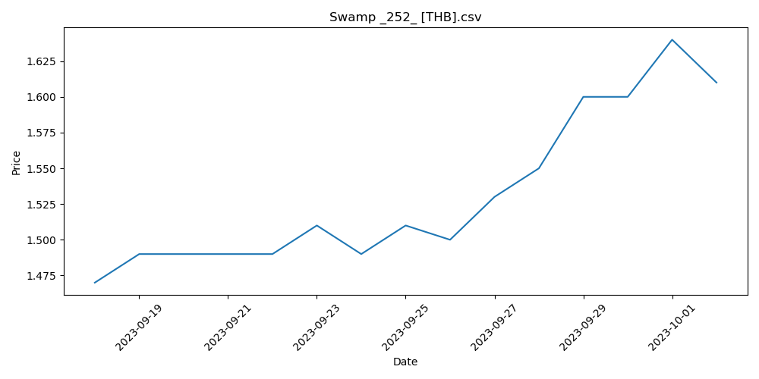

# Portable Hole [AFR].csv

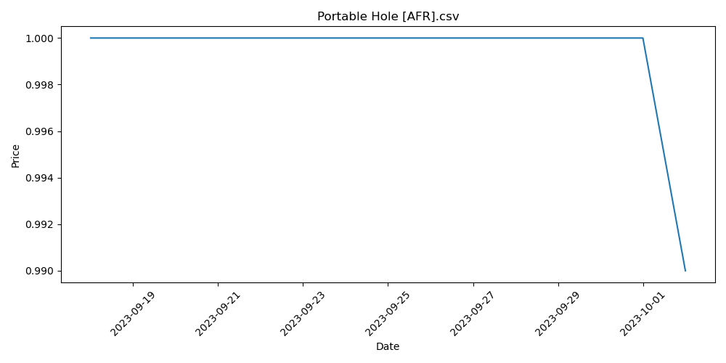

# Gemstone Mine [WL].csv

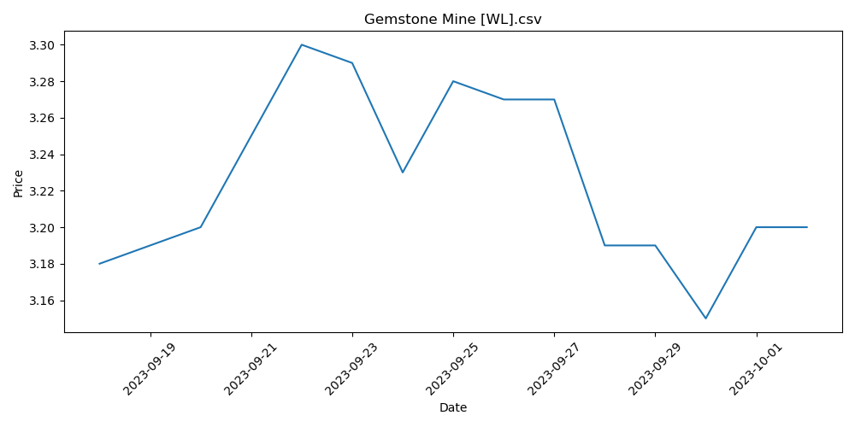

# Wear __ Tear [DGM].csv

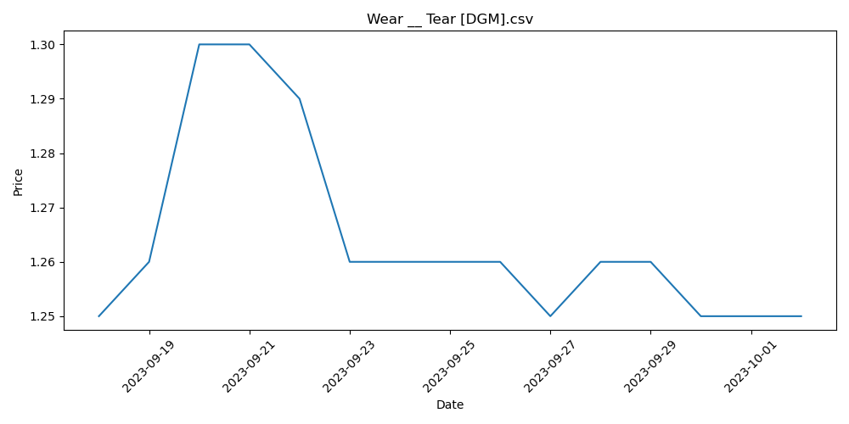

# Cathartic Reunion [KLD] (F).csv

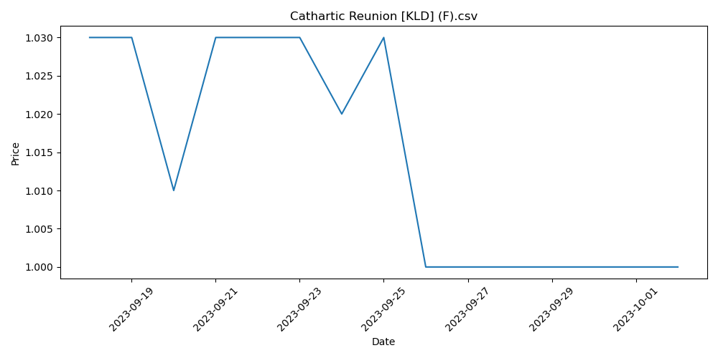

# Mountain _253_ [THB].csv

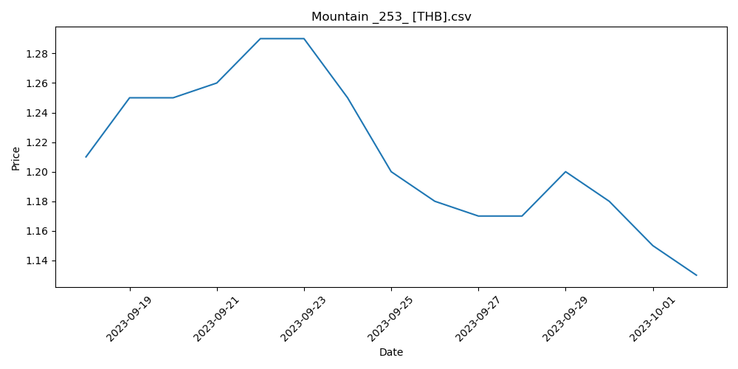

# Narcomoeba [GRN].csv

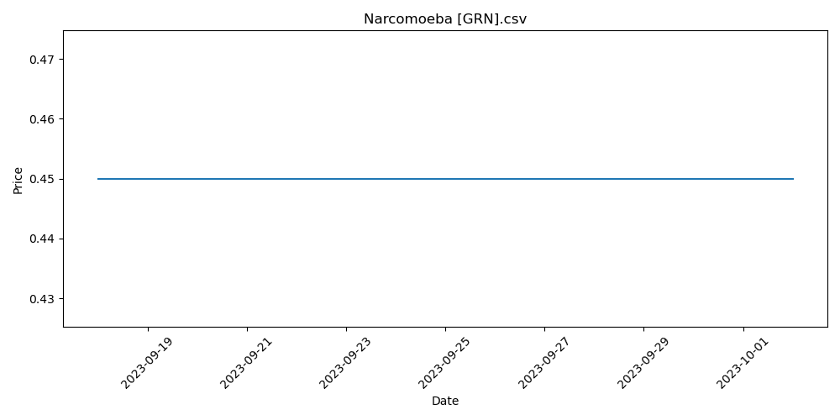

# Sulfurous Springs [9ED].csv

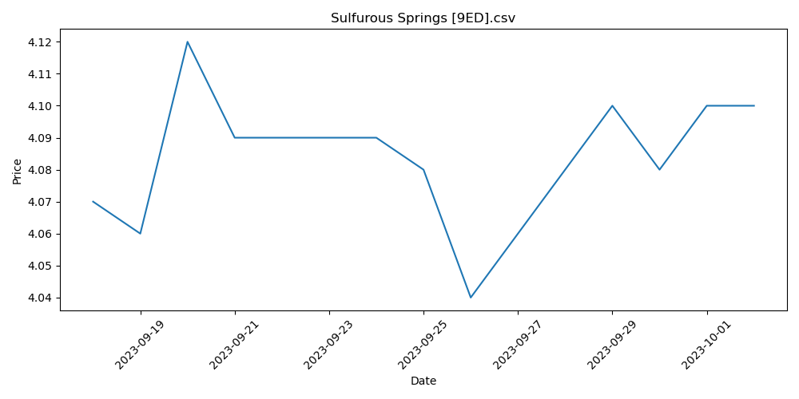

# Battlefield Forge [9ED].csv

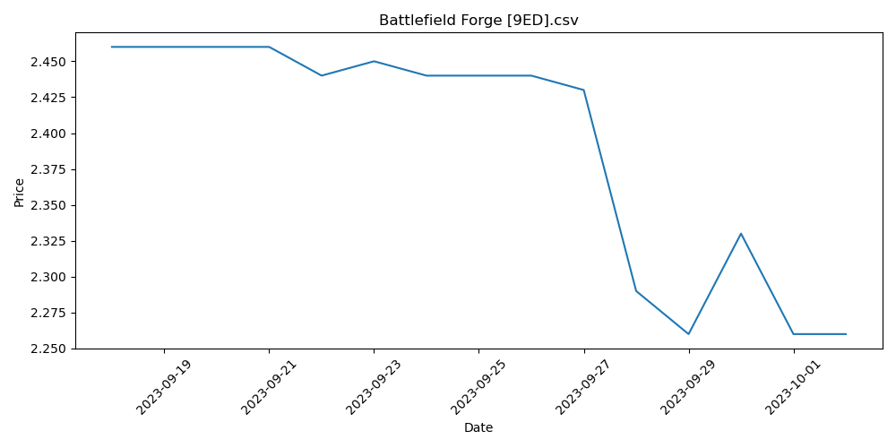

# Leyline of Sanctity [WOT].csv

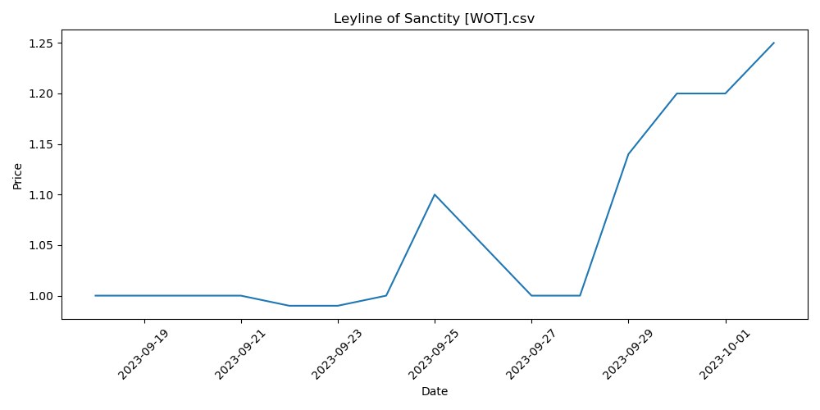

# Golgari Thug [RAV].csv

