Quantitative detection of mixed low micrometer microplastics in freshwater enabled by an ultrasensitive multimodal machine learning workflow

Ziyan Wu¹, Patrick Wang², Mohan Qin^{1*}, Haoran Wei^{1*}
- Department of Civil and Environmental Engineering, University of Wisconsin–Madison, Madison, Wisconsin 53706, USA
- Department of Computer Science, University of Wisconsin–Madison, Madison, Wisconsin 53706, USA

* Corresponding author. E-mail: haoran.wei3@wisc.edu; mohan.qin@wisc.edu

ABSTRACT.

KEYWORDS. Microplastics, Raman micro-spectroscopy, machine learning, foundation model, freshwater

SYNOPSIS.

INTRODUCTION
Why are LMMPs concerning?
How to detect LMMPs in water? What are the challenges?
Why do we need an advanced data processing process for LMMP detection?
What are the current algorithms to advance LMMP imaging and characterization?
Objectives of this study:
Develop a streamlined framework to automatically image, characterize, and quantify individual LMMPs with Raman. We presented AIMs, an automatic identification model for microplastics.

MATERIALS AND METHODS
Materials.
Acquisition of LMMP images and image augmentation.
Raman analysis of LMMPs.
Particle Identification Procedure of AIM-MP.
A key decision of the AIM-MP pipeline is to use a dedicated object detection stage before segmentation, rather than relying on a segmentation model alone. Segmentation models are great at drawing pixel wise masks, but they were designed to expect input prompts, whether that be from a click or a tap. When applied to microscopy images without explicit prompts, our segmentation model’s automatic mask generator tended to miss certain particles altogether while merging other distinct particles together, especially when particles appeared in close proximity. We needed a way to localize regions of interest before running our segmentation models. Thus, we developed two stage pipeline:
- An object detection stage utilizing a custom tuned YOLO11-Large architecture (25.3 M parameters, 86.6 GFLOPS) initialized from COCO-pretrained weights and fine tuned on custom labeled dataset to localize potential regions of interest.
- A segmentation stage utilizing Meta’s native SAM2 pretrained segmentation model from Meta to draw pixel wise masks for individual Microplastics and Aggregates.
The YOLO detection stage identifies bounding boxes containing a region of interest in the image. These bounding boxes are passed as spatial prompts to the SAM2 layer. The SAM2 layer can then create just one pixel level mask for each YOLO prompt, allowing us to exploit the benefits of each model while ignoring their limitations.

The YOLO object detection model was trained using the AdamW optimizer with an initial learning rate of 0.0015, cosine annealing, and a final learning rate of 0.01 and weight decay of 0.01. Early stopping with a patience of 200 epochs halted training at epoch 977. The training was conducted on an Nvidia H200 through the Center for High Throughput Computing (CHTC) at the University of Wisconsin – Madison. The model achieved 89.3% precision, 96.1% recall, 95.3% mAP@50, and 64.1% mAP@50-95.

Chemical Characterization Procedure of AIM-MP.
Quantification Procedure of AIM-MP.
Testing AIM-MP on LMMP samples in lake water.

RESULTS AND DISCUSSION
AI-driven imaging of LMMPs.

Characterization of LMMPs via ML models.

Quantitative Detection of LMMPs in Lake Water via AIM-MP.

ENVIRONMENTAL IMPLICATIONS

ASSOCIATED CONTENT
Supporting Information.

AUTHOR INFORMATION
Corresponding Author

Funding Sources

ACKNOWLEDGMENT

ABBREVIATIONS

REFERENCES

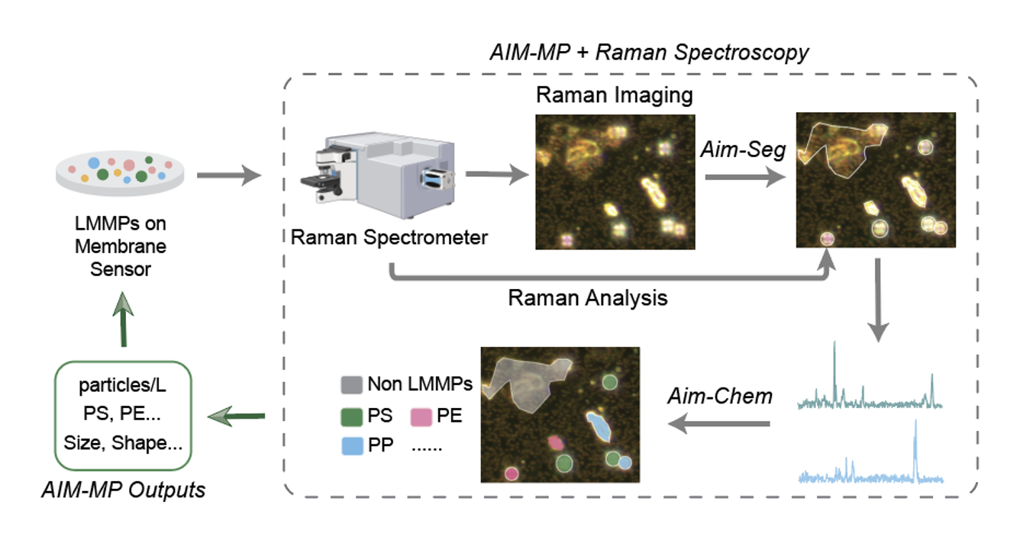
Figure 1. Schematic of AIM-MP to simultaneously image, characterize, and quantify LMMPs in water samples. AIM-MP consisted of AIM-Seg (imaging segmentation) and AIM-Chem (chemical characterization and quantification). AIM-Seg deployed a pretrained LLM-based model, SAM, and post-trained the model on labeled images collected from a Raman spectrometer. AIM-Seg delineated the shapes and locations of identified particles on the membrane sensor, and the identified particles were further analyzed in AIM-Chem. AIM-Chem deployed ML models to characterize the chemical composition of the delineated particles from AIM-Seg based on the acquired Raman spectra of the particles. The concentration of each identified LMMP types was also quantified in AIM-Seg.

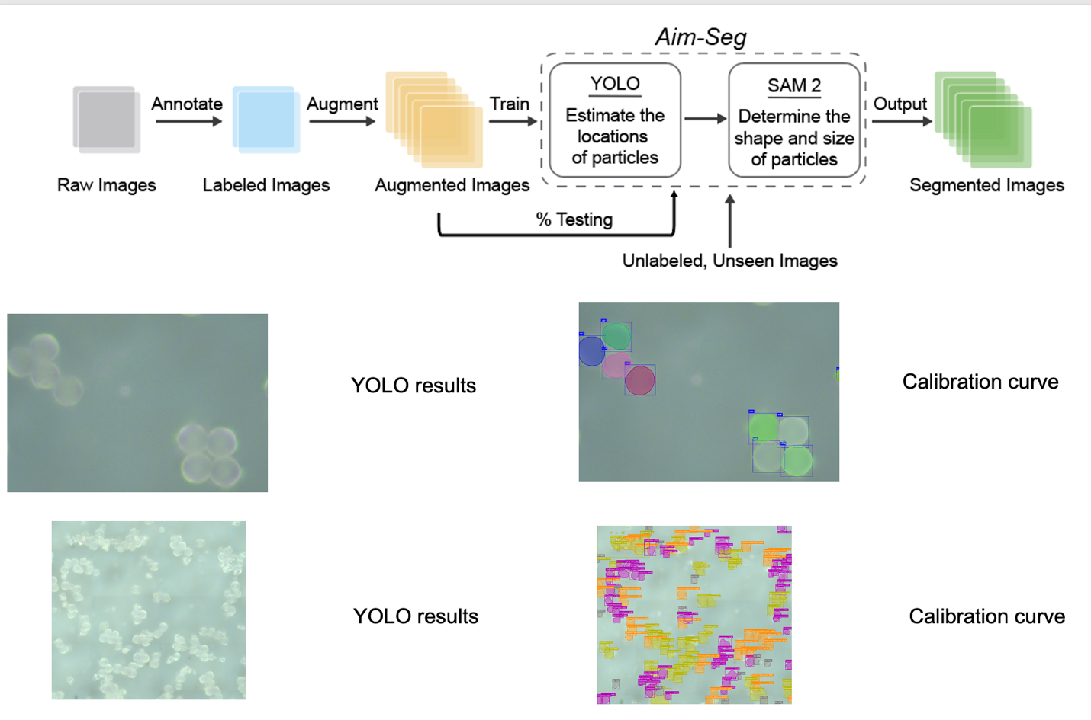

Figure 2. Schematic of AIM-Seg and the segmented images of LMMPs.
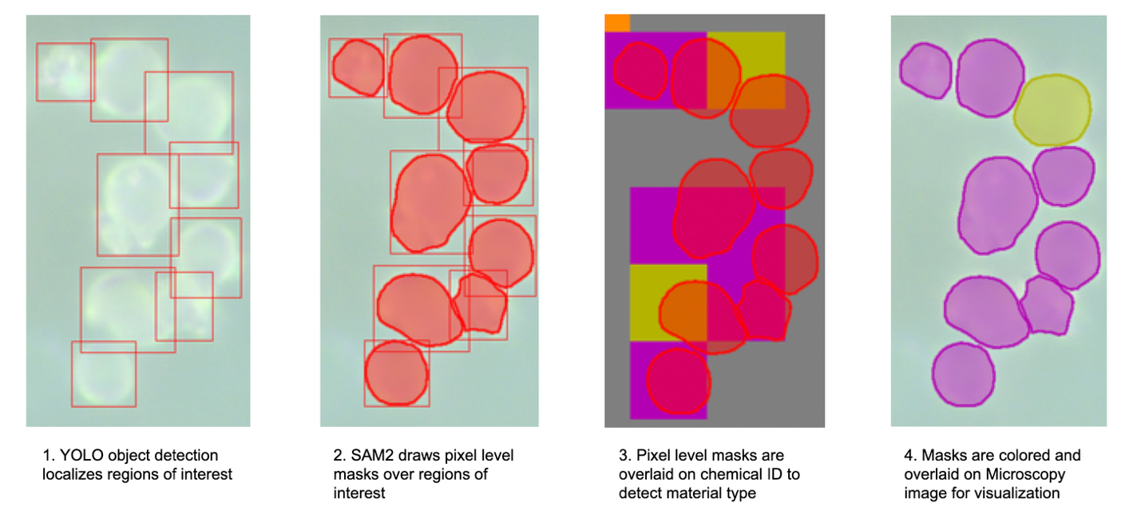

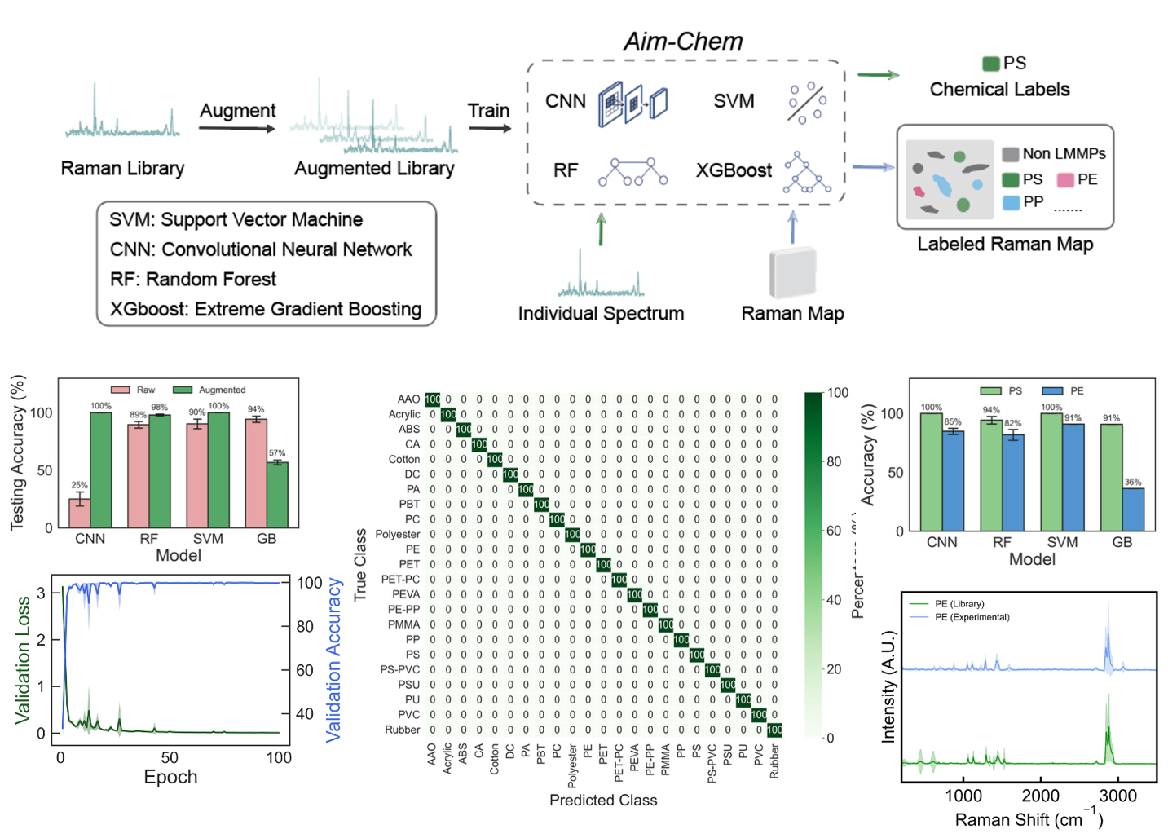
Figure 3. Raman spectra of LMMPs before and after preprocessing. Prediction accuracy for raw and preprocessed data. Prediction accuracy for lib data and exp data. Confusion matrix of CNN, RF, Xboost, and SVM.

Figure 4.

Figure 5.

