-Booting into Emergency Mode for Centos-

To enter Emergency boot mode on a centos machine, you need to access the machine directly, no SSH or Telnet. Power off the server, and then power it back on, when the GRUB2 launcher appears, press ‘e’.

After pressing ‘e’ you’ll see the screenshot above, located the line that begins with “linux”, and append “system.unit=\emergency.target”

Press CTRL+X to reboot the device, and you’ll be in emergency mode.

-Ubuntu Emergency Boot-

The process for getting an Ubuntu machine into emergency mode is quite similar. Get to the GRUB2 launcher, if the machine doesn’t show this screen, just repeatedly press ESC as soon as the device powers on. Once again, press ‘e’ to enter the edit mode.

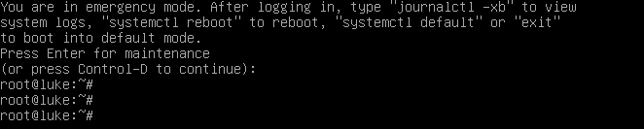

Located the line beginning with “Linux” once again, and then append “systemd.unit=emergency.target” and press “Ctrl-X” to reboot.

While hopefully not necessary, emergency mode will provide only the bare-minimum environment possible, allowing for repairs to be done to the system, and deactivating all network interfaces. This can be a useful mode to use if the device won’t boot otherwise, or you suspect that the server has been compromised in some way, and want to keep an unwanted entity out while you work on the machine.