**Task 1:**

**Reading a greyscale, colour and binary image in the form of a matrix in Matlab.**

Matlab code :

% 16BCE2147

% Akshay Gugale

% CSE4019 Image Processing

% TASK 1 - Reading Greyscale, Color and Binary images in the form of a Matrix

clc

clear all

close all

%Greyscale img

i1 = imread('/Users/akshaygugale/Downloads/sem3-VIT/CSE4019/project/aerial.tif');

[m1 n1] = size(i1);

%disp(i1);

disp('GreyScale Image');

disp(['Matrix size is ', num2str(m1), ' x ', num2str(n1), ' .']);

%Coloured img

i2 = imread('/Users/akshaygugale/Downloads/sem3-VIT/CSE4019/project/lenna_coloured.png');

[m2 n2 o2] = size(i2);

%disp(i2);

disp('Coloured Image');

disp(['Matrix size is ', num2str(m2), ' x ', num2str(n2), ' x ' num2str(o2) , ' .']);

%Binary img

i3 = imread('/Users/akshaygugale/Downloads/sem3-VIT/CSE4019/project/Neighborhood.png');

[m3 n3] = size(i3);

%disp(i3);

disp('Binary Image');

disp(['Matrix size is ', num2str(m3), ' x ', num2str(n3), ' .']);

Output:

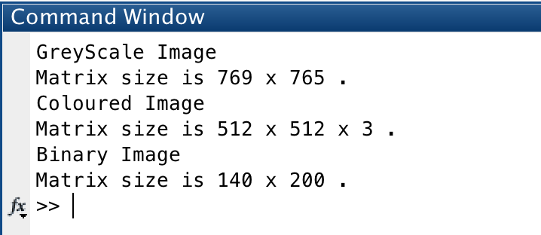

**Workspace:**

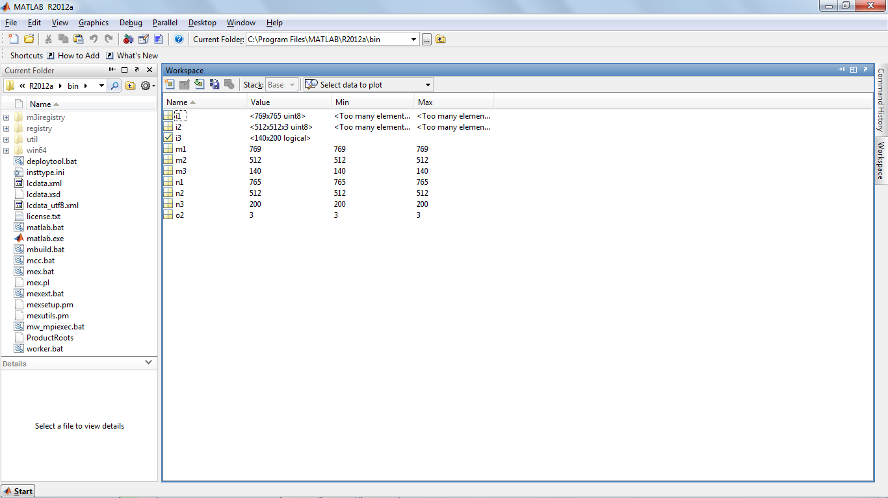

Greyscale image has one plane with values from 0 to 255.

Coloured image has 3 planes with R, G and B values ranging from 0 to 255 in each plane.

Binary image has a one plane with values 0 or 1.