PRAKHAR LOHIYA

16BCE0721

JAVA LAB CAT 1

**QUESTION 14**

**14 .If there are 4 batches in BTech - “CSE1007” course, read the count of the slow learners (who have scored <25) in each batch. Tutors should be assigned in the ratio of 1:4 (For every 4 slow learners, there should be one tutor). Determine the number of tutors for each batch. Create a 2-D jagged array with 4 rows to store the count of slow learners in the 4 batches. The number of columns in each row should be equal to the number of groups formed for that particular batch ( Eg., If there are 23 slow learners in a batch, then there should be 6 tutors and in the jagged array, the corresponding row should store 4 4 4 4 4 3.**

**CODE:**

import java.util.Scanner;

class Jagged{

public static void main(String[] args){

Scanner sc = new Scanner(System.in);

System.out.println("Enter number of slow learners in 4 batches");

int arr[] = new int[4];

for(int i=0;i<4;i++)

arr[i]=sc.nextInt();

int j_arr[][] = new int[4][];

for(int i=0;i<4;i++){

int x = arr[i]/4;

j_arr[i] = new int[x+1];

for(int j=0;j<x;j++){

j_arr[i][j] = 4;

if(arr[i]%4 != 0)

j_arr[i][x]=arr[i]%4;

else

j_arr[i][x]=4;

}

}

for(int i=0;i<4;i++){

for(int j=0;j<j_arr[i].length;j++){

System.out.print(j_arr[i][j]+" ");

}

System.out.println();

}

}

}

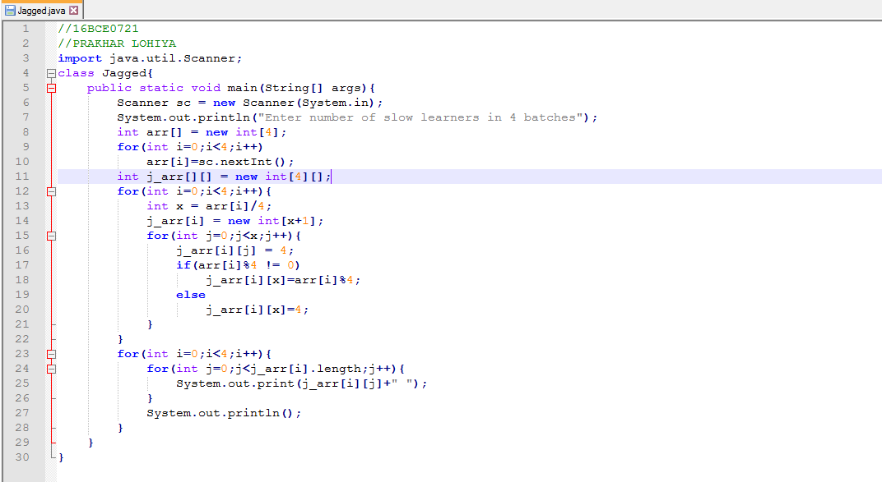

**OUTPUT:**

