**Sample Layout: Title of Article Should Concisely and Accurately Specify Subject of Paper**

A. B. Fish*, C. D. Flesch* and E. Fowle**

* Department of Superficial Research, University of Life, 99 Crow Road, Addlestrop, Borsetshire BB3 1TC, UK (E-mail: *fish@imaginaryaddresss.com*; *stag@bay.matrix.edu.uk)*

** Bodgett & Billham plc, Hamilton House, Hangover Square, London NC1 4TS, UK

(E-mail: *birdie@walford.cotton.co.uk*)

**Abstract**

This example is to demonstrate the layout of the first page of a "camera-ready" article for *Water Science and Technology*. The title, authors' names and addresses should be indented 1.5 cm from the left-hand margin of the text area; the abstract is indented 1.5 cm from both margins. The abstract itself, set in 10 pt type like the authors' addresses, should start about 9 cm down from the top of the text area. Please do not make reference citations in the abstract and please keep within the limit of **300 words.**

**Keywords**

Abstract; author details; example; headings; layout; title page

**MAJOR HEADINGS**

Major headings are typed bold in 12pt upper case (capital letters), with two lines space above and none below. Text should be justified (extend to the right-hand margin) and be typed to fill the full depth of the text area. Please use a 12pt Times typeface. Do not indent the text paragraphs. The publication should not be more than 5 Mb.

**Minor headings**

Minor headings are in 12pt bold type, not indented, with one line of space above and none below. Do not number headings.

*Sub-headings*. Sub-headings are typed in 12pt italic (or underlined if italics are not available), not indented, with the paragraph running on after a full stop; there is one line of space above.

New paragraphs are not indented, but are preceded by a line of space. Also please avoid using footnotes or splitting tables over two (or more) pages. The references should be indicated this way (Daims, 2001).

Formulas should be centralized and numbered on the right. For example “the cost function represents the cost of boundary flows”:

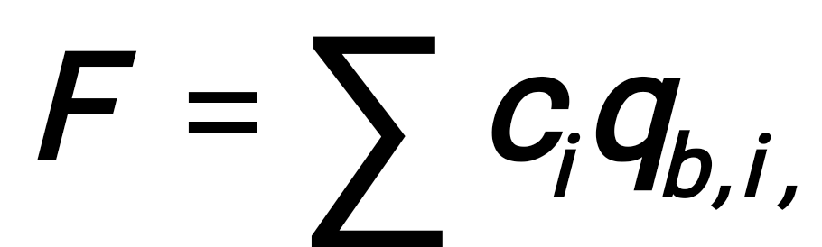 (1)

where *qb;i* is a boundary flow and *ci* is the price of a boundary flow.

**Table 1**. This is an example of table layout. It shows the dimensions of the text area to be used for *Water Science and Technology* articles and of international and US paper sizes (and the consequent recommended margin settings). Note that a minimum number of horizontal rules and (usually) no vertical rules are used.

|  |  |  |  |  |  |  |
| --- | --- | --- | --- | --- | --- | --- |
|  | Text area | A4 paper | |  | US (Imperial) paper | |
|  | (mm) | (mm) | (in) |  | (mm) | (in) |
| Depth | 250 | 297 | 11.69 |  | 279.32 | 11.0 |
| Top/bottom margin | - | 25 | 1.0 |  | 15 | 0.6 |
| Width | 170 | 210 | 8.27 |  | 215.84 | 8.5 |
| Left/right margin | - | 20 | 0.8 |  | 23 | 0.9 |

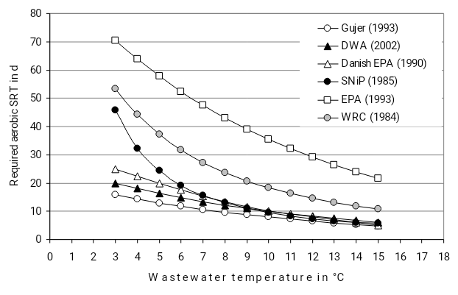

**Figure 1**. This is an example of figure layout.

**REFERENCES**

Abwasserverordnung (2004) Abwasserverordnung (Verordnung über Anforderungen an das Einleiten von Abwasser in Gewässer) Bundesgesetzblatt I No. 28, p 1108 22.6.2004 (in German).

Daims, H., Purkhold, U., Bjerrum, L., Arnold, E., Wilderer, P. and Wagner, M. (2001) Nitrification in sequencing biofilm batch reactor: lessons from molecular approaches. *Water Science and Technology*, **43**(3), 9-18.

DWA (2002) ATV-DVWK Worksheet A 131 E. Dimensioning of Single-Stage activated Sludge Plants, GFA Publishing Hennef 2002.

Additional request:

* Max number of pages – 8.
* Min number of pages – 6.
* Do not number pages.
* Do not link numbers of pictures/tables with numbers in the text.
* Max size 5 Mb