Race | Elf
Class | Devil / Demon
Faction
Location | Brawl
Age
Goal | Kill Angel
Physical Description | Black suit, red tie
Personality | Super arrogant, narcissistic
Occupation | Devil / Mayor of Brawl
Habits/Mannerisms | Talks with his hands
Notes

- Symbol of Brawl and also the symbol of Denis’ patron
- Controls imps, guards, runs the town of Brawl and is very rich
- Took Denis’ soul when he was a child and has given her magical powers
- One of the few really powerful magical creatures left
- He knows what we do and have video evidence of Cordelia blowing up Naxalith
- He exposes Cordelia’s acts to the group
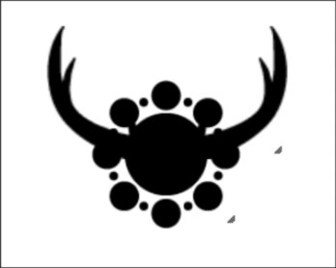
Bag of weed symbol

