# 

# 

# 

# 

# CENG / ELEC / SENG 499

# **Avatari - FitBit Game**

# Progress Report #1

Denholm Scrimshaw - V00759740

Tyler Potter - V00780941

Charlotte Fedderly - V00729142

Evan Hildebrandt - V00778723

Darren Prince - V00320999

Supervisor: Jens Weber

Group Number: 8

Date: June 1st, 2016

## **Problem Statement**

Personal fitness can be a challenge to many, a lack of motivation being the number one reason for neglect. The FitBit is a wearable device that tracks a variety of metrics relating to the user’s fitness activities. It has the ability to track steps walked, calories burned, heart rate, and sleep patterns. FitBit has developed a way to visualize the results of your exercise and keep a running record of your progress. These devices have become very popular with nearly 20 million registered users as of the first quarter of 2015 [1]. However, according to FitBit, only half of those 20 million users are actually actively using their FitBit. This disparity between active FitBit users and inactive users could be attributable to the novelty of a new device wearing off shortly after purchase. A method to keep the FitBit fresh and interesting, such as interactive gaming, could improve user retention. While FitBits provide a useful tool for monitoring fitness, their compatible apps are lacking the gamification present in other fields.

## **Pro**posed Solution and Project **Scope**

The goal is to provide a fun way to promote exercise by creating a mobile game that integrates with the FitBit. The game will strive to build a relationship with the user and use this relationship to motivate the user to exercise on a daily basis. Furthermore it will profile the user to determine the appropriate level of fitness and, by means of fun games and challenges, will incrementally increase the user’s fitness level. Users will be challenged to complete physical tests such as running/walking a specified distance, or running/walking for a specified time. Completing challenges will develop a user’s ‘Tari’ character, which represents a ‘living’ abstraction of the user’s fitness state.

The game will be an Android application. A database will store all data recorded, both from those supplied by the FitBit and our own application data. The data will then be analyzed and used to determine the appropriate daily games and challenges.

The app will be free to users and all potential sources of revenue will stem from advertising and data sales.

## Technologies

By utilizing FitBit’s suite of API’s, Avatari will interface with the FitBit and use real life exercise to progress your own personal avatar within the game. The app will be created using Unity, a cross-platform game engine used to develop video games. The app will store information about the user’s avatar and game related stats in a MySQL database hosted on an Amazon Relational Database Service (RDS) and a web server which will be hosted on an Amazon Web Service (AWS) Elastic Compute Cloud (EC2) container. The containers will be running a Linux, Apache, MySQL, and PHP (LAMP) stack. The app will also pull information about a user’s FitBit through that same container.

EC2 containers are particularly useful as the amount of containers can be scaled alongside variation in user activity. EC2 containers were chosen for this project as the demand for hardware can be shifted as required. The LAMP stack was used as it’s a very popular web development stack in software development.

This container will talk to the FitBit API by first using the authentication method provided by the API, followed up with various requests to that API which are dependent on the statistics desired. The web service running on the container will also subscribe to the FitBit API to obtain real time updates from the user of the FitBit. The product web page will interact with the EC2 container instance to pull possible statistics from the game for informative purposes.

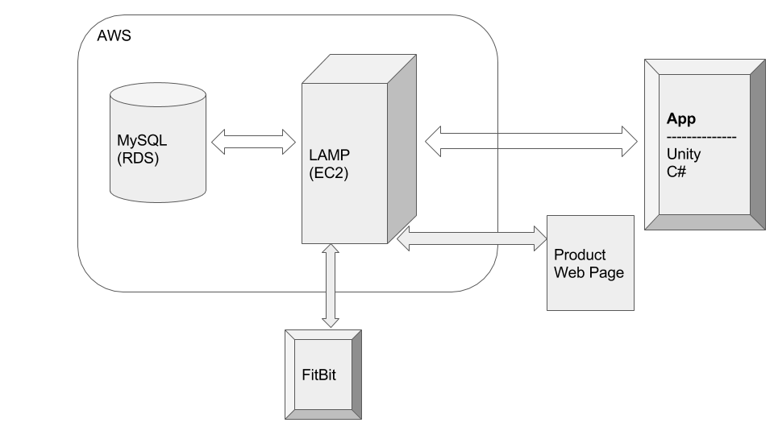

Figure 1. Avatar Framework Diagram

## **Team**

|  |  |  |
| --- | --- | --- |
| Tyler Potter | V00780941 | tjpotter@uvic.ca |
| Evan Hildebrandt | V00778723 | ehildebr@uvic.ca |
| Charlotte Fedderly | V00729142 | fedderly@uvic.ca |
| Denholm Scrimshaw | V00759740 | denholmses@gmail.com |
| Darren Prince | V00320999 | dprince@uvic.ca |

## **Assigned Tasks**

Mobile Application Development

* Denholm

Server Side/API Development

* Evan

Fitbit Integration

* Charlotte

Social Integration

* Tyler

Project Website

* Darren

## **Current Progress**

In order to secure a foundation for which all group members can contribute, we have secured an AWS account and started to setup an EC2 instance. Each group member has also registered an account with FitBit and downloaded the application in order to further investigate the data available. After investigating the FitBit API we have started to develop the possible ‘Tari’ (avatar) tasks and feature design.

## **Milestones**

|  |  |
| --- | --- |
| Date (week of) | Tasks |
| May 30 | Progress Report 1, Milestones 1, Work Log 1, obtain FitBit device, EC2 instance, preliminary UI mock-up, start building the menus in Unity |
| June 6 | Model database, finalize UI and begin implementing mobile application |
| June 13 | Milestones 2, Work Log 2, get information from FitBit device and store it in database |
| June 20 | Integrate the FitBit metrics into the mobile application |
| June 27 | Progress Report 2, Milestones 3, Work Log 3, find/create artwork, implement levelling up and rewards for achieving goals |
| July 4 | Continue work on the application, get social media integration, implement “battles” between users |
| July 11 | Milestones 4, Work Log 4, finish the application, start testing final product, prepare public presentation |
| July 18 | Create pamphlets for presentation, public presentation, create project website |
| July 25 | Final Report, Milestones 5, Work Log 5, project website completed |

## References

[1] CBC, 'Fitness Trackers Often Abandoned Within Months', 2015. [Online]. Available: http://www.cbc.ca/news/technology/fitbit-quitters-fitness-trackers-often-abandoned-within-months-1.3144534 [Accessed: 2- Jun- 2015].