- Arch 3. Funded by Co: Gioseffo Carpegna.
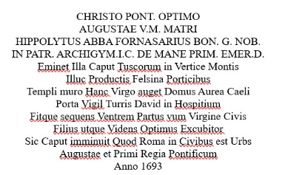
[SPLIT_BLOCK:Arco3_Carpegna.jpg]

Fornasari tombstone, with a sandstone sculpture by Francesco Albertoni. Ippolito di Antonio Fornasari, archpriest-abbot of Poggio Renatico and teacher at the Bologna university; he died at the age of seventy in 1697.
Translation of the Latin text from Google Translate:
CHRISTO PONT. OPTIMO
AUGUSTAE VM MATRI
IPPOLITO ABBA FORNASARIUS BON. G. NOB.
IN PATR. ARCHIGYM.IC DE MANE PRIM. EMER.D.
She stands as the leader of the Tuscans on the top of the mountain
There, with the Felsini Portici, the wall of the temple, the Virgin increases this golden house of heaven
The door of the Tower of David's guardian in a hospital
And becomes the next womb of the Virgin, the Citizen
The Son, as well as the Seer, the Best Watcher
So the head is diminished, That Rome is a city among the Citizens
Augusta and the First Royal Pontiff

