**Enocean Information**

The USB300 Enocean USB stick contains a TCM310U communications module, which is compatible with the CERV. For communicating with the USB stick with your Raspberry PI, your COM port should be configured to 57600 Baud, 8-N-1. The rest of this guide, and the included Excel file should hopefully be enough information to figure out how to read messages from the CERV.

**Step 1 – Getting the Device ID of the Module**

Download and install the Enocean DolphinView software (<https://www.enocean.com/en/download/>).

Plug in the USB300 stick, and then run DolphinView. You should see the following screen:

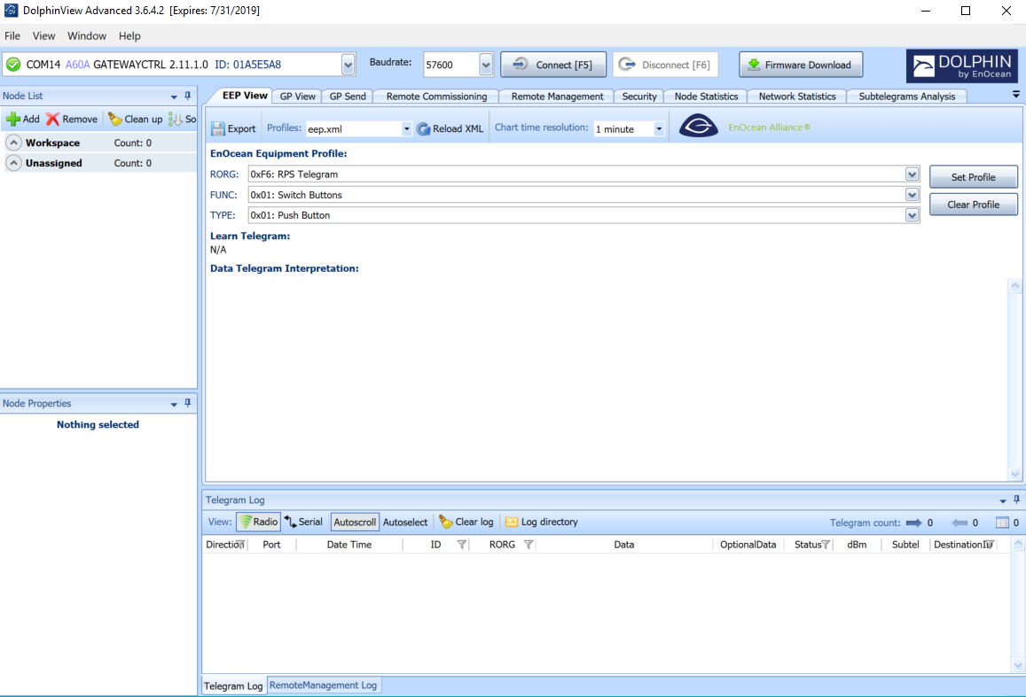

At the top left, it will show the COM port for the USB stick.

At the end of that line, it will say ID: __ __ __ __ __ __ __ __

Write down the ID – you will be using this to pair your device with the CERV. Keep the USB stick in your computer, and keep DolphinView open, because this will allow you to view incoming messages.

**Step 2 – Pairing the Enocean USB Module to the CERV2**

The CERV2 has the ability to communicate with a remote touchscreen interface, allowing the user to control it in the same way they would from the touchscreen built into the unit. For your home automation system, you will essentially be tricking the CERV into thinking that your USB stick is actually a remote touchscreen. This is very simple to do. On the CERV touchscreen, follow the instructions below. When it goes to the “Scanning for Touchscreen” screen, press the Manual Entry button, then type in the ID from **Step 1** above.

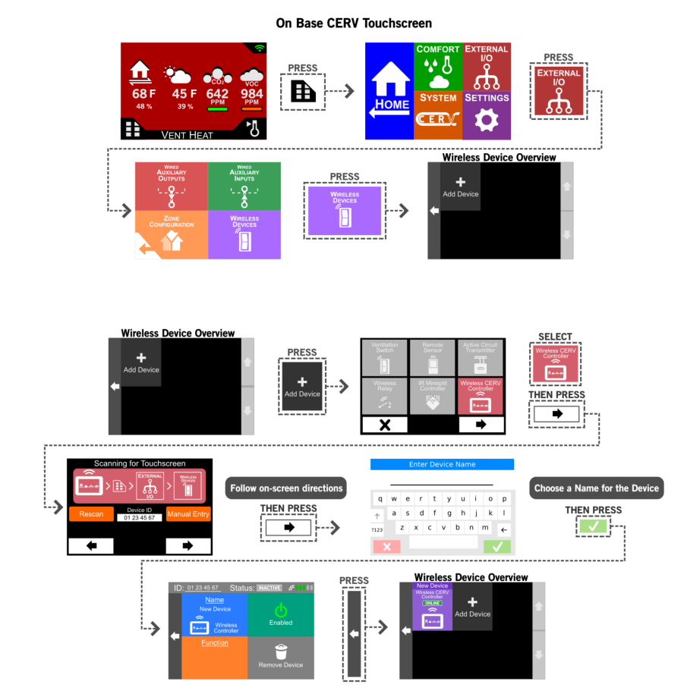

That’s all – once this has been done, the CERV will begin sending out messages to the USB module. DolphinView will log all the incoming messages and allow you to view the raw data. Since the remote touchscreen is capable of fully controlling and monitoring the CERV, there are going to be many more received messages than what you actually need. The messages you will be looking for are the STATUS and SETTINGS messages – the CERV2_Enocean_Status_Registers_032019r1.xlsx file should contain the information you need.

Additionally, the following two Enocean datasheets may be good references:

Enocean Serial Protocol: <https://www.enocean.com/esp>

Enocean Equipment Protocols: <https://www.enocean-alliance.org/eep/>