Programowanie komponentowe

Sprawozdanie z pracy projektowej

[Terminarz]

Michał Andrzejczak 195556

Konrad Nojman 195666

Informatyka, sem. IV

2015/ 2016

Class Hierarchy
- java.lang.Object
  - view.AboutProgram
  - view.AddEvent
    - view.UpdateEvent
  - controllers.AlarmClock
  - model.AlarmSound
  - java.awt.Component (implements java.awt.image.ImageObserver, java.awt.MenuContainer, java.io.Serializable)
    - java.awt.Container
      - javax.swing.JComponent (implements java.io.Serializable)
        - javax.swing.JMenuBar (implements javax.accessibility.Accessible, javax.swing.MenuElement)
          - view.MainMenu
  - controllers.Controller
  - controllers.DeleteEventAction (implements java.awt.event.ActionListener)
  - controllers.EditEventAction (implements java.awt.event.ActionListener)
  - model.EventBase (implements java.io.Serializable)
    - model.Birthday (implements java.io.Serializable)
    - model.BussinesMeeting
  - model.EventRepository
  - controllers.ExportXmlAction (implements java.awt.event.ActionListener)
  - view.FilterEvents
  - controllers.FilterEventsAction (implements java.awt.event.ActionListener)
  - controllers.ImportXmlAction (implements java.awt.event.ActionListener)
  - program.Program
  - controllers.SQLConnection
  - controllers.SQLConnection.AlarmName
  - java.lang.Throwable (implements java.io.Serializable)
    - java.lang.Exception
      - exceptions.ColumnOutOfRangeException
      - exceptions.DateFormatException
  - controllers.UserEventAction (implements java.awt.event.ActionListener)
  - view.View
  - controllers.XMLActions

Warstwa Danych

Package model

Class Summary
Class | Description
AlarmSound | This class holds a reference to a sound file used for alarm
Birthday | This class is plainly for extension purposes we don't use it in the current version of the application
BussinesMeeting | This class represents business meeting
EventBase | Base Event Class is a super class we use for our events
EventRepository | Repository class helps us with saving data to XML

Class AlarmSound

Constructor Summary
Constructors
Constructor and Description
AlarmSound(java.lang.String path)
Constructor requires path to an audio file used as an alarm sound

Method Summary
Modifier and Type | Method and Description
void | playAlarm()  Starting alarm sound
void | stopAlarm()  Stopping alarm sound

Constructor Detail

public AlarmSound(java.lang.String path)

Constructor requires path to an audio file used as an alarm sound

Parameters:
path – to a sound file

Method Detail

public void playAlarm()

this method is responsible for starting alarm sound

public void stopAlarm()
this method is responsible for stopping alarm sound
Class EventBase
implements java.io.Serializable
Base Event Class is a super class we use for our events

Constructor Summary
Constructor and Description
EventBase()
Constructor without parameters is needed for xml serialization
EventBase(int id, java.lang.String title, java.lang.String date, java.lang.String location, java.lang.String description, java.lang.String alarmDate)
Constructor of base event class

Constructor Detail

public EventBase()

constructor without parameters is needed for xml serialization
public EventBase(int id,
java.lang.String title,
java.lang.String date,
java.lang.String location,
java.lang.String description,
java.lang.String alarmDate)
Constructor of base event class
Parameters:
id - event id
title - event title
date - event date
location – location of the event
description - event description
alarmDate - date of the alarm

Class EventRepository

Constructor Summary
Constructors
Constructor and Description
EventRepository()
Allocates memory for Array List of events

Method Summary
Modifier and Type | Method and Description
void | addRecord(EventBase obj)  Method for adding new events to local repository
java.lang.String | filterByLocation(java.lang.String location)  Deprecated.  we found not much usage for it yet
java.util.ArrayList<EventBase> | getEventList()
void | setEventList(java.util.ArrayList<EventBase> eventList)
java.lang.String | toString()

Method Detail
public void addRecord(EventBase obj)
method for adding new events to local repository
Parameters:
obj - event
public java.lang.String filterByLocation(java.lang.String location)
Deprecated.
we found not much usage for it yet
method filters repository by location
Parameters:
location -
Returns:
String

Warstwa Logiki

Package controllers
Class Summary
Class | Description
AlarmClock | Alarm Clock starts a timer that performs a task every minute task is to check if there is an alarm set for event
ArchivedEventsAction | This class is an event handler for ArchivedEvents window
Controller | Controller is a class that connects all other components of the application
DeleteEventAction | This class is a handler for deleting events
EditEventAction | Event Handle for Editing events
ExportXmlAction | This class is responsible for xml export user actions
FilterEventsAction | This Class is responsible for event handling in FilterEvents window
ImportXmlAction | this class is responsible for xml import user actions
SQLConnection | This class is responsible for connecting to database as well as providing methods for extracting and inserting data to Database
UserEventAction | This Class is an event handler for AddEvent window
XMLActions | This class provides us with with functionality of a top level static class It lets us (de)serialize an object to xml file

Package exceptions
Exception Summary
Exception | Description
ColumnOutOfRangeException | This Class represents custom exception.
DateFormatException | This Class represents custom exception.

Class AlarmClock

Constructor Summary
Constructor and Description
AlarmClock(AlarmSound sound, View view, SQLConnection connection)
Constructor requires reference to AlarmSound class View and SQLConnection

Constructor Detail
public AlarmClock(AlarmSound sound,
View view,
SQLConnection connection)
Constructor requires reference to AlarmSound class View and SQLConnection
Parameters:
sound - provides an audio stream
view - reference to a View Class
connection - reference to database connection
See Also:
AlarmSound, View, SQLConnection

Method Detail
public void checkForAlarm()
method performs a TimerTask.It checks database for next alarm

public void soundAlarm(SQLConnection.AlarmName alarm)
Method starts and alarm using AlarmName class which hold a reference to name and alarm date
Parameters:
alarm - return alarm name and alarm date
See Also:
SQLConnection.AlarmName

Class Controller

Field Summary
Modifier and Type | Field and Description
(package private) AddEvent | addEventView
(package private) SQLConnection | sqlConnection
(package private) View | view

Constructor Summary
Constructor and Description
Controller(View view, SQLConnection sqlConnection)
Constructor need a reference to Event Repository View and SQLConnention

Constructor Detail
public Controller(View view,
SQLConnection sqlConnection)
Constructor need a reference to Event Repository View and SQLConnention
Parameters:
repo – holds a reference to EventRepository
view – provides a reference to View Class
sqlConnection - provides a reference to database using SQLConnection
See Also:
EventRepository, View, SQLConnection

Class ArchivedEventsAction
All Implemented Interfaces:
java.awt.event.ActionListener, java.util.EventListener

Field Summary
Modifier and Type | Field and Description
(package private) java.sql.Date | date
(package private) SQLConnection | sqlConnection

Constructor Summary
Constructor and Description
ArchivedEventsAction(SQLConnection sqlConnection)
Constructor requires reference to SQLConnection

Method Summary
Modifier and Type | Method and Description
void | actionPerformed(java.awt.event.ActionEvent e)  event handler for showing archived Events

Constructor Detail

public ArchivedEventsAction(SQLConnection sqlConnection)

Constructor requires SQLConnection

Parameters:
sqlConnection - connection to database

Method Detail

public void actionPerformed(java.awt.event.ActionEvent e)

event handler for showing archived Events

Specified by:
actionPerformed in interface java.awt.event.ActionListener

Class DeleteEventAction
All Implemented Interfaces:
java.awt.event.ActionListener, java.util.EventListener

Field Summary
Modifier and Type | Field and Description
(package private) SQLConnection | sqlConnection
(package private) View | view

Constructor Summary
Constructor and Description
DeleteEventAction(SQLConnection sqlConnection, View view)
Constructor needs reference to SQLConnection and View

Method Summary
Modifier and Type | Method and Description
void | actionPerformed(java.awt.event.ActionEvent e)  method responsible for event handling

Constructor Detail
public DeleteEventAction(SQLConnection sqlConnection,
View view)
Constructor needs reference to SQLConnection and View
Parameters:
sqlConnection – database connection
view - MainWindow

Class EditEventAction
All Implemented Interfaces:
java.awt.event.ActionListener, java.util.EventListener

Field Summary
Modifier and Type | Field and Description
(package private) int | Id
(package private) SQLConnection | sqlConnection
(package private) UpdateEvent | upEvent
(package private) View | view

Constructor Summary
Constructor and Description
EditEventAction(View view, SQLConnection sqlConnection)
Constructor with View and SQLConnection references

Method Summary
Modifier and Type | Method and Description
void | actionPerformed(java.awt.event.ActionEvent arg0)  this method performs event handling using local classes which are implementations of ActionListener

Constructor Detail
public EditEventAction(View view,
SQLConnection sqlConnection)
Constructor with View and SQLConnection references
Parameters:
view – provides a reference to View object
sqlConnection - connection to database

Method Detail
public void actionPerformed(java.awt.event.ActionEvent arg0)
this method performs event handling using local classes which are implementations of ActionListener
Specified by:
actionPerformed in interface java.awt.event.ActionListener

Class ExportXmlAction
All Implemented Interfaces:
java.awt.event.ActionListener, java.util.EventListener

Field Summary
Modifier and Type | Field and Description
(package private) SQLConnection | sqlConnection
(package private) View | view

Constructor Summary
Constructor and Description
ExportXmlAction(View view, SQLConnection sqlConnection)

Method Summary
Modifier and Type | Method and Description
void | actionPerformed(java.awt.event.ActionEvent e)

Constructor Detail
public ExportXmlAction(View view,
SQLConnection sqlConnection)
constructor requires reference View SQLConnection and EventRepository
Parameters:
view - MainWindow class
sqlConnection – database connection
repo - event repository
See Also:
MainWindow, SQLConnection, EventRepository

Method Detail
public void actionPerformed(java.awt.event.ActionEvent e)
Specified by:
actionPerformed in interface java.awt.event.ActionListener

Class ImportXmlAction
All Implemented Interfaces:
java.awt.event.ActionListener, java.util.EventListener

Field Summary
Modifier and Type | Field and Description
(package private) SQLConnection | sqlConnection
(package private) View | view

Constructor Summary
Constructor and Description
ImportXmlAction(View view, SQLConnection sqlConnection)
constructor requires reference View SQLConnection and EventRepository

Method Summary
Modifier and Type | Method and Description
void | actionPerformed(java.awt.event.ActionEvent e)  event handling xml import

Constructor Detail
public ImportXmlAction(View view,
SQLConnection sqlConnection)
constructor requires reference View SQLConnection and EventRepository
Parameters:
view - MainWindow class
sqlConnection – database connection
repo - event repository
See Also:
main window, sqlConnection, repo

Class FilterEventsAction
All Implemented Interfaces:
java.awt.event.ActionListener, java.util.EventListener

Field Summary
Modifier and Type | Field and Description
(package private) FilterEvents | filterEvents
(package private) SQLConnection | sqlconnection
(package private) View | view

Constructor Summary
Constructor and Description
FilterEventsAction(View view, SQLConnection sqlconnection)
constructor with reference to SQLConnection and View

Method Summary
Modifier and Type | Method and Description
void | actionPerformed(java.awt.event.ActionEvent e)  implementation of Action Listener Method

Constructor Detail
public FilterEventsAction(View view,
SQLConnection sqlconnection)
constructor with reference to SQLConnection and View
Parameters:
view - MainWindow class
sqlConnection – database connection

Class SQLConnection

Nested Class Summary
Modifier and Type | Class and Description
class | SQLConnection.AlarmName  this inner class holds necessary information about alarm - name and date

Field Summary
Modifier and Type | Field and Description
private java.sql.Connection | dbConnection
private java.lang.String | jdbcConnectionString
private java.lang.String | password
private java.lang.String | user

Constructor Summary
Constructor and Description
SQLConnection(java.lang.String jdbcConnectionString, java.lang.String user, java.lang.String password)
Constructor takes parameters responsible for user credential information necessary to connect to database server

Method Summary

Modifier and Type | Method and Description
void | addAllarmToDatabase(int id, java.lang.String datetime)  This mathod is responsible for adding alarm to data base event record
void | addEventToDatabaseTable(java.lang.String table, java.lang.String title, java.lang.String date, java.lang.String location, java.lang.String description, java.lang.String personImeetWith, java.lang.String alarm)  This method is responsible for adding a new record to event database
void | connectToDataBase()  This Method Performs a connection to database it has to be invoked before attempting to query database
EventRepository | filterEventsByDate(java.lang.String date, boolean older)  This method filters events in database by date
java.lang.String | filtereventsByLocation(java.lang.String location)  This method filters events in database by Location
java.lang.String | filtereventsByLocationAndDate(java.lang.String location, java.lang.String date)  This method filters events in database by date and location
java.lang.String | filterEventsByYear(java.lang.String date)  This method filters events in database by date
EventRepository | getAllEvents()  This Method return all existing events form the database
SQLConnection.AlarmName | getNextAlarm()  This Method queries database for the next alarm and returns Alarm name and date
java.lang.String | PrintEvents()  This method return string representation of events in database
void | removeEventFromTableWithID(int id, java.lang.String table)  This mehtod is used to remove record for the database
EventBase | SelectEventWithId(int id)  This method performs a select query and returns the event with matching id
void | setAlarmToNull()  This method is used to set alarm date to null so it won't ring more then once
void | setDbConnection(com.mysql.jdbc.Connection dbConnection)
void | updateRecordInTable(java.lang.String table, java.lang.String id, java.lang.String title, java.lang.String date, java.lang.String location, java.lang.String description, java.lang.String personImeetWith)  This method is used for updating existing event in database

Constructor Detail
public SQLConnection(java.lang.String jdbcConnectionString,
java.lang.String user,
java.lang.String password)
throws java.lang.ClassNotFoundException
Constructor takes parameters responsible for user credential information necessary to connect to database server
Parameters:
jdbcConnectionString - connection string for database server
user - User name
password - User password
Throws:
java.lang.ClassNotFoundException

Method Detail
public void connectToDataBase()
This Method Performs a connection to database it has to be invoked before attempting to query database
public void addEventToDatabaseTable(java.lang.String table,
java.lang.String title,
java.lang.String date,
java.lang.String location,
java.lang.String description, java.lang.String personImeetWith,
java.lang.String alarm)
This method is responsible for adding a new record to event database
Parameters:
table - name of the database table
title - title of the event
date - date of the event
location -
description -
personImeetWith -
alarm - date of the alarm

public void removeEventFromTableWithID(int id,
java.lang.String table)
this mehtod is used to remove record for the database
Parameters:
id - event id in database
table - name of a table in database
public void updateRecordInTable(java.lang.String table,
java.lang.String id,
java.lang.String title,
java.lang.String date,
java.lang.String location,
java.lang.String description,
java.lang.String personImeetWith)
this method is used for updating existing event in database
Parameters:
table - name of the table in databse
id - event id in database
title - event title
date - event date
location – event location
description – event description

public void addAllarmToDatabase(int id,
java.lang.String datetime)
this method is responsible for adding alarm to data base event record
Parameters:
id - event id
datetime - date of the alarm
public EventBase SelectEventWithId(int id)
throws java.sql.SQLException
This method performs a select query and returns the event with matching id
Parameters:
id - event id
Returns:
EventBase
Throws:
java.sql.SQLException
See Also:
EventBase
public EventRepository getAllEvents()
This Method return all existing events form the database
Returns:
EventRepository
See Also:
EventRepository

public java.lang.String PrintEvents()
This method return string representation of events in database
Returns:
String
public java.lang.String filterEventsByYear(java.lang.String date)
This method filters events in database by date
Parameters:
date – shows events past this date.
Returns:
String
public EventRepository filterEventsByDate(java.lang.String date,
boolean older)
This method filters events in database by date
Parameters:
date - shows events past this date.
Returns:
EventRepository
See Also:
EventRepository
public java.lang.String filtereventsByLocation(java.lang.String location)
This method filters events in database by Location
Parameters:
location – shows events that match specified location.
Returns:
String
public java.lang.String filtereventsByLocationAndDate(java.lang.String location,
java.lang.String date)
This method filters events in database by date and location
Parameters:
location - shows events that match specified location.
date - date of the event
Returns:
String

public SQLConnection.AlarmName getNextAlarm()
this Method queries database for the next alarm and returns Alarm name and date
Returns:
SQLConnection.AlarmName
See Also:
SQLConnection.AlarmName
public void setAlarmToNull()
this method is used to set alarm date to null so it won't ring more then once

Class UserEventAction
All Implemented Interfaces:
java.awt.event.ActionListener, java.util.EventListener

Field Summary
Modifier and Type | Field and Description
(package private) AddEvent | addEvent
(package private) SQLConnection | sqlConnection
(package private) View | view

Constructor Summary
Constructor and Description
UserEventAction(View view, SQLConnection sqlConnection)
constructor requires a reference to view and sql connection

Method Summary
Modifier and Type | Method and Description
void | actionPerformed(java.awt.event.ActionEvent arg0)  This method contains two local classes responsible which are implementation of action listener These two listeners are responsible for adding event and and alarm if user chooses to set one

Constructor Detail
public UserEventAction(View view,
SQLConnection sqlConnection)
constructor requires a reference to view and sql connection
Parameters:
view – Main window class
sqlConnection – database connection
public void actionPerformed(java.awt.event.ActionEvent arg0)
This method contains two local classes responsible which are implementation of action listener These two listeners are responsible for adding event and and alarm if user chooses to set one
Specified by:
actionPerformed in interface java.awt.event.ActionListener

Class XMLActions

Field Summary
Modifier and Type | Field and Description
private static java.beans.XMLDecoder | decoder
private static java.beans.XMLEncoder | encoder
private static EventRepository | eventRepo
private static MainMenu | menu

Constructor Summary
Modifier | Constructor and Description
private | XMLActions()  constructor is private so this class works like a top level static class

Method Summary
Modifier and Type | Method and Description
static void | loadEventsFromXML()  this method is responsible for importing events form xml file
static void | saveEventsToXML()  this method is responsible for saving events from the event repository to the xml file

Constructor Detail
private XMLActions()
constructor is private so this class works like a top level static class

Method Detail
public static void saveEventsToXML()
this method is responsible for saving events from the event repository to the xml file
public static void loadEventsFromXML()
this method is responsible for importing events form xml fil

Wartswa Prezentacji
Class Summary
Class | Description
AboutProgram | This Class represents window which display info about the program
AddEvent | this class represents a window for adding new events
ArchivedEvents | Class represents window with archived events
FilterEvents | this class represents a window for filtering events We can filter either by date or location
MainMenu | this class represents a main menu of the application
UpdateEvent | this class represents a window for updating events
View | this class represents a MainWindow of our Application it shows all events and JCallendar also provides buttons for adding filtering and updating events

Class View

Field Summary
Modifier and Type | Field and Description
private javax.swing.JButton | archEventsBtn  shows archived events
private javax.swing.JPanel | buttonPanel
private com.toedter.calendar.JCalendar | calendar
private javax.swing.JPanel | calendarPanel
private javax.swing.JPanel | contentPanel
private javax.swing.JButton | DeleteEventBtn  delets event with id
private com.toedter.components.JSpinField | deleteEventId  holds event id
private javax.swing.JButton | EditEventbtn  opens event update window
private javax.swing.JTextPane | eventList  list of events
private javax.swing.JScrollPane | eventlistSlider
private javax.swing.JPanel | eventPanel
private javax.swing.JButton | filterBtn  opens window for filtering events
private javax.swing.JFrame | frame
(package private) MainMenu | mainMenu
private boolean | todayBtnVisible
private javax.swing.JButton | UserEventBtn  opens add event window

Constructor Summary
Constructor and Description
View()
constructor of the view class

Method Summary

Modifier and Type | Method and Description
void | addArchiveBtnActionListener(java.awt.event.ActionListener listener)  Sets up action listener for archive button
void | addDeleteBtnActionListener(java.awt.event.ActionListener listener)  Sets up action listener for delete button
void | addEditEventActionListener(java.awt.event.ActionListener listener)  Sets up action listener for edit button
void | addfilterEventsActionListener(java.awt.event.ActionListener listener)  Action listener for filter button
void | addUserEventActionListener(java.awt.event.ActionListener listener)  Sets up action listener for addEvent button
void | showAlarmMessage(java.lang.String message)  this method shows JOptionPane with an alarm message
void | showMessage(java.lang.String message)  this method shows JOptionPane with an error message

Constructor Detail
public View()
constructor of the view class

Method Detail
public void addEditEventActionListener(java.awt.event.ActionListener listener)
Action listener for edit button
Parameters:
listener - action listener
public void addfilterEventsActionListener(java.awt.event.ActionListener listener)
Action listener for filter button
Parameters:
listener - action listener
public void showMessage(java.lang.String message)
this method shows JOptionPane with an error message
Parameters:
message - error message
public void showAlarmMessage(java.lang.String message)
this method shows JOptionPane with an alarm message
Parameters:
message - alarm info
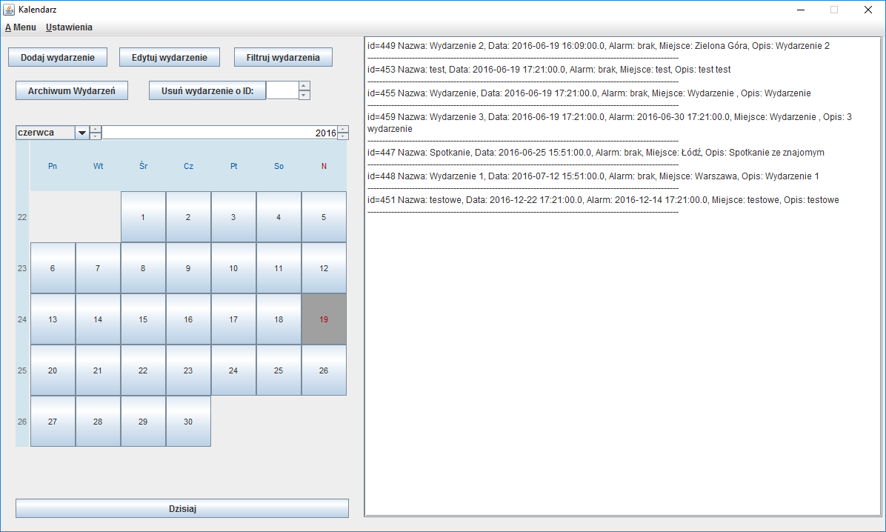Illustration 1: Main Window of application which presents a calendar, list of upcoming events and action buttons.

Class AddEvent

Field Summary

Modifier and Type | Field and Description
protected java.awt.Button | addBtn  adds new event
protected javax.swing.JCheckBox | alarmbox  set alarm checkbox
protected com.toedter.calendar.JDateChooser | AlarmDate  alarm date chooser
protected com.toedter.components.JSpinField | AlarmHour  time of the alarm
protected javax.swing.JLabel | alarmlabel
protected com.toedter.components.JSpinField | alarmMinutes  time of the alarm
(package private) java.util.GregorianCalendar | calendar
protected javax.swing.JPanel | contentPanel
protected com.toedter.calendar.JDateChooser | date  date of the event
protected javax.swing.JScrollPane | descriptionScroll
protected javax.swing.JTextArea | descriptionTxt  event description
protected java.awt.Button | exitBtn  close button
protected javax.swing.JFrame | frame
protected com.toedter.components.JSpinField | hour  time of the event
protected javax.swing.JLabel | label
protected javax.swing.JTextField | localizationField
protected com.toedter.components.JSpinField | minutes  time of the event
protected javax.swing.JTextField | nameField  event title

Constructor Summary
Constructor and Description
AddEvent(java.util.GregorianCalendar calendarDate)
Constructor uses GregorianCalendar for date setting

Method Summary

Modifier and Type | Method and Description
void | addAddBtnListener(java.awt.event.ActionListener listener)  this method sets action listener for add event button
void | AddAlarmAcionListener(java.awt.event.ActionListener turnOnTheAlarm)  this Method sets action listener for alarm checkbox

Constructor Detail
public AddEvent(java.util.GregorianCalendar calendarDate)
Constructor uses GregorianCalendar for date setting
Parameters:
calendarDate - Gregorian calendar

Method Detail
public void addAddBtnListener(java.awt.event.ActionListener listener)
this method sets action listener for add event button
Parameters:
listener - action listener
public void AddAlarmAcionListener(java.awt.event.ActionListener turnOnTheAlarm)
this Method sets action listener for alarm checkbox
Parameters:
turnOnTheAlarm - action listener
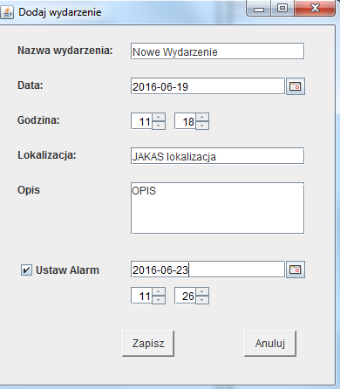Illustration 2: A window lets you add new event and set a alarm.

Class UpdateEvent
extends AddEvent

Field Summary
Modifier and Type | Field and Description
protected com.toedter.components.JSpinField | chooseId  holds event Id
protected javax.swing.JLabel | chooseIdLabel
protected javax.swing.JButton | FillData  loads event from database

Constructor Summary
Constructor and Description
UpdateEvent(java.util.GregorianCalendar calendarDate)
Constructor uses GregorianCalendar for date setting

Method Summary
Modifier and Type | Method and Description
JSpinField | getChooseId()
JLabel | getChooseIdLabel()
JButton | getFillData()
void | setChooseId(com.toedter.components.JSpinField chooseId)
void | setChooseIdLabel(javax.swing.JLabel chooseIdLabel)
void | setFillData(javax.swing.JButton fillData)
void | setFillEventDataBtn(java.awt.event.ActionListener listener)

Constructor Detail
public UpdateEvent(java.util.GregorianCalendar calendarDate)
Constructor uses GregorianCalendar for date setting
Parameters:
calendarDate - Gregorian calendar
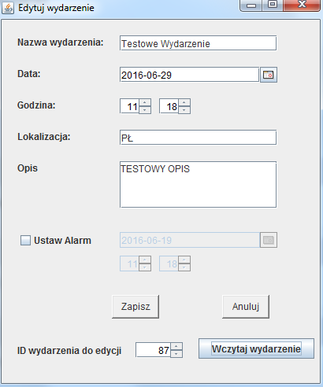Illustration 3: A window for editing events. At the bottom is a field that lets you load informations about event with given ID.

Class ArchivedEvents

Field Summary
Modifier and Type | Field and Description
private javax.swing.JPanel | contentPanel
private javax.swing.JTextPane | eventList  archived events
private java.awt.Button | exitBtn  exit button
private javax.swing.JFrame | frame
private javax.swing.JScrollPane | scroll

Constructor Summary
Constructor and Description
ArchivedEvents()
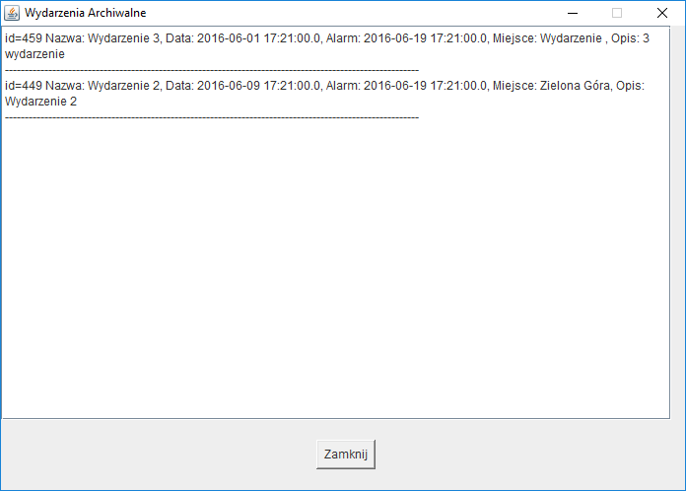Illustration 4: A window showing archival events from the past.

Class FilterEvents

Field Summary
Modifier and Type | Field and Description
private java.awt.Button | addBtn  shows filtered events
private com.toedter.calendar.JDateChooser | alarmDate  calendar to help with setting up the date
(package private) java.util.GregorianCalendar | calendar
private javax.swing.JPanel | contentPanel
private com.toedter.calendar.JDateChooser | date  calendar to help with setting up the date
private javax.swing.JCheckBox | datebox  checkboxes to apply filers
private java.awt.Button | exitBtn  closes the window
private javax.swing.JFrame | frame
private javax.swing.JLabel | label
private javax.swing.JTextField | localization  event localization
private javax.swing.JCheckBox | localizationbox  checkboxes to apply filers

Constructor Summary
Constructor and Description
FilterEvents(java.util.GregorianCalendar calendarDate)
Constructor uses GregorianCalendar for date setting

Method Summary
void | addLocalizationBoxListener(java.awt.event.ActionListener  listener)  listener for localization of the event

Constructor Detail

public FilterEvents(java.util.GregorianCalendar calendarDate)
Constructor uses GregorianCalendar for date setting
Parameters:
calendarDate – Gregorian calendar

Method Detail
public void addLocalizationBoxListener(java.awt.event.ActionListener listener)
listener for localization of the event
Parameters:
listener - action listener

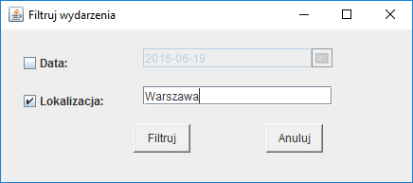Illustration 5: A window for filtering results. You can filter events by date, location or both.

Class MainMenu

Field Summary
Modifier and Type | Field and Description
(package private) javax.swing.JMenuItem | aboutProgram  menu options
(package private) javax.swing.JCheckBoxMenuItem | cbMenuItem
(package private) javax.swing.JMenuItem | close  menu options
(package private) javax.swing.JMenuItem | exportXml  menu options
(package private) javax.swing.JMenuItem | importXml  menu options
(package private) javax.swing.JMenu | menu  menus
(package private) javax.swing.JMenuBar | menuBar  Where the GUI is created:
(package private) javax.swing.JRadioButtonMenuItem | rbMenuItem
private static long | serialVersionUID
(package private) javax.swing.JMenu | submenu  menus

Constructor Summary
Constructor and Description
MainMenu(View view)
constructor needs a view formal parameter

Constructor Detail
MainMenu(View view)
constructor needs a view formal parameter
Parameters:
view - reference to our MainWindow (View Class)
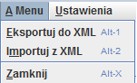Illustration 6: A menu for serialization to XML and closing application.
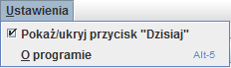Illustration 7: A menu for setting visibility of "Dzisiaj" button, and opening "About program" window.

Class AboutProgram

Field Summary

Modifier and Type | Field and Description
private java.lang.String | about  information about the program
private javax.swing.JPanel | contentPanel
private java.awt.Button | exitBtn  button to exit the program
private javax.swing.JFrame | frame
private javax.swing.JTextArea | txt  text area for information

Constructor Summary
Constructor and Description
AboutProgram()
constructor iniciates all the components of the window
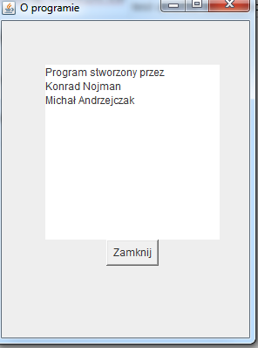Illustration 8: A "about program" window. It contains informations about authors of the application.

Przyciski i skróty klawiszowe

Dodaj wydarzenie – przycisk wyświetla okienko pozwalające dodać nowe wydarzenie do terminarza.
Edytuj wydarzenie – wyświetla okno edycji wydarzenia. Korzystając z przycisku „Wczytaj wydarzenie” możemy wczytać informacje o wydarzeniu, którego ID wpisaliśmy w pole obok.
Filtruj wydarzenia – otwiera okienko pozwalające filtrować wyświetlane wydarzenia zarówno po dacie, lokalizacji jak i korzystając z obydwu kryteriów.
Archiwum wydarzeń – pokazuje okno zawierające wszystkie wydarzenia, które już się odbyły.
Usuń wydarzenie – Usuwa wydarzenie o ID wpisanym w polu po prawej stronie przycisku. Jeśli wydarzenie o podanym ID nie istnieje zostaje wyświetlony stosowny komunikat.
Dzisiaj – przycisk pod kalendarzem. Po naciśnięciu go powracamy w kalendarzu do obecnej daty. Można włączyć/wyłączyć jego widoczność w ustawieniach programu.

Skróty klawiszowe:
Alt + M – otwiera z wstęgi Menu w którym znajdują się opcję do serializacji wydarzeń do pliku XML, oraz przycisk do zamknięcia programu.
- Alt + 1 – Exportuje listę wydarzeń z bazy danych do pliku XML.
- Alt + 2 – Importuje do bazy danych listę obiektów zapisaną w pliku XML.
- Alt + X – Zamknięcie programu.
Alt + U – Otwiera z wstęgi ustawienia programu.
- Przy zaznaczonym polu Pokaż/Ukryj przycisk „Dzisiaj” naciśnięcie Spacji sprawia, że przycisk się pokazuje/znika
- Alt + 5 – Otwiera okno „O programie” zawierające informacje o autorach programu.

XML File Example
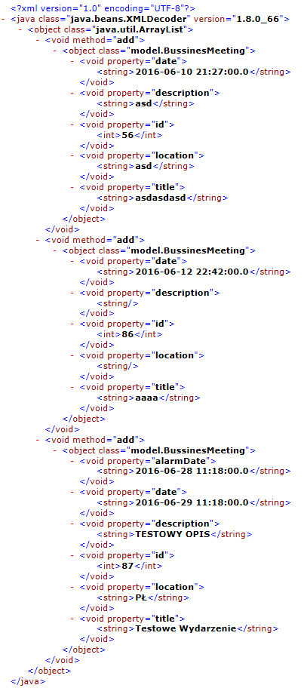
Database Table
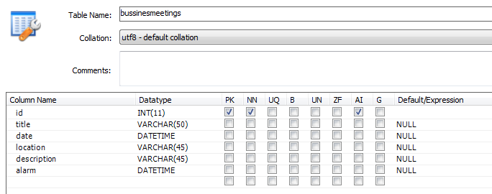
Database Records
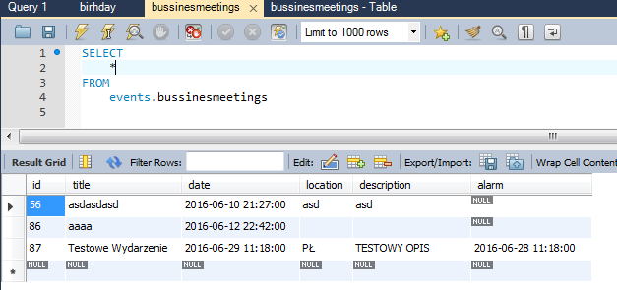
Database Business Meetings Table Source Code
CREATE TABLE `events`.`bussinesmeetings` (
`id` INT NOT NULL DEFAULT 1,
`title` VARCHAR(50) NULL,
`date` DATETIME NULL,
`location` VARCHAR(45) NULL,
`description` VARCHAR(45) NULL,
`alarm` DATETIME NULL ,
PRIMARY KEY (`id`));
Podsumowanie
Przygotowany przez nas program posiada większość oczekiwanych funkcjonalności terminarza. Pozwala dodać zdarzenie przypisać mu datę, opis, nazwę, a także ustawić przypomnienie dźwiękowe.
Mamy możliwość filtrowania dodanych przez nas wydarzeń poczynając od określonej daty lub wydarzeń które są związane z konkretną lokalizacją. Możemy również wykorzystać obydwa te kryteria do filtrowania. Wydarzenia które już miały miejsce są archiwizowane.
Aplikacja zapisuje dodane przez nas wydarzenia do bazy danych MySQL. Mamy również możliwość wyeksportowania/zaimportowania tej bazy do/z pliku XML.
Obecnie program umożliwia zapisywanie jednego rodzaju wydarzeń ale istnieje łatwa możliwość rozszerzenia aplikacji.

