Programowanie komponentowe

Sprawozdanie z pracy projektowej

[Terminarz]

Michał Andrzejczak 195556

Konrad Nojman 195666

Informatyka, sem. IV

2015/ 2016

- Najważniejsze klasy warstwy danych projektu
- załączyć fragmenty (nie całości !!) dokumentów wygenerowanych przez JavaDoc,
czyli nagłówek dokumentu klasy, field summary, constructor summary, method summary, constructor oraz method details) z czytelnymi opisami
- Najważniejsze klasy warstwy logiki
-opis jw.
- Najważniejsze klasy warstwy interfejsu
  - jw.
  - Zrzuty ekranu najważniejszych widoków działającej aplikacji
    - Główne okno kalendarza ,,organizera''
    - Okienko ,,O programie''
    - Okienka dialogowe zapisujące/odczytujące dane i ustawienia do/z bazy/pliku XML
    - Okno dialogowe ,,ustawienia''
    - Dodatkowe funkcje uzgodnione z prowadzącym.
  - Jasny i czytelny opis klawiszy funkcyjnych i przycisków obsługujących aplikację

UWAGA: Po przeczytaniu sprawozdania do tego miejsca, prowadzący powinien mieć wystarczającą ilość danych do swobodnej obsługi programu w celu testowania jego funkcjonalności oraz do orientacji w jednostkach kodu odpowiadającego poszczególnym funkcjom

4. Postać bazy danych z zapisanymi informacjami o zdarzeniach. (zrzut ekranu, fragment kodu/tekstu itp.)
5. Podsumowanie i ewentualne uwagi grupy nt. projektu.

Class Hierarchy
- java.lang.Object
  - view.AboutProgram
  - view.AddEvent
    - view.UpdateEvent
  - controllers.AlarmClock
  - model.AlarmSound
  - java.awt.Component (implements java.awt.image.ImageObserver, java.awt.MenuContainer, java.io.Serializable)
    - java.awt.Container
      - javax.swing.JComponent (implements java.io.Serializable)
        - javax.swing.JMenuBar (implements javax.accessibility.Accessible, javax.swing.MenuElement)
          - view.MainMenu
  - controllers.Controller
  - controllers.DeleteEventAction (implements java.awt.event.ActionListener)
  - controllers.EditEventAction (implements java.awt.event.ActionListener)
  - model.EventBase (implements java.io.Serializable)
    - model.Birthday (implements java.io.Serializable)
    - model.BussinesMeeting
  - model.EventRepository
  - controllers.ExportXmlAction (implements java.awt.event.ActionListener)
  - view.FilterEvents
  - controllers.FilterEventsAction (implements java.awt.event.ActionListener)
  - controllers.ImportXmlAction (implements java.awt.event.ActionListener)
  - program.Program
  - controllers.SQLConnection
  - controllers.SQLConnection.AlarmName
  - java.lang.Throwable (implements java.io.Serializable)
    - java.lang.Exception
      - exceptions.ColumnOutOfRangeException
      - exceptions.DateFormatException
  - controllers.UserEventAction (implements java.awt.event.ActionListener)
  - view.View
  - controllers.XMLActions

Warstwa Danych

Package model

Class Summary
Class | Description
AlarmSound | This class holds a reference to a sound file used for alarm
Birthday | This class is plainly for extension purposes we don't use it in the current version of the application
BussinesMeeting | This class represents business meeting
EventBase | Base Event Class is a super class we use for our events
EventRepository | Repository class helps us with saving data to XML

Class AlarmSound

Constructor Summary
Constructors
Constructor and Description
AlarmSound(java.lang.String path)
Constructor requires path to an audio file used as an alarm sound

Method Summary
Modifier and Type | Method and Description
void | playAlarm()  Starting alarm sound.
void | stopAlarm()  Stopping alarm sound.

Constructor Detail

public AlarmSound(java.lang.String path)

Constructor requires path to an audio file used as an alarm sound

Parameters:
path – to a sound file

Method Detail

public void playAlarm()

this method is responsible for starting alarm sound

public void stopAlarm()
this method is responsible for stopping alarm sound
Class EventBase
implements java.io.Serializable
Base Event Class is a super class we use for our events

Constructor Summary
Constructor and Description
EventBase()
constructor without parameters is needed for xml serialization
EventBase(int id, java.lang.String title, java.lang.String date, java.lang.String location, java.lang.String description, java.lang.String alarmDate)
Constructor of base event class

Constructor Detail

public EventBase()

constructor without parameters is needed for xml serialization
public EventBase(int id,
java.lang.String title,
java.lang.String date,
java.lang.String location,
java.lang.String description,
java.lang.String alarmDate)
Constructor of base event class
Parameters:
id - event id
title - event title
date - event date
location – location of the event
description - event description
alarmDate - date of the alarm

Class EventRepository

Constructor Summary
Constructors
Constructor and Description
EventRepository()
allocates memory for Array List of events

Method Summary
Modifier and Type | Method and Description
void | addRecord(EventBase obj)  Method for adding new events to local repository
java.lang.String | filterByLocation(java.lang.String location)  Deprecated.  we found not much usage for it yet
java.util.ArrayList<EventBase> | getEventList()
void | setEventList(java.util.ArrayList<EventBase> eventList)
java.lang.String | toString()

Method Detail
public void addRecord(EventBase obj)
Method for adding new events to local repository
Parameters:
obj - event
public java.lang.String filterByLocation(java.lang.String location)
Deprecated.
we found not much usage for it yet
method filters repository by location
Parameters:
location -
Returns:
String

Warstwa Logiki

Package controllers
Class Summary
Class | Description
AlarmClock | Alarm Clock starts a timer that performs a task every minute task is to check if there is an alarm set for event
ArchivedEventsAction | this class is an event handler for ArchivedEvents window
Controller | Controller is a class that connects all other components of the application
DeleteEventAction | This class is a handler for deleting events
EditEventAction | Event Handle for Editing events
ExportXmlAction | this class is responsible for xml export user actions
FilterEventsAction | This Class is responsible for event handling in FilterEvents window
ImportXmlAction | this class is responsible for xml import user actions
SQLConnection | this class is responsible for conencting to database as well as providing methods for extracting and inserting data to Database
UserEventAction | This Class is an event handler for AddEvent window
XMLActions | this class provides us with with functionality of a top level static class It lets us (de)serialize an object to xml file

Package exceptions
Exception Summary
Exception | Description
ColumnOutOfRangeException | This Class represents custom exception.
DateFormatException | This Class represents custom exception.

Class AlarmClock

Constructor Summary
Constructor and Description
AlarmClock(AlarmSound sound, View view, SQLConnection connection)
Constructor requires reference to AlarmSound class View and SQLConnection

Constructor Detail
public AlarmClock(AlarmSound sound,
View view,
SQLConnection connection)
Constructor requires reference to AlarmSound class View and SQLConnection
Parameters:
sound - provides an audio stream
view - reference to a View Class
connection - reference to database connection
See Also:
AlarmSound, View, SQLConnection

Method Detail
public void checkForAlarm()
method performs a TimerTask.It checks database for next allarm

public void soundAlarm(SQLConnection.AlarmName alarm)
Method starts and alarm using AlarmName class which hold a reference to name and alarm date
Parameters:
alarm - return alarm name and alarm date
See Also:
SQLConnection.AlarmName

Class Controller

Field Summary
Modifier and Type | Field and Description
(package private) AddEvent | addEventView
(package private) SQLConnection | sqlConnection
(package private) View | view

Constructor Summary
Constructor and Description
Controller(View view, SQLConnection sqlConnection)
Constructor need a refference to Event Repository View and SQLConnention

Constructor Detail
public Controller(View view,
SQLConnection sqlConnection)
Constructor need a refference to Event Repository View and SQLConnention
Parameters:
repo - holdsa reference to EventRepository
view - providesarefference to View Class
sqlConnection - provides reference to database using SQLConnection
See Also:
EventRepository, View, SQLConnection

Class ArchivedEventsAction
All Implemented Interfaces:
java.awt.event.ActionListener, java.util.EventListener

Field Summary
Modifier and Type | Field and Description
(package private) java.sql.Date | date
(package private) SQLConnection | sqlConnection

Constructor Summary
Constructor and Description
ArchivedEventsAction(SQLConnection sqlConnection)
Constructor requires SQLConnection

Method Summary
Modifier and Type | Method and Description
void | actionPerformed(java.awt.event.ActionEvent e)  event handler for showing archived Events

Constructor Detail

public ArchivedEventsAction(SQLConnection sqlConnection)

Constructor requires SQLConnection

Parameters:
sqlConnection - connection to database

Method Detail

public void actionPerformed(java.awt.event.ActionEvent e)

event handler for showing archived Events

Specified by:
actionPerformed in interface java.awt.event.ActionListener

Class DeleteEventAction
All Implemented Interfaces:
java.awt.event.ActionListener, java.util.EventListener

Field Summary
Modifier and Type | Field and Description
(package private) SQLConnection | sqlConnection
(package private) View | view

Constructor Summary
Constructor and Description
DeleteEventAction(SQLConnection sqlConnection, View view)
constructor needs reference to SQLConnection and View

Method Summary
Modifier and Type | Method and Description
void | actionPerformed(java.awt.event.ActionEvent e)  method responsible for event handling

Constructor Detail
public DeleteEventAction(SQLConnection sqlConnection,
View view)
constructor needs reference to SQLConnection and View
Parameters:
sqlConnection – database connection
view - MainWindow

Class EditEventAction
All Implemented Interfaces:
java.awt.event.ActionListener, java.util.EventListener

Field Summary
Modifier and Type | Field and Description
(package private) int | Id
(package private) SQLConnection | sqlConnection
(package private) UpdateEvent | upEvent
(package private) View | view

Constructor Summary
Constructor and Description
EditEventAction(View view, SQLConnection sqlConnection)
Constructro with View and SQLConnection references

Method Summary
Modifier and Type | Method and Description
void | actionPerformed(java.awt.event.ActionEvent arg0)  this method performs event handling using local classes which are implementations of ActionListener

Constructor Detail
public EditEventAction(View view,
SQLConnection sqlConnection)
Constructor with View and SQLConnection references
Parameters:
view -
sqlConnection -

Method Detail
public void actionPerformed(java.awt.event.ActionEvent arg0)
this method performs event handling using local classes which are implementations of ActionListener
Specified by:
actionPerformed in interface java.awt.event.ActionListener

Class ExportXmlAction
All Implemented Interfaces:
java.awt.event.ActionListener, java.util.EventListener

Field Summary
Modifier and Type | Field and Description
(package private) SQLConnection | sqlConnection
(package private) View | view

Constructor Summary
Constructor and Description
ExportXmlAction(View view, SQLConnection sqlConnection)

Method Summary
Modifier and Type | Method and Description
void | actionPerformed(java.awt.event.ActionEvent e)

Constructor Detail
public ExportXmlAction(View view,
SQLConnection sqlConnection)
constructor requires reference View SQLConnection and EventRepository
Parameters:
view - MainWindow class
sqlConnection – database connection
repo - event repository
See Also:
main window, sqlConnection, repo

Method Detail
public void actionPerformed(java.awt.event.ActionEvent e)
Specified by:
actionPerformed in interface java.awt.event.ActionListener

Class ImportXmlAction
All Implemented Interfaces:
java.awt.event.ActionListener, java.util.EventListener

Field Summary
Modifier and Type | Field and Description
(package private) SQLConnection | sqlConnection
(package private) View | view

Constructor Summary
Constructor and Description
ImportXmlAction(View view, SQLConnection sqlConnection)
constructor requires reference View SQLConnection and EventRepository

Method Summary
Modifier and Type | Method and Description
void | actionPerformed(java.awt.event.ActionEvent e)  event handling for xml import

Constructor Detail
public ImportXmlAction(View view,
SQLConnection sqlConnection)
constructor requires reference View SQLConnection and EventRepository
Parameters:
view - MainWindow class
sqlConnection – database connection
repo - event repository
See Also:
main window, sqlConnection, repo

Class FilterEventsAction
All Implemented Interfaces:
java.awt.event.ActionListener, java.util.EventListener

Field Summary
Modifier and Type | Field and Description
(package private) FilterEvents | filterEvents
(package private) SQLConnection | sqlconnection
(package private) View | view

Constructor Summary
Constructor and Description
FilterEventsAction(View view, SQLConnection sqlconnection)
constructor with reference to SQLConnection and View

Method Summary
Modifier and Type | Method and Description
void | actionPerformed(java.awt.event.ActionEvent e)  implementation of Action Listener Method

Constructor Detail
public FilterEventsAction(View view,
SQLConnection sqlconnection)
constructor with reference to SQLConnection and View
Parameters:
view - MainWindow class
sqlConnection – database connection

Class SQLConnection

Nested Class Summary
Modifier and Type | Class and Description
class | SQLConnection.AlarmName  this inner class holds necessary information about alarm - name and date

Field Summary
Modifier and Type | Field and Description
private java.sql.Connection | dbConnection
private java.lang.String | jdbcConnectionString
private java.lang.String | password
private java.lang.String | user

Constructor Summary
Constructor and Description
SQLConnection(java.lang.String jdbcConnectionString, java.lang.String user, java.lang.String password)
Constructor takes parameters responsible for user credential information necessary to connect to database server

Method Summary

Modifier and Type | Method and Description
void | addAllarmToDatabase(int id, java.lang.String datetime)  this mathod is responsible for adding alarm to data base event record
void | addEventToDatabaseTable(java.lang.String table, java.lang.String title, java.lang.String date, java.lang.String location, java.lang.String description, java.lang.String personImeetWith, java.lang.String alarm)  This method is responsible for adding a new record to event database
void | connectToDataBase()  This Method Performs a connection to database it has to be invoked before attempting to query database
EventRepository | filterEventsByDate(java.lang.String date, boolean older)  This method filters events in database by date
java.lang.String | filtereventsByLocation(java.lang.String location)  This method filters events in database by Location
java.lang.String | filtereventsByLocationAndDate(java.lang.String location, java.lang.String date)  This method filters events in database by date and location
java.lang.String | filterEventsByYear(java.lang.String date)  This method filters events in database by date
EventRepository | getAllEvents()  This Method return all existing events form the database
SQLConnection.AlarmName | getNextAlarm()  this Method queries database for the next alarm and returns Alarm name and date
java.lang.String | PrintEvents()  This method return string representation of events in database
void | removeEventFromTableWithID(int id, java.lang.String table)  this mehtod is used to remove record for the database
EventBase | SelectEventWithId(int id)  This method performs a select query and returns the event with matching id
void | setAlarmToNull()  this method is used to set alarm date to null so it won't ring more then once
void | setDbConnection(com.mysql.jdbc.Connection dbConnection)
void | updateRecordInTable(java.lang.String table, java.lang.String id, java.lang.String title, java.lang.String date, java.lang.String location, java.lang.String description, java.lang.String personImeetWith)  this method is used for updating existing event in database

Constructor Detail
public SQLConnection(java.lang.String jdbcConnectionString,
java.lang.String user,
java.lang.String password)
throws java.lang.ClassNotFoundException
Constructor takes parameters responsible for user credential information necessary to connect to database server
Parameters:
jdbcConnectionString - connection string for database server
user - User name
password - User password
Throws:
java.lang.ClassNotFoundException

Method Detail
public void connectToDataBase()
This Method Performs a connection to database it has to be invoked before attempting to query database
public void addEventToDatabaseTable(java.lang.String table,
java.lang.String title,
java.lang.String date,
java.lang.String location,
java.lang.String description, java.lang.String personImeetWith,
java.lang.String alarm)
This method is responsible for adding a new record to event database
Parameters:
table - name of the database table
title - title of the event
date - date of the event
location -
description -
personImeetWith -
alarm - date of the alarm

public void removeEventFromTableWithID(int id,
java.lang.String table)
this mehtod is used to remove record for the database
Parameters:
id - event id in database
table - name of a table in database
public void updateRecordInTable(java.lang.String table,
java.lang.String id,
java.lang.String title,
java.lang.String date,
java.lang.String location,
java.lang.String description,
java.lang.String personImeetWith)
this method is used for updating existing event in database
Parameters:
table - name of the table in databse
id - event id in database
title - event title
date - event date
location – event location
description – event description

public void addAllarmToDatabase(int id,
java.lang.String datetime)
this method is responsible for adding alarm to data base event record
Parameters:
id - event id
datetime - date of the alarm
public EventBase SelectEventWithId(int id)
throws java.sql.SQLException
This method performs a select query and returns the event with matching id
Parameters:
id - event id
Returns:
EventBase
Throws:
java.sql.SQLException
See Also:
EventBase
public EventRepository getAllEvents()
This Method return all existing events form the database
Returns:
EventRepository
See Also:
EventRepository

public java.lang.String PrintEvents()
This method return string representation of events in database
Returns:
String
public java.lang.String filterEventsByYear(java.lang.String date)
This method filters events in database by date
Parameters:
date -
Returns:
String
public EventRepository filterEventsByDate(java.lang.String date,
boolean older)
This method filters events in database by date
Parameters:
date -
Returns:
EventRepository
See Also:
EventRepository
public java.lang.String filtereventsByLocation(java.lang.String location)
This method filters events in database by Location
Parameters:
location -
Returns:
String
public java.lang.String filtereventsByLocationAndDate(java.lang.String location,
java.lang.String date)
This method filters events in database by date and location
Parameters:
location -
date - date of the event
Returns:
String

public SQLConnection.AlarmName getNextAlarm()
this Method queries database for the next alarm and returns Alarm name and date
Returns:
SQLConnection.AlarmName
See Also:
SQLConnection.AlarmName
public void setAlarmToNull()
this method is used to set alarm date to null so it won't ring more then once

Class UserEventAction
All Implemented Interfaces:
java.awt.event.ActionListener, java.util.EventListener

Field Summary
Modifier and Type | Field and Description
(package private) AddEvent | addEvent
(package private) SQLConnection | sqlConnection
(package private) View | view

Constructor Summary
Constructor and Description
UserEventAction(View view, SQLConnection sqlConnection)
constructor requires a reference to view and sql connection

Method Summary
Modifier and Type | Method and Description
void | actionPerformed(java.awt.event.ActionEvent arg0)  This method contains two local classes responsible which are implementation of action listener These two listeners are responsible for adding event and and alarm if user chooses to set one

Constructor Detail
public UserEventAction(View view,
SQLConnection sqlConnection)
constructor requires a reference to view and sql connection
Parameters:
view – Main window class
sqlConnection – db connection
public void actionPerformed(java.awt.event.ActionEvent arg0)
This method contains two local classes responsible which are implementation of action listener These two listeners are responsible for adding event and and alarm if user chooses to set one
Specified by:
actionPerformed in interface java.awt.event.ActionListener

Class XMLActions

Field Summary
Modifier and Type | Field and Description
private static java.beans.XMLDecoder | decoder
private static java.beans.XMLEncoder | encoder
private static EventRepository | eventRepo
private static MainMenu | menu

Constructor Summary
Modifier | Constructor and Description
private | XMLActions()  constructor is private so this class works like a top level static class

Method Summary
Modifier and Type | Method and Description
static void | loadEventsFromXML()  this method is responsible for importing events form xml file
static void | saveEventsToXML()  this method is responsible for saving events from the event repo to the xml file

Constructor Detail
private XMLActions()
constructor is private so this class works like a top level static class

Method Detail
public static void saveEventsToXML()
this method is responsible for saving events from the event repo to the xml file
public static void loadEventsFromXML()
this method is responsible for importing events form xml fil

Wartswa Prezentacji
Class Summary
Class | Description
AboutProgram | This Class represents window which display info about the program
AddEvent | this class represents a window for adding new events
ArchivedEvents | Class represens window with archived events
FilterEvents | this class represents a window for filtering events We can filter either by date or location
MainMenu | this class represents a main menu of the application
UpdateEvent | this class represents a window for updating events
View | this class represents a MainWindow of our Application it shows all events and Jcallendar also provides buttos for adding filtering and updating events

Class View

Field Summary
Modifier and Type | Field and Description
private javax.swing.JButton | archEventsBtn
private javax.swing.JPanel | buttonPanel
private com.toedter.calendar.JCalendar | calendar
private javax.swing.JPanel | calendarPanel
private javax.swing.JPanel | contentPanel
private javax.swing.JButton | deleteEventBtn
private com.toedter.components.JSpinField | deleteEventId
private javax.swing.JButton | editEventbtn
private javax.swing.JTextPane | eventList
private javax.swing.JScrollPane | eventlistSlider
private javax.swing.JPanel | eventPanel
private javax.swing.JButton | filterBtn
private javax.swing.JFrame | frame
(package private) MainMenu | mainMenu
private boolean | todayBtnVisible
private javax.swing.JButton | userEventBtn

Constructor Summary
Constructor and Description
View()
constructor of the view class

Method Summary

Modifier and Type | Method and Description
void | addArchiveBtnActionListener(java.awt.event.ActionListener listener)
void | addDeleteBtnActionListener(java.awt.event.ActionListener listener)
void | addEditEventActionListener(java.awt.event.ActionListener listener)  Action listener for edit button
void | addfilterEventsActionListener(java.awt.event.ActionListener listener)  Action listener for filter button
void | addUserEventActionListener(java.awt.event.ActionListener listener)
void | showAlarmMessage(java.lang.String message)  this method shows JOptionPane with an alarm message
void | showMessage(java.lang.String message)  this method shows JOptionPane with an error message

Constructor Detail
public View()
constructor of the view class

Method Detail
public void addEditEventActionListener(java.awt.event.ActionListener listener)
Action listener for edit button
Parameters:
listener - action listener
public void addfilterEventsActionListener(java.awt.event.ActionListener listener)
Action listener for filter button
Parameters:
listener - action listener
public void showMessage(java.lang.String message)
this method shows JOptionPane with an error message
Parameters:
message - error message
public void showAlarmMessage(java.lang.String message)
this method shows JOptionPane with an alarm message
Parameters:
message - alarm info
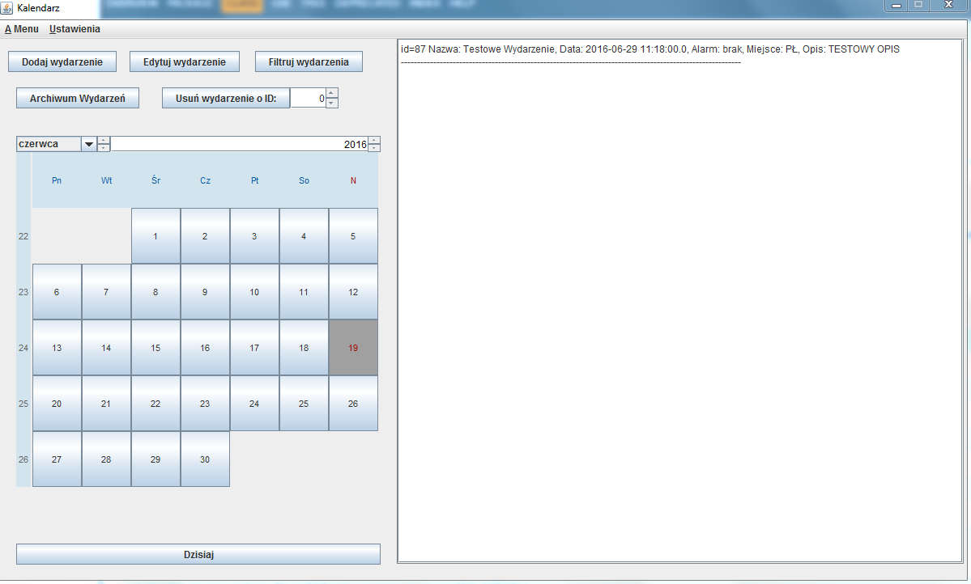

Class AddEvent

Field Summary

Modifier and Type | Field and Description
protected java.awt.Button | addBtn
protected javax.swing.JCheckBox | alarmbox
protected com.toedter.calendar.JDateChooser | alarmDate
protected com.toedter.components.JSpinField | alarmHour
protected javax.swing.JLabel | alarmlabel
protected com.toedter.components.JSpinField | alarmMinutes
(package private) java.util.GregorianCalendar | calendar
protected javax.swing.JPanel | contentPanel
protected com.toedter.calendar.JDateChooser | date
protected javax.swing.JScrollPane | descriptionScroll
protected javax.swing.JTextArea | descriptionTxt
protected java.awt.Button | exitBtn
protected javax.swing.JFrame | frame
protected com.toedter.components.JSpinField | hour
protected javax.swing.JLabel | label
protected javax.swing.JTextField | localizationField
protected com.toedter.components.JSpinField | minutes
protected javax.swing.JTextField | nameField

Constructor Summary
Constructor and Description
AddEvent(java.util.GregorianCalendar calendarDate)
Constructor uses GregorianCalendar for date setting

Method Summary

Modifier and Type | Method and Description
void | addAddBtnListener(java.awt.event.ActionListener listener)  this method sets action listener for add event button
void | AddAlarmAcionListener(java.awt.event.ActionListener turnOnTheAlarm)  this Method sets action listener for alarm checkbox

Constructor Detail
public AddEvent(java.util.GregorianCalendar calendarDate)
Constructor uses GregorianCalendar for date setting
Parameters:
calendarDate - gregorian callendar

Method Detail
public void addAddBtnListener(java.awt.event.ActionListener listener)
this method sets action listener for add event button
Parameters:
listener - action listener
public void AddAlarmAcionListener(java.awt.event.ActionListener turnOnTheAlarm)
this Method sets action listener for alarm checkbox
Parameters:
turnOnTheAlarm - action listener

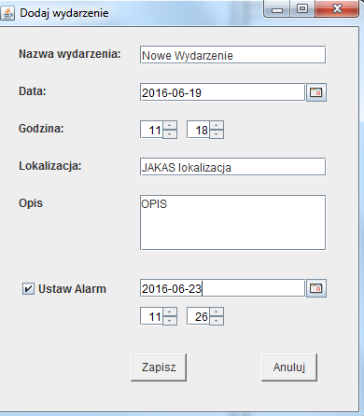

Class UpdateEvent

Field Summary
Modifier and Type | Field and Description
protected com.toedter.components.JSpinField | chooseId
protected javax.swing.JLabel | chooseIdLabel
protected javax.swing.JButton | fillData

Constructor Summary
Constructor and Description
UpdateEvent(java.util.GregorianCalendar calendarDate)
Constructor uses GregorianCalendar for date setting

Method Summary
Modifier and Type | Method and Description
JSpinField | getChooseId()
JLabel | getChooseIdLabel()
JButton | getFillData()
void | setChooseId(com.toedter.components.JSpinField chooseId)
void | setChooseIdLabel(javax.swing.JLabel chooseIdLabel)
void | setFillData(javax.swing.JButton fillData)
void | setFillEventDataBtn(java.awt.event.ActionListener listener)

Constructor Detail
public UpdateEvent(java.util.GregorianCalendar calendarDate)
Constructor uses GregorianCalendar for date setting
Parameters:
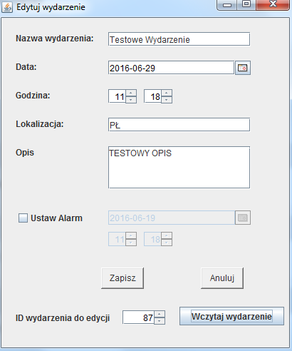
calendarDate - gregorian calendar

Class ArchivedEvents

Field Summary
Modifier and Type | Field and Description
private javax.swing.JPanel | contentPanel
private javax.swing.JTextPane | eventList
private java.awt.Button | exitBtn
private javax.swing.JFrame | frame
private javax.swing.JScrollPane | scroll

Constructor Summary
Constructor and Description
ArchivedEvents()

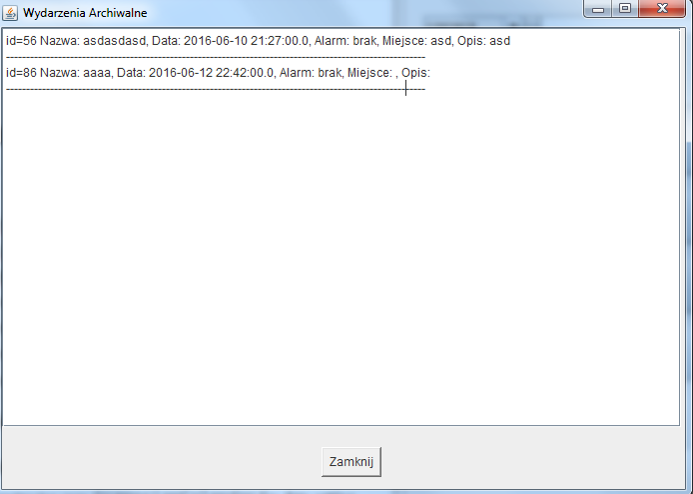

Class FilterEvents

Field Summary
Modifier and Type | Field and Description
private java.awt.Button | addBtn
private com.toedter.calendar.JDateChooser | alarmDate  callendar to help with setting up the date
(package private) java.util.GregorianCalendar | calendar
private javax.swing.JPanel | contentPanel
private com.toedter.calendar.JDateChooser | date  callendar to help with setting up the date
private javax.swing.JCheckBox | datebox  checkboxes to apply filers
private java.awt.Button | exitBtn  closes the window
private javax.swing.JFrame | frame
private javax.swing.JLabel | label
private javax.swing.JTextField | localization  event localization
private javax.swing.JCheckBox | localizationbox  checkboxes to apply filers

Constructor Summary
Constructor and Description
FilterEvents(java.util.GregorianCalendar calendarDate)
Constructor uses GregorianCalendar for date setting

Method Summary
void | addLocalizationBoxListener(java.awt.event.ActionListener listener)  listener for localization of the event

Constructor Detail

public FilterEvents(java.util.GregorianCalendar calendarDate)
Constructor uses GregorianCalendar for date setting
Parameters:
calendarDate – gregorian callendar

Method Detail
public void addLocalizationBoxListener(java.awt.event.ActionListener listener)
listener for localization of the event
Parameters:
listener - action listener

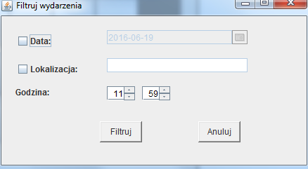
Class MainMenu

Field Summary

Modifier and Type | Field and Description
(package private) javax.swing.JMenuItem | aboutProgram  menu options
(package private) javax.swing.JCheckBoxMenuItem | cbMenuItem
(package private) javax.swing.JMenuItem | close  menu options
(package private) javax.swing.JMenuItem | exportXml  menu options
(package private) javax.swing.JMenuItem | importXml  menu options
(package private) javax.swing.JMenu | menu  menus
(package private) javax.swing.JMenuBar | menuBar  Where the GUI is created:
(package private) javax.swing.JRadioButtonMenuItem | rbMenuItem
private static long | serialVersionUID
(package private) javax.swing.JMenu | submenu  menus

Constructor Summary
Constructor and Description
MainMenu(View view)
constructor needs a view formal parameter

Constructor Detail
MainMenu(View view)
constructor needs a view formal parameter
Parameters:
view - reference to our MainWindow (View Class)
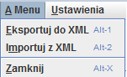
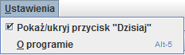

Class AboutProgram

Field Summary

Modifier and Type | Field and Description
private java.lang.String | about  information about the program
private javax.swing.JPanel | contentPanel
private java.awt.Button | exitBtn  button to exit the program
private javax.swing.JFrame | frame
private javax.swing.JTextArea | txt  text area for information

Constructor Summary
Constructor and Description
AboutProgram()
constructor iniciates all the components of the window

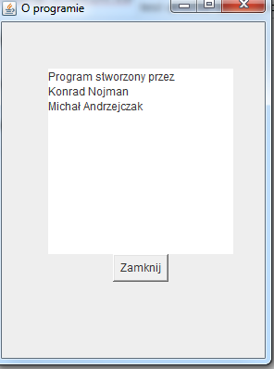

XML File Example
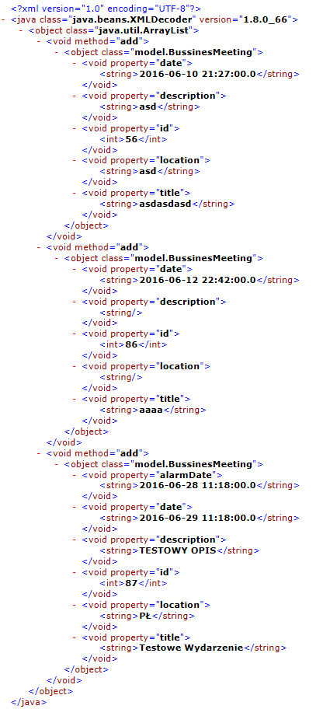
Data Base Table
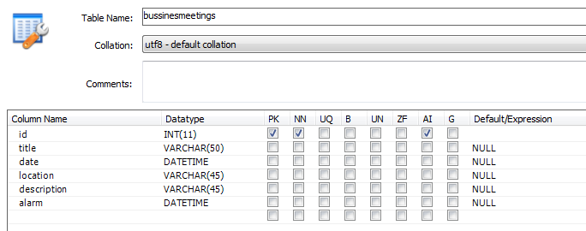
Data Base Records
