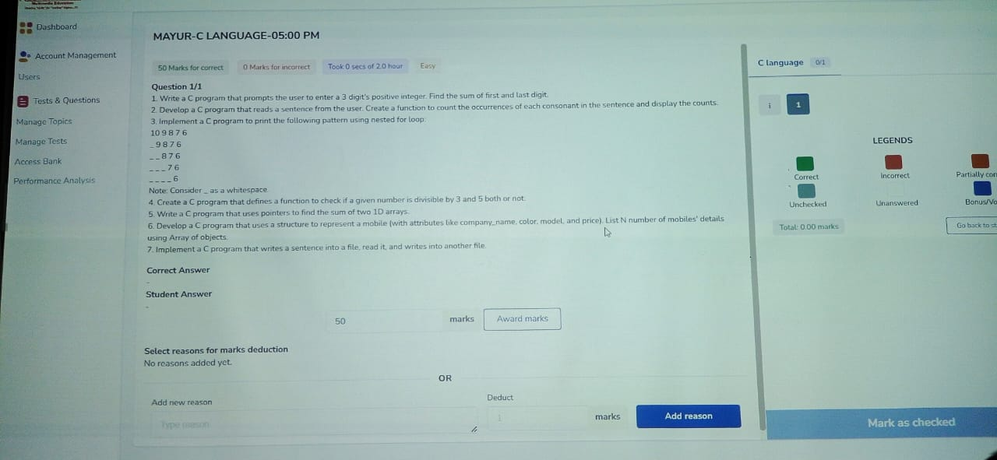

Dashboard

Account Management

MAYUR-C LANGUAGE-05:00 PM

Users

Tests & Questions

Manage Topics

Manage Tests

Access Bank

Performance Analysis

50 Marks for correct Question 1/1

0 Marks for incorrect

Took 0 secs of 2.0 hour

Easy

1. Write a C program that prompts the user to enter a 3 digit's positive integer. Find the sum of first and last digit.

2. Develop a C program that reads a sentence from the user. Create a function to count the occurrences of each consonant in the sentence and display the counts. 3. Implement a C program to print the following pattern using nested for loop.

109876

9876

--876

---76

Note: Consider as a whitespace

4. Create a C program that defines a function to check if a given number is divisible by 3 and 5 both or not.

5. Write a C program that uses pointers to find the sum of two 1D arrays.

6. Develop a C program that uses a structure to represent a mobile (with attributes like company name, color, model, and price). List N number of mobiles' details using Array of objects

7. Implement a C program that writes a sentence into a file, read it, and writes into another file.

Correct Answer

Student Answer

Select reasons for marks deduction

No reasons added yet.

Add new reason

Type reason

50

marks

Award marks

C language

0/1

LEGENDS

Correct

Incorrect

Partially com

Unchecked

Unanswered

Bonus/Vor

**Total: 0.00 marks**

**Go back to st**

OR

Deduct

**marks**

Add reason

**Mark as checked**