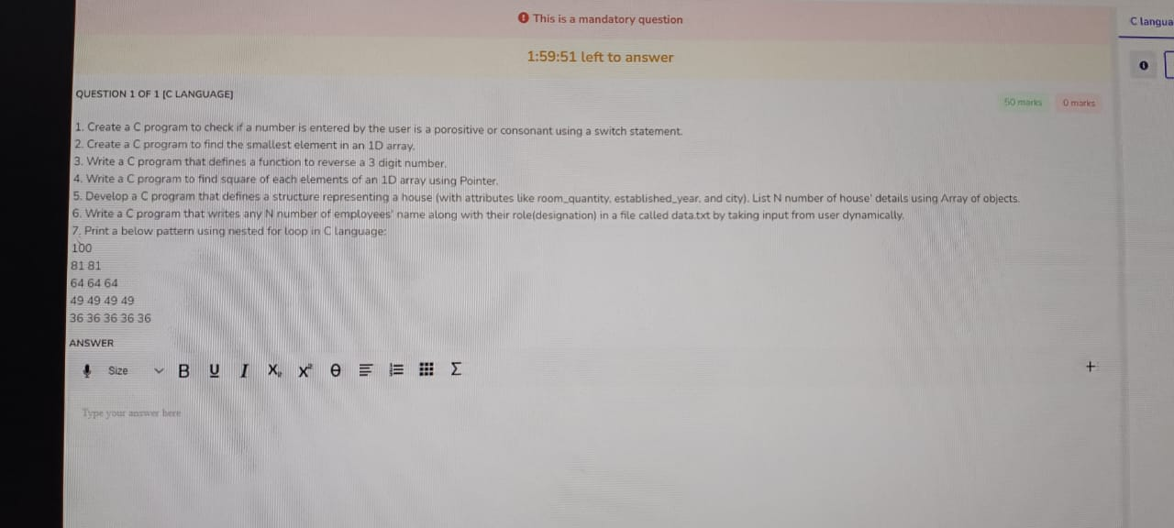

QUESTION 1 OF 1 [C LANGUAGE]

This is a mandatory question

1:59:51 left to answer

50 marks

1. Create a C program to check if a number is entered by the user is a porositive or consonant using a switch statement.

2. Create a C program to find the smallest element in an 1D array.

3. Write a C program that defines a function to reverse a 3 digit number.

4. Write a C program to find square of each elements of an 1D array using Pointer.

5. Develop a C program that defines a structure representing a house (with attributes like room quantity, established year, and city). List N number of house' details using Array of objects. 6. Write a C program that writes any N number of employees' name along with their role(designation) in a file called data.txt by taking input from user dynamically.

7. Print a below pattern using nested for loop in C Language:

100

81 81

64 64 64

49 49 49 49

36 36 36 36 36

ANSWER

Size

+ BUI X x 0 = E . .

Type your answer here

O marks

+

C langua

0