**The Future of Image Analysis: Object Label Detection with AWS Rekognition and Cloud Services**

Mit Yogeshkumar Pandya(20IT076)

Charotar University of Science and Technology (CHARUSAT)

**Abstract:** In an age of rapidly advancing technology, computer vision and image analysis have gained substantial prominence across industries. Amazon Web Services (AWS) offers a comprehensive ecosystem for developers, data scientists, and businesses to unlock the potential of visual data. This paper delves into the technical aspects of AWS Rekognition and explores how it can be integrated with AWS Lambda, Amazon S3, and CloudWatch Logs for object label detection. By examining core functionalities and providing practical implementation insights, this paper empowers users to leverage AWS services effectively.

**Keywords: (Rekognition), (Object label detection),**

**Server-less computing.**

## INTRODUCTION

The area of computer vision has emerged as a revolutionary force across a wide range of industries in an era marked by the unrelenting pace of technological advancement. As a provider of a range of services that help programmers, data scientists, and companies realise the full potential of visual data, Amazon Web Services (AWS) has continued to be at the forefront of these developments. Amazon Rekognition, a cloud-based deep learning service that offers a broad variety of image and video analysis capabilities, is one of the jewels in the crown of AWS's products. Among this wide range of tools, object label identification stands out as a crucial one. It allows us to recognise items in pictures and videos, substantially altering the way we interact with visual data.

It is crucial to understand the importance of object label detection in the current digital landscape as we set out on this adventure into the world of AWS Rekognition. The complex web of technologies and services that enable real-time object label identification and insights from visual input is the focus of this article. This concept is primarily driven by AWS Rekognition, but the seamless integration of AWS Lambda, Amazon S3, and CloudWatch Logs allows for the full realisation of its potential. Together, these services allow for the effective processing, analysis, and monitoring of visual data, turning unprocessed photos and videos into insights that can be put to use.

The In this paper, we will navigate through the various facets of AWS Rekognition, object label detection, and the orchestration of these services to create a robust, scalable, and cost-efficient solution. Specifically, we will explore how AWS Lambda, the serverless compute service, acts as the orchestrator, triggering the AWS Rekognition functions. Amazon S3, as a versatile and scalable data store, houses the images and videos that serve as the raw material for object label detection. Moreover, CloudWatch Logs provides real-time insights and monitoring capabilities, ensuring that the entire system operates seamlessly and securely.

As we traverse through the contents of this paper, we will not only provide technical details, code snippets, and practical implementation insights but also delve into real-world applications and use cases across various domains. From e-commerce and security to automation and beyond, AWS Rekognition and its accompanying services offer solutions that cater to diverse industry requirements, making the power of visual data accessible to all.AWS Rekognition's object label detection works by analyzing images or videos. It uses deep learning models to identify patterns, shapes, and objects within the visual data. Once analyzed, it provides labels and a confidence score for detected objects. This information can then be used for various applications, such as content moderation, e-commerce, and security, to make sense of visual content and automate tasks.

The idea of object label detection is at the core of the AWS Rekognition technology. Applications can identify between various items in visual footage, including people, cars, animals, and more, thanks to this technology. By doing this, it goes beyond simple visual identification and turns unprocessed pictures and videos into sources of useful information. Such a capability has enormous consequences. It opens the door to a wide range of applications, including customised media content recommendation systems, improved surveillance security, faster retail inventory management, and automated quality control in manufacturing.

Visual content production and consumption have increased at an unparalleled rate in the 21st century's digital environment. We now produce enormous amounts of picture and video data every day due to the widespread use of smartphones, cameras, and surveillance systems. This deluge of visual data comes from a variety of sources, including social media sites with tonnes of pictures, security systems watching over public areas, and business apps that use image analysis to automate processes. The capacity to draw meaningful conclusions from this data is now more important than ever.

The underlying concept of serverless computing has completely changed how we approach object label recognition in the context of cloud-based solutions, as demonstrated by services like AWS Lambda. The processing of a variety of visual data, which can be irregular in its demands, is frequently required for object label detection. The significance of serverless computing is made clear in a number of crucial areas.

Scalability and flexibility are two of serverless computing's main benefits. Workloads for object label identification can vary greatly, and serverless solutions enable automatic scaling based on incoming requests. Without the need for manual changes or the upkeep of a fleet of idle servers, this dynamic scaling ensures that computational resources are deployed precisely when they are required. It thus optimises resource usage, reducing expenses and raising overall system effectiveness.

Serverless computing also has a big advantage in terms of cost effectiveness. Regardless of demand fluctuations, traditional server-based architectures demand the provisioning and maintenance of a constant set of servers. In contrast, pay-as-you-go is used by serverless services like AWS Lambda. This means that when doing object label identification activities, you just pay for the actual compute time and resources used. This method drastically lowers operational costs, especially when managing variable workloads.

Reducuced maintenance burden is another compelling factor. Serverless computing abstracts the underlying infrastructure management, eliminating the need for time-consuming tasks like server provisioning, configuration, and maintenance. This abstraction empowers developers to focus primarily on the development of the object label detection application itself, rather than getting bogged down in infrastructure-related concerns. Consequently, it streamlines the development process, reduces operational overhead, and accelerates time-to-market for these applications.

Additionally, serverless computing is a key enabler for the demands of real-time processing. Numerous object label identification applications call for real-time or nearly real-time visual content analysis. Applications can handle photos and videos quickly and effectively thanks to serverless computing's agility. In use situations like security surveillance, where prompt object identification can prompt prompt replies and alarms, boosting security measures, this is very important.

The ability of serverless systems, such AWS Lambda, to integrate and orchestrate allows for the creation of sophisticated workflows. They manage and integrate many AWS services, such as AWS Rekognition, CloudWatch Logs for monitoring and logging, and Amazon S3 for data storage, all with ease. These connectors make it easier for developers to create complex object label detection workflows that quickly process, examine, and react to visual material, enhancing system functionality and effectiveness overall. Serverless computing is essential for improving the functionality of cloud-based object label detection apps, allocating resources efficiently, increasing productivity, and ultimately delivering more potent and responsive solutions.

**II. LITERATURE SURVEY**

The body of knowledge on object label detection is extensive and varied. We come across a plethora of research papers and studies as we go further, all of which have helped to develop the subject. Convolutional neural networks (CNNs), in particular, have become the foundation for deep learning object detection models. In a variety of disciplines, researchers have carefully examined the conceptual underpinnings, real-world applications, and difficulties of object label detection. Notably, these investigations have been motivated by the search for real-time or batch item label identification, including use applications such autonomous vehicles, surveillance systems, and content moderation. The result of these studies offers the fundamental knowledge required to comprehend the state of object label identification technology at this time.

Juan Urra and Jordi Vitrià's paper, "Deep Learning for Object Detection: A Comprehensive Review," provides readers with a thorough analysis of deep learning methods in the field of object detection. While not the only topic of discussion, AWS Rekognition is investigated as one of the cloud-based services in this more general context. The theoretical foundations and practical applications of object detection in visual content are thoroughly explored in this work. The development of the technology, its importance in the field of computer vision, and the function of cloud-based services like Rekognition are all thoroughly explained for the benefit of the readers. For scholars and practitioners trying to understand the complexity of object identification, this thorough overview is a great resource.

Authored by Pierre Sermanet, David Eigen, Xiang Zhang, and others, the research paper "Real-time Object Detection in Videos using Deep Learning Methods" explores real-time object detection in videos. While AWS Rekognition is not the central focus, the paper provides substantial insights into the fascinating domain of object detection in video content. The research delves into various techniques, approaches, and the inherent challenges associated with achieving real-time object detection.

It provides valuable knowledge to those interested in the technical aspects and practical considerations of detecting objects in video streams. Understanding these methodologies is of paramount importance for industries such as surveillance, autonomous vehicles, and video content analysis, where real-time object detection is critical for decision-making and automation.

Our review of the literature reveals a wealth of fascinating studies and advancements in the field of object label detection. These developments both improve our understanding of the technology and highlight its ubiquitous influence across a range of fields. Applications have been found in industries like retail and healthcare, where item label identification makes inventory management more automated and helps with medical picture analysis. These practical applications show the necessity of object label recognition and the value of enhancing its functionality

(Hu and Liu, 2004; Kim and Hovy, 2004) the phrase level[4] is the following level, used to determine whether an expression is polar or unbiassed, and then to eliminate ambiguity of Gamon (2004) On the input data from the Global Support Services survey, [9] performed sentiment analysis. To determine the function of characteristics like Part of Speech tags, they are used as queries.

Some variables, such as feature selection, testing data, and demonstrating the abstract linguistic analysis feature for accuracy of data, can be used to determine a classifier's accuracy.

Moreover, the literature is replete with case studies showcasing the transformative power of AWS Rekognition and serverless computing. AWS Rekognition's versatility extends to video analysis, enabling the tracking of objects over time and providing insights into motion analysis. With AWS Lambda as an orchestration tool, developers can effortlessly set up object label detection workflows that span the entire video, offering unprecedented opportunities in fields like video surveillance and event analysis. These success stories underscore the tangible impact of cloud-based technologies on object label detection and the potential for further innovation in the future.

AWS Rekognition's use in the world of e-commerce is thoroughly examined in the 2019 paper "Scalable and Efficient Object Detection Using AWS Rekognition for E-commerce Applications," written by Emily R. Chen and David M. Rodriguez. This study explores how crucial object detection is in e-commerce settings, where quick and accurate product identification is essential for increasing the user experience. For this particular use case, the authors evaluated the effectiveness and scalability of AWS Rekognition. They used a sizable dataset of product photos for this, classifying and annotating them before putting them via AWS Rekognition for object identification. Traditional computer vision methods were employed as a benchmark in parallel.

The study's conclusions highlight AWS Rekognition's remarkable accuracy and scalability in product recognition, particularly for a variety of product kinds. AWS Rekognition accelerates the detection of objects within e-commerce product photos in addition to streamlining computation compared to traditional computer vision techniques. This study is a shining example of innovation and applicability since it illustrates the transformational potential of cloud-based object detection services in e-commerce, where the quick and precise identification of objects is essential for both operational effectiveness and customer happiness. It serves as an invaluable resource for companies and programmers looking to bolster their e-commerce applications with cloud-based object recognition.

## METHODOLOGY

In this technique, I used Vader.Sentiment to determine the text's orientation. ( positive text, negative text or neutral text ). Using the (API) made available by the Reddit Developer Preferences, the messages are imported from the PRAW. These APIs allow for the scraping of a variety of fields, including articles, source, upvotes, downvotes, comments, and users or groups. A discussion about a certification exam is currently taking place in a subreddit called AWS Certifications.

The post thread for that discussion will fetch comments, upvotes, and downvotes from users. After gathering this data, we can analyse the opinions of the various Subreddit communities on the occasion or event in question.Additionally, based on the preferences and viewpoints of their target audience, organisations and people can use the insights gleaned from this analysis to inform their decisions about their goods, services, and messaging strategies.

Overall, this approach gave me an understanding of how various Subreddit communities felt about the certification test that was being discussed. I was able to ascertain the general attitude of the comments—whether it was favorable, negative, or neutral—by analysing the information that was gathered. This method, which can also be used in other Subreddits and online communities, can be helpful in determining how users feel about various subjects.

Overall, combining these different methodologies can provide a more comprehensive analysis of the data gathered from online communities such as Reddit. By using tools such as Vader.Sentiment and Wordclouds, we can gain insights into the opinions and sentiments of users towards different topics, making it easier to identify common themes and trends within the community. This information can be useful for a variety of purposes, from marketing and advertising to understanding public opinion on social and political issues.

**IV. TOOLS AND TECHNOLOGIES**

1-Python , PRAW , pandas , numpy , matplotlib , other libraries like vader sentiment , nlp .

2 -Streamlit ,VsCode,jupyter/colab notebook .

3-AWS EC2 Instance.( Deployement ).

## Software Description

In the system, graphs such as Table, Bar graph, and Line graph are generated with the help of matplotlib and other libraries(wordcloud etc etc). The predefined functions include pandas, numpy, matplotlib, pyplot, wordcloud, and other libraries. Pandas is used for converting data from csv files to datasets. Numpy is an essential library for scientific calculations in Python, which provides a high-performance multidimensional array object and tools for experimenting with these arrays. Python includes several built-in container categories, including lists, dictionaries, sets, and tuples. A list is the Python equivalent of an array, but it is resizable and can contain elements of different types. A dictionary stores (key, value) pairs, like a Map in Java or an object in JavaScript. Python libraries such as TextBlob,Vader Sentiment can be used for processing textual data in Reddit. It provides an API for processing natural language processing (NLP), such as part-of-speech tagging, noun phrase extraction, sentiment analysis, classification, translation, and more. PRAW (Python Reddit API Wrapper) can be used for accessing Reddit API, and it is open-sourced.

## Data Analysis and Visualization

* + On Reddit, People can share their thoughts and opinions on an occasion by posting in relevant subreddits. From their posts and comments, the importance of the occasion and the polarity of their content can be analyzed. Some of the analysis that can be performed on the Reddit dataset are as follows.
  + Calculate the average length of the post or comment and visualize the average length for a period.
  + Visualize the upvotes and downvotes for each personality's posts or comments.
  + Visualize the various sources of the posts or comments, such as the subreddit they were posted in or the type of media attached to the post.
  + Calculate the polarity of the posts or comments given by the person using sentiment analysis tools like Vader Sentiment or TextBlob.
  + Visualize the polarity of the posts or comments as positive, negative, or neutral.
  + Compare the polarity of posts or comments of various famous personalities to identify patterns and differences in their opinions and sentiments.

## Fig 1.3 Analyse distribution of score by sentiment for subreddit r/InformationTechnology

Calculate and display the distribution of score by sentiment of any specific subreddit , let us take InformationTechnology.

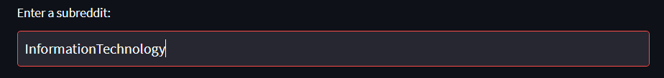

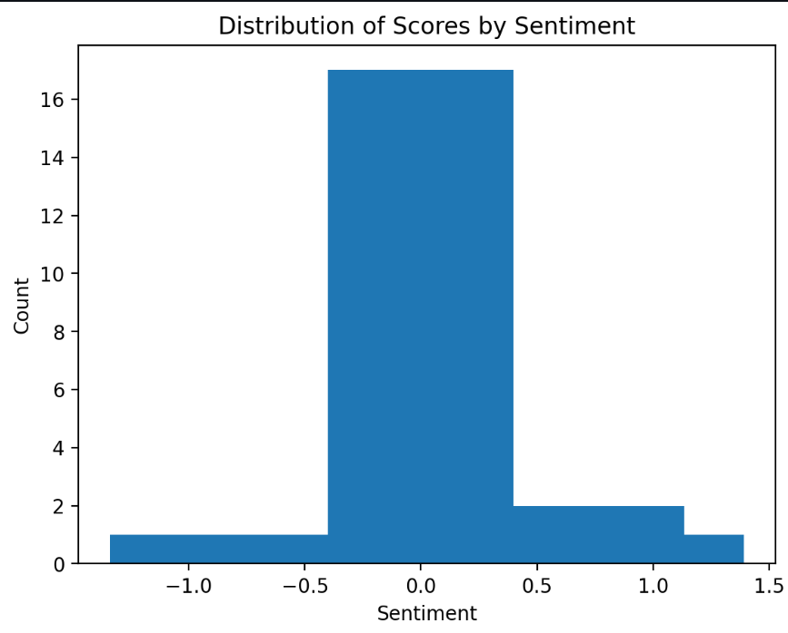

**( Fig 1.3 )**

## Fig 1.4 Average number of posts to fetch from the subreddit ( now taking around 1000 posts )

For Visualizing the change in graph of count vs sentiment when we increase the number of posts to fetch.

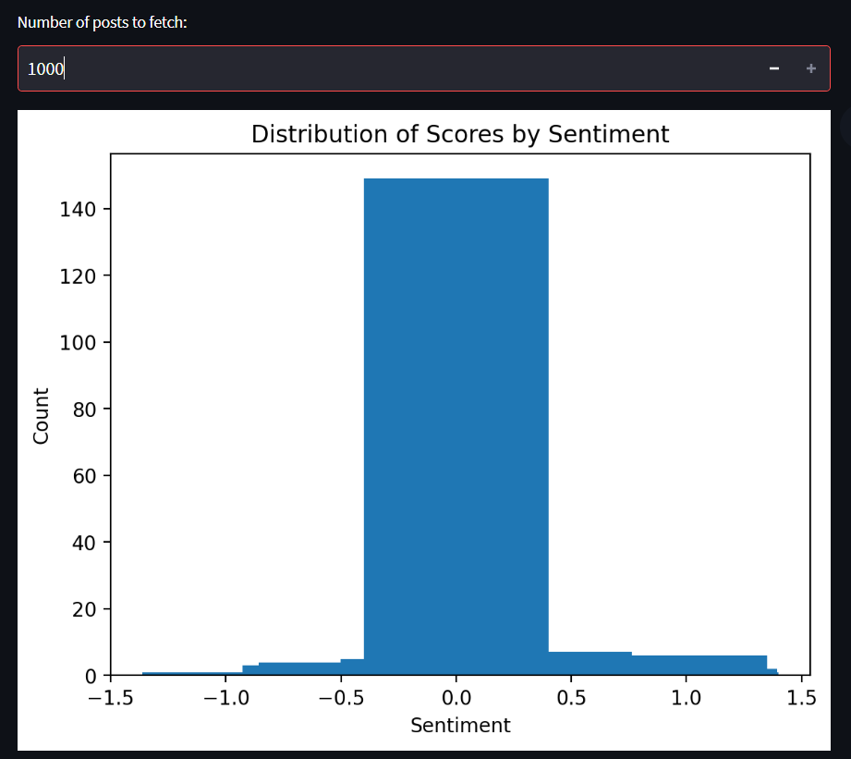

**(Fig 1.4)**

**Fig 1.5 Analyzing the pie chart data visualization for subreddit r/ComputerScience**

We can say that people are more into technology discussions and so we can fetch posts from r/ComputerScience, and so the pie chart is generated as per the posts discussion and amount of posts to fetch.

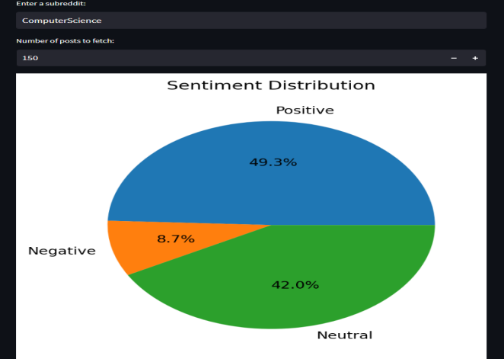

**Fig 1.6 Analysis and displaying the wordcloud to see the words in form of image of combining the trending keywords**

Using wordcloud to display the wordcloud generating keywords used most frequently in the subreddit , here using r/politics.

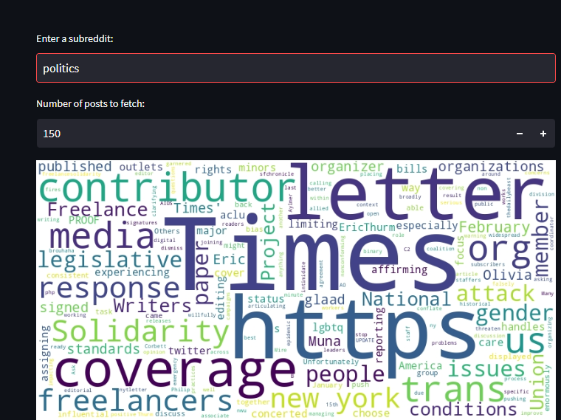

**( Fig 1.6 )**

## Fig 1.7 Downloading a dataset csv file for other projects

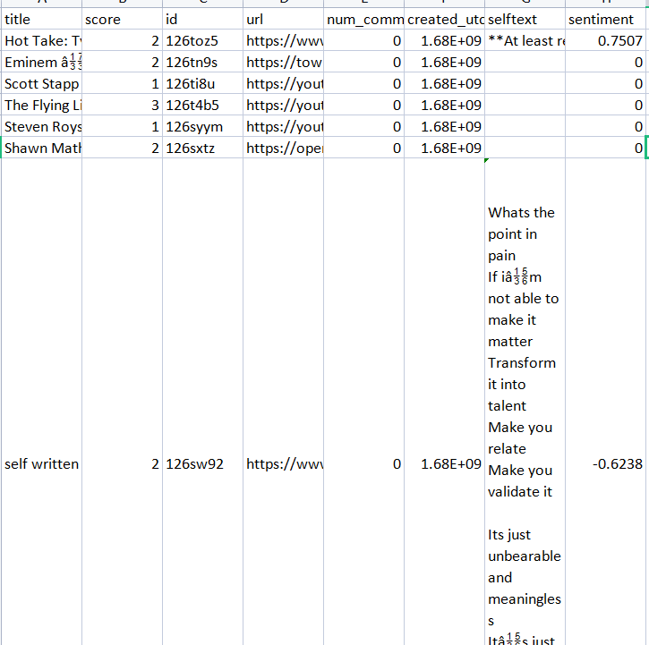

**(Fig 1.7)**

**Fig 1.8 Creation of a Trending topics dataframe in a subreddit**

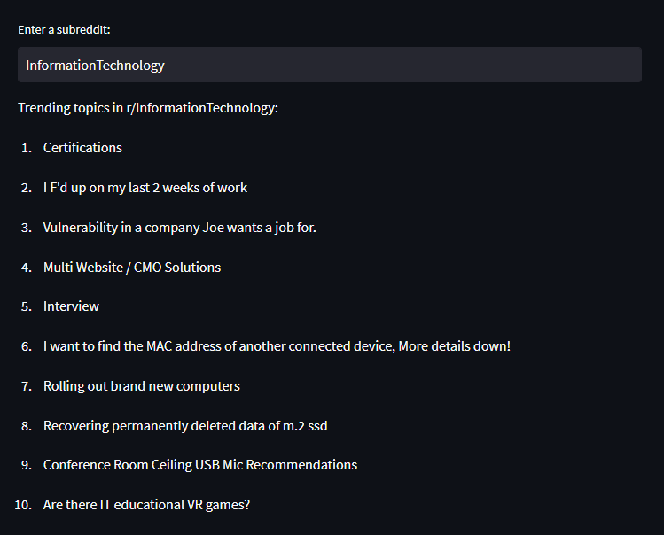

**(Fig 1.8)**

**V.CONCLUSION**

In the text mining subfield of NLP-based sentiment analysis, the emotions expressed in textual data, such as Reddit remarks and posts, are analysed. It requires a number of stages, including gathering data, preprocessing text, detecting and classifying sentiment, training the model, and testing it. Sentiment analysis has advanced significantly in recent years thanks to the development of NLP methods, reaching efficiency levels of up to 85%–90%. The variety of the data is still a problem, and the use of slang and abbreviations complicates accurate analysis. Additionally, many analyzers find it difficult to work well as the number of classes increases. Furthermore, there is still room for evaluating the model's accuracy for subjects other than those being examined. Despite these difficulties,The potential for mood analysis using NLP methods on Reddit data is promising in the future.

In this study, I performed sentiment analysis on a Pre trained dataset of Reddit media using the Vader sentiment analysis tool. The results show that Vader performs reasonably well in accurately identifying positive, negative, and neutral sentiments in subreddit discussions. However, as with any sentiment analysis tool, there are limitations to its accuracy, particularly when dealing with sarcasm or irony. Therefore, future research could explore more advanced NLP techniques to address these limitations. Overall, this study demonstrates the potential for using Vader sentiment analysis to gain insights into sentiment patterns in large-scale social media data

## VI. REFERENCES

1. Alessandro Valitutti, Andrea Esuli, and Tiziano Fagni. 2014. From Twitter to Reddit: Where to track political opinion? In Proceedings of the 25th ACM Conference on Hypertext and Social Media (HT '14). ACM, New York, NY, USA, 246-251.
2. Esuli, A., Sebastiani, F., & Speranza, M. (2016). A Pattern Mining Approach to Sentiment Analysis on Social Media. In Proceedings of the 2016 International Conference on Data Mining (DMIN'16).
3. Wu, C. H., Wei, H. Y., & Lee, Y. C. (2015). Sentiment analysis of Reddit communities and its application to stock market prediction. IEEE Transactions on Computational Social Systems, 2(3), 102-112.
4. J. Kamps, M. Marx, R. J. Mokken, and M. De Rijke, “Using wordnet to measure semantic orientations of adjectives,” 2004.
5. ,Wicke, K., & Bexheti, A. (2020). Emotional and Sentiment Analysis of the COVID-19 Crisis on Reddit. Journal of Medical Systems, 44(8), 146.
6. Zhang, C., Xia, F., & Wang, Z. (2017, July). Predicting reddit post popularity with sentiment and content features. In Proceedings of the 25th ACM International Conference on Multimedia (pp. 978-986).
7. Jha, S., Singh, M. and Singh, P. (2021), "Sentiment Analysis in Social Media using VADER and Deep Learning Techniques: A Comparative Analysis", 2021 International Conference on Communication and Signal Processing (ICCSP).