Mizuho Securities USA, Inc.
Core Database Servers: Apply Patch to SQL Server

Version History
Version Number | Date Created | Created By | Reviewed By | Date Reviewed
1.0 | May 25, 2017 | Mitulkumar Patankar

Purpose
Core database servers are very critical for Data Warehouse applications and business continuity. Applying patches in specific order is very important for High Availability as well as to minimize downtime. This document will help DBA to understand the steps and process involved in upgrade/patch core servers.

Overview
Following servers are co-related with each other regarding Disaster Recovery, Always-on, Mirroring and replication process. This document will provide step by step instructions on how to apply Patch on these servers.
ENV | Server Name | Current Version | Patch
PROD(MCDB) | MCOPSQMCDB (SHOBMCDBWNPRD06)  Primary Replica  And  Publication/Distributor | Microsoft SQL Server 2014 (SP2-GDR) (KB3194714) - 12.0.5203.0 (X64)  Sep 23 2016 18:13:56  Copyright (c) Microsoft Corporation  Enterprise Edition: Core-based Licensing (64-bit) on Windows NT 6.1 <X64> (Build 7601: Service Pack 1) (Hypervisor) | Apply CU5
PROD(MRPT) | MCOPSQMRPT (SHOBMRPTWNPRD01)  Secondary replica  And MRPT DB with  SSAS | Microsoft SQL Server 2014 (SP2-GDR) (KB3194714) - 12.0.5203.0 (X64)  Sep 23 2016 18:13:56  Copyright (c) Microsoft Corporation  Enterprise Edition: Core-based Licensing (64-bit) on Windows NT 6.1 <X64> (Build 7601: Service Pack 1) (Hypervisor) | Apply CU5
BCP (Secondary) | SCHIMCDBWNBCP02  BCP secondary replica for Disaster Recovery | Microsoft SQL Server 2014 (SP1-GDR) (KB3194720) - 12.0.4232.0 (X64)  Sep 23 2016 18:45:14  Copyright (c) Microsoft Corporation  Enterprise Edition: Core-based Licensing (64-bit) on Windows NT 6.1 <X64> (Build 7601: Service Pack 1) (Hypervisor) | Apply SP2 and then CU5
BCP(MRPT) | MCOBSQMRPT  (SCHIMRPTWNBCP01)  Mirrored Database | Microsoft SQL Server 2014 (SP2-GDR) (KB3194714) - 12.0.5203.0 (X64)  Sep 23 2016 18:13:56  Copyright (c) Microsoft Corporation  Enterprise Edition: Core-based Licensing (64-bit) on Windows NT 6.1 <X64> (Build 7601: Service Pack 1) (Hypervisor) | Apply CU5
BCP(MCDB) | MCOBSQMCDB (SCHIMCDBWNBCP06)  BCP Server for testing application releases. | Microsoft SQL Server 2014 (SP2) (KB3171021) - 12.0.5000.0 (X64)  Jun 17 2016 19:14:09  Copyright (c) Microsoft Corporation  Enterprise Edition: Core-based Licensing (64-bit) on Windows NT 6.1 <X64> (Build 7601: Service Pack 1) (Hypervisor) | Apply CU5
PROD | SHOBSQLDWNPRD01 (Subscription) | Microsoft SQL Server 2014 - 12.0.2269.0 (X64)  Jun 10 2015 03:35:45  Copyright (c) Microsoft Corporation  Standard Edition (64-bit) on Windows NT 6.1 <X64> (Build 7601: Service Pack 1) (Hypervisor) | Apply SP2 and then CU5
PROD | SHOBRISKWNPRD01 (Subscription) | Microsoft SQL Server 2014 (SP2-GDR) (KB3194714) - 12.0.5203.0 (X64)  Sep 23 2016 18:13:56  Copyright (c) Microsoft Corporation  Enterprise Edition (64-bit) on Windows NT 6.1 <X64> (Build 7601: Service Pack 1) (Hypervisor) | Apply CU5

Process:

Core Cluster (Four Node) + Replication subscriber
- Apply upgrade on BCP (SCHIMCDBWNBCP02) Chicago secondary replica server.
- Pause Mirroring from PROD MRPT (SHOBMRPTWNPRD01) server. Apply patch on BCP MRPT (SCHIMRPTWNBCP01) mirrored server.
- Resume Mirroring from MRPT (SHOBMRPTWNPRD01) and wait for Status = databases are fully synchronized. Failover MRPTDB from MRPT Prod server to BCP mirrored server. (High Safety Mode)
- Pause Mirroring from BCP (SCHIMRPTWNBCP01). Apply patch on MRPT (SHOBMRPTWNPRD01) secondary replica server.
- Resume Mirroring from BCP (SCHIMRPTWNBCP01) and wait for Status = databases are fully synchronized. Fail back MRPTDB from BCP to MRPT Prod server.
- Change availability mode from asynchronous commit to synchronous commit between MCDB and MRPT servers to avoid data loss.
Note: Make sure automatic failover is disabled.
Failover AG group “MCDB_PROD_AG2” from MCDB (SHOBMCDBWNPRD06) replica to MRPT (SHOBMRPTWNPRD01).
- Apply patch on MCDB (SHOBMCDBWNPRD06) Server.
- Fail Back Always-On group MCDB_PROD_AG2 from MRPT (SHOBMRPTWNPRD01) to MCDB (SHOBMCDBWNPRD06) replica.
- Change availability mode from synchronous commit to asynchronous commit.
- Apply patch on BCP (SCHIMCDBWNBCP06) server.
- Apply patch on SHOBSQLDWNPRD01 (Subscription) server.
- Apply patch on SHOBRISKWNPRD01 (Subscription) server

Importance:

Always On Availability Groups:
Do not upgrade the primary replica instance before failing over the availability group to an upgraded instance with a secondary replica first. Otherwise, client applications may suffer extended downtime during the upgrade on the primary replica instance.
For more detail: https://docs.microsoft.com/en-us/sql/database-engine/availability-groups/windows/upgrading-always-on-availability-group-replica-instances

Mirroring:
https://support.microsoft.com/en-us/help/926824/how-to-install-service-packs-and-hotfixes-on-an-instance-of-sql-server-that-is-configured-to-use-database-mirroring

Replication:
In a replication topology, you can apply any hotfix for SQL Server to the Distributor or to the Publisher. However, if you have more than one version of SQL Server installed, you must also meet the following requirements: After you apply the hotfix, the version of SQL Server on the Distributor must be later than or the same as the version of SQL Server on the Publisher.
Note: typically, the Distributor is the same server as the Publisher.
After you apply the hotfix, the version of SQL Server on the Publisher must be earlier than or the same as the version of SQL Server on the Distributor.
The SQL Server version requirement for the Subscriber after you apply a hotfix depends on the type of publication. If you have a read-only Subscriber to a transactional publication, you can apply any hotfix to the Subscriber. If you have a Subscriber to a merge publication, the version of SQL Server on the Subscriber must be earlier than or the same as the version of SQL Server on the Publisher after you apply the hotfix.
For more detail: https://support.microsoft.com/en-us/help/941232/how-to-apply-a-hotfix-for-sql-server-in-a-replication-topology

METHOD:

Pre Upgrade Steps
- Download Upgrade and store media to \\hob-filer08\installs\microsoft\ folder.
- Copy media over destination server.
- Protect data by performing a full database backup on every database including copy of resource databases to diff folder.
- Run DBCC CHECKDB on every database. (Optional)

Upgrade Steps
- Run (SQLServer2014-KB4013098-x64) setup file as an Administrator.
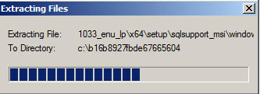
- Run check:
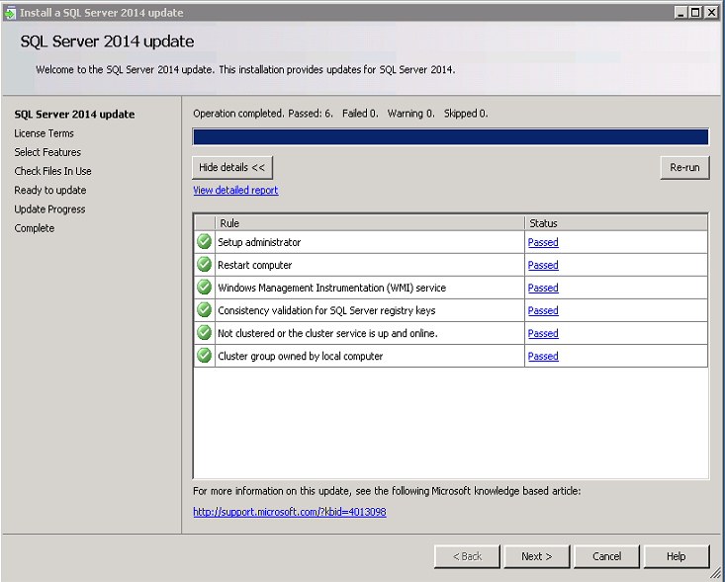
- Accept License terms:
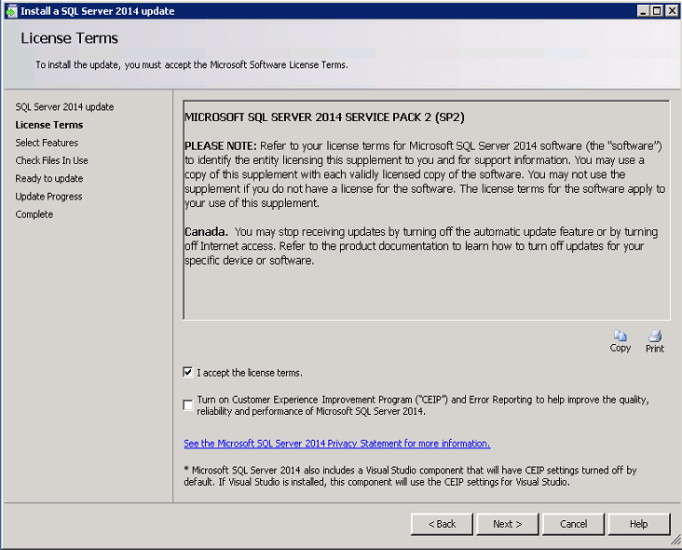
- Select Features:
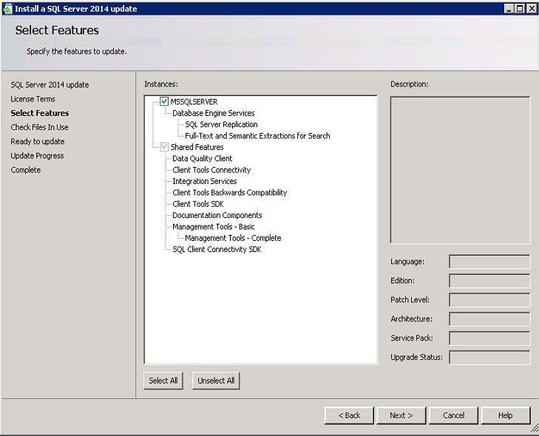
- Check File in use:
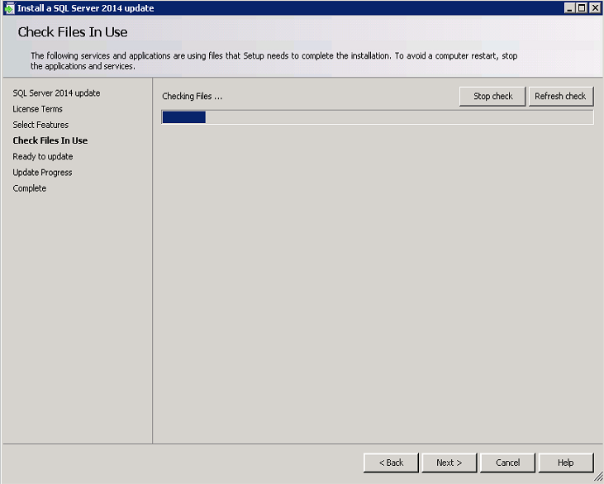
- Ready to update/Summary:
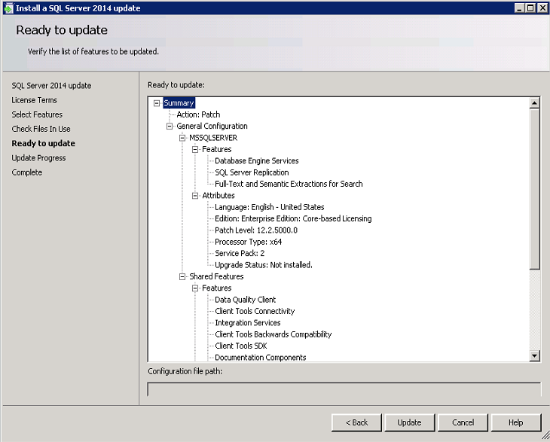
- Update and Complete.

Post Upgrade/Validation
- Check upgrade report file for validation. Restart server if required.
- Go to Control Panel → Programs → Programs and Features → View installed updates → Verify new version match the KB article number.
- Run Select @@version as Version in SSMS and verify upgraded version is correct
- Check SQL Server Error log file from installed log directory for validation
- Check SQL Server Logs for validation.
- Verify Databases – run below SQL Command
Select name as Database_Name, compatibility_level, user_access_desc,state_desc, recovery_model_desc from sys.databases

- If there are any unknown/unresolved issues → ROLLBACK

ROLLBACK
- Go to Control Panel → Programs → Programs and Features → View installed updates
- Uninstall each upgraded SQL programs that match with new KB number.
- Restart Computer
- Go to Control Panel → Programs → Programs and Features → View installed updates → Verify new version match the old KB article number.
- Run Select @@version as Version in SSMS and verify rollback version is correct
- Check SQL Server Error log file from installed log directory for validation
- Check SQL Server Logs for validation.

