Management Data Warehouse Reports

Disk Usage and Query Statistics

Jane 09, 2017
Version 1.0

Document Control

Editor | Description | Date | Version
Mitulkumar Patankar | Initial Release | 06/09/2017 | 1.0

Reviewed By | Description | Date | Version

Table of Contents
Introduction 4
Purpose and Scope 4
Audience 4
System Design 4
Key Components 4
1 Operating Procedure 5
1.1 MDW Database Configuration 5
1.2 Configure Data Collection on Mizuho Servers 7
1.3 Validate Data Collection Jobs 10
1.4 Validate MDW Reports 11

Introduction

Purpose and Scope
This document will detail the process to configure Data Collection using Management Data Warehouse Database on MCOPSQIDERA as a Centralized Management Server and how to view reports from MDW Database.

Audience
This document is intended for personnel responsible for supporting the database environment for Mizuho.

System Design
The MDW database acts as a repository database on MCOPSQIDERA server for Data Collection. It is also important to view Management Data Warehouse reports for all configured servers.

Key Components

MDW Database:
Hoboken hosts: SHOBIDRAWNPRD01

Operating Procedure

MDW Database Configuration
Steps:
- On MCOPSQIDERA server, go to Management → Data Collection → Right click → Tasks → Select Configure Management Data Warehouse.
- In GUI wizard window select MCOPSQIDERA as a server name and create database MDW using new button if Database is not present on the server.
- Next page → grant USI\_zsql and USI\RES_SQL_DBA all permissions and finish the wizard.
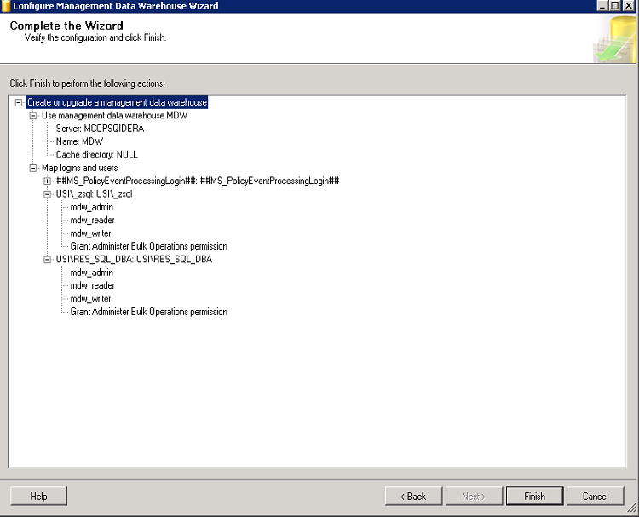
- Assign USI\_zsql permissions on MSDB database.
USE [msdb]
GO
CREATE USER [USI\_zsql] FOR LOGIN [USI\_zsql]
GO
USE [msdb]
GO
ALTER ROLE [dc_admin] ADD MEMBER [USI\_zsql]
GO
USE [msdb]
GO
ALTER ROLE [dc_operator] ADD MEMBER [USI\_zsql]
GO
USE [msdb]
GO
ALTER ROLE [dc_proxy] ADD MEMBER [USI\_zsql]
GO

Configure Data Collection on Mizuho Servers
This section will go over the procedure on how to configure data collection on database server.
Steps:
- Create proxy account on Database server.
USE [master]
GO
CREATE CREDENTIAL [Agent_proxy] WITH IDENTITY = N'USI\_zsql', SECRET = N'*********'
GO
USE [msdb]
GO
EXEC msdb.dbo.sp_add_proxy @proxy_name=N'MDW',@credential_name=N'Agent_proxy',
@enabled=1
GO
EXEC msdb.dbo.sp_grant_proxy_to_subsystem @proxy_name=N'MDW', @subsystem_id=3
GO
EXEC msdb.dbo.sp_grant_proxy_to_subsystem @proxy_name=N'MDW', @subsystem_id=10
GO
EXEC msdb.dbo.sp_grant_proxy_to_subsystem @proxy_name=N'MDW', @subsystem_id=9
GO
EXEC msdb.dbo.sp_grant_proxy_to_subsystem @proxy_name=N'MDW', @subsystem_id=11
GO
EXEC msdb.dbo.sp_grant_proxy_to_subsystem @proxy_name=N'MDW', @subsystem_id=12
GO

- On Database Server, go to Management → Data Collection → Right click → Tasks → Select Configure Data Collection
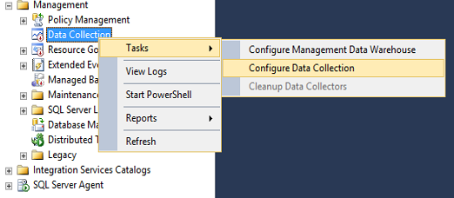

- In GUI, select MCOPSQIDERA as a host and MDW as a database for management data warehouse.
G:\DCCACHE as a cache directory
Select System Data Collection Sets
Select Use a SQL Server agent Proxy for remote uploads.
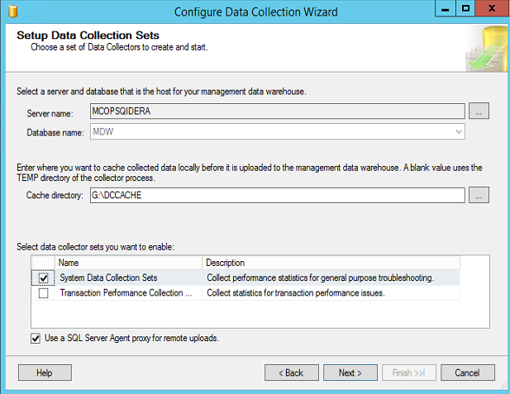
- Select MDW as a proxy account to run data collection jobs.
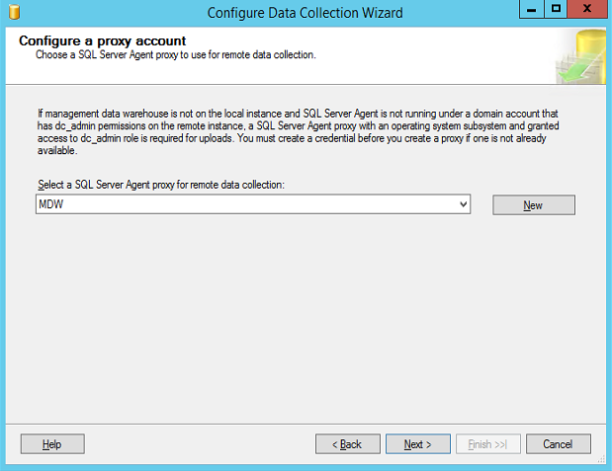
- Complete the wizard.
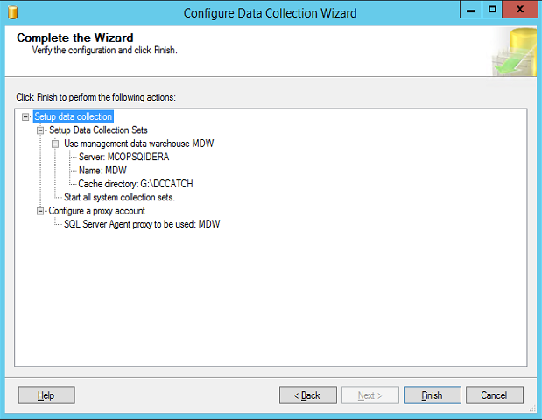
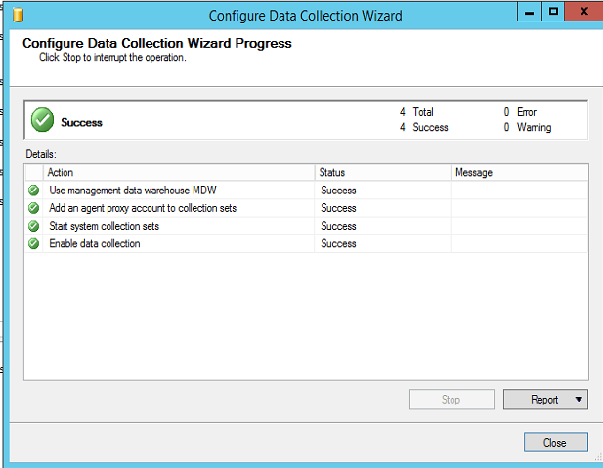
- Stop Server Activity data collection. Does not provide much details.
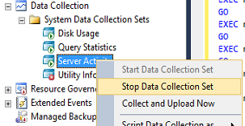

Validate Data Collection Jobs
Steps:
- Open job activity monitor to check jobs current status and history.
- Disk Usage: Make sure Collection set_1 job completed successfully.
- Query Statistics: Make sure Set_2 collection job is running and Upload job completing successfully.
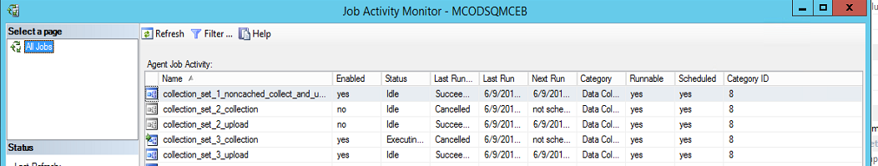

Validate MDW Reports
Steps:
- On MCOPSQIDERA, go to MDW database → right click → reports → Management Data Warehouse → Select Management Data Warehouse Overview
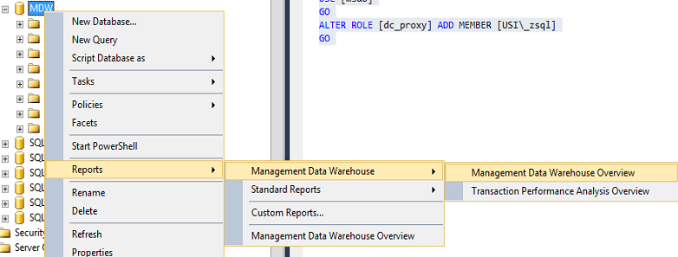
- Overview wizard: It will list details on data collection from registered servers.
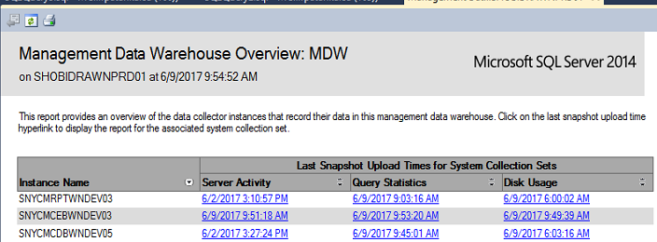
- DISK Usage Report:
Select trend graph for database to see DB growth trend in detail.
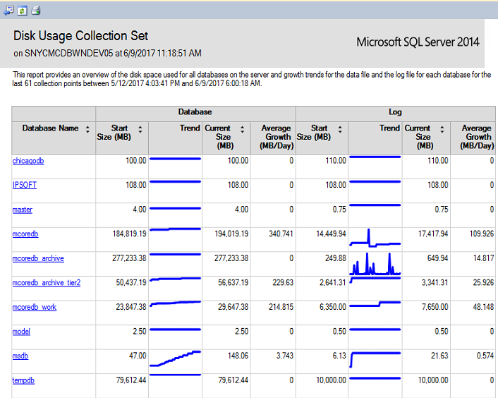
- Query Statistics History Report. (Default history up to 14 days)
Select the diff times range to get Expensive Queries and tune them based on resource/Duration.
