Nutrition App QA Test Specification
Version: 1.0
Purpose: Regression and release validation for the Nutrition App.

FOOD-DEL-001 — Historical Log Preservation
Feature | Historical Log Preservation
Priority | Critical
Function Being Tested | Historical nutrition snapshots remain unchanged after source food deletion.
Preconditions | • Create a food with distinctive nutrition.  • Log it on a known date.  • Record values before deletion.
Test Data to Record | • Food name  • Logged amount/unit  • Calories  • Protein  • Fat  • Carbohydrates  • Other notable nutrients
Test Steps | 1. Log the food.  2. Delete the source food.  3. Return to the original date.  4. Verify entry exists.  5. Verify values exactly match the recorded snapshot.  6. Edit/delete the historical log if supported.
Expected Result | Historical logs are immutable snapshots and are unaffected by deleting the source food.
Actual Result | Nutrition facts stay, but food name is gone
Pass / Fail | Partial pass
Build Version | Beta
Tester | Mitchell
Date | July 11, 2026
Environment | iOS Simulator / Physical Device
Frequency | Per release unless otherwise noted
Defect ID
Notes

Screenshots
Before: During: After:
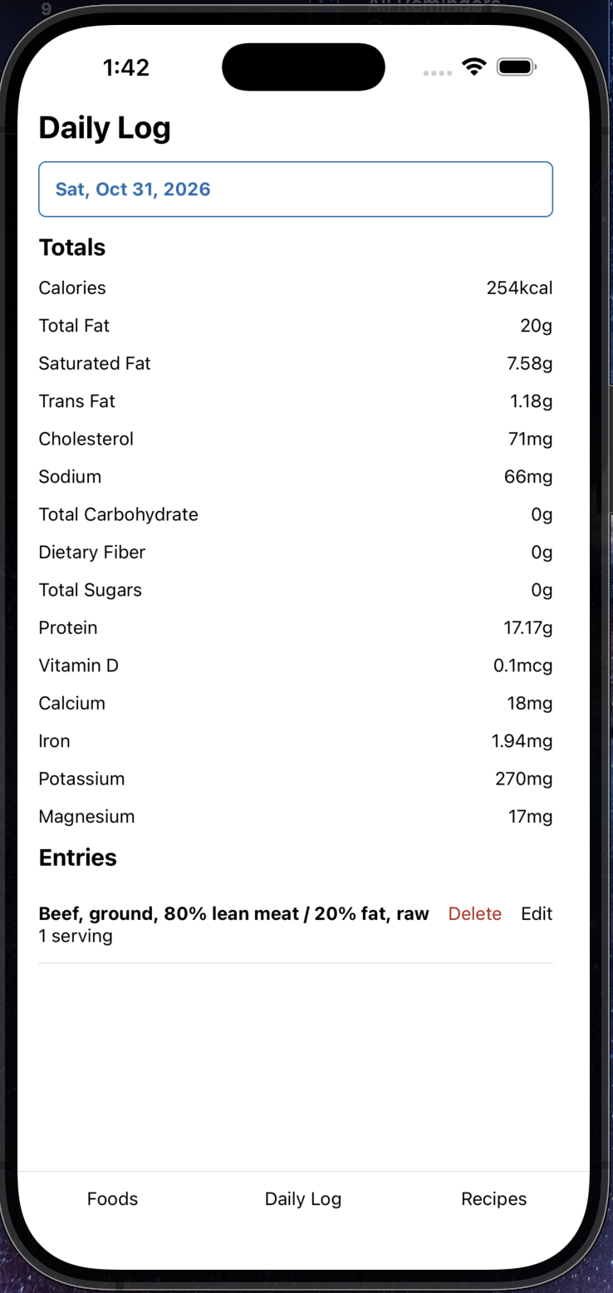
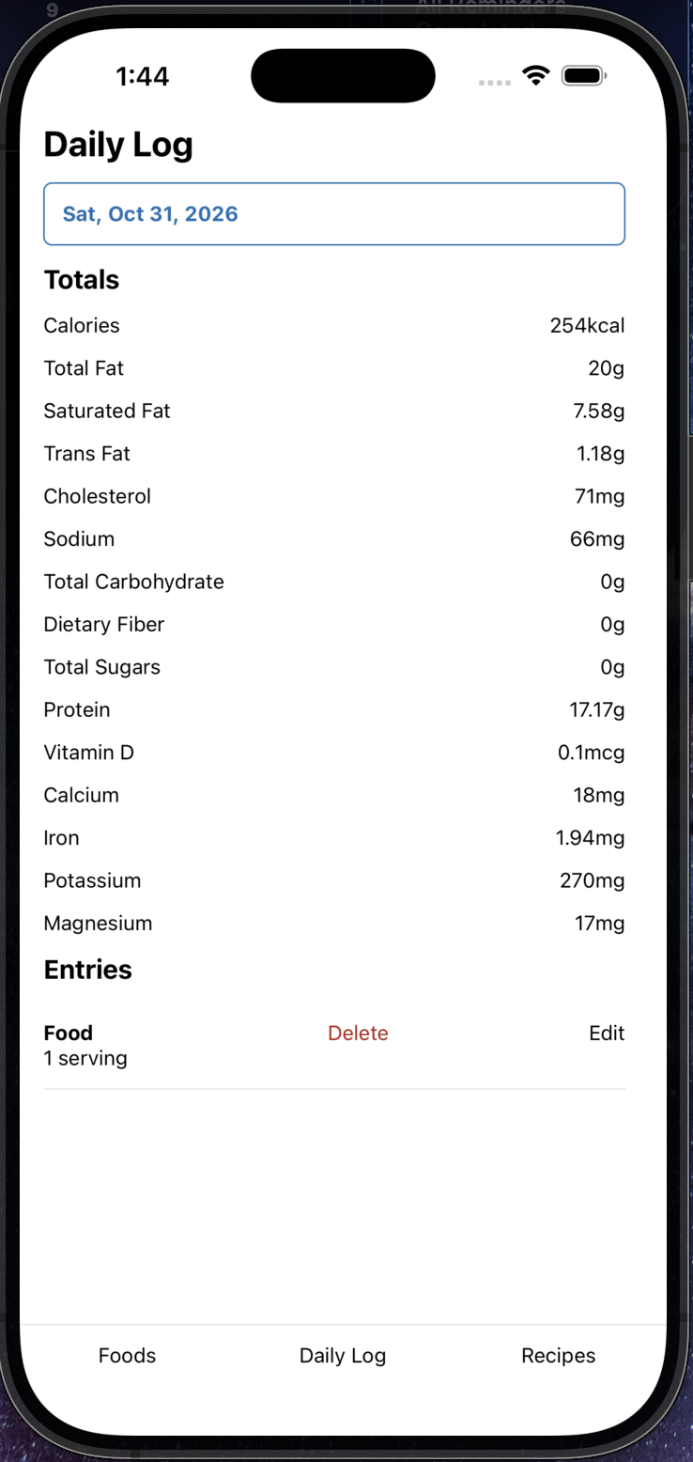
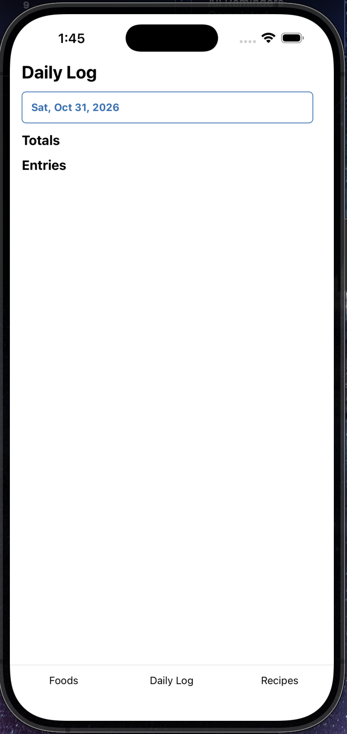

FOOD-DEL-002 — Restart & Persistence
Feature | Restart & Persistence
Priority | High
Function Being Tested | Persistence after restart.
Preconditions | • Delete at least one food.  • Leave one recipe marked for republish.
Test Data to Record | • Deleted foods  • Affected recipes
Test Steps | 1. Restart the app.  2. Restart backend if applicable.  3. Verify deleted foods remain deleted.  4. Verify recipe state persists.
Expected Result | Persisted state survives restart.
Actual Result | Food remains deleted, and recipe still needs to be republished.
Pass / Fail | Pass
Build Version | Beta
Tester | Mitchell
Date | July 11, 2026
Environment | iOS Simulator / Physical Device
Frequency | Per release unless otherwise noted
Defect ID
Notes | Recipes are shown in the add ingredients portion of recipes. It looks to be a reused asset of the saved foods, but recipes should be hidden because there are very few cases where a recipe would be used in another recipe. Some format is saved with a comma in the cooked weight which causes the recipe unable to be saved. It seems to be saved as a str rather than an int.

Screenshots
Before: During:
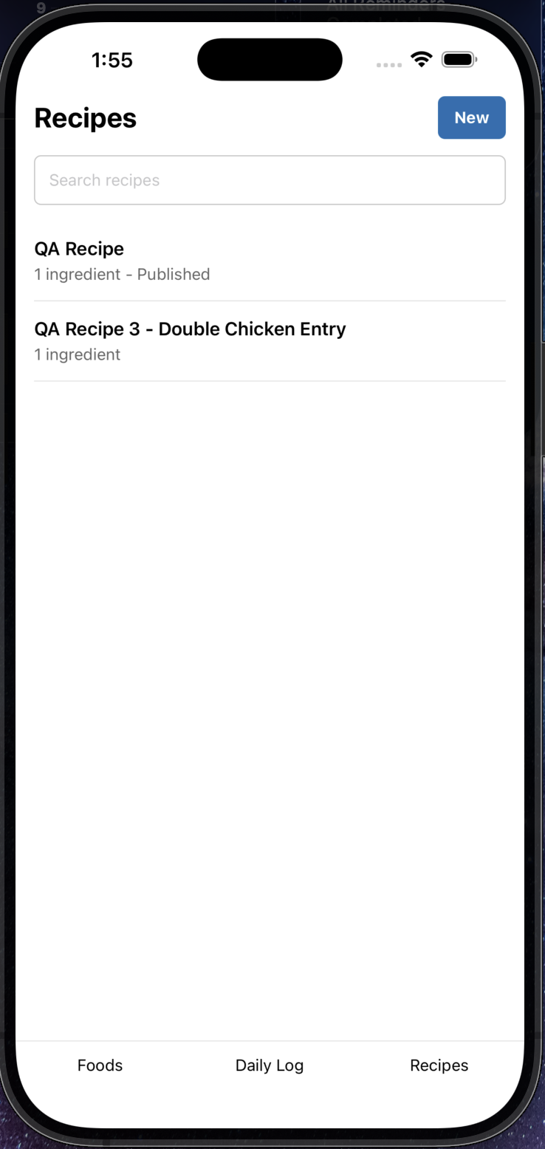
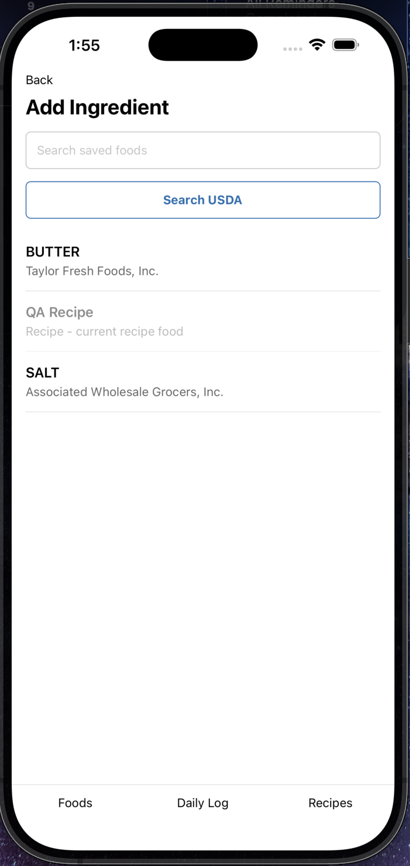
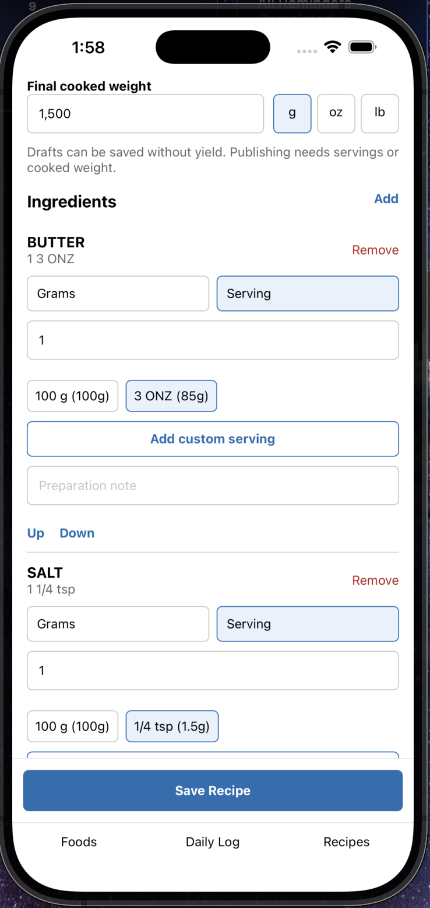
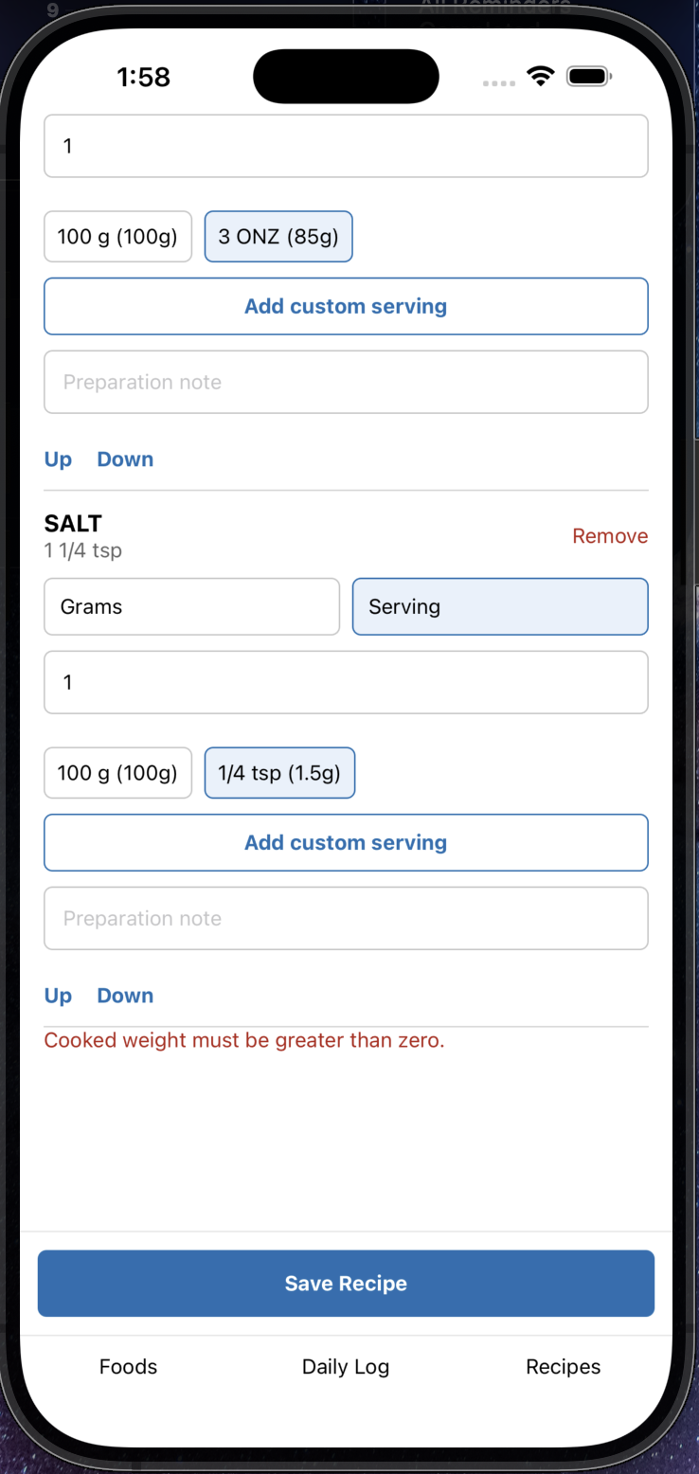

After:
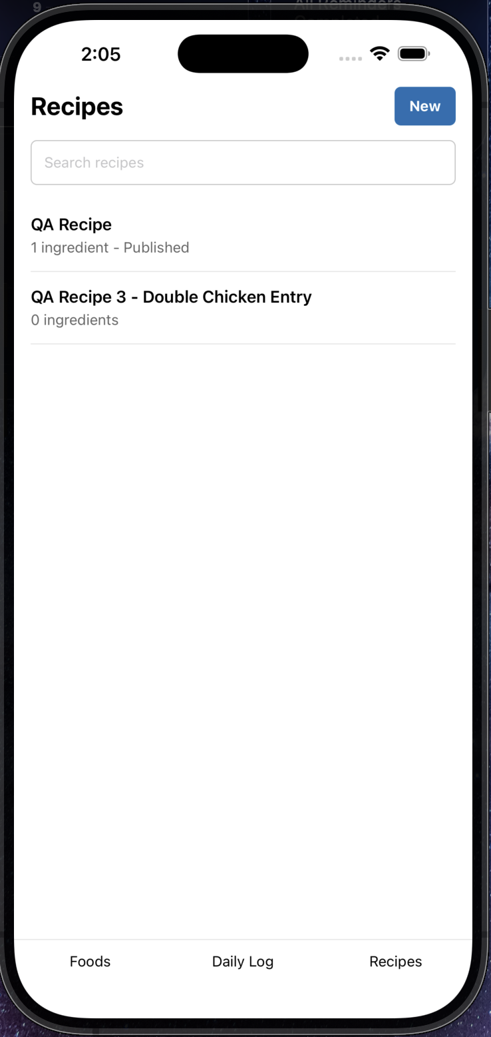
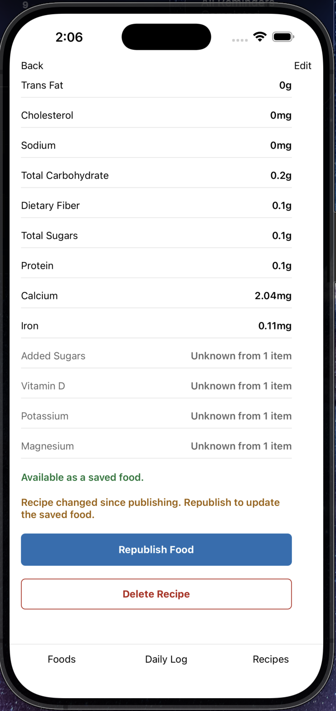
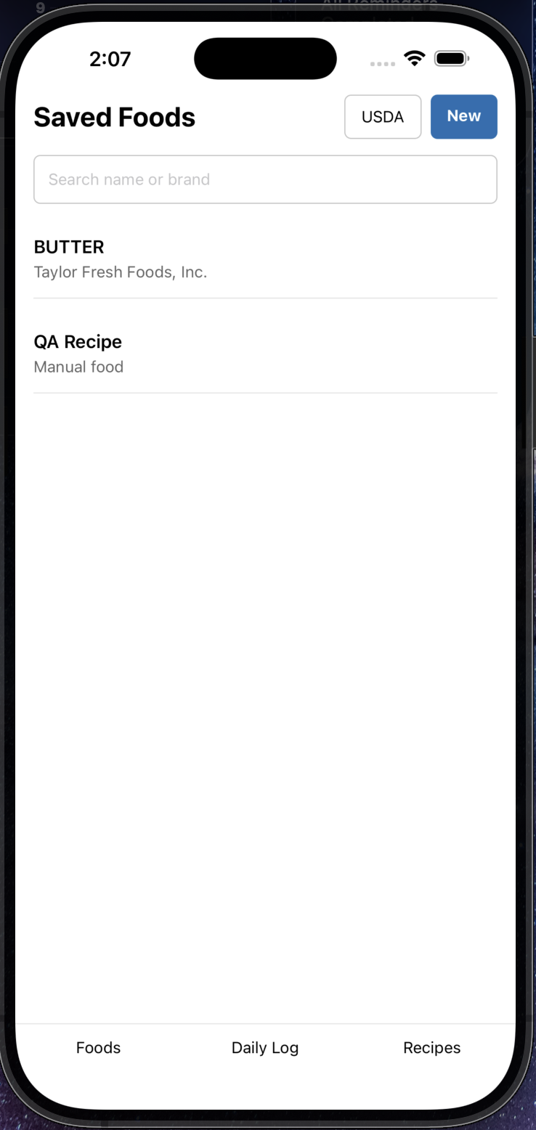

FOOD-DEL-003 — Network Failure Handling
Feature | Network Failure Handling
Priority | High
Function Being Tested | Graceful handling of backend/network failures.
Preconditions | • Disable backend or network.
Test Data to Record | • Operation  • Error message
Test Steps | 1. Delete unused food.  2. Force delete dependent food.  3. Republish recipe.  4. Restore connectivity.  5. Retry.
Expected Result | No partial mutations occur.
Actual Result | Couldn’t reach offline ingredients or recipes.
Pass / Fail | Partial Pass
Build Version | Beta
Tester | Mitchell
Date | July 11, 2026
Environment | iOS Simulator / Physical Device
Frequency | Per release unless otherwise noted
Defect ID
Notes

Screenshots
Before: During:
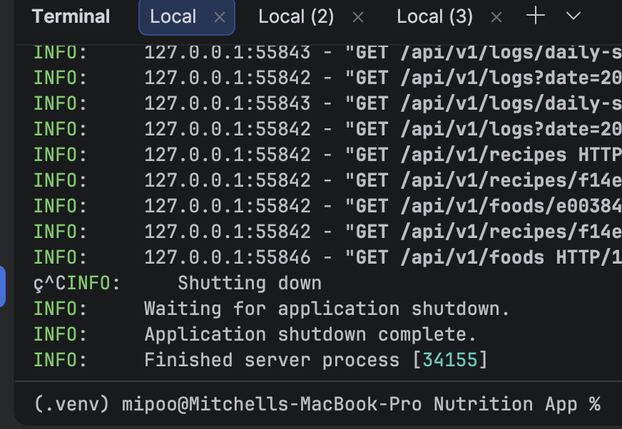
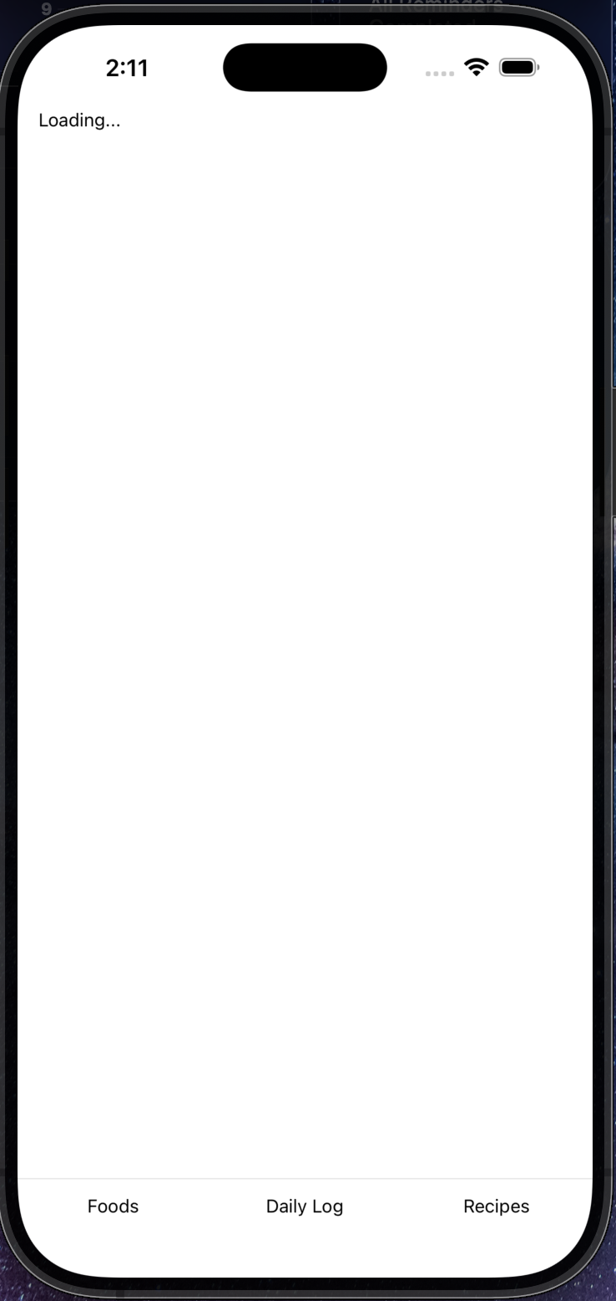
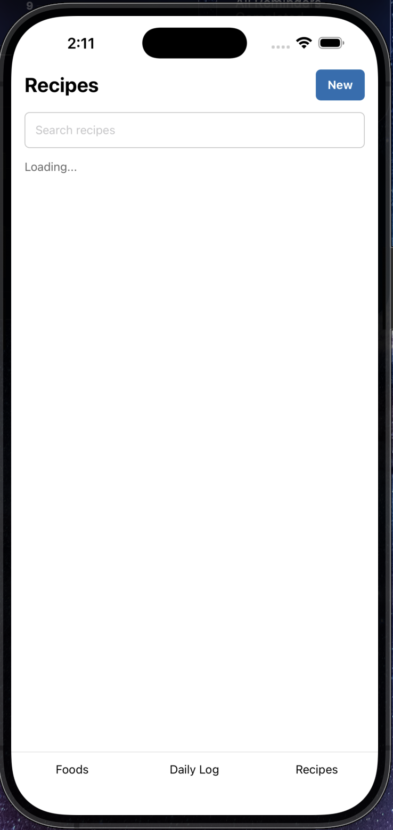

After:
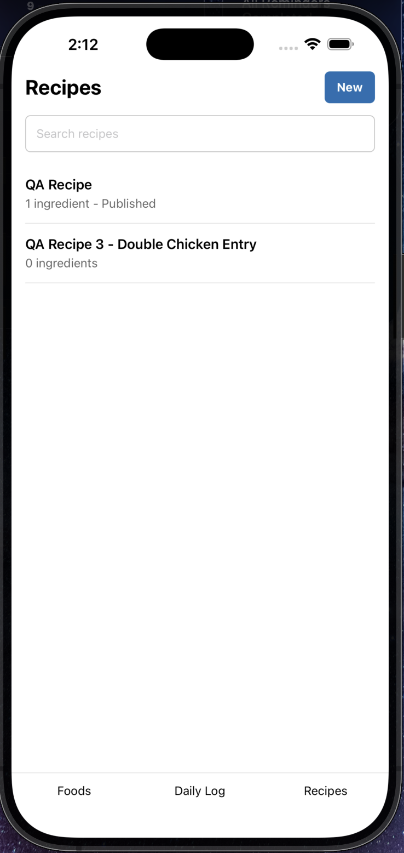

FOOD-DEL-004 — Interrupted Force Delete – Skipped based on previous outcome from FOOD-DEL-003
Feature | Interrupted Force Delete
Priority | Critical
Function Being Tested | Transactional rollback.
Preconditions | • Open dependency confirmation dialog.
Test Data to Record | • Food  • Affected recipes
Test Steps | 1. Disconnect network.  2. Tap Delete Anyway.  3. Verify nothing changes.  4. Reconnect and retry.
Expected Result | Atomic rollback.
Actual Result
Pass / Fail
Build Version
Tester
Date
Environment | iOS Simulator / Physical Device
Frequency | Per release unless otherwise noted
Defect ID
Notes

Screenshots
Before:
_______________________________
During:
_______________________________
After:
_______________________________

FOOD-DEL-005 — Rapid Repeated Taps
Feature | Rapid Repeated Taps
Priority | Medium
Function Being Tested | Duplicate submission prevention.
Preconditions | • Locate destructive buttons.
Test Data to Record | • Button tested
Test Steps | 1. Rapidly tap Delete Anyway.  2. Rapidly tap Publish.  3. Rapidly tap Republish.
Expected Result | Exactly one mutation occurs.
Actual Result | Action was performed immediately with no ability to press multiple times.
Pass / Fail | Pass
Build Version | Beta
Tester | Mitchell
Date | July 11, 2026
Environment | iOS Simulator / Physical Device
Frequency | Per release unless otherwise noted
Defect ID
Notes

Screenshots
Before:
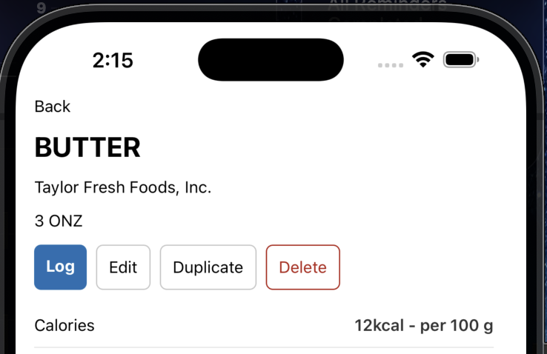
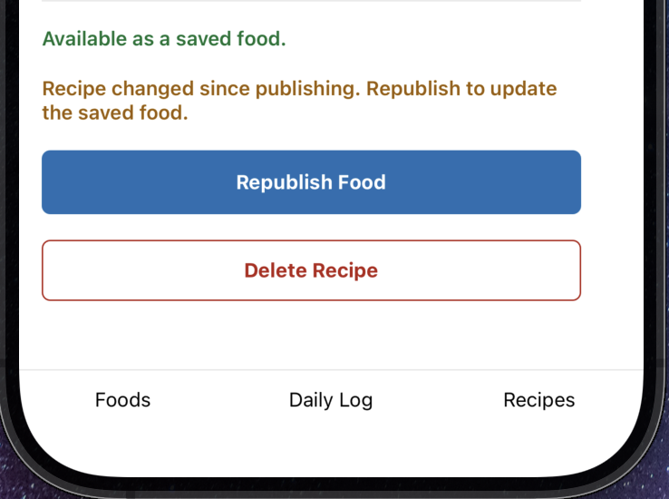
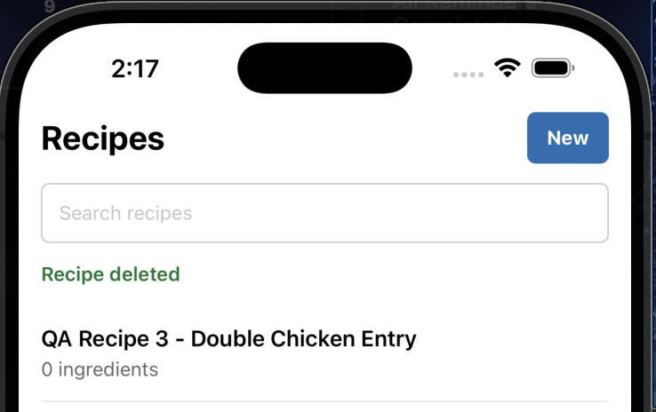
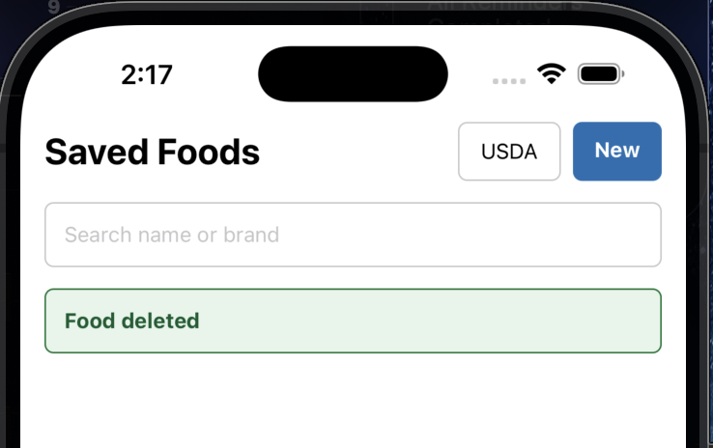
After:

CACHE-001 — Cache Invalidation
Feature | Cache Invalidation
Priority | High
Function Being Tested | Cross-screen cache refresh.
Preconditions | • Delete a food referenced by recipes.
Test Data to Record | • Affected food  • Affected recipes
Test Steps | 1. Open Saved Foods.  2. Open Recipe List.  3. Open Recipe Detail.  4. Open Daily Log.
Expected Result | All screens reflect current state.
Actual Result
Pass / Fail
Build Version
Tester
Date
Environment | iOS Simulator / Physical Device
Frequency | Per release unless otherwise noted
Defect ID
Notes | Searches don’t clear when moving among the various functions. USDA search textbox retains searched item, saved foods search does the same. Should incorporate the USDA search into the shown search bar. Display saved foods first, and USDA items following it. If no foods are saved with that name, it shows as a normal USDA search.

Screenshots
Before:
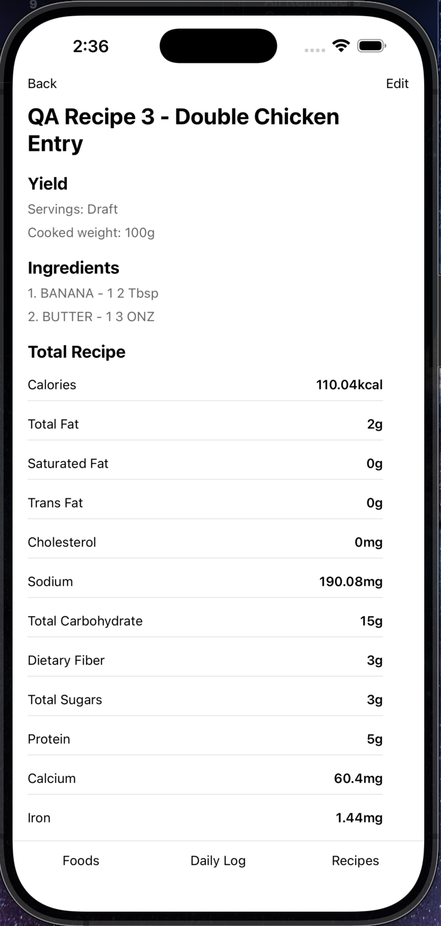
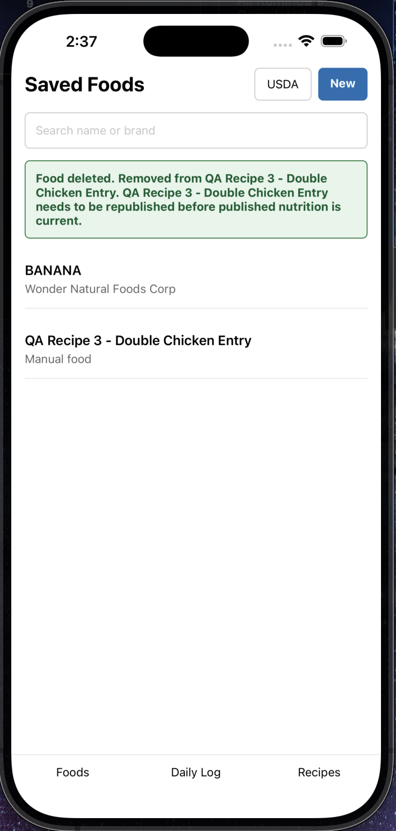
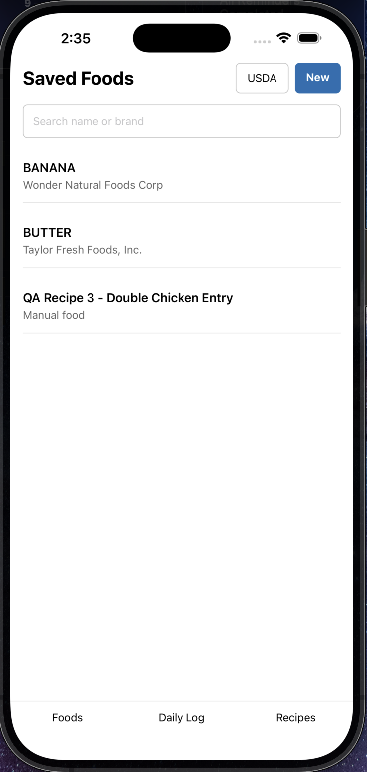

After:
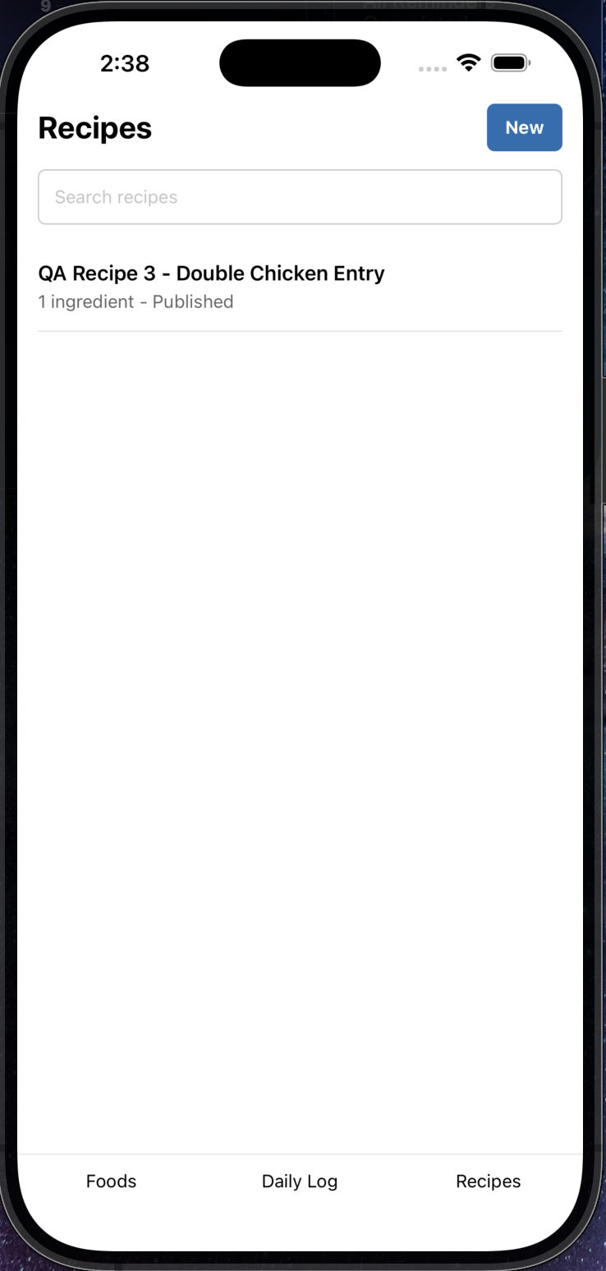
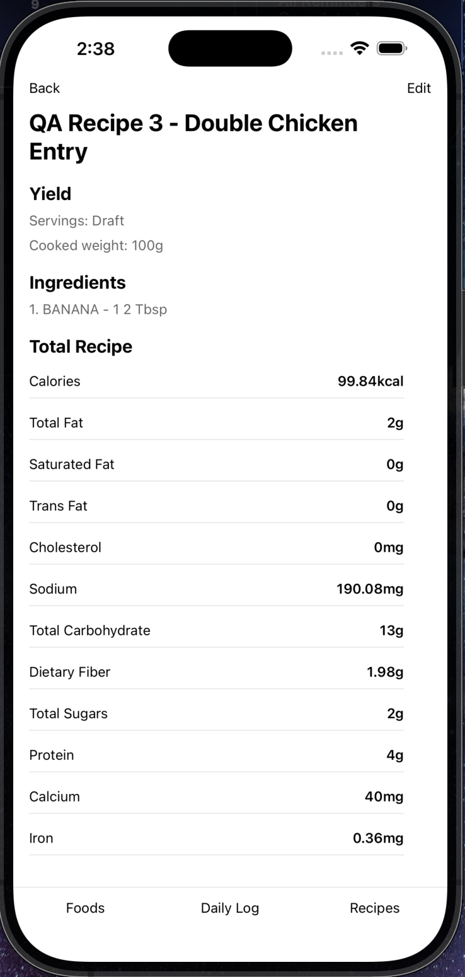
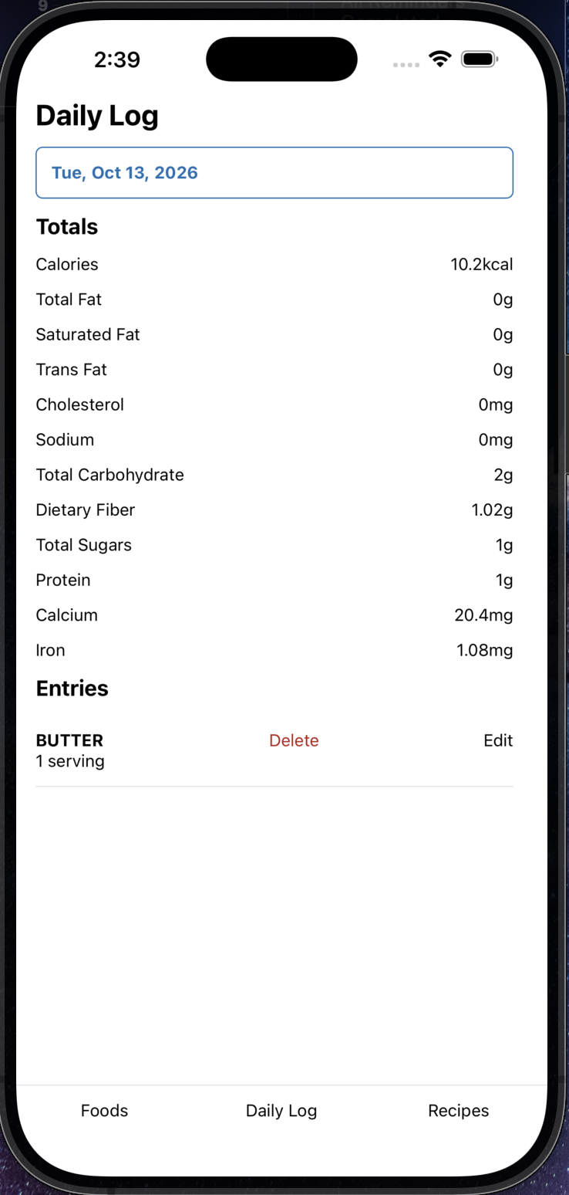
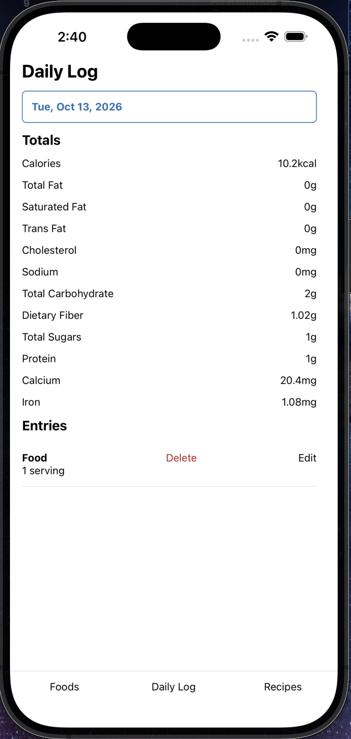

AUTH-001 — Cross-user Security – Skipped: No Users yet
Feature | Cross-user Security
Priority | Critical
Function Being Tested | Ownership isolation.
Preconditions | • Two user accounts available.
Test Data to Record | • Account A  • Account B
Test Steps | 1. Attempt delete operations from both accounts.
Expected Result | No cross-account access or data leakage.
Actual Result
Pass / Fail
Build Version
Tester
Date
Environment | iOS Simulator / Physical Device
Frequency | Per release unless otherwise noted
Defect ID
Notes

Screenshots
Before:
_______________________________
During:
_______________________________
After:
_______________________________

REG-001 — Full Regression Smoke Test
Feature | Full Regression Smoke Test
Priority | Critical
Function Being Tested | Overall regression.
Preconditions | • Clean build.
Test Data to Record | • Build number
Test Steps | 1. USDA search/import  2. USDA ratio searches (80/20, 93/7, etc.)  3. Manual food creation  4. Food editing  5. Food duplication  6. Recipe creation/editing  7. Gram mode  8. Serving mode  9. Custom servings  10. Publish/Republish  11. Daily logging  12. Edit/Delete logs  13. Food search  14. Recipe search  15. Nutrient calculations  16. Unknown nutrient handling  17. Daily Log date picker
Expected Result | All workflows complete successfully.
Actual Result
Pass / Fail
Build Version
Tester
Date
Environment | iOS Simulator / Physical Device
Frequency | Per release unless otherwise noted
Defect ID
Notes

Screenshots
Before:
_______________________________
During:
_______________________________
After:
_______________________________

