This project provides a counter for notifications received from the select option.

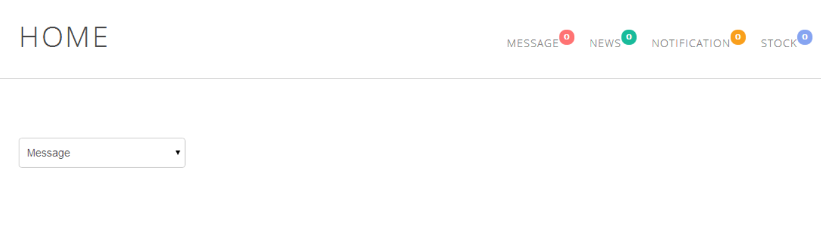

Based on the items selected, the widget updates respective notification.

