1. The visualization graph from Reuters Digital news report about how many different news providers do people regularly pay to?

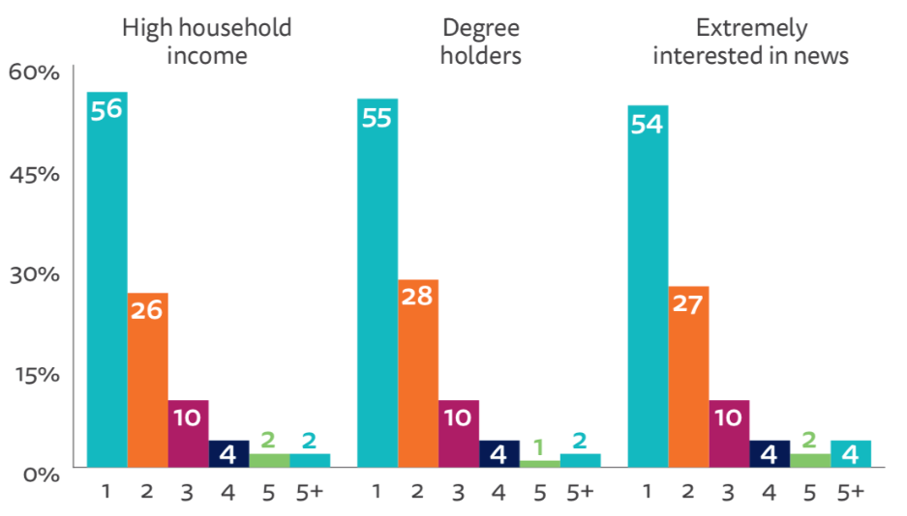

The above visualization violates the two principles of data visualization that are:

1. **Design and layout matter**

* The purpose of the design and layout matter in data visualization is to facilitate ease of understanding the message.
* From the above graph, axes are not labeled and legends are not mentioned. This makes it harder for the audience to interpret the details from the graph.

1. **Use color purposely and effectively**

* The purpose of using the color is to make the visualization attractive to the audience. It is also used to distinguish the categories in the data.
* From the above graph, color for number of Subscriptions of 1 and 5+ news article is same. This confuses the audience that are trying to interpret details from the chart.

**Ways to improve the above visualization**:

* **Design and layout matter**: We can improve the chart by providing appropriate axes label and legends that would easily help audience to interpret details from the chart.
* **Avoid Clutter:** We can improve the chart by presenting different charts (like stacked bar charts, pie chart etc.) for different categories of people (High household income, Degree holders, extremely interested in news)
* **Use color purposely and effectively:** Using different colors for the number of news article subscriptions can improve the above chart. This would aid in getting the message across to the audience.

1. The news article by Illinois reviews about ‘100 million now receiving federal welfare’

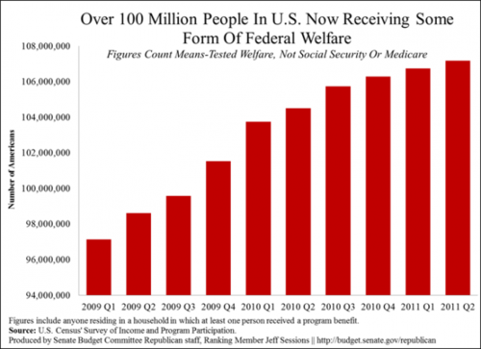

The above chart violates two principles of data visualization that are:

1. **Design and layout matter**: The x-axis is not labeled, and the y-axis value starts at 94 million.
2. **Avoid clutter**: The chart contains far too much information that may mislead the audience.

**Ways to improve the above visualization:**

* **Design and layout matter:** Both axes should be labeled, and the graph can be rotated horizontally without the need for x axes. Each bar of the chart can simply be labeled with the number of Americans.
* **Avoid clutter:** Unnecessary information that distracts the audience should be removed. When the same year is mentioned more than once, it should be removed.
* **Use color purposely and effectively:** Colors can be used to represent different quarters (Q1, Q2, Q3, Q4) of a year to help the audience understand the chart.

3) The chart represents that Women get only 2-3 percent of Tv sports news coverage (Source: Feministing)

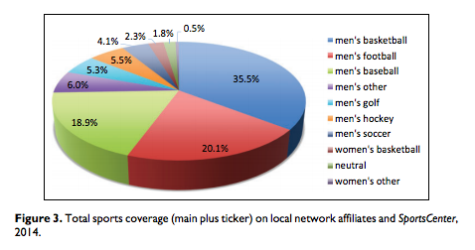

The above pie chart violates two principles of data visualization that are:

1. **Design and layout matter**: The layout and design do not facilitate easy comparison because the viewer must move back and forth between legend and pie.
2. **Use color purposely and effectively**: With 10 categories, some of the colors are very similar which makes the comparison difficult for the viewer.

**Ways to improve the above visualization:**

* **Design and Layout matter:** A bar chart would be better design for the above chart. Either vertical bar chart or horizontal bar chart can be used to display the above categories. Sorting of data from high to low would make chart easier to read and more useful to the reader.
* **Use color purposely and effectively:** Here after transforming the above chart into bar chart, different colors are no longer necessary between different sports however 3 different colors can be used to distinguish between the three categories that are Male, Female and neutral.