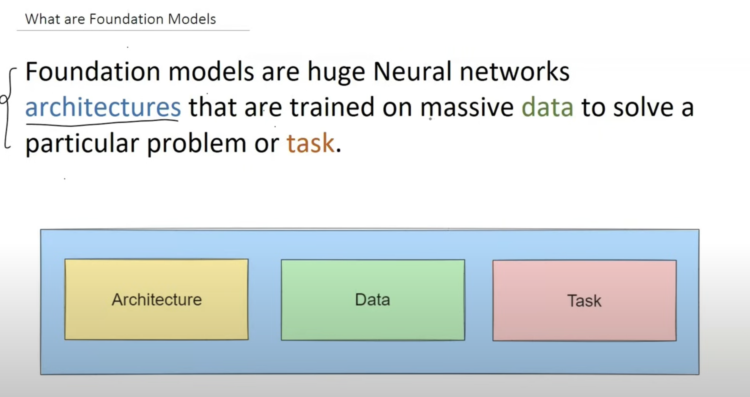

**Architecture:**

* Large Number of Parameters
* Scalable
* SOTA (State of the Art) which means good performance.

1. Transformers
2. GAN
3. Auto Encoders

**Data:**

* Massive Data is required.
* Diverse data ( To remove Bias in the data set)
* Modality : The type of data like Language, Vision

**Task:**

* General or Broad Task because we give such task so that the learning through this task is transferable.

**There are following 3 Stages :**

**Stage 1:**

**Pre-Training :** The data is trained for a broader task through the architecture with which it develops knowledge and concepts. The fundamentals can be used applied later.

**Stage 2:**

**Alignment:** Techniques used to filter the output of the pre-trained model. For example:

Chat-GPT cannot reply or give negative or inappropriate comments.

Techniques for example:

1. RLHF( Reinforced Learning thru Human Feedback)

**Stage 3:**

**Fine-Tuning:**  Use the foundation model generated above and tune it based on the task need to perform. Task like Text Summarisation, text classification.

Before the AI-model use to be very task specific, as in the model was trained by the data scientist with the available data you have and on training the model was developed. But the major problem is that we don’t have enough data or insufficient resources to train the model.

But the now the after the release of foundation model. You don’t train the model from scratch . What you do is you select open-source model and then you pass little data based on the task. Then you fine tune it. The major advantage is that the foundation model is trained by pouring lot of money so there is no doubt regarding. All we need to do it add a layer based on your application.

**Foundation Model**

1. Language Based
2. Vison Based : Model which are trained on Images.
3. Multi-modal : Can understand multiple type of data like image or text
4. Domain Specific Model
5. **Language Based:** It is also Known as LLMs. Example GPT , Bert

* Text Generation
* Text Summarisation
* Question and Answer
* Classification

1. **Vison Based:** Example: Dall-Efrom Open-AI

* Image generation
* Object Detection

1. **Multimodal:** Example: CLIP from Open-AI

* Image Captioning
* Visual Question Answering

1. **Domain Specific:** Example: Bloomberg GPT( Finance), Codex

**Disadvantages**

* Bias
* Ethical Concern
* Misinformation
* Security
* Explanability
* Environmental Concern