AFTER QUITTING THE ORIGINAL SESSION , AND RUNNING THE SCRIPT AGAIN WE GOT THE ABOUT PAGE WITH THE LOGIN CREDITIONAL

HOW TO CONFIRM THAT FLASK IS BY DEFUALT CLIENT SESSION.

THIS IS THE DATA IN THE VALUE

eyJjc3JmX3Rva2VuIjoiODdlMWQ2NmUxMmYxMzZlMjNkMmZhOGZjYjk0OWEzMjkzOWUyYzMwOSIsInVzZXJfbmFtZSI6Ik1BWCJ9.Zn2_uQ.jrtchoypiXtLq8FtqqfESwEjEaM

ON DECODING THE BASE64 DATA, WE CAN SEE THE USER NAME AS WELL AS SECRET KEY IS THERE. THAT IS WHY CLIENT SESSION IS NOT GOOD FOR SENSITIVE DATA

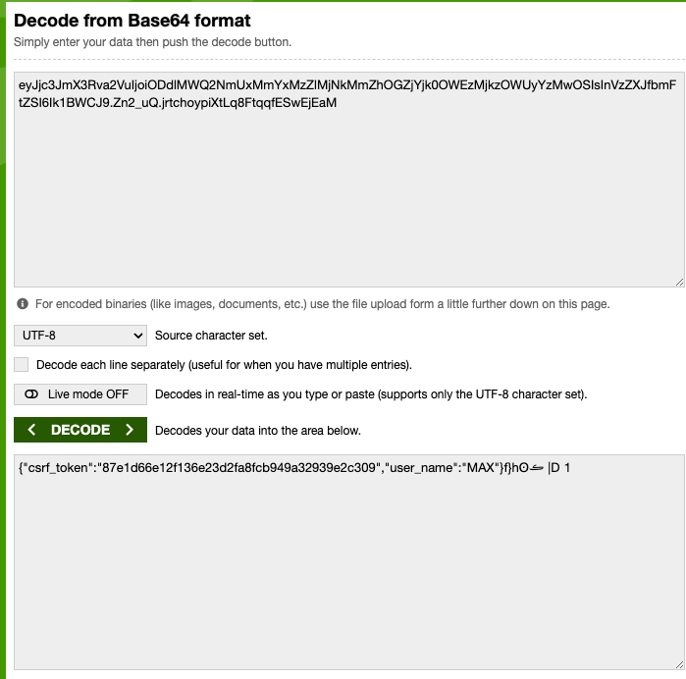

On Using Server Session

No data can be seen.

