**CLOUD NATIVE APPLICATION DEVELOPMENT**

**By-Mitali Kaur**

**(Deakin Id- s224582251)**

**Github Link:**

**https://github.com/Mita22-1/sit737-2025-prac4c**

**Calculator Microservice- What It’s About**

This project builds upon the calculator microservice introduced earlier by expanding its functionality and improving robustness. Implemented using Node.js and Express, the microservice now supports additional arithmetic operations and adopts advanced error handling strategies, making it more reliable and practical for real-world use.

The calculator now supports:

* **Exponentiation** (/power route): Raises one number to the power of another.
* **Square Root** (/sqrt route): Computes the square root of a number.
* **Modulo** (/modulo route): Returns the remainder of division between two numbers.

Each operation is accessible through a dedicated API endpoint, allowing both UI-based and programmatic interaction.

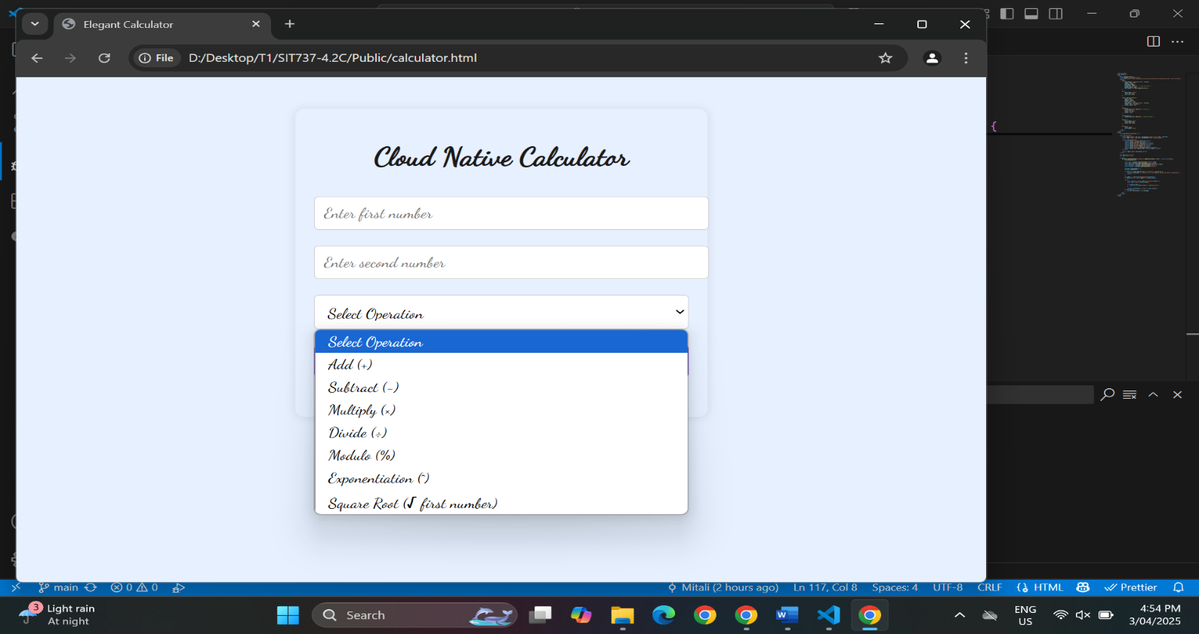

**Handling Errors & Keeping Logs**

Robust error handling mechanisms ensure invalid inputs, such as non-numeric values or illegal operations (e.g., dividing by zero or square root of a negative number), are caught and handled gracefully.

* **Winston Logger** tracks every request and error, supporting monitoring and debugging.

**Logging:**

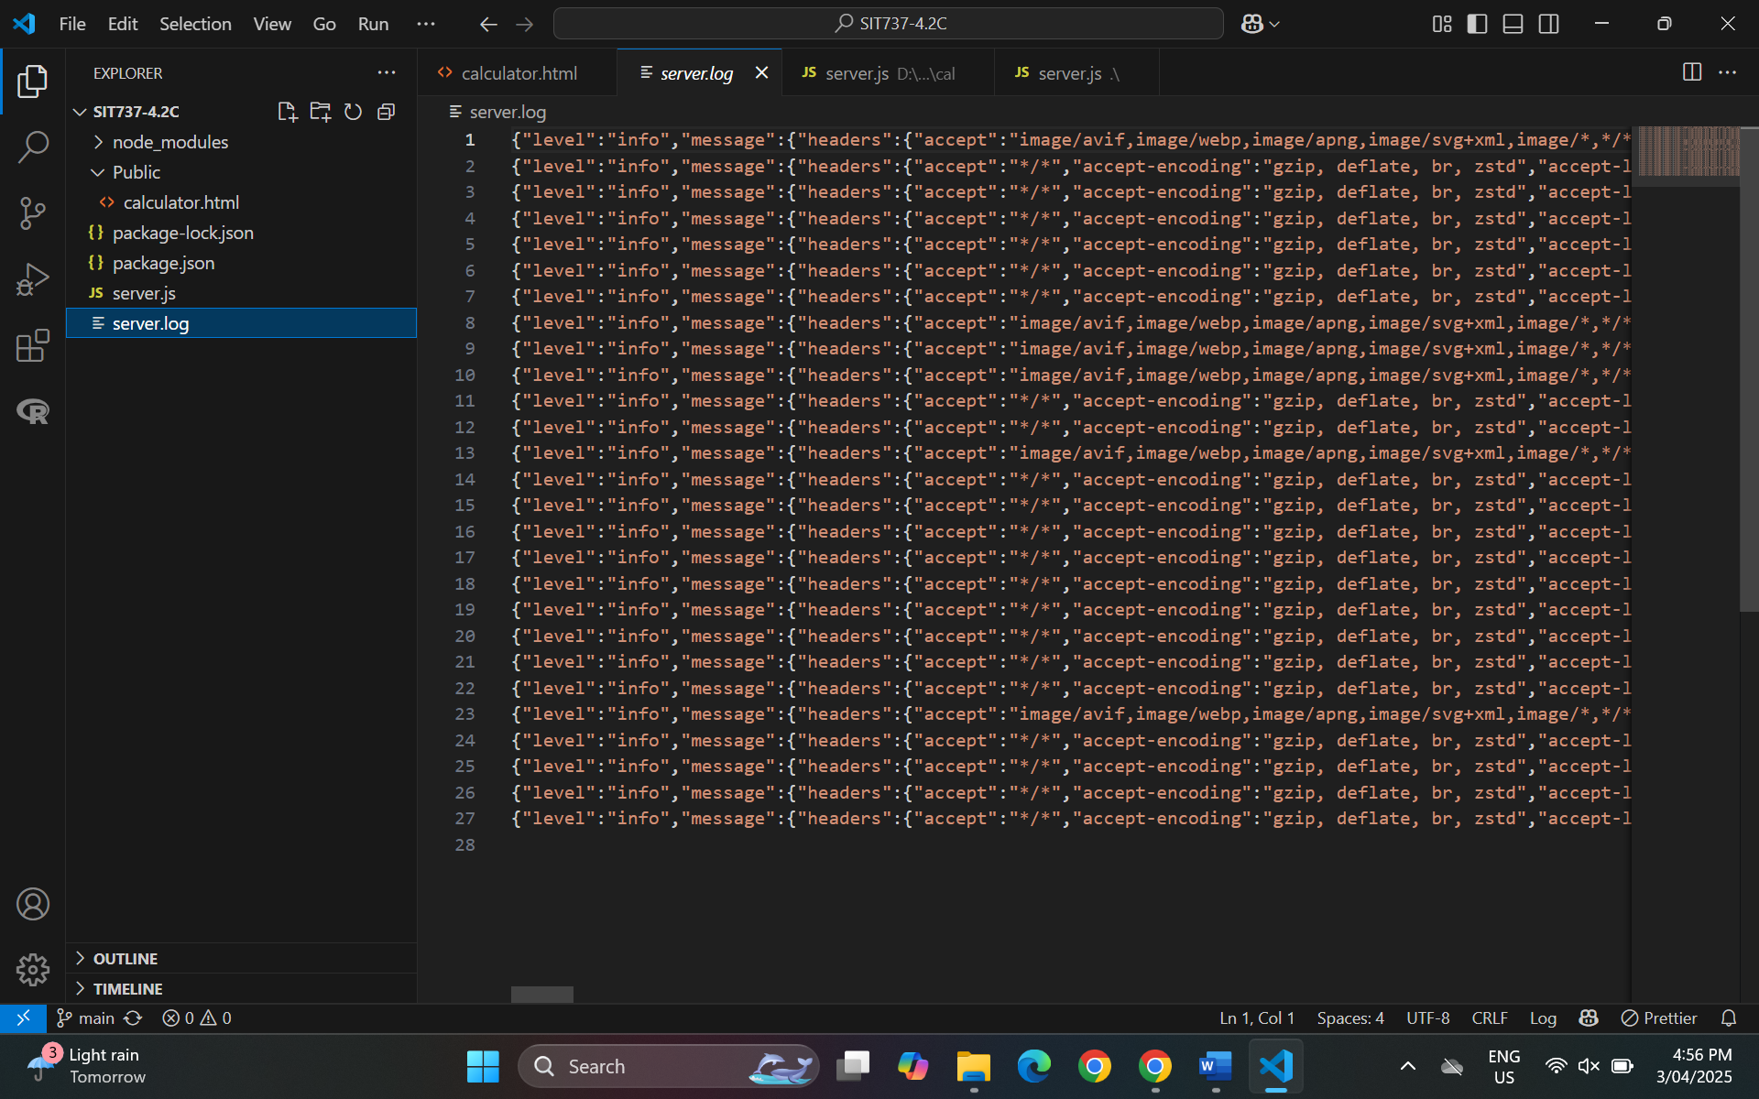

**Index.html**

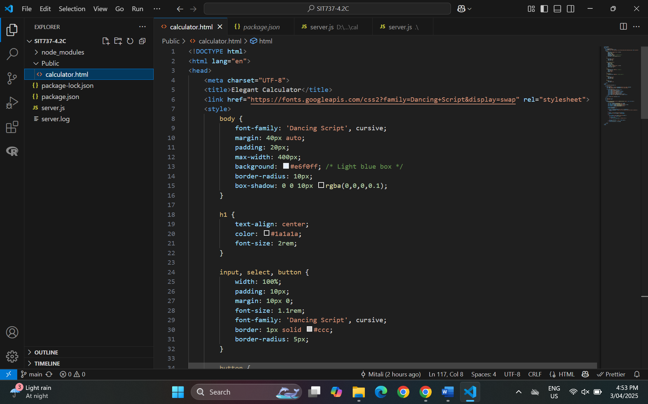

**Server.js**

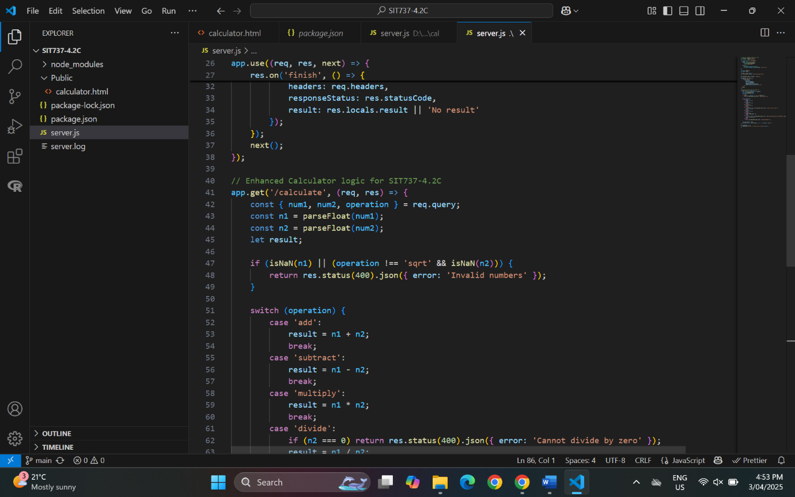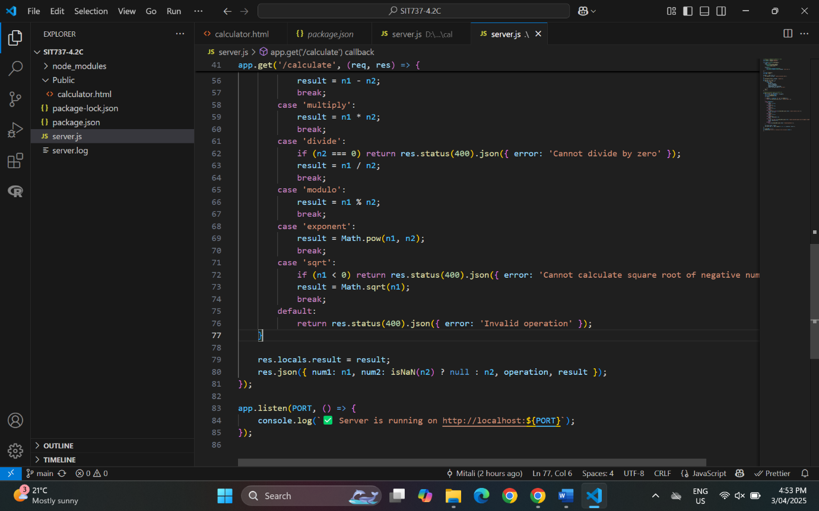

**Wrapping Up**

This project started as a basic calculator but grew into something more powerful. With new features like square root, exponentiation, and modulo, it now handles more than just the basics. I also looked into how microservices deal with errors, learning about smart patterns like circuit breakers and retries.

Overall, this was a great way to get hands-on with building better, more reliable services—and there’s still room to grow it further.