**ANALYSIS FOR DIFFERENT NUMBER OF DATA RECORDS OF THE RATINGS**

|  |  |  |  |  |
| --- | --- | --- | --- | --- |
| **Number of Records** | **Method** | **RMSE** | **TIME** | **MEMORY(Bytes)** |
| 300k | SGD | 0.3906 | 88s | 1.5*10e9 |
| SVD | 0.2329 | 53s | 1.65*10e9 |
| KNN | 02379 | 95s | 0.56*10e9 |
| 500k | SGD | 0.3301 | 153s | 1.58*10e9 |
| SVD | 0.2323 | 88s | 1.77*10e9 |
| KNN | 0.2381 | 230s | 1*10e9 |
| 600k | SGD | 0.3211 | 189s | 1.63*10e9 |
| SVD | 0.2324 | 105s | 1.779*10e9 |
| KNN | 0.2382 | 320s | 1.46*10e9 |

To confirm the analysis below graphs(plotted through program) can be considered

**For SGD Method**

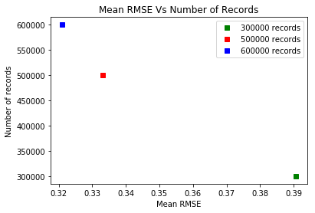

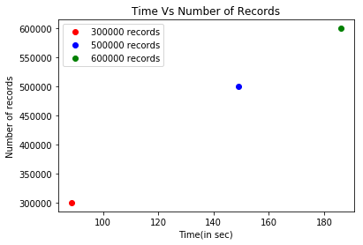

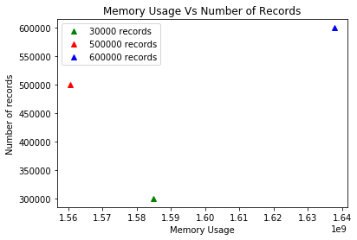

**For SVD Method**

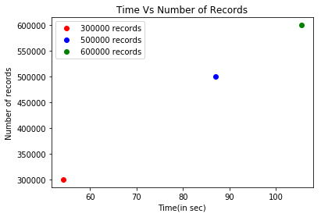

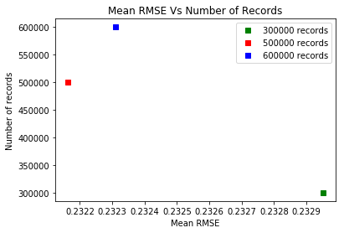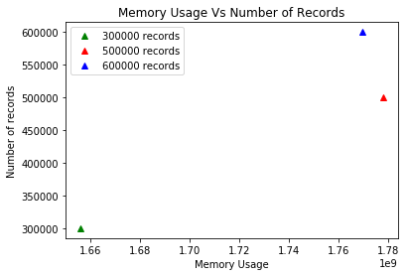

**For KNN Method**

