Assignment: Git Hands-on Practice

Task 1: Configure Git

1. Set your username and email in Git.
2. Verify the configuration.

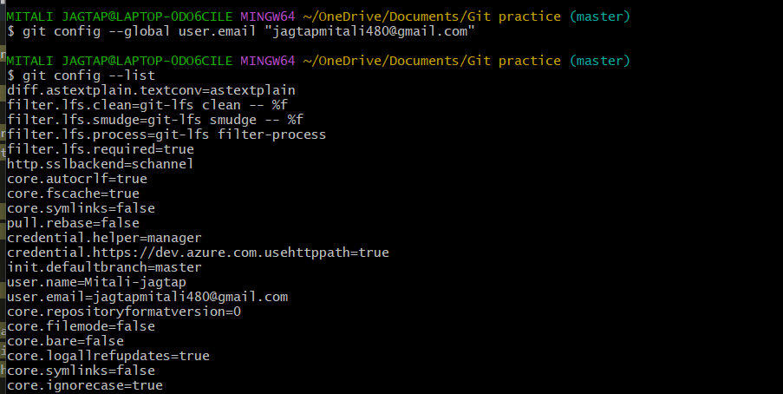

Task 2: Initialize a Local Repository

1. Create a new folder named `git-hands-on`.
2. Initialize it as a Git repository.
3. Check the repository status.

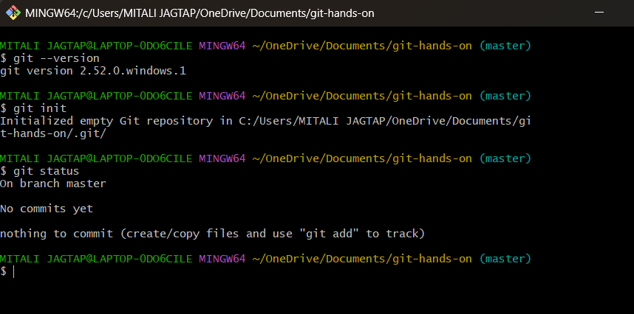

Task 3: Create and Track Files**

1. Create a file named `documentation.txt`.
2. Add a short project description inside it.
3. Check file status.
4. Stage the file.
5. Commit the changes with an appropriate message.

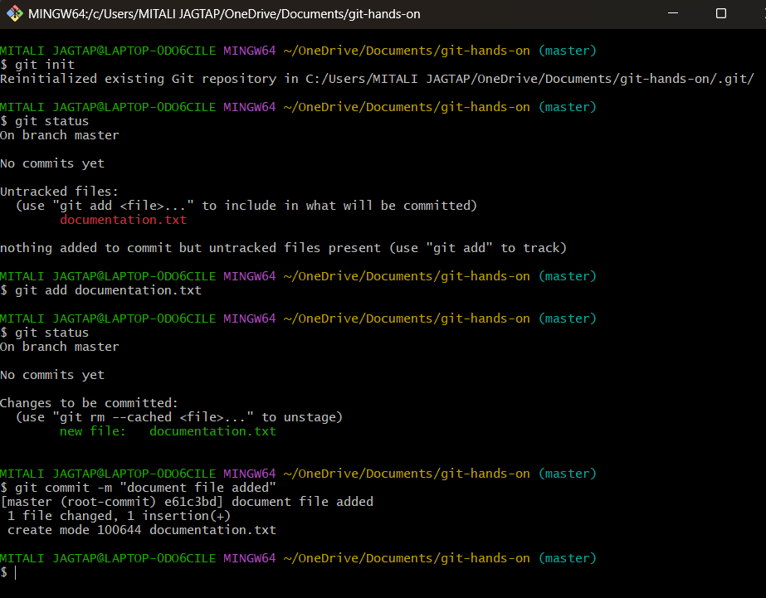

Task 4: Modify and Commit Changes

1. Edit `documentation.txt` and add one more line.
2. View the differences between working directory and staging area.
3. Stage and commit the changes.

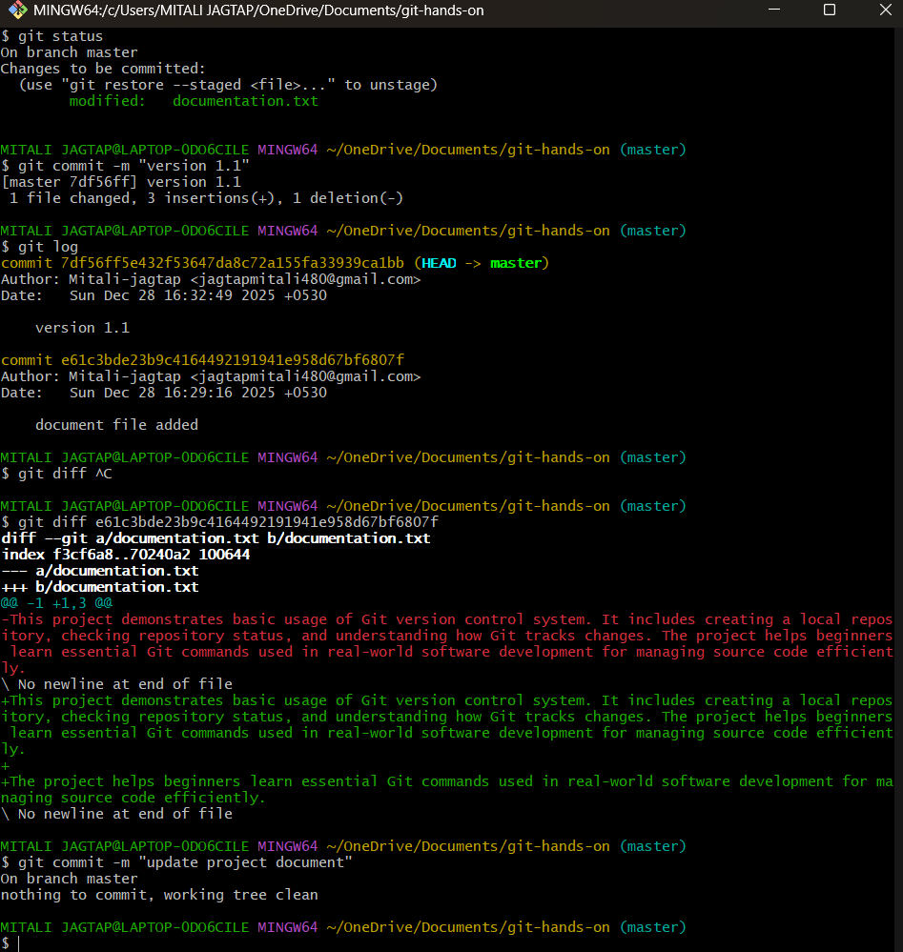

Task 5: View Commit History

1. View the complete commit history.
2. View commit history in one-line format.

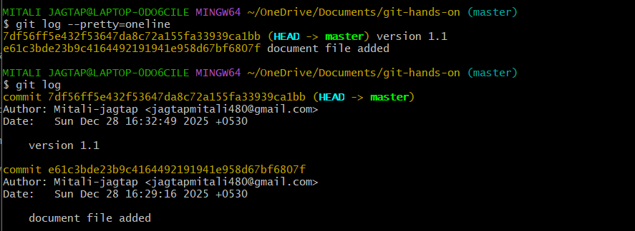

Task 6: Create and Work with Branches
1. Create a new branch named `feature-1`.
2. Switch to the new branch.
3. Create a new file `feature.txt`.
4. Commit the changes.
5. Switch back to the main branch.
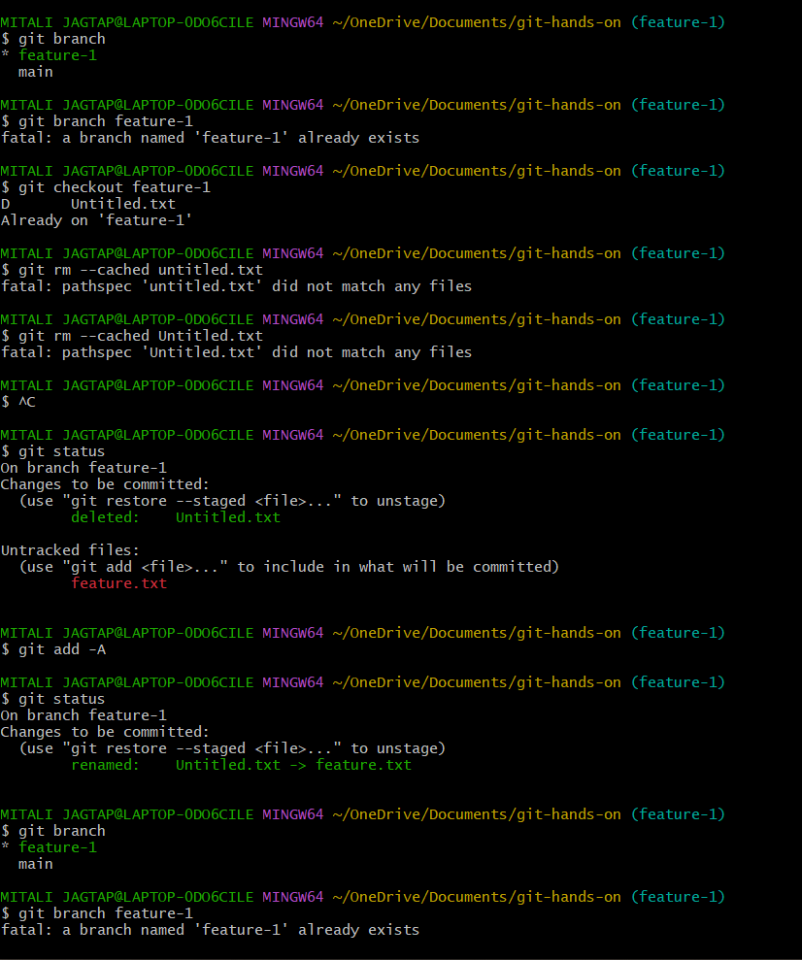
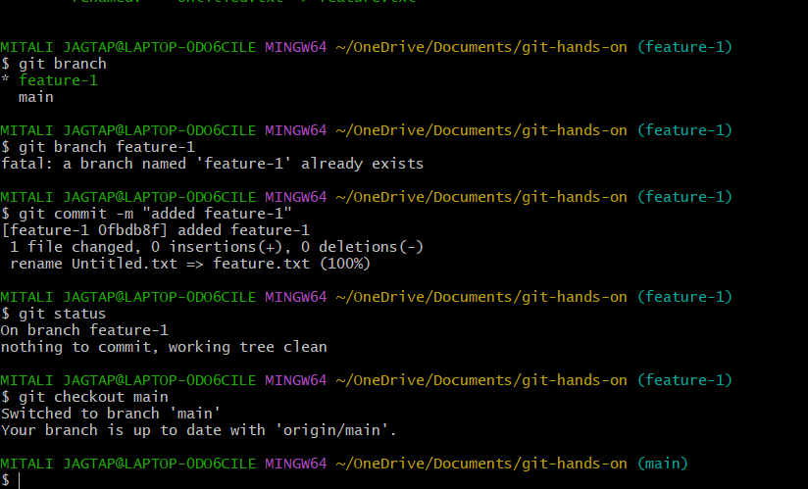

Task 7: Merge Branches

1. Merge `feature-1` branch into `main`.
2. Verify the merge using commit history.
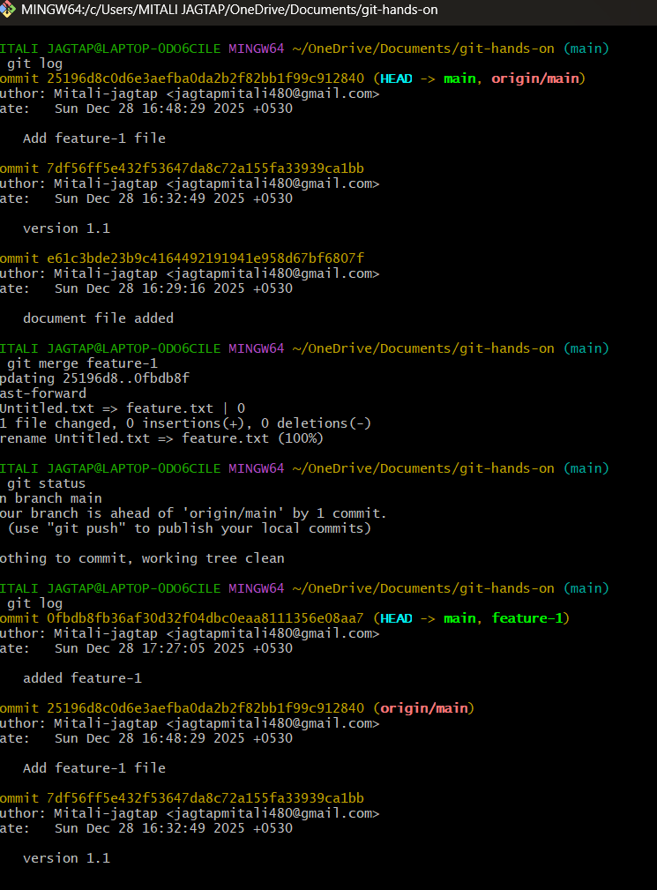
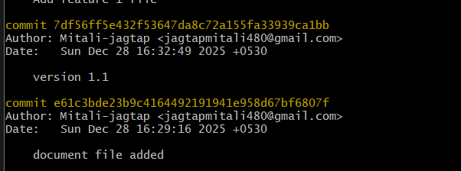
Task 8: Connect to a Remote Repository

1. Create a new repository on GitHub.
2. Add the remote repository URL to your local repo.
3. Verify the remote connection.

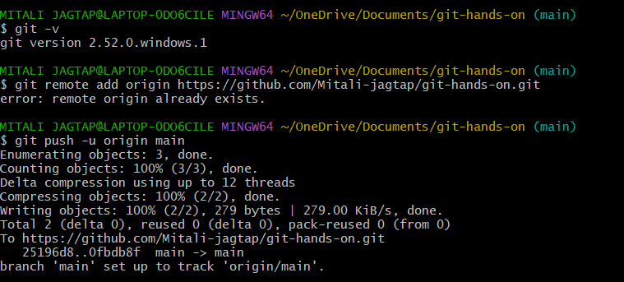

Task 9: Push Code to GitHub

1. Push the `main` branch to GitHub.
2. Verify files on GitHub.
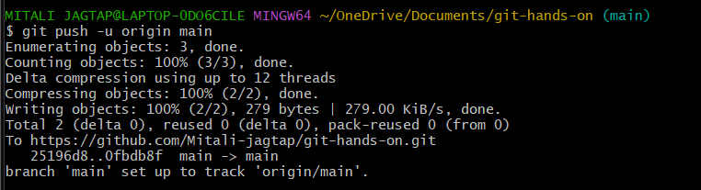

Task 10: Clone a Repository

1. Clone the same GitHub repository into a different folder.
2. Verify the cloned content.
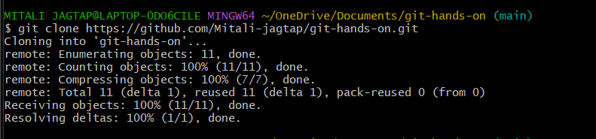
Task 11: Undo Changes

1. Make a change in `documentation.txt` but do not commit.
2. Discard the changes.
3. Verify the file status.
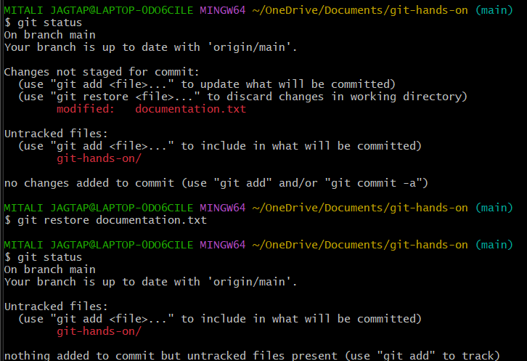

Task 12: Remove Files

1. Delete `feature.txt` using Git.
2. Commit the deletion.

